**MINISTRY OF EDUCATION AND TRAINING VIET NAM**

**FPT UNIVERSITY**  
Capstone Project Document

[eRestaurant]

|  |  |  |
| --- | --- | --- |
| **eRestaurant Group** | | |
| **Group Members** | Au Van Thinh | SE04295 |
| Duong Tuan Nhat | SE03990 |
| Nguyen Anh Dung | SE04066 |
| Nguyen Chi Nghia | SE04270 |
| Nguyen Minh Hieu | SE04319 |
| **Supervisor** | **Tran Dinh Tri** | |
| **Capstone Project code** | ER | |

Hanoi, 5/2018

[CHAPTER 1: INTRODUCTION 10](#_Toc523174657)

[1.1 Purpose 10](#_Toc523174658)

[1.2 Project information 10](#_Toc523174659)

[1.2.1 Project member 10](#_Toc523174660)

[1.2.2 Problems 11](#_Toc523174662)

[1.2.3 Solution 11](#_Toc523174663)

[1.2.4 Overview Of Existing System 11](#_Toc523174664)

[1.3 Technology 12](#_Toc523174665)

[1.4 Out of scope 12](#_Toc523174666)

[1.5 Benefit 12](#_Toc523174667)

[1.6 Limitation 13](#_Toc523174668)

[CHAPTER 2: SOFTWARE PROJECT MANAGEMENT PLAN 14](#_Toc523174669)

[2.1 Purpose 14](#_Toc523174670)

[2.2 Problem Definition 14](#_Toc523174671)

[2.2.1 Name of this Capstone Project 14](#_Toc523174672)

[2.2.2 Problem Abstraction 14](#_Toc523174673)

[2.3 Project Overview 14](#_Toc523174674)

[2.3.1 The Current System 14](#_Toc523174675)

[2.3.2 Boundaries of System 15](#_Toc523174676)

[2.3.3 Development Environment 15](#_Toc523174677)

[2.4 Project organization 15](#_Toc523174678)

[2.4.1 Software Process Model 15](#_Toc523174679)

[2.4.2 Roles and Responsibilities 16](#_Toc523174680)

[2.4.3 Tools and Techniques 19](#_Toc523174681)

[2.5 Project management plan 19](#_Toc523174682)

[2.5.1 Master plan 19](#_Toc523174683)

[2.5.2 Meeting Minutes 21](#_Toc523174684)

[2.5.3 Risk Management Plan 22](#_Toc523174685)

[CHAPTER 3: SOFTWARE REQUIREMENT SPECIFICATION 25](#_Toc523174686)

[3.1 Purpose 25](#_Toc523174687)

[3.2 User Requirement Specification 25](#_Toc523174688)

[3.2.1 User Description 25](#_Toc523174689)

[3.2.2 User Requirement 28](#_Toc523174690)

[3.3 System Requirement Specification 29](#_Toc523174691)

[3.3.1 External Interface Requirement 29](#_Toc523174692)

[3.3.2 System Use Case 29](#_Toc523174693)

[3.3.3 List of Use Cases 36](#_Toc523174694)

[3.3.4 Business Rule 36](#_Toc523174695)

[3.3.5 Use Case Specification 38](#_Toc523174696)

[3.3.6 Non-functional Requirements 75](#_Toc523174697)

[3.4 Entity Relationship Diagram (ERD) 76](#_Toc523174698)

[CHAPTER 4: SOFTWARE DESIGN DESCRIPTION 77](#_Toc523174699)

[4.1 Purpose 77](#_Toc523174700)

[4.2 Architecture Overview 77](#_Toc523174701)

[4.2.1 Choice of System Architecture 77](#_Toc523174702)

[4.2.2 System Architecture 79](#_Toc523174703)

[4.2.3 System Architecture Explanation 80](#_Toc523174704)

[4.3 Component Diagram 81](#_Toc523174705)

[4.4 Sequence Diagram 82](#_Toc523174706)

[4.4.1 Login by Facebook 82](#_Toc523174707)

[4.4.2 Login 82](#_Toc523174708)

[4.4.3 Logout 83](#_Toc523174709)

[4.4.4 Show menu 83](#_Toc523174710)

[4.4.5 Add food 84](#_Toc523174711)

[4.4.6 Delete food 85](#_Toc523174712)

[4.4.7 Add account 86](#_Toc523174713)

[4.4.8 Edit account 87](#_Toc523174714)

[4.4.9 Delete account 88](#_Toc523174715)

[4.4.10 View account 89](#_Toc523174716)

[4.4.11 Add table 89](#_Toc523174717)

[4.4.12 Edit table 90](#_Toc523174718)

[4.4.13 View table 91](#_Toc523174719)

[4.4.14 View statistics 92](#_Toc523174720)

[4.4.15 Book table 93](#_Toc523174721)

[4.4.16 Cancel table book 93](#_Toc523174722)

[4.4.17 Add order 94](#_Toc523174723)

[4.4.18 View order 95](#_Toc523174724)

[4.4.19 Delete order 95](#_Toc523174725)

[4.4.20 Change order status 96](#_Toc523174726)

[4.4.21 View customer booking status 96](#_Toc523174727)

[4.4.22 Checkout 97](#_Toc523174728)

[4.5 Algorithm 98](#_Toc523174729)

[4.6 CRC Cards and Class Diagram 100](#_Toc523174730)

[4.6.1 CRC Cards 100](#_Toc523174731)

[4.6.2 Class Diagram 116](#_Toc523174732)

[**4.7 Use Interface Design** 155](#_Toc523174733)

[4.7.1 Home page 155](#_Toc523174734)

[4.7.2 Restaurant’s Info 155](#_Toc523174735)

[4.7.3 Login(by staff) 156](#_Toc523174736)

[4.7.4 Agent account management 156](#_Toc523174737)

[4.7.5 Create/update agent account 157](#_Toc523174738)

[4.7.6 Table management 157](#_Toc523174739)

[4.7.7 Create/update table 158](#_Toc523174740)

[4.7.8 Category management 158](#_Toc523174741)

[4.7.9 Create/update category 159](#_Toc523174742)

[4.7.10 Food management 159](#_Toc523174743)

[4.7.11 Create/update food 160](#_Toc523174744)

[4.7.12 Available table 160](#_Toc523174745)

[4.7.13 Manage table booking 161](#_Toc523174746)

[4.7.14 Manage order 161](#_Toc523174747)

[4.7.15 Waiting foods to serve 162](#_Toc523174748)

[4.7.16 Waiting foods to cook 162](#_Toc523174749)

[4.7.17 List order 163](#_Toc523174750)

[4.7.18 Check out 163](#_Toc523174751)

[4.7.19 View statistic 164](#_Toc523174752)

[**4.8 Database Design** 165](#_Toc523174753)

[4.8.1 Role Table 165](#_Toc523174754)

[4.8.2 User table 165](#_Toc523174755)

[4.8.3 Food table 166](#_Toc523174756)

[4.8.4 Category table 166](#_Toc523174757)

[4.8.5 Food Category table 166](#_Toc523174758)

[4.8.6 Customer table 166](#_Toc523174759)

[4.8.7 “Table” table 166](#_Toc523174760)

[4.8.8 Order\_table table 167](#_Toc523174761)

[4.8.9 Order table 167](#_Toc523174762)

[4.8.10 Order Detail table 167](#_Toc523174763)

[CHAPTER 5: SOFTWARE TESTING DOCUMENT 167](#_Toc523174764)

[5.1 Introduction 167](#_Toc523174765)

[5.1.1 Scope of testing 167](#_Toc523174766)

[5.1.2 Stages of testing 168](#_Toc523174767)

[5.2 Test Plan 170](#_Toc523174768)

[5.2.1 Testing tools and environment 170](#_Toc523174769)

[5.2.2 Resources and responsibilities 172](#_Toc523174770)

[5.2.3 Test strategy 172](#_Toc523174771)

[5.2.4 Feature to be tested 175](#_Toc523174772)

[5.2.5 Feature not to be tested 175](#_Toc523174773)

[5.3 Test Approach 176](#_Toc523174774)

[5.3.1 Unit Test 176](#_Toc523174775)

[5.3.2 Acceptance Test 187](#_Toc523174776)

[5.3.3 Defect Log 188](#_Toc523174777)

[5.4 Test Report 188](#_Toc523174778)

[5.4.1 Bug list report 188](#_Toc523174779)

[5.4.2 Iteration 1 191](#_Toc523174780)

[5.4.3 Iteration 2 191](#_Toc523174781)

[CHAPTER 6: SOFTWARE USER’S MANUAL 192](#_Toc523174782)

[6.1 User Guidelines 192](#_Toc523174783)

[6.1.1 HomePage 192](#_Toc523174784)

[6.1.2 Information page 192](#_Toc523174785)

[6.1.3 Login by staff 194](#_Toc523174786)

[6.1.4 Logout 197](#_Toc523174787)

[6.1.5 List account 198](#_Toc523174788)

[6.1.6 Search account 199](#_Toc523174789)

[6.1.7 Delete account 200](#_Toc523174790)

[6.1.8 Edit account 201](#_Toc523174791)

[6.1.9 Create account 202](#_Toc523174792)

[6.1.10 List table 203](#_Toc523174793)

[6.1.11 Delete table 203](#_Toc523174794)

[6.1.12 Edit table 203](#_Toc523174795)

[6.1.13 Create table 204](#_Toc523174796)

[6.1.14 List category 205](#_Toc523174797)

[6.1.15 Search category 206](#_Toc523174798)

[6.1.16 Delete category 206](#_Toc523174799)

[6.1.17 Edit category 208](#_Toc523174800)

[6.1.18 Create category 209](#_Toc523174801)

[6.1.19 List food 211](#_Toc523174802)

[6.1.20 Search food 211](#_Toc523174803)

[6.1.21 Delete food 212](#_Toc523174804)

[6.1.22 Edit food 213](#_Toc523174805)

[6.1.23 Create food 215](#_Toc523174806)

[6.1.24 View statistic 217](#_Toc523174807)

[6.1.25 Login/Register 219](#_Toc523174808)

[6.1.26 List available table 220](#_Toc523174809)

[6.1.27 Book table 222](#_Toc523174810)

[6.1.28 Manage booking table (customer) 223](#_Toc523174811)

[6.1.29 Manage booking table (waiter) 226](#_Toc523174812)

[6.1.30 Manage order 230](#_Toc523174813)

[6.1.31 List food waiting to cook 235](#_Toc523174814)

[6.1.32 Change status of food 236](#_Toc523174815)

[6.1.33 List food waiting to be served 237](#_Toc523174816)

[6.1.34 Serve food 238](#_Toc523174817)

[6.1.35 List order has been served 239](#_Toc523174818)

[6.1.36 CheckOut 240](#_Toc523174819)

# INTRODUCTION

## Purpose

The purpose of this chapter is to provide an overview of Restaurant Management Web App and why we choose it. And we also show Idea, solution, some basic functions in this project. Besides, we have some benefit and limitation in the project. Thereby, we will research orientation of future.

## Project information

|  |  |
| --- | --- |
| **Project name** | eRestaurant |
| **Project code** | ER |
| **Project type** | Web Base Application |
| **Project manager** | Au Van Thinh |
| **Timeline** | May, 2018 – August, 2018 |

### Project member



* **Supervisor:**

|  |  |  |
| --- | --- | --- |
| Full name | E-mail | Title |
| **Tran Dinh Tri** | **Tritd@fpt.edu.vn** | **Lecturer** |

* **Team member :**

|  |  |  |  |  |
| --- | --- | --- | --- | --- |
| Full name | Code | Roll Number | E-mail | Phone |
| **Au Van Thinh** | ThinhAV | SE04295 | thinhavse04295@fpt.edu.vn | (+84) 967239959 |
| **Duong Tuan Nhat** | NhatDT | SE03990 | nhatdtse03990@fpt.edu.vn | (+84) 1663058353 |
| **Nguyen Anh Dung** | DungNA | SE04066 | dungnase04066@fpt.edu.vn | (+84) 947960112 |
| **Nguyen Chi Nghia** | NhiaNC | SE04270 | nghiancse04270@fpt.edu.vn | (+84) 865911747 |
| **Nguyen Minh Hieu** | HieuNM | SE04319 | hieunmse04319@fpt.edu.vn | (+84) 962919852 |

### Problems

In The Fourth Industrial Revolution, an application which helps people manage their business easily and effective is very popular and must-have. So, we will build a Web Based Application for Restaurant Management which have many diffrent functions to helps restaurant manager and customer for:

* Saving time for customer in pre-order
* Saving time in order phase.
* Improving waiter to chef interaction.
* Improving revenues of restaurant
* Saving time and money in statistics.

### Solution

To reach our above goals, we will develop a Web Based Application with MVVM Model and many functions which support these goals:

* Pre-order System
* Real time Order System
* Dishes Suggesting System
* Statistics System

### Overview Of Existing System

In Vietnam, there are several web apps and mobile apps which are used in some restaurants. For instance, **AnVietSoft** is a mobile application are using by a wide range of restaurants for supporting management but it still exists some limitations such as lack of real-time order. It causes delays when customer order. Or like **PosApp** is good enough for customer. However, it does not have order suggesting system which can help their revenues grow up, so our project not only haves must-have functions such as Pre-order and Statistics System but also develop Real time Order and Dishes Suggesting System which are really different from others.

## Technology

|  |  |
| --- | --- |
| Programming Language | Java, Typescript, HTML5 |
| Framework | Spring Boot Framework 2.0.2, Hibernate , Angular 6 |
| Version Control | BitBucket |
| IDEs | eclipse |
| DBMS | MySQL 8.0.11 |
| UML Tools | Microsoft Visio 2016, Draw.io |
| Other | Microsoft Office 2016, Microsoft Project 2016 |

## Out of scope

* The system is supported by all current browsers
* Support native app for Android OS and iOS
* Supports data recovery when system is corrupted
* Other system integration: warehouse management system, staff management system, Membership Point Accumulation System, Bank Card Payment System
* Multi language Interface

## Benefit

* For our group
* Have change and experiment to develop a project, how to manage plan, how to promote effective teamwork.
* Training skill about HTML5, Typescript, JAVA, MySQL, SCSS.
* For restaurants manager
* Increase revenues of restaurant.
* Save time and prevent confusing on order phase.
* Save time and money for restaurant on management.
* Make customers pleased when they come to restaurant.

## Limitation

* We do not know professional knowledge clearly.
* We are not invested.
* We do not have experiment to develop a project.

# SOFTWARE PROJECT MANAGEMENT PLAN

## Purpose

In this chapter, we will talk about the specific roles of the project team members. Plan and organize the project, the responsibilities of the members in each task. Project team members use this document to know their responsibilities and actions in the project.

## Problem Definition

### Name of this Capstone Project

* **Capstone Project Name:** eRestaurant
* **Abbreviation:** ER

### Problem Abstraction

In The Fourth Industrial Revolution, an application which helps people manage their business easily and effective is very popular and must-have. So, we will provide a Web Based Application for Restaurant Management which have many functions to helps restaurants manager and customer:

* Save time for customer in pre-order
* Save time in order phase.
* Improve waiter to chef interaction.
* Improve revenues of restaurant
* Save time and money in statistics.

## Project Overview

### The Current System

In almost restaurants in Vietnam, waiters write down dishes are ordered then bring it to kitchen. When kitchen finish, waiters bring dishes to customers. In big restaurants, this way not only leads to wasting time and effort but also cause confusing in orders. Therefore, this simple system is not effective and may be unpleasant of customers.

### Boundaries of System

System includes:

* The functioning web services support many end-devices.
* Web Based Application
* All relevant documents.

### Development Environment

**Hardware requirement:**

* System requirement for Web Services(minimum): Ram 4GB, CPU 2.5Ghz
* System requirement for Web Application: Android device, IOS device, Windows device

**Software requirement:**

* Operating system: Windows, Android, IOS
* Application server: ER application system requires an application server running on Windows 7
* Browsers: Firefox (latest), Chrome(latest)
* Mobile device: IOS(2 most recent major versions), Android(4.0 or higher)
* Framework: Spring Framework, Angular 6, Hibernate
* Apache Tomcat 9
* Database: MySQL
* Tool: Eclipse

**Testing requirement:**

* Laptop, PC: Internet connection
* Mobile device: Internet connection

## Project organization

### Software Process Model

To develop our project we choose Iterative & Incremental software process model:

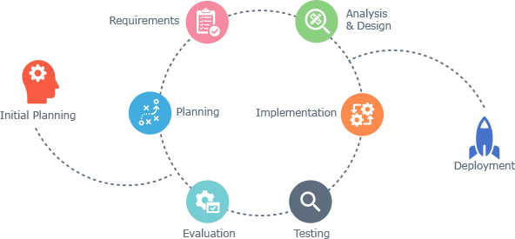

*Figure 1: Iterative and Incremental process model*

The reason why the project team chooses Iterative & Incremental software process model:

* This model is more flexible – less costly to change scope and requirements.
* Reduce the risk of delay due to the important work done first.
* Establish a good relationship between users and developers. Project team will always communicate with users to obtain information to meet the needs of users.
* Repetition of the phases can be built so that the system really met the demand of users
* Through every iterative, we can control scope and requirements, flexibly update or even change things if we think it will help us to have a better product.
* It is easy to manage risk by dividing it into pieces and solve it as quick as possible in each iterative.

### Roles and Responsibilities

#### Team organization structure

*Figure 2: Human Resource*

#### Roles and responsibilities

|  |  |  |
| --- | --- | --- |
| **Name** | **Role** | **Quality Responsibility** |
| Au Van Thinh | PM, BA, Dev | - Define scope and planning, allocate resources to the project.  - Managing process  - Analyze requirements  - Create documents. Reports  - Coding  - Unit testing |
| Duong Tuan Nhat | Designer, Dev, Doc, QA | - Coding  - Design project.  (Investigate solution. Build system architecture, coding. Review codes)  - Responsible for test execution, including test set-up and test run, evaluation of test run and error recovery, defect logging and test results recording.  - Create test cases, Execute test cases  - Manage the Quality Assurance function |
| Nguyen Anh Dung | Designer, Dev Doc | - Support designing system  - Support designing database  - Deployment  - GUI Design  - Coding |
| Nguyen Chi Nghia | Doc, Tester | - Create and review document  - Unit testing |
| Nguyen Minh Hieu | Designer, Dev, Doc | - Support designing system  - Support designing database  - Support GUI design  - Deployment |

### Tools and Techniques

|  |  |
| --- | --- |
| Programming Language | Java, Typescript, HTML5 |
| Framework | Spring Boot Framework 2.0.2, Hibernate, Angular 6 |
| Version Control | BitBucket |
| IDEs | eclipse |
| DBMS | MySQL 8.0.11 |
| UML Tools | Microsoft Visio 2016, Draw.io |
| Other | Microsoft Office 2016, Microsoft Project 2016 |

## Project management plan

### Master plan

The master plan of this project is managed in the following summary task level.

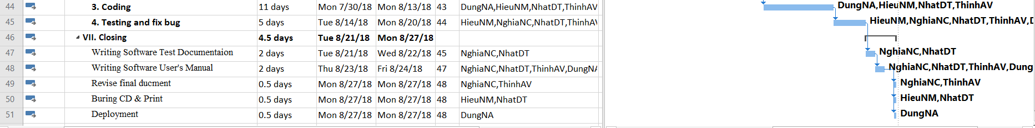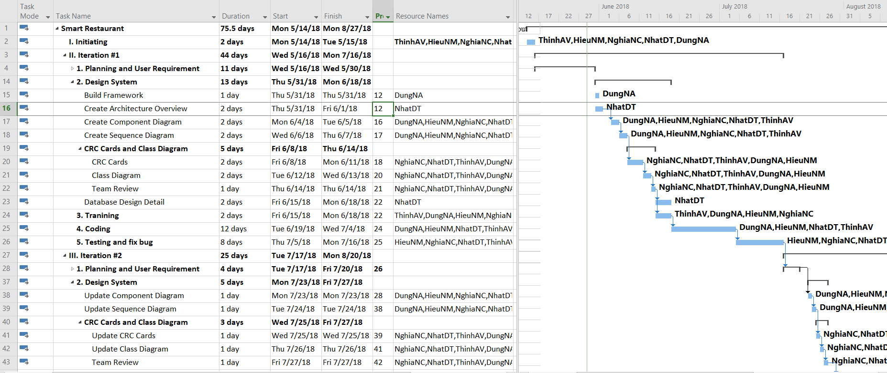

Figure 3: Master Schedules

### Meeting Minutes

Because of the project doing in the short time, we have to hold the meeting regularly, at least twice a week:

* **Meeting with team members:** 2 times per week, meeting will be held at 9: am on Tuesday and Friday.In these meetings, each member will report their current tasks to others. The issues, rules and knowledge will be shared. Moreover, PM conduct the discussion of the plan in next week.
* **Meeting with supervisor:** 1 time per week, at 4: pm on Tuesday. All activities and issues in former week will be discussed and reported to supervisor. With the senior experiment, supervisor will instruct project team to solve the problems.
* **Special meeting:** When there are anomalous issues which need to solve immediately, a special meeting will be held to find out the most effective solution to ensure progress of the project.

Meeting template:

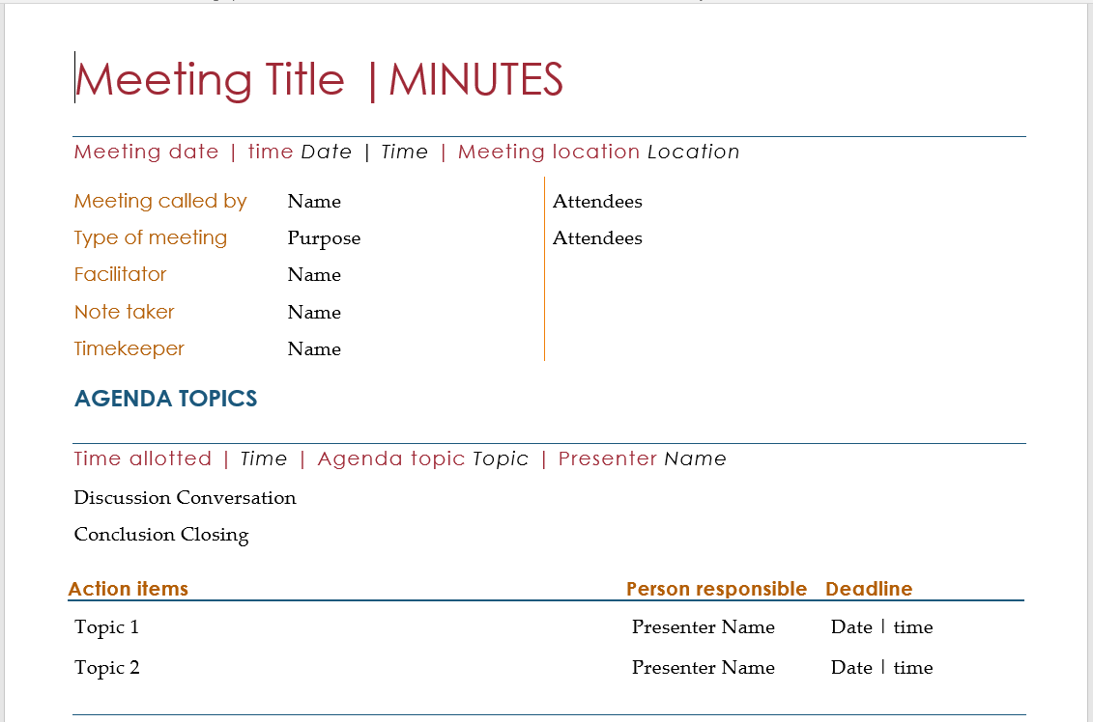

*Figure 5 – Meeting Minute template*

### Risk Management Plan

|  |  |  |  |  |  |
| --- | --- | --- | --- | --- | --- |
| No | Description | Probability | Avoidance Plan | Contingency Plan | Impact |
| 1 | Team members refuse to cooperate with each other | High | Hold teambuilding activities to build team’s spirit.  Create a friendly environment. | Talk to involved team members personally and in group to work out a solution. | Very High |
| 2 | Absences of team members | Medium | Provide meeting schedules and deadlines in advance so that all team members know the time and place where they will be needed  PM should be warned immediately when team member plan to be absent for a period of time. | Assign important tasks to other suitable team members | High |
| 3 | Team members lack technical skills and knowledge | High | Person in charge of Development Team provides workshops and training sessions for developers to acquire needed knowledge and techniques.  Encourage team members to study on themselves for their technical personal needs  Develop project plan with regards to training and self-study period | Person in charge of Development Team assists team member personally or in group to develop required skills and knowledge | Very High |

# SOFTWARE REQUIREMENT SPECIFICATION

## Purpose

The main purpose of this chapter is providing specific information the system. It covers details specification about user requirements, software requirements and entity relationship diagram. This chapter provides the overview description about features of eRestaurant Web Based Application.

This chapter includes:

* User requirements
* System requirements
* Software system attributes
* Entity relationship diagram

## User Requirement Specification

### User Description

In eRestaurant System, there are 6 types of user groups: Guest, Customer, Waiter, Chef, Cashier and Manager.

|  |
| --- |
| **1. Guest: who has not had account in system yet** |
| *View restaurant info* |
| *View menu* |
| *Register* |
| **2. Customer: who already had an account in system** |
| *Login by Facebook account* |
| *Logout* |
| View available table |
| View menu |
| **Manage table booking** |
| *Book table* |
| *Cancel table book* |
| *View table book* |
| **Manage order** |
| *Add order* |
| *Edit order* |
| *Delete order* |
| *View order* |
| *Submit order for waiter*  *Recommend* |
| **3. Waiter: who helps customer make order and booking.** |
| *Login* |
| *Logout* |
| View menu |
| **Manage table Booking** |
| *Book table* |
| *Cancel table book* |
| *View table book* |
| **Manage order** |
| *Add order* |
| *Edit order* |
| *Delete order* |
| *View order* |
| *Submit order for chef*  *Recommend* |
| *Notified order* |
| *Serve order* |
| **4. Chef: who pick dish from order list to cook.** |
| *Login* |
| *Logout* |
| *List waiting order* |
| *Change order status* |
| **5. Cashier: who has responsibility to help customer check out** |
| *Login* |
| *Logout* |
| List served order |
| Find served order |
| Check out |
| **6. Manager: who can manage business process and view reports** |
| *Login* |
| *Logout* |
| **Manage category** |
| Add category |
| Edit category |
| Delete category |
| View category |
| **Manage food** |
| Add food |
| Edit food |
| Delete food |
| View food |
| **Manage table** |
| Add table |
| Edit table |
| Delete table |
| View table |
| **Manage agent account** |
| Add account |
| Edit account |
| Delete account |
| View account |
| View statistics |

In the system there are 6 user groups as shown in the following:

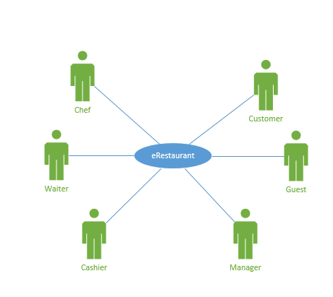

*Figure 6 – Use case level 0*

### 

### User Requirement

Here is the total use case diagram:

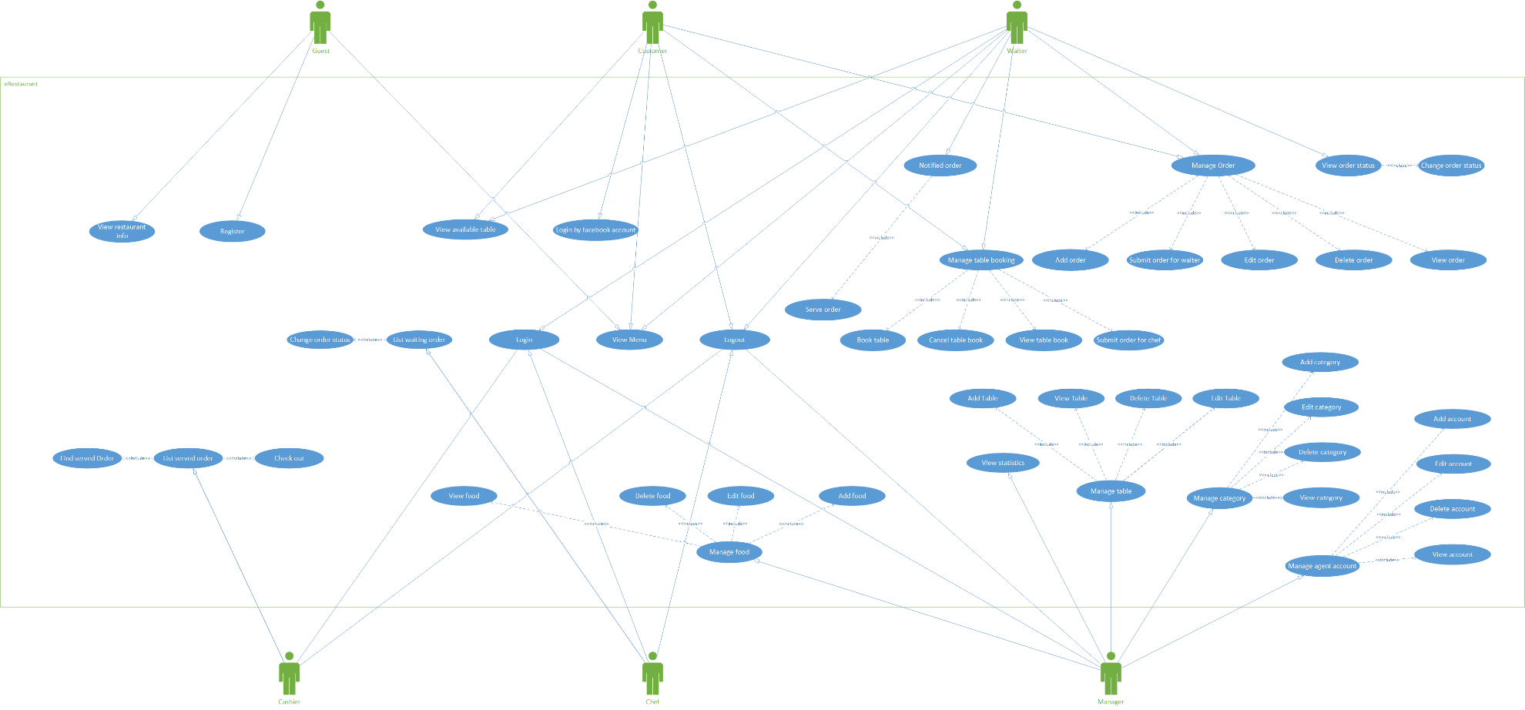

*Figure 7 – Total Use Case Diagram*

## System Requirement Specification

### External Interface Requirement

#### User Interface

* Vietnamese is the official language of ER website.
* System has been designed with less and simple color to make the page clearly to use. Users can easily focus on their work.
* Each user interface element must be arranged logically, not overlapped over other, allowing user access easily.
* If any error occurs, the system displays an error message clearly.
* All text bases on Cambria. Their size and font style will rely on their type, their function. The text style will be divided into some specific types to make the website be unified.

#### Hardware Interface

* Web browsers: Google Chrome, Firefox, Safari

#### Software Interface

* Database is stored on MySQL 8.0.11
* Tool for development is Eclipse

#### Constraints

* The scope of the project is not changed in the process of the project so time of the project is unchanged.
* Must finish of the project work within 4 months.
* Must work within the available resources.
* Risks relating to the project must be notified in advance.

### System Use Case

Below are the detail use cases for every user groups:

#### Guest

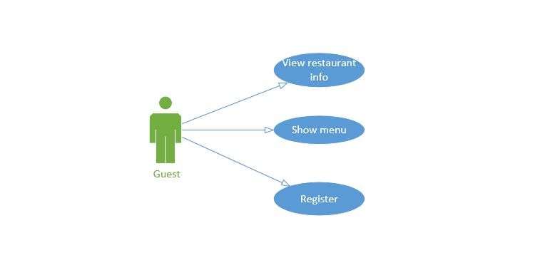

*Figure 11 – Use Case - Guest*

* **Register:**  User use this function to sign up a customer account.
* **View restaurant info:** User use this function to view some description about restaurant.
* **View menu:** User uses this feature to view all dishes and drinks in menu.

#### Customer

*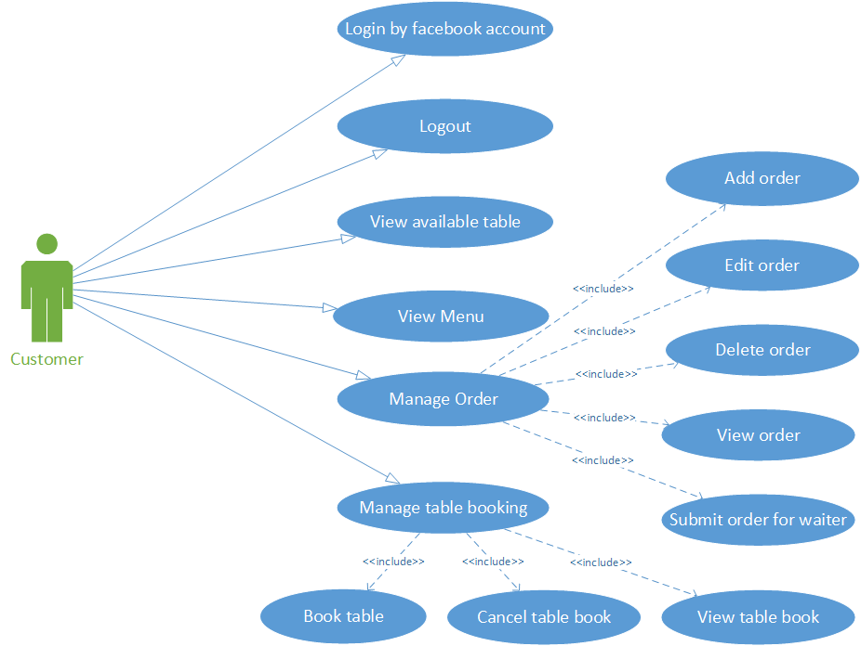*

*Figure 12 – Use Case - Customer*

* **Login by Facebook account:** User uses this function to access to the system by using existent Facebook account.
* **Logout:** The user uses this feature to logout account.
* **View available table:** User use this feature to view available tables in restaurant.
* **View menu:** User uses this feature to display all dishes and drinks in menu.
* **Manage table booking:** User uses this feature to create new table book, view table book, edit table book and cancel table book.
* **Manage order:** User uses this feature to add a new order, view order, edit order, delete order and submit order to chef.
* **Recommend:**System will suggest food for user’s order from the data were collected in former orders

#### Waiter

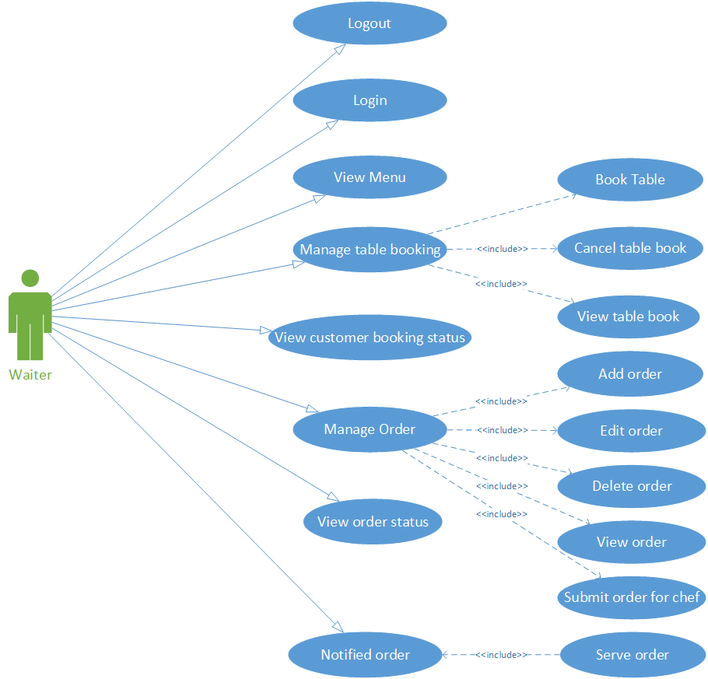

*Figure 9 – Use Case - Waiter*

* **Login:** User use their username and password to access to the system in order to use other functions.
* **Logout:** The user uses this feature to logout account.
* **Show menu:** User uses this feature to display all dishes and drinks in menu.
* **Manage table booking:** User uses this feature to create new table book, view table book, edit table book and cancel table book.
* **Manage order:** User uses this feature to add a new order, view order, edit order, delete order and submit order to chef.
* **Notified order:** User uses this feature to view info of customer’s order if they had created an order when they booked table ,user use this feature to mark the order as served.
* **Recommend:**System will suggest food for user’s order from the data were collected in former orders

#### Chef

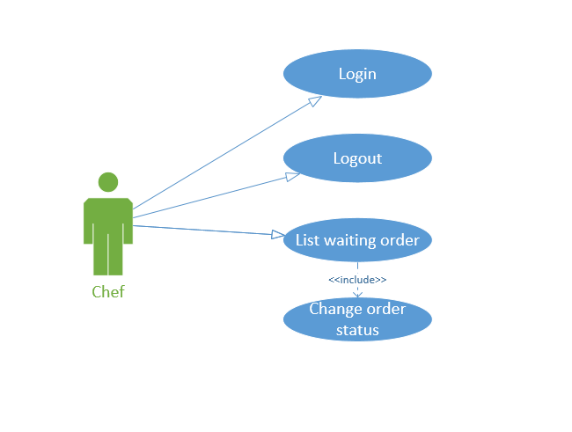

*Figure 8 – Use Case - Chef*

* **Login:** User uses username and password to access to the system in order to use other functions.
* **Logout:** User uses this feature to logout account.
* **List waiting order:** User uses this feature to display all orders are waiting to cook,and then user use the feature to mark the order which have been chosen to cook has cooking or ready.
* **Change order status:** User uses this feature to change status of an order.

#### Cashier

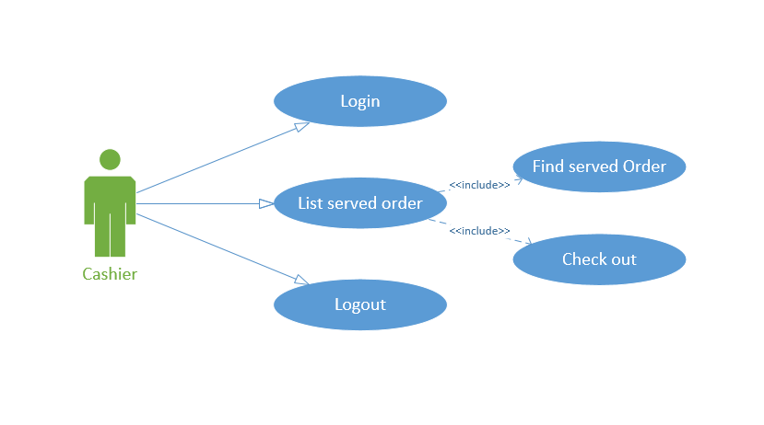

*Figure 10 – Use Case - Cashier*

* **Login:** User use their username and password to access to the system in order to use other functions.
* **Logout:** The user uses this feature to logout account.
* **List served Order:** User use this function to display all orders has been served.
* **Find served Order:** User use this function to find specific orders.
* **Check out:** User use this function to mark the order’s checkout has been done.

#### Manager

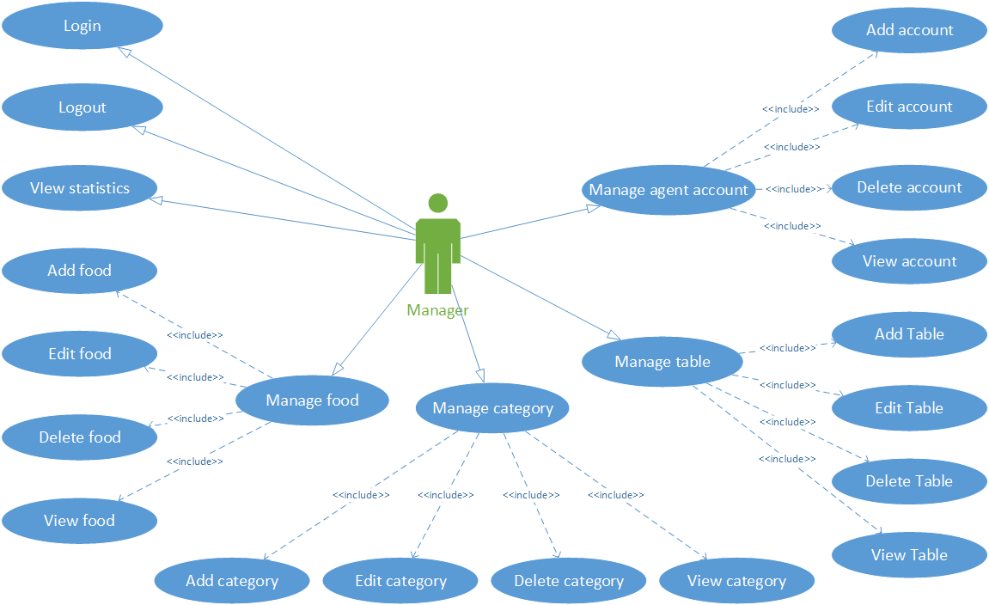

*Figure 13 – Use Case level 1- Manager*

* **Login:** User use their username and password to access to the system in order to use other functions.
* **Logout:** The user uses this feature to logout account.
* **Manage agent account:** User uses this function to create new, view, edit and delete agent account.
* **Manage table:** User uses this function to create new, view, edit and delete table.
* **Manage food:** User uses this function to create new, view, edit and delete foods.
* **Manage category:** User uses this function to create new, view, edit and delete category
* **View statistics:** User uses this function to view statistics by day, by week, by month and by year.

### List of Use Cases

|  |  |  |  |  |  |  |  |
| --- | --- | --- | --- | --- | --- | --- | --- |
| No | Use case | Guest | Customer | Waiter | Chef | Cashier | Manager |
| 1 | View restaurant info | X |  |  |  |  |  |
| 2 | View menu | X | X | X |  |  |  |
| 3 | Register | X |  |  |  |  |  |
| 4 | Login by Facebook account |  | X |  |  |  |  |
| 5 | Login |  |  | X | X | X | X |
| 6 | Logout |  | X | X | X | X | X |
| 7 | View available table |  | X |  |  |  |  |
| 8 | Manage table booking |  | X | X |  |  |  |
| 9 | Book table |  | X | X |  |  |  |
| 10 | Manage order |  | X | X |  |  |  |
| 11 | Notified order |  |  | X |  |  |  |
| 12 | Serve order |  |  | X |  |  |  |
| 13 | List waiting order |  |  |  | X |  |  |
| 14 | Change order status |  |  |  | X |  |  |
| 15 | List served order |  |  |  |  | x |  |
| 16 | Find served order |  |  |  |  | X |  |
| 17 | Check out |  |  |  |  | X |  |
| 18 | Manage category |  |  |  |  |  | X |
| 19 | Manage food |  |  |  |  |  | X |
| 20 | Manage table |  |  |  |  |  | X |
| 21 | Manage agent account |  |  |  |  |  | X |
| 22 | View statistics |  |  |  |  |  | X |

### Business Rule

|  |  |  |  |  |  |
| --- | --- | --- | --- | --- | --- |
| **No** | **Function** | **Item** | **Validation** | **Description** | **Error Message** |
| B1 | Register/Login/  Edit/Add | All text field items (Text field | Not empty | Message is displayed when user doesn’t enter text field | “Trường này không được bỏ trống” |
| B2 | Register profile | Username (Text field) | Contains at least 3 characters | Message is displayed when user enter less than 3 characters | “Tài khoản không đúng định dạng” |
| B3 | Register profile | Username (Text field) | No duplicate | Message is displayed when username is existed | “Yêu cầu không hợp lệ” |
| B4 | Register profile | Username (Text field) | Not contain special symbols | Message is displayed when username contains special symbols | “Tài khoản không đúng định dạng” |
| B5 | Register/Login/  Edit/Add | All text field items (Text field | Not contain only dashes | Message is displayed when textfield contains only dashes | “Trường này không được bỏ trống” |
| B6 | Register/Update profile | Password (Text field) | Match password | Message is displayed when user enter “Confirm password” different from “Password ” | “Mật khẩu không trùng nhau” |
| B7 | Register/Update profile | Phone number  (Text field) | Contains at least 10 characters | Message is displayed when user enter less than 10 characters | “Số điện thoại không đúng định dạng” |
| B8 | Register/Update profile | Phone number  (Text field) | Contain numeric only | Message is displayed when user enter any characters other than numeric | “Số điện thoại không đúng định dạng” |
| B9 | Add/Update food | Avatar image (File) | Incorrect file format | Message is displayed when uploaded wrong image file format(acc epted image format are .png & .jpg) | “Phai không hợp lệ” |
| B10 | Book table | Table  (List checkbox) | Choose at least 1 element | Message is displayed when click bottun “Đặt bàn” | “Bạn cần chọn ít nhất 1 bàn” |
| B11 | Book table | Hẹn giờ đặt bàn  (Datepicker) | Choose a date greater than the current date | Message is displayed when click bottun “Đặt bàn” | “Không thể đặt bàn” |
| B12 | Checkout | Tiền nhận  (Text field) | The receipt must be greater than the payment required | Message is displayed when click bottun “thanh toán” | “Không đủ tiền thanh toán” |

### Use Case Specification

#### View restaurant info

|  |  |  |  |
| --- | --- | --- | --- |
| **Use case ID** | UC001 | **Version** | 1.0 |
| **Use case Name** | View restaurant info | | | |
| **Created by** | HieuNM | **Last Update** | 23/7/2018 |
| **Primary Actor** | Guest | **Secondary Actor** | Admin |
| **Description** | The user uses this feature to view restaurant info | | | |
| **Preconditions** | * ER must be connected to Internet * User browsed ER Website | | | |
| **Post conditions** | Display page matching each role account | | | |
| **Normal flows** | | | | |
| **Step** | **Actor** | **Action** | |
| 1 | Guest | Click on button “Giới thiệu” in nav bar in Homepage | |
| 2 | ER System | Redirect user to information page which display the restaurant’s info | |
| **Priority** | | High | |
| **Frequency of Use** | | High | |
| **Business rules** | |  | |

#### View menu

|  |  |  |  |
| --- | --- | --- | --- |
| **Use case ID** | UC002 | **Version** | 1.0 |
| **Use case Name** | View Menu | | | |
| **Created by** | NghiaNC | **Last Update** | 26/7/2018 |
| **Primary Actor** | Guest, Customer | **Secondary Actor** | Waiter |
| **Description** | User uses this feature to view all of foods in menu | | | |
| **Preconditions** | * ER must be connected to Internet * User browsed ER Website * User is in homepage | | | |
| **Post conditions** | Menu has been displayed | | | |
| **Normal flows** | | | | |
| **Step** | **Actor** | **Action** | |
| 1 | Guest, Customer | Clicks on category tabs in sidebar | |
| 2 | ER System | Display menu which matches with each category | |
|  | | | |
| **Priority** | | High | |
| **Frequency of Use** | | High | |
| **Business rules** | |  | |

#### Register

|  |  |  |  |
| --- | --- | --- | --- |
| **Use case ID** | UC003 | **Version** | 1.0 |
| **Use case Name** | Register | | | |
| **Created by** | ThinhAV | **Last Update** | 26/7/2018 |
| **Primary Actor** | Guest | **Secondary Actor** | N/A |
| **Description** | The user uses this feature to register to ER System | | | |
| **Preconditions** | * ER must be connected to Internet * User browsed ER Website * User must have a Facebook account | | | |
| **Post conditions** | * Add account information into Database * Logs user into system * Redirect user to Homepage & display as Customer | | | |
| **Normal flows** | | | | |
| **Step** | **Actor** | **Action** | |
| 1 | Guest | Clicks on “Đăng nhập/ Đăng ký” nav bar | |
| 2 | ER System | Redirect User to Facebook Login Page | |
| 3 | Guest | Login by Facebook account | |
| 4 | ER System | Add account information into Database | |
| 5 | ER System | Display Homepage as Customer | |
|  | | | |
| **Priority** | | High | |
| **Frequency of Use** | | High | |
| **Business rules** | |  | |

#### Login by Facebook account

|  |  |  |  |
| --- | --- | --- | --- |
| **Use case ID** | UC004 | **Version** | 1.0 |
| **Use case Name** | Login by Facebook account | | | |
| **Created by** | HieuNM | **Last Update** | 26/7/2018 |
| **Primary Actor** | Cutomer | **Secondary Actor** | N/A |
| **Description** | The user uses this feature to login account as customer | | | |
| **Preconditions** | * ER must be connected to Internet * User browsed ER Website * User’s Facebook account has registered with ER System * User is currently not logged in | | | |
| **Post conditions** | * Log this account into system * Redirects User to Homepage | | | |
| **Normal flows** | | | | |
| **Step** | **Actor** | **Action** | |
| 1 | Customer | Clicks on “Đăng nhập/ Đăng ký” in nav bar | |
| 2 | ER Sytem | Log this account into system | |
| 3 | ER System | Display Homepage as Customer | |
|  | | | |
| **Priority** | | High | |
| **Frequency of Use** | | High | |
| **Business rules** | |  | |

#### Login

|  |  |  |  |  |
| --- | --- | --- | --- | --- |
| **Use case ID** | UC005 | | **Version** | 1.0 |
| **Use case Name** | Login | | | | |
| **Created by** | ThinhAV | | **Last Update** | 24/7/2018 |
| **Primary Actor** | Admin | | **Secondary Actor** | Waiter, Chef, Cashier |
| **Description** | The user uses this feature to manage agent account | | | | |
| **Preconditions** | * ER must be connected to Internet * User browsed ER Website * User is currently not logged in | | | | |
| **Post conditions** | * User has logged into ER System as User’s role * Redirect User to Manage screen | | | | |
| **Normal flows** | | | | | |
| **Step** | **Actor** | | **Action** | |
| 1 | Admin | | Click on “Quản lý đăng nhập” button in navigation bar | |
| 2 | ER system | | Redirect user to Login page which includes:   * Tài khoản (text box) * Mật khẩu (text box) * Đăng nhập (button) | |
| 3 | Admin | | Enter “Tài khoản” and “Mật khẩu” | |
| 4 | Admin | | Click on “Đăng nhập” button | |
| 5 | ER system | | Redirect user to Manage screen | |
| **Exception** | | | | |
| **EC1** | | At step 3, Username and Password fields are blank | | |
| **Step** | | **Actor** | **Action** | |
| 3.1 | | Admin | Left “Tài khoản” field or “Mật khẩu” field blank | |
| 3.2 | | Admin | Click on “Đăng nhập” button | |
| 3.3 | | ER System | Display message: “Trường này không được bỏ trống” | |
|  | | | | |
| **Priority** | | | High | |
| **Frequency of Use** | | | High | |
| **Business rules** | | | B1 | |

#### Logout

|  |  |  |  |
| --- | --- | --- | --- |
| **Use case ID** | UC006 | **Version** | 1.0 |
| **Use case Name** | Logout | | | |
| **Created by** | HieuNM | **Last Update** | 24/7/2018 |
| **Primary Actor** | Admin | **Secondary Actor** | Waiter, Chef, Cashier, Customer |
| **Description** | The user uses this feature to logout account. | | | |
| **Preconditions** | * ER must be connected to Internet * User browsed ER Website * User logged into ER system | | | |
| **Post conditions** | * Log User out from system * Redirects User to Homepage | | | |
| **Normal flows** | | | | |
| **Step** | **Actor** | **Action** | |
| 1 | Admin | Click on User’s avatar in navigation bar | |
| 2 | ER System | Display Account Setting | |
| 3 | Admin | Click on “Thoát” button | |
| 4 | ER System | Display Homepage as Guest | |
| **Exception** | | | |
|  | | | |
| **Priority** | | High | |
| **Frequency of Use** | | High | |
| **Business rules** | |  | |

#### View available table

|  |  |  |  |
| --- | --- | --- | --- |
| **Use case ID** | UC007 | **Version** | 1.0 |
| **Use case Name** | View Available Table | | | |
| **Created by** | NghiaNC | **Last Update** | 27/7/2018 |
| **Primary Actor** | Waiter | **Secondary Actor** | Customer |
| **Description** | User uses this feature to view available tables in restaurant | | | |
| **Preconditions** | * ER must be connected to Internet * User has logged into ER System as Waiter or Customer | | | |
| **Post conditions** | Available Tables List has been displayed | | | |
| **Normal flows** | | | | |
| **Step** | **Actor** | **Action** | |
| 1 | Waiter | Clicks on “Đặt bàn” button in nav bar in homepage | |
| 2 | ER System | Redirect user to Manage Table Booking Screen | |
| 3 | Waiter | Clicks on “Danh sách bàn trống” in sidebar | |
| 4 | ER System | Display all available tables | |
|  | | | |
| **Priority** | | High | |
| **Frequency of Use** | | High | |
| **Business rules** | |  | |

#### Manage table booking

|  |  |  |  |
| --- | --- | --- | --- |
| **Use case ID** | UC008 | **Version** | 1.0 |
| **Use case Name** | Manage Table Booking | | | |
| **Created by** | ThinhAV | **Last Update** | 28/7/2018 |
| **Primary Actor** | Waiter | **Secondary Actor** | Customer |
| **Description** | When Customer or Waiter want to book, edit, cancel and view status table | | | |
| **Preconditions** | * ER must be connected to Internet * User has logged into ER System as Waiter, Customer * User is in Table Booking Screen | | | |
| **Post conditions** | Booked table’s information is displayed | | | |
| **Normal flows** | | | | |
| **Step** | **Actor** | **Action** | |
| 1 | Waiter | Actor clicks on “Quản lý đặt bàn” button in sidebar | |
| 2 | Waiter | Click on “Kiểm tra” button | |
| 3 | ER System | Display tables which are booked by customer | |
|  | | | |
| **Priority** | | High | |
| **Frequency of Use** | | High | |
| **Business rules** | |  | |

|  |  |  |  |
| --- | --- | --- | --- |
| **Use case ID** | UC008.1 | **Version** | 1.0 |
| **Use case Name** | Find Table Booking | | | |
| **Created by** | ThinhAV | **Last Update** | 28/7/2018 |
| **Primary Actor** | Waiter | **Secondary Actor** | N/A |
| **Description** | User uses this function to find table booking by customer’s phone number | | | |
| **Preconditions** | * ER must be connected to Internet * User has logged into ER System as Waiter * User is in Table Booking Screen | | | |
| **Post conditions** | Booked table’s information is displayed | | | |
| **Normal flows** | | | | |
| **Step** | **Actor** | **Action** | |
| 1 | Waiter | Actor enter phone number in “Số điện thoại của khách” text filed | |
| 2 | ER System | Display booked table’s information | |
|  | | | |
| **Priority** | | High | |
| **Frequency of Use** | | High | |
| **Business rules** | |  | |

|  |  |  |  |  |
| --- | --- | --- | --- | --- |
| **Use case ID** | UC008 | | **Version** | 1.0 |
| **Use case Name** | Book table | | | | |
| **Created by** | NghiaNC | | **Last Update** | 27/7/2018 |
| **Primary Actor** | Watter | | **Secondary Actor** | Customer |
| **Description** | User uses this feature to book table | | | | |
| **Preconditions** | * ER must be connected to Internet * User has logged into ER System as Waiter or Customer * List Available Table is displayed | | | | |
| **Post conditions** | * Redirect user to Order mangement screen * Display message: "Book table successfully" | | | | |
| **Normal flows** | | | | | |
| **Step** | **Actor** | | **Action** | |
| 1 | Waiter | | Clicks in Checkbox belows each table to choose tables | |
| 2 | Waiter | | Clicks in "Đặt bàn" button | |
| 3 | ER System | | * Redirect user to Order mangement screen * Display message: "Book table successfully" | |
|  | | | | |
| **EC1** | | At step 3, Username and Password fields are blank | | |
| **Step** | | **Actor** | **Action** | |
| 3.1 | | Waiter | Clicks in "Đặt bàn" button | |
| 3.2 | | ER System | Display message: "Bạn cần chọn ít nhất 1 bàn" | |
| **Priority** | | | High | |
| **Frequency of Use** | | | High | |
| **Business rules** | | | B10,B11 | |

|  |  |  |  |
| --- | --- | --- | --- |
| **Use case ID** | UC008.2 | **Version** | 1.0 |
| **Use case Name** | Cancel Table Book | | | |
| **Created by** | ThinhAV | **Last Update** | 28/7/2018 |
| **Primary Actor** | Waiter | **Secondary Actor** | Customer |
| **Description** | When Customer or Waiter want to book, edit, cancel and view status table | | | |
| **Preconditions** | * ER must be connected to Internet * User has logged into ER System as Waiter, Customer * User is in Manage Table Booking Screen | | | |
| **Post conditions** | Chosen Booked table has been deleted | | | |
| **Normal flows** | | | | |
| **Step** | **Actor** | **Action** | |
| 1 | Waiter | Actor clicks on “Hủy bànl” button besides booked table | |
| 2 | ER System | Display confirm options | |
| 3 | Waiter | Click on “Đồng ý” button | |
| 4 | ER System | Remove chosen table from list then display message “Hủy bàn thành công” | |

|  |  |  |
| --- | --- | --- |
| **Exception** | | |
| **EC1** | At step 3, actor do not confirm to delete booked table | |
| **Step** | **Actor** | **Action** |
| 3.1 | Admin | Clicks on “Không” button |
| 3.2 | ER System | Display Booked Table List |

|  |  |
| --- | --- |
| **Priority** | High |
| **Frequency of Use** | High |
| **Business rules** |  |

#### Manage order

|  |  |  |  |
| --- | --- | --- | --- |
| **Use case ID** | UC009 | **Version** | 1.0 |
| **Use case Name** | Manage Order | | | |
| **Created by** | HieuNM | **Last Update** | 28/7/2018 |
| **Primary Actor** | Waiter | **Secondary Actor** | N/A |
| **Description** | The user uses this feature to manage order. | | | |
| **Preconditions** | * ER must be connected to Internet * User has logged into ER System as Waiter, Customer * Booked tables’s list is displayed | | | |
| **Post conditions** | Order is submited to chef | | | |
| **Normal flows** | | | | |
| **Step** | **Actor** | **Action** | |
| 1 | Waiter | Clicks on “Quản lý đặt món” button beside booked table | |
| 2 | ER System | Redirect user to Manage Order screen | |
| 3 | Waiter | Pick foods and drinks from menu and recomend list to order | |
| 4 | Waiter | Clicks on “Đặt món” button | |
| 5 | ER System | Display message “Đặt món thành công” | |
|  | | | |

|  |  |  |
| --- | --- | --- |
| **EC1** | At step 4, actor clicks on “Làm mới” button and confirm to refresh order | |
| **Step** | **Actor** | **Action** |
| 4.1 | Admin | Clicks on “làm mới” button |
| 4.2 | ER System | Display confirm options |
| 4.3 | Admin | Click on “Đồng ý” button |
| 4.4 | ER System | Refresh order |
| **EC2** | At step 4, actor clicks on “Làm mới” button and not confirm to refresh order | |
| **Step** | **Actor** | **Action** |
| 4.1 | Admin | Clicks on “làm mới” button |
| 4.2 | ER System | Display confirm options |
| 4.3 | Admin | Click on “Không” button |
| 4.4 | ER System | Return to Manage Order screen |

|  |  |
| --- | --- |
| **Priority** | High |
| **Frequency of Use** | High |
| **Business rules** |  |

#### Notified order

|  |  |  |  |
| --- | --- | --- | --- |
| **Use case ID** | UC010 | **Version** | 1.0 |
| **Use case Name** | Notified Order | | | |
| **Created by** | NghiaNC | **Last Update** | 28/7/2018 |
| **Primary Actor** | Waiter | **Secondary Actor** | N/A |
| **Description** | The user uses this feature to receive food status | | | |
| **Preconditions** | * ER must be connected to Internet * User has logged into ER System as Waiter | | | |
| **Post conditions** | Food Status has been change to be “Chế biến xong” in waiter screen | | | |
| **Normal flows** | | | | |
| **Step** | **Actor** | **Action** | |
| 1 | Waiter | Click on pop-up “Có món nấu xong” | |
| 2 | ER System | Display food and status which has status “Chế biến xong” in Waiter’s “Danh sách trạng thái món ăn” screen | |
|  | | | |
| **Priority** | | High | |
| **Frequency of Use** | | High | |
| **Business rules** | |  | |

#### Serve order

|  |  |  |  |
| --- | --- | --- | --- |
| **Use case ID** | UC011 | **Version** | 1.0 |
| **Use case Name** | Serve Order | | | |
| **Created by** | NghiaNC | **Last Update** | 28/7/2018 |
| **Primary Actor** | Waiter | **Secondary Actor** | N/A |
| **Description** | The user uses this feature to change order status | | | |
| **Preconditions** | * ER must be connected to Internet * User has logged into ER System as Waiter | | | |
| **Post conditions** | Food has been remove from List Food in waiter’s screen | | | |
| **Normal flows** | | | | |
| **Step** | **Actor** | **Action** | |
| 1 | Waiter | Clicks on “Các món ăn” in sidebar | |
| 2 | ER System | Displays all foods which has finished cooked | |
| 3 | Waiter | Clicks on “Phục vụ” button besides each food | |
| 4 | ER System | Remove food from List Food in waiter’s screen | |
|  | | | |
| **Priority** | | High | |
| **Frequency of Use** | | High | |
| **Business rules** | |  | |

#### List waiting order

|  |  |  |  |
| --- | --- | --- | --- |
| **Use case ID** | UC012 | **Version** | 1.0 |
| **Use case Name** | List Waiting Order | | | |
| **Created by** | NghiaNC | **Last Update** | 27/7/2018 |
| **Primary Actor** | Chef | **Secondary Actor** | N/A |
| **Description** | User uses this feature to view all orders are waiting to cook | | | |
| **Preconditions** | * ER must be connected to Internet * User has logged into ER System as Chef | | | |
| **Post conditions** | Display list of food which are waiting to be cooked | | | |
| **Normal flows** | | | | |
| **Step** | **Actor** | **Action** | |
| 1 | Chef | Clicks on “Các món ăn” button in sidebar | |
| 2 | ER System | Display list of food which are waiting to be cooked | |
|  | | | |
| **Priority** | | High | |
| **Frequency of Use** | | High | |
| **Business rules** | |  | |

#### Change order status

|  |  |  |  |
| --- | --- | --- | --- |
| **Use case ID** | UC013 | **Version** | 1.0 |
| **Use case Name** | Change Order Status | | | |
| **Created by** | NghiaNC | **Last Update** | 27/7/2018 |
| **Primary Actor** | Chef | **Secondary Actor** | N/A |
| **Description** | The user uses this feature to change order status | | | |
| **Preconditions** | * ER must be connected to Internet * User has logged into ER System as Chef * Waiting food is displayed | | | |
| **Post conditions** | Status of food is changed which are displayed in “Tình trạng” column | | | |
| **Normal flows** | | | | |
| **Step** | **Actor** | **Action** | |
| 1 | Chef | Clicks on button in “Hành động” column | |
| 2 | ER System | Change current food status to next status | |
|  | | | |
| **Priority** | | High | |
| **Frequency of Use** | | High | |
| **Business rules** | |  | |

#### List served order

|  |  |  |  |
| --- | --- | --- | --- |
| **Use case ID** | UC014 | **Version** | 1.0 |
| **Use case Name** | List Served order | | | |
| **Created by** | NghiaNC | **Last Update** | 26/7/2018 |
| **Primary Actor** | Cashier | **Secondary Actor** | N/A |
| **Description** | The user uses this feature to view all orders has been served | | | |
| **Preconditions** | * ER must be connected to Internet * User has logged into ER System as Cashier | | | |
| **Post conditions** | * Display all orders which have been served | | | |
| **Normal flows** | | | | |
| **Step** | **Actor** | **Action** | |
| 1 | Cashier | Clicks on “Thanh toán” button in sidebar | |
| 2 | ER System | Display all orders which have been served | |
|  | | | |
| **Priority** | | High | |
| **Frequency of Use** | | High | |
| **Business rules** | |  | |

#### Find Served Order

|  |  |  |  |
| --- | --- | --- | --- |
| **Use case ID** | UC015 | **Version** | 1.0 |
| **Use case Name** | Find Served order | | | |
| **Created by** | NghiaNC | **Last Update** | 26/7/2018 |
| **Primary Actor** | Cashier | **Secondary Actor** | N/A |
| **Description** | The user uses this feature to find specific orders have been served | | | |
| **Preconditions** | * ER must be connected to Internet * User has logged into ER System as Cashier * User is in List Served Oders screen | | | |
| **Post conditions** | * Display all orders which have been served and matches with search condition | | | |
| **Normal flows** | | | | |
| **Step** | **Actor** | **Action** | |
| 1 | Cashier | Enter customer’s name or phone number in search bar | |
| 2 | Cashier | Clicks on “Tìm” button | |
| 3 | ER System | Display all orders which have been served and matches with search condition | |
|  | | | |
| **Priority** | | High | |
| **Frequency of Use** | | High | |
| **Business rules** | |  | |

#### Check out

|  |  |  |  |  |
| --- | --- | --- | --- | --- |
| **Use case ID** | UC0016 | | **Version** | 1.0 |
| **Use case Name** | Check out | | | | |
| **Created by** | ThinhAV | | **Last Update** | 26/7/2018 |
| **Primary Actor** | Cashier | | **Secondary Actor** | N/A |
| **Description** | The user use this feature to check out | | | | |
| **Preconditions** | * ER must be connected to Internet * User has logged into ER System as Cashier * User is in List Served Oders screen | | | | |
| **Post conditions** | The chosen order has been checked out successfully | | | | |
| **Normal flows** | | | | | |
| **Step** | **Actor** | | **Action** | |
| 1 | Cashier | | Clicks on “CheckOut” button which beside each order | |
| 2 | ER System | | Redirect User to Checkout screen which includes:   * List of items that served * “Tổng chi phí” (Text Box) * “Nhận” (Text Box) * “Trả lại” (Text Box) | |
| 3 | Cashier | | Enter the money that received in Receive | |
| 4 | ER System | | Display the rutern money in Return | |
| 5 | Cashier | | Clicks on “Thanh toán hóa đơn” button | |
| 6 | ER System | | Display message “The order checkout successfully” | |
| **Exception** | | | | |
| **EC** | | In step 3, actor do not enter the money that received in Receive | | |
| **Step** | | **Actor** | **Action** | |
| 3.1 | | Cashier | Actor do not enter the money that received in Receive | |
| 3.2 | | Cashier | Clicks on “Thanh toán hóa đơn” button | |
| 3.3 | | ER System | Display message: “” | |
|  | | | | |
| **Priority** | | | High | |
| **Frequency of Use** | | | High | |
| **Business rules** | | | B12 | |

#### Manage category

|  |  |  |  |
| --- | --- | --- | --- |
| **Use case ID** | UC017 | **Version** | 1.0 |
| **Use case Name** | Manage Category | | | |
| **Created by** | NghiaNC | **Last Update** | 24/7/2018 |
| **Primary Actor** | Admin | **Secondary Actor** | N/A |
| **Description** | The user uses this feature to manage category | | | |
| **Preconditions** | * ER must be connected to Internet * User browsed ER Website * User logged into ER system as Admin | | | |
| **Post conditions** | Display Manage Category Menu in sidebar | | | |
| **Normal flows** | | | | |
| **Step** | **Actor** | **Action** | |
| 1 | Admin | Click on “Quản lý danh mục thực đơn” button in sidebar | |
| 2 | ER System | Display Manage Category Menu in sidebar | |
|  | | | |
| **Priority** | | High | |
| **Frequency of Use** | | High | |
| **Business rules** | |  | |

**View Category**

|  |  |  |  |
| --- | --- | --- | --- |
| **Use case ID** | UC017.1 | **Version** | 1.0 |
| **Use case Name** | View Category | | | |
| **Created by** | NghiaNC | **Last Update** | 24/7/2018 |
| **Primary Actor** | Admin | **Secondary Actor** | N/A |
| **Description** | User uses this feature to view list of categories | | | |
| **Preconditions** | * ER must be connected to Internet * User browsed ER Website * Manage Category Menu is displayed | | | |
| **Post conditions** | Display list of Categories | | | |
| **Normal flows** | | | | |
| **Step** | **Actor** | **Action** | |
| 1 | Admin | Click on “Danh sách danh mục” button in sidebar | |
| 2 | ER System | Display list of Categories and Search Bar | |
|  | | | |
| **Priority** | | High | |
| **Frequency of Use** | | High | |
| **Business rules** | |  | |

**Edit Category**

|  |  |  |  |  |
| --- | --- | --- | --- | --- |
| **Use case ID** | UC017.2 | | **Version** | 1.0 |
| **Use case Name** | Edit Category | | | | |
| **Created by** | NghiaNC | | **Last Update** | 24/7/2018 |
| **Primary Actor** | Admin | | **Secondary Actor** | N/A |
| **Description** | The user uses this feature to update category | | | | |
| **Preconditions** | * ER must be connected to Internet * User browsed ER Website * Category List is displayed | | | | |
| **Post conditions** | Category has been updated and User is redirected to Category List | | | | |
| **Normal flows** | | | | | |
| **Step** | **Actor** | | **Action** | |
| 1 | Admin | | Click on “Sửa” button which besides the Category’s info | |
| 2 | ER System | | Redirect User to Edit Category screen which includes:   * “Tên” (Text Box) * “Danh mục mẹ” (Combo Box) * “Mô tả” (Text Box) | |
| 3 | Admin | | Enter all required information  All fields contain currently info of chosen category | |
| 4 | Admin | | Click on “Lưu” button | |
| 5 | ER System | | Redirect User to Category List and display message: “Danh mục được cập nhật thành công” | |
| **Exception** | | | | |
| **EC1** | | At step 3, Category Name field are blank | | |
| **Step** | | **Actor** | **Action** | |
| 3.1 | | Admin | Left Category Name field blank | |
| 3.2 | | Admin | Click on “Lưu” button | |
| 3.3 | | ER System | Display message: “Trường này không được bỏ trống” | |
| **EC2** | | At step 3, actor enters only space in Category Name field | | |
| **Step** | | **Actor** | **Action** | |
| 3.1 | | Admin | Actor enters only space | |
| 3.2 | | Admin | Click on “Lưu” button | |
| 3.3 | | ER System | Display message: “Yêu cầu không hợp lệ ” | |
|  | | | | |
| **Priority** | | | High | |
| **Frequency of Use** | | | High | |
| **Business rules** | | | B2, B3, B4, B5. B6. B7. B8 | |

**Delete Category**

|  |  |  |  |  |
| --- | --- | --- | --- | --- |
| **Use case ID** | UC017.3 | | **Version** | 1.0 |
| **Use case Name** | Delete Category | | | | |
| **Created by** | NghiaNC | | **Last Update** | 24/7/2018 |
| **Primary Actor** | Admin | | **Secondary Actor** |  |
| **Description** | The user uses this feature to delete category | | | | |
| **Preconditions** | * ER must be connected to Internet * User browsed ER Website * Category List is displayed | | | | |
| **Post conditions** | Chosen Category has been deleted | | | | |
| **Normal flows** | | | | | |
| **Step** | **Actor** | | **Action** | |
| 1 | Admin | | Clicks on “Xóa” button which besides the Category’s info | |
| 2 | ER System | | Display message which need actor’s confirmation | |
| 3 | Admin | | Clicks on “Xóa” button | |
| 4 | ER System | | Delete the chosen Category then display Category List | |
| **Exception** | | | | |
| **EC1** | | At step 3, actor do not confirm to delete Category | | |
| **Step** | | **Actor** | **Action** | |
| 3.1 | | Admin | Clicks on “Quay lại” button | |
| 3.2 | | ER System | Display Category List | |
|  | | | | |
| **Priority** | | | High | |
| **Frequency of Use** | | | High | |
| **Business rules** | | |  | |

**Add Category**

|  |  |  |  |  |
| --- | --- | --- | --- | --- |
| **Use case ID** | UC017.4 | | **Version** | 1.0 |
| **Use case Name** | Add Category | | | | |
| **Created by** | NghiaNC | | **Last Update** | 24/7/2018 |
| **Primary Actor** | Admin | | **Secondary Actor** | N/A |
| **Description** | The user uses this feature to add a new category | | | | |
| **Preconditions** | * ER must be connected to Internet * User browsed ER Website * Manage Category Menu is displayed | | | | |
| **Post conditions** | A new category has been created and User is redirected to Category List | | | | |
| **Normal flows** | | | | | |
| **Step** | **Actor** | | **Action** | |
| 1 | Admin | | Click on “Tạo danh mục” button in sidebar | |
| 2 | ER System | | Redirect User to Add new Category screen which includes:   * “Tên” (Text Box) * “Danh mục mẹ” (Combo Box) * “Mô tả” (Text Box) | |
| 3 | Admin | | Enter all required information | |
| 4 | Admin | | Click on “Lưu” button | |
| 5 | ER System | | Redirect User to Category List and display message: “Danh mục được tạo thành công” | |
| **Exception** | | | | |
| **EC1** | | At step 3, Category Name field are blank | | |
| **Step** | | **Actor** | **Action** | |
| 3.1 | | Admin | Left Category Name field blank | |
| 3.2 | | Admin | Click on “Lưu” button | |
| 3.3 | | ER System | Display message: “Trường này không được bỏ trống” | |
| **EC2** | | At step 3, actor enters only space in Category Name field | | |
| **Step** | | **Actor** | **Action** | |
| 3.1 | | Admin | Actor enters only space | |
| 3.2 | | Admin | Click on “Lưu” button | |
| 3.3 | | ER System | Display message: “Yêu cầu không hợp lệ” | |
|  | | | | |
| **Priority** | | | High | |
| **Frequency of Use** | | | High | |
| **Business rules** | | | B2, B3, B4, B5. B6. B7. B8 | |

**Search Category**

|  |  |  |  |  |
| --- | --- | --- | --- | --- |
| **Use case ID** | UC017.5 | | **Version** | 1.0 |
| **Use case Name** | Search Category | | | | |
| **Created by** | NghiaNC | | **Last Update** | 27/7/2018 |
| **Primary Actor** | Admin | | **Secondary Actor** | N/A |
| **Description** | User use this function to search category from list category | | | | |
| **Preconditions** | * ER must be connected to Internet * User browsed ER Website * Category List is displayed | | | | |
| **Post conditions** | The specific category which user want to search has been displayed | | | | |
| **Normal flows** | | | | | |
| **Step** | **Actor** | | **Action** | |
| 1 | Admin | | Enter category name in search textfield | |
| 2 | Admin | | Clicks on “Tìm” button | |
| 3 | ER System | | Display all specific categories which matches with search conditions | |
| **Exception** | | | | |
| **EC1** | | In step 1, User do not enter category name in search textfield | | |
| **Step** | | **Actor** | **Action** | |
| 1.1 | | Admin | Left search textfield blank | |
| 1.2 | | Admin | Clicks on “Tìm” button | |
| 1.3 | | ER System | Display all specific categories which matches with search conditions( all category name) | |
|  | | | | |
| **Priority** | | | High | |
| **Frequency of Use** | | | High | |
| **Business rules** | | |  | |

#### Manage food

|  |  |  |  |
| --- | --- | --- | --- |
| **Use case ID** | UC018 | **Version** | 1.0 |
| **Use case Name** | Manage Food | | | |
| **Created by** | HieuNM | **Last Update** | 25/7/2018 |
| **Primary Actor** | Admin | **Secondary Actor** | N/A |
| **Description** | The user uses this feature to manage food | | | |
| **Preconditions** | * ER must be connected to Internet * User browsed ER Website * User logged into ER system as Admin | | | |
| **Post conditions** | Display Manage Food Menu in sidebar | | | |
| **Normal flows** | | | | |
| **Step** | **Actor** | **Action** | |
| 1 | Admin | Click on “Quản lý món ăn” button in sidebar | |
| 2 | ER System | Display Manage Food Menu | |
|  | | | |
| **Priority** | | High | |
| **Frequency of Use** | | High | |
| **Business rules** | |  | |

**View Food**

|  |  |  |  |
| --- | --- | --- | --- |
| **Use case ID** | UC018.1 | **Version** | 1.0 |
| **Use case Name** | View Food | | | |
| **Created by** | HieuNM | **Last Update** | 25/7/2018 |
| **Primary Actor** | Admin | **Secondary Actor** | N/A |
| **Description** | User uses this feature to view list of food | | | |
| **Preconditions** | * ER must be connected to Internet * User browsed ER Website * Manage Category Menu is displayed | | | |
| **Post conditions** | Display list of food | | | |
| **Normal flows** | | | | |
| **Step** | **Actor** | **Action** | |
| 1 | Admin | Click on “Danh sách món an” button in sidebar | |
| 2 | ER System | Display list of food and Search Bar | |
|  | | | |
| **Priority** | | High | |
| **Frequency of Use** | | High | |
| **Business rules** | |  | |

**Edit Food**

|  |  |  |  |  |
| --- | --- | --- | --- | --- |
| **Use case ID** | UC018.2 | | **Version** | 1.0 |
| **Use case Name** | Edit Food | | | | |
| **Created by** | HieuNM | | **Last Update** | 25/7/2018 |
| **Primary Actor** | Admin | | **Secondary Actor** | N/A |
| **Description** | The user uses this feature to update food | | | | |
| **Preconditions** | * ER must be connected to Internet * User browsed ER Website * Food List is displayed | | | | |
| **Post conditions** | Food has been updated and User is redirected to Food List | | | | |
| **Normal flows** | | | | | |
| **Step** | **Actor** | | **Action** | |
| 1 | Admin | | Click on “Lưu” button which besides the Food’s info | |
| 2 | ER System | | Redirect User to Edit Food screen which includes:   * “Tên món” (Text Box) * “Trạng thái” (Combo Box) * “Giá tiền” (Combo Box) * “Danh mục thực đơn” (Text Box) * “Mô tả” (Text Box) * “Ảnh” (File Chooser) | |
| 3 | Admin | | Enter all required information  All fields contain currently info of chosen food | |
| 4 | Admin | | Click on “Lưu” button | |
| 5 | ER System | | Redirect User to Food List and display message: “ The food updated successfully” | |
| **Exception** | | | | |
| **EC1** | | At step 3, Food Name field are blank | | |
| **Step** | | **Actor** | **Action** | |
| 3.1 | | Admin | Left Food Name field blank | |
| 3.2 | | Admin | Click on “Lưu” button | |
| 3.3 | | ER System | Do not update the food | |
| **EC2** | | At step 3, actor enters only space in Food Name field | | |
| **Step** | | **Actor** | **Action** | |
| 3.1 | | Admin | Actor enters only space | |
| 3.2 | | Admin | Click on “Submit” button | |
| 3.3 | | ER System | Do not update the food | |
| **EC3** | | Actor uploads incorrect file format | | |
| **Step** | | **Actor** | **Action** | |
| 3.1 | | Admin | Click on “Choose File” buton and choose a file that not an image or incorrect image format | |
| 3.2 | | Admin | Click on “Lưu” button | |
| 3.3 | | ER System |  | |
|  | | | | |
| **Priority** | | | High | |
| **Frequency of Use** | | | High | |
| **Business rules** | | | B2, B3, B4, B5. B6. B7. B8, B9 | |

**Delete Food**

|  |  |  |  |  |
| --- | --- | --- | --- | --- |
| **Use case ID** | UC018.3 | | **Version** | 1.0 |
| **Use case Name** | Delete Food | | | | |
| **Created by** | HieuNM | | **Last Update** | 25/7/2018 |
| **Primary Actor** | Admin | | **Secondary Actor** |  |
| **Description** | The user uses this feature to delete food | | | | |
| **Preconditions** | * ER must be connected to Internet * User browsed ER Website * Food List is displayed | | | | |
| **Post conditions** | Chosen Food has been deleted | | | | |
| **Normal flows** | | | | | |
| **Step** | **Actor** | | **Action** | |
| 1 | Admin | | Clicks on “Xóa” button which besides the Food’s info | |
| 2 | ER System | | Display message which need actor’s confirmation | |
| 3 | Admin | | Clicks on “Xóa” button | |
| 4 | ER System | | Delete the chosen Category then display Category List | |
| **Exception** | | | | |
| **EC1** | | At step 3, actor do not confirm to delete Category | | |
| **Step** | | **Actor** | **Action** | |
| 3.1 | | Admin | Clicks on “Quay lại” button | |
| 3.2 | | ER System | Display Category List | |
|  | | | | |
| **Priority** | | | High | |
| **Frequency of Use** | | | High | |
| **Business rules** | | |  | |

**Add Food**

|  |  |  |  |  |
| --- | --- | --- | --- | --- |
| **Use case ID** | UC018.4 | | **Version** | 1.0 |
| **Use case Name** | Add Food | | | | |
| **Created by** | HieuNM | | **Last Update** | 24/7/2018 |
| **Primary Actor** | Admin | | **Secondary Actor** | N/A |
| **Description** | The user uses this feature to add a new food | | | | |
| **Preconditions** | * ER must be connected to Internet * User browsed ER Website * Manage Food Menu is displayed | | | | |
| **Post conditions** | A new food has been created and User is redirected to Food List | | | | |
| **Normal flows** | | | | | |
| **Step** | **Actor** | | **Action** | |
| 1 | Admin | | Click on “Tạo món ăn” button in sidebar | |
| 2 | ER System | | Redirect User to Create Food screen which includes:   * “Tên món” (Text Box) * “Trạng thái” (Combo Box) * “Giá tiền” (Combo Box) * “Danh mục thực đơn” (Text Box) * “Mô tả” (Text Box) * “Ảnh” (File Chooser) | |
| 3 | Admin | | Enter all required information  All fields contain currently info of chosen food | |
| 4 | Admin | | Click on “Lưu” button | |
| 5 | ER System | | Redirect User to Food List and display message: “The food created sucessfully” | |
| **Exception** | | | | |
| **EC1** | | At step 3, Food Name field are blank | | |
| **Step** | | **Actor** | **Action** | |
| 3.1 | | Admin | Left Food Name field blank | |
| 3.2 | | Admin | Click on “Lưu” button | |
| 3.3 | | ER System | Do not create the food | |
| **EC2** | | At step 3, actor enters only space in Food Name field | | |
| **Step** | | **Actor** | **Action** | |
| 3.1 | | Admin | Actor enters only space | |
| 3.2 | | Admin | Click on “Submit” button | |
| 3.3 | | ER System | Do not create the food | |
| **EC4** | | Actor uploads incorrect file format | | |
| **Step** | | **Actor** | **Action** | |
| 3.1 | | Admin | Click on “Choose File” buton and choose a file that not an image or incorrect image format | |
| 3.2 | | Admin | Click on “Lưu” button | |
| 3.3 | | ER System |  | |
|  | | | | |
| **Priority** | | | High | |
| **Frequency of Use** | | | High | |
| **Business rules** | | | B2, B3, B4, B5. B6. B7. B8, B9 | |

**Search Food**

|  |  |  |  |  |
| --- | --- | --- | --- | --- |
| **Use case ID** | UC016.5 | | **Version** | 1.0 |
| **Use case Name** | Search Food | | | | |
| **Created by** | NghiaNC | | **Last Update** | 27/7/2018 |
| **Primary Actor** | Admin | | **Secondary Actor** | N/A |
| **Description** | User use this function to search food from list category | | | | |
| **Preconditions** | * ER must be connected to Internet * User browsed ER Website * Food List is displayed | | | | |
| **Post conditions** | The specific food which user want to search has been displayed | | | | |
| **Normal flows** | | | | | |
| **Step** | **Actor** | | **Action** | |
| 1 | Admin | | * Enter food name in search textfield * Select Status from Status Combobox | |
| 2 | Admin | | Clicks on “Tìm” button | |
| 3 | ER System | | Display all specific foods which matches with search conditions | |
| **Exception** | | | | |
| **EC1** | | In step 1, User do not enter food name in search textfield | | |
| **Step** | | **Actor** | **Action** | |
| 1.1 | | Admin | Left search textfield blank | |
| 1.2 | | Admin | Clicks on “Tìm” button | |
| 1.3 | | ER System | Display all specific foods which matches with search conditions( all food name) | |
|  | | | | |
| **Priority** | | | High | |
| **Frequency of Use** | | | High | |
| **Business rules** | | |  | |

#### Manage table

|  |  |  |  |
| --- | --- | --- | --- |
| **Use case ID** | UC019 | **Version** | 1.0 |
| **Use case Name** | Manage Table | | | |
| **Created by** | NghiaNC | **Last Update** | 25/7/2018 |
| **Primary Actor** | Admin | **Secondary Actor** | N/A |
| **Description** | The user uses this feature to manage table | | | |
| **Preconditions** | * ER must be connected to Internet * User browsed ER Website * User logged into ER system as Admin | | | |
| **Post conditions** | Display Manage Table Menu | | | |
| **Normal flows** | | | | |
| **Step** | **Actor** | **Action** | |
| 1 | Admin | Click on “Quản lý bàn” button in sidebar | |
| 2 | ER System | Display Manage Table Menu | |
|  | | | |
| **Priority** | | High | |
| **Frequency of Use** | | High | |
| **Business rules** | |  | |

**View Table**

|  |  |  |  |
| --- | --- | --- | --- |
| **Use case ID** | UC019.1 | **Version** | 1.0 |
| **Use case Name** | View Table | | | |
| **Created by** | NghiaNC | **Last Update** | 25/7/2018 |
| **Primary Actor** | Admin | **Secondary Actor** | N/A |
| **Description** | User uses this feature to view list of tables | | | |
| **Preconditions** | * ER must be connected to Internet * User browsed ER Website * Manage Table Menu is displayed | | | |
| **Post conditions** | Display list of tables | | | |
| **Normal flows** | | | | |
| **Step** | **Actor** | **Action** | |
| 1 | Admin | Click on “Danh sách bàn” button in sidebar | |
| 2 | ER System | Display list of table and Search Bar | |
|  | | | |
| **Priority** | | High | |
| **Frequency of Use** | | High | |
| **Business rules** | |  | |

**Edit Table**

|  |  |  |  |  |
| --- | --- | --- | --- | --- |
| **Use case ID** | UC019.2 | | **Version** | 1.0 |
| **Use case Name** | Edit Table | | | | |
| **Created by** | NghiaNC | | **Last Update** | 25/7/2018 |
| **Primary Actor** | Admin | | **Secondary Actor** | N/A |
| **Description** | The user uses this feature to update table’s info | | | | |
| **Preconditions** | * ER must be connected to Internet * User browsed ER Website * Table List is displayed | | | | |
| **Post conditions** | Food has been updated and User is redirected to Table List | | | | |
| **Normal flows** | | | | | |
| **Step** | **Actor** | | **Action** | |
| 1 | Admin | | Click on “Sửa” button which besides the Food’s info | |
| 2 | ER System | | Redirect User to Edit Table screen which includes:   * “Tên bàn” (Text Box) * “Số ghế” (Text Box) | |
| 3 | Admin | | Enter all required information  All fields contain currently info of chosen table | |
| 4 | Admin | | Click on “Lưu” button | |
| 5 | ER System | | Redirect User to Table List and display message: “Table has been updated successfully” | |
| **Exception** | | | | |
| **EC1** | | At step 3, actor left required field are blank | | |
| **Step** | | **Actor** | **Action** | |
| 3.1 | | Admin | Left Table Name field and Number of Seating field blank | |
| 3.2 | | ER System | Display message: “Trường này không được bỏ trống” | |
| **EC2** | | At step 3, actor enters only space in Table Name field | | |
| **Step** | | **Actor** | **Action** | |
| 3.1 | | Admin | Actor enters only space | |
| 3.2 | | Admin | Click on “Lưu” button | |
| 3.3 | | ER System | Display message: “” | |
|  | | | | |
| **Priority** | | | High | |
| **Frequency of Use** | | | High | |
| **Business rules** | | |  | |

**Delete Table**

|  |  |  |  |  |
| --- | --- | --- | --- | --- |
| **Use case ID** | UC019.3 | | **Version** | 1.0 |
| **Use case Name** | Delete Table | | | | |
| **Created by** | NghiaNC | | **Last Update** | 25/7/2018 |
| **Primary Actor** | Admin | | **Secondary Actor** |  |
| **Description** | The user uses this feature to delete table | | | | |
| **Preconditions** | * ER must be connected to Internet * User browsed ER Website * Table List is displayed | | | | |
| **Post conditions** | Chosen Table has been deleted | | | | |
| **Normal flows** | | | | | |
| **Step** | **Actor** | | **Action** | |
| 1 | Admin | | Clicks on “Xóa” button which besides the Table’s info | |
| 2 | ER System | | Display message which need actor’s confirmation | |
| 3 | Admin | | Clicks on “Xóa” button | |
| 4 | ER System | | Delete the chosen Table then display Table List | |
| **Exception** | | | | |
| **EC1** | | At step 3, actor do not confirm to delete Table | | |
| **Step** | | **Actor** | **Action** | |
| 3.1 | | Admin | Clicks on “Quay lại” button | |
| 3.2 | | ER System | Display Table List | |
|  | | | | |
| **Priority** | | | High | |
| **Frequency of Use** | | | High | |
| **Business rules** | | |  | |

**Add Table**

|  |  |  |  |  |
| --- | --- | --- | --- | --- |
| **Use case ID** | UC019.4 | | **Version** | 1.0 |
| **Use case Name** | Add Table | | | | |
| **Created by** | NghiaNC | | **Last Update** | 24/7/2018 |
| **Primary Actor** | Admin | | **Secondary Actor** | N/A |
| **Description** | The user uses this feature to add a new food | | | | |
| **Preconditions** | * ER must be connected to Internet * User browsed ER Website * Manage Table Menu is displayed | | | | |
| **Post conditions** | A new food has been created and User is redirected to Food List | | | | |
| **Normal flows** | | | | | |
| **Step** | **Actor** | | **Action** | |
| 1 | Admin | | Click on “Tạo bàn” button in sidebar | |
| 2 | ER System | | Redirect User to Edit Table screen which includes:   * “Tên bàn” (Text Box) * “Số ghế” (Text Box) * “Ghi chú” (Text Box) | |
| 3 | Admin | | Enter all required information | |
| 4 | Admin | | Click on “Lưu” button | |
| 5 | ER System | | Redirect User to Table List and display message: “Create table success” | |
| **Exception** | | | | |
| **EC1** | | At step 3, actor left required field are blank | | |
| **Step** | | **Actor** | **Action** | |
| 3.1 | | Admin | Left Table Name field and Number of Seating field blank | |
| 3.2 | | ER System | Display message: “Trường này không được bỏ trống” | |
| **EC2** | | At step 3, actor enters only space in Table Name field | | |
| **Step** | | **Actor** | **Action** | |
| 3.1 | | Admin | Actor enters only space | |
| 3.2 | | Admin | Click on “Lưu” button | |
| 3.3 | | ER System | Display message: “ ” | |
|  | | | | |
| **Priority** | | | High | |
| **Frequency of Use** | | | High | |
| **Business rules** | | |  | |

**Search Table**

|  |  |  |  |  |
| --- | --- | --- | --- | --- |
| **Use case ID** | UC019.5 | | **Version** | 1.0 |
| **Use case Name** | Search Table | | | | |
| **Created by** | NghiaNC | | **Last Update** | 27/7/2018 |
| **Primary Actor** | Admin | | **Secondary Actor** | N/A |
| **Description** | User use this function to search table from list table | | | | |
| **Preconditions** | * ER must be connected to Internet * User browsed ER Website * Table List is displayed | | | | |
| **Post conditions** | The specific table which user want to search has been displayed | | | | |
| **Normal flows** | | | | | |
| **Step** | **Actor** | | **Action** | |
| 1 | Admin | | * Enter table name in search textfield * Select number of seats form Combobox | |
| 2 | Admin | | Clicks on “Tìm” button | |
| 3 | ER System | | Display all specific tables which matches with search conditions | |
| **Exception** | | | | |
| **EC1** | | In step 1, User do not enter table name in search textfield | | |
| **Step** | | **Actor** | **Action** | |
| 1.1 | | Admin | Left search textfield blank | |
| 1.2 | | Admin | Clicks on “Tìm” button | |
| 1.3 | | ER System | Display all specific tables which matches with search conditions( all table name) | |
|  | | | | |
| **Priority** | | | High | |
| **Frequency of Use** | | | High | |
| **Business rules** | | |  | |

#### Manage agent account

|  |  |  |  |
| --- | --- | --- | --- |
| **Use case ID** | UC020 | **Version** | 1.0 |
| **Use case Name** | Manage Agent Account | | | |
| **Created by** | ThinhAV | **Last Update** | 24/7/2018 |
| **Primary Actor** | Admin | **Secondary Actor** | N/A |
| **Description** | The user uses this feature to manage agent account | | | |
| **Preconditions** | * ER must be connected to Internet * User browsed ER Website * User logged into ER system as Admin | | | |
| **Post conditions** | Display Manage Agents Menu | | | |
| **Normal flows** | | | | |
| **Step** | **Actor** | **Action** | |
| 1 | Admin | Click on “Nhân viên” button in sidebar | |
| 2 | ER System | Display Manage Agents Menu | |
|  | | | |
| **Priority** | | High | |
| **Frequency of Use** | | High | |
| **Business rules** | |  | |

**View Agents List**

|  |  |  |  |
| --- | --- | --- | --- |
| **Use case ID** | UC020.1 | **Version** | 1.0 |
| **Use case Name** | **View Agents List** | | | |
| **Created by** | ThinhAV | **Last Update** | 24/7/2018 |
| **Primary Actor** | Admin | **Secondary Actor** | N/A |
| **Description** | User uses this feature to view list of agents | | | |
| **Preconditions** | * ER must be connected to Internet * User browsed ER Website * Manage Agents Menu is displayed | | | |
| **Post conditions** | * Display list of Agents and their information | | | |
| **Normal flows** | | | | |
| **Step** | **Actor** | **Action** | |
| 1 | Admin | Click on “Danh sách” button in sidebar | |
| 2 | ER System | Display list of Agents’s information and Search Bar | |
|  | | | |
| **Priority** | | High | |
| **Frequency of Use** | | High | |
| **Business rules** | |  | |

**Edit Agent Account**

|  |  |  |  |  |
| --- | --- | --- | --- | --- |
| **Use case ID** | UC020.2 | | **Version** | 1.0 |
| **Use case Name** | Edit Agent Account | | | | |
| **Created by** | ThinhAV | | **Last Update** | 24/7/2018 |
| **Primary Actor** | Admin | | **Secondary Actor** | N/A |
| **Description** | The user uses this feature to update agent’s account info | | | | |
| **Preconditions** | * ER must be connected to Internet * User browsed ER Website * Agents Account List is displayed | | | | |
| **Post conditions** | Agent Account has been updated and User is redirected to Agents Account List | | | | |
| **Normal flows** | | | | | |
| **Step** | **Actor** | | **Action** | |
| 1 | Admin | | Click on “Sửa” button which besides the Agent Account’s info | |
| 2 | ER System | | Redirect User to Edit Account screen which includes:   * “Chức vụ” (Combo Box) * “Trạng thá” (Combo Box) * “Tài khoản” (Not Editable) * “Họ và tên” (Text Box) * “Mật khẩu” (Text Box) * “Nhập lại mật khẩu” (Text Box) * “Số điên thoại” (Text Box) * “Địa chỉ” (Text Box) | |
| 3 | Admin | | Enter all required information  Password and Re-enter Password fields are blank  All others fields contain currently info of chosen account | |
| 4 | Admin | | Click on “Lưu” button | |
| 5 | ER System | | Redirect User to Agents Account List and display message: “Nhân viên đã được sửa thành công” | |
| **Exception** | | | | |
| **EC1** | | At step 3, required fields are blank | | |
| **Step** | | **Actor** | **Action** | |
| 3.1 | | Admin | Left required fields blank | |
| 3.2 | | ER System | Display message: “Trường này không được bỏ trống” | |
| **EC2** | | At step 3, actor enters only space in Full Name field | | |
| **Step** | | **Actor** | **Action** | |
| 3.1 | | Admin | Actor enters only space | |
| 3.2 | | Admin | Click on “Lưu” button | |
| 3.3 | | ER System | Display message: “Họ và tên không đúng định dạng ” | |
| **EC3** | | At step 3, actor enters only space in Phone Number field | | |
| **Step** | | **Actor** | **Action** | |
| 3.1 | | Admin | Actor enters only space | |
| 3.2 | | Admin | Click on “Lưu” button | |
| 3.3 | | ER System | Display message: “Số điện thoại không đúng định dạng ” | |
| **EC4** | | At step 3, actor enters space or special symbol in address field | | |
| **Step** | | **Actor** | **Action** | |
| 3.1 | | Admin | Actor enters space or special symbol in addressr field | |
| 3.2 | | Admin | Click on “Lưu” button | |
| 3.3 | | ER System | Display message: “Địa chỉ không đúng định dạng” | |
|  | |  |  | |
| **EC5** | | At step 3, actor enters Re-enter Password field do not match with Password field | | |
| **Step** | | **Actor** | **Action** | |
| 3.1 | | Admin | Actor enters Password field | |
| 3.2 | | Admin | Actor enters Re-enter Password field | |
| 3.3 | | Admin | Click on “Lưu” button | |
| 3.4 | | ER System | Display message: “Mật khẩu nhập lại không đúng” | |
| **EC6** | | Actor edit his/her own account | | |
| **Step** | | **Actor** | **Action** | |
| 1 | | Admin | Actor clicks on “Sửa” button in his/her own account | |
| 2 | | ER System | Redirect User to Edit Account screen | |
| 3 | | Admin | Enter all required information | |
|  | |  | | |
| 4 | | Admin | Click on “Lưu” button | |
| 5 | | ER System | Display message: “You can not update your account” | |
|  | | | | |
| **Priority** | | | High | |
| **Frequency of Use** | | | High | |
| **Business rules** | | | B2, B3, B4, B5. B6. B7. B8 | |

**Delete Account**

|  |  |  |  |  |
| --- | --- | --- | --- | --- |
| **Use case ID** | UC020.3 | | **Version** | 1.0 |
| **Use case Name** | Delete Account | | | | |
| **Created by** | ThinhAV | | **Last Update** | 24/7/2018 |
| **Primary Actor** | Admin | | **Secondary Actor** |  |
| **Description** | The user uses this feature to delete account | | | | |
| **Preconditions** | * ER must be connected to Internet * User browsed ER Website * Agents Account List is displayed | | | | |
| **Post conditions** | Agent Account has been deleted | | | | |
| **Normal flows** | | | | | |
| **Step** | **Actor** | | **Action** | |
| 1 | Admin | | Clicks on “Xóa” button which besides the Agent Account’s info | |
| 2 | ER System | | Display message which need actor’s confirmation | |
| 3 | Admin | | Clicks on “Xóa” button | |
| 4 | ER System | | Delete the chosen Agent Account, display message: ”Xóa thành công” then display Agent Account List | |
| **Exception** | | | | |
| **EC1** | | At step 3, actor do not confirm to delete Agent Account | | |
| **Step** | | **Actor** | **Action** | |
| 3.1 | | Admin | Clicks on “Quay lại” button | |
| 3.2 | | ER System | Display Agent Account List | |
| **EC2** | | At step 1, actor choose his/her own account to delete | | |
| **Step** | | **Actor** | **Action** | |
| 1.1 | | Admin | Clicks on “Xóa” button beside his/her own account | |
| 1.2 | | ER System | Display message which need actor’s confirmation | |
| 1.3 | | Admin | Clicks on “Xóa” button | |
| 1.4 | | ER System | Display message: “Bạn không thể xóa tài khoản của chính mình” | |
|  | | | | |
| **Priority** | | | High | |
| **Frequency of Use** | | | High | |
| **Business rules** | | |  | |

**Add Account**

|  |  |  |  |  |
| --- | --- | --- | --- | --- |
| **Use case ID** | UC020.4 | | **Version** | 1.0 |
| **Use case Name** | Add Account | | | | |
| **Created by** | ThinhAV | | **Last Update** | 24/7/2018 |
| **Primary Actor** | Admin | | **Secondary Actor** | N/A |
| **Description** | The user uses this feature to create new agent’s account | | | | |
| **Preconditions** | * ER must be connected to Internet * User browsed ER Website * Manage Agents Menu is displayed | | | | |
| **Post conditions** | New Agent Account has been Created and user is redirected to Agents Account List | | | | |
| **Normal flows** | | | | | |
| **Step** | **Actor** | | **Action** | |
| 1 | Admin | | Click on “Thêm mới” button in sidebar | |
| 2 | ER System | | Redirect User to Add new Account screen which includes:   * “Chức vụ” (Combo Box) * “Trạng thá” (Combo Box) * “Tài khoản” (Not Editable) * “Họ và tên” (Text Box) * “Mật khẩu” (Text Box) * “Nhập lại mật khẩu” (Text Box) * “Số điên thoại” (Text Box) * “Địa chỉ” (Text Box) | |
| 3 | Admin | | Enter all required information | |
| 4 | Admin | | Click on “Lưu” button | |
| 5 | ER System | | Redirect User to Agents Account List and display message: “Tạo nhân viên thành công” | |
| **Exception** | | | | |
| **EC1** | | At step 3, actor enters only space or left blank in Username field | | |
| **Step** | | **Actor** | **Action** | |
| 3.1 | | Admin | Left required fields blank | |
| 3.2 | | ER System | Display message: “tài khoản không đúng định dạng” | |
| **EC2** | | At step 3, actor enters only space or left blank in Full Name field | | |
| **Step** | | **Actor** | **Action** | |
| 3.1 | | Admin | Actor enters only space or left blank | |
| 3.2 | | Admin | Click on “Lưu” button | |
| 3.3 | | ER System | Display message: “Họ và tên không đúng định dạng ” | |
| **EC3** | | At step 3, actor enters only space or left blank in Phone Number field | | |
| **Step** | | **Actor** | **Action** | |
| 3.1 | | Admin | Actor enters only space or left blank | |
| 3.2 | | Admin | Click on “Lưu” button | |
| 3.3 | | ER System | Display message: “Số điện thoại không đúng định dạng ” | |
| **EC4** | | At step 3, actor enters space or special symbol in Username field | | |
| **Step** | | **Actor** | **Action** | |
| 3.1 | | Admin | Actor enters space or special symbol in Username field | |
| 3.2 | | Admin | Click on “Lưu” button | |
| 3.3 | | ER System | Display message: “Tài khoản không đúng định dạng ” | |
| **EC5** | | At step 3, actor enters space or special symbol in Phone Number field | | |
| **Step** | | **Actor** | **Action** | |
| 3.1 | | Admin | Actor enters space or special symbol in Phone Number field | |
| 3.2 | | Admin | Click on “Lưu” button | |
| 3.3 | | ER System | Display message: “Số điện thoại không đúng định dạng” | |
|  | |  |  | |
| **EC6** | | At step 3, actor enters Re-enter Password field do not match with Password field | | |
| **Step** | | **Actor** | **Action** | |
| 3.1 | | Admin | Actor enters Password field | |
| 3.2 | | Admin | Actor enters Re-enter Password field | |
| 3.3 | | Admin | Click on “Lưu” button | |
| 3.4 | | ER System | Display message: “Mật khẩu nhập lại không đúng” | |
| **EC7** | | At step 3, actor enters username which has already exist in database | | |
| **Step** | | **Actor** | **Action** | |
| 3.1 | | Admin | Actor enters username which has already exist in database | |
| 3.2 | | Admin | Click on “Lưu” button | |
| 3.3 | | ER System | Display message: “Username already exist” | |
|  | | | | |
| **Priority** | | | High | |
| **Frequency of Use** | | | High | |
| **Business rules** | | | B2, B3, B4, B5. B6. B7. B8 | |

**Search Agent Account**

|  |  |  |  |  |
| --- | --- | --- | --- | --- |
| **Use case ID** | UC020.5 | | **Version** | 1.0 |
| **Use case Name** | Search Agent Account | | | | |
| **Created by** | NghiaNC | | **Last Update** | 27/7/2018 |
| **Primary Actor** | Admin | | **Secondary Actor** | N/A |
| **Description** | User use this function to search agent account from list agent account | | | | |
| **Preconditions** | * ER must be connected to Internet * User browsed ER Website * Agents Account List is displayed | | | | |
| **Post conditions** | The specific accounts which user want to search has been displayed | | | | |
| **Normal flows** | | | | | |
| **Step** | **Actor** | | **Action** | |
| 1 | Admin | | * Enter Name or Phone Number in search textfield * Select role form Role Combobox * Select Status from Combobox | |
| 2 | Admin | | Clicks on “Tìm” button | |
| 3 | ER System | | Display all specific accounts which matches with search conditions | |
| **Exception** | | | | |
| **EC1** | | In step 1, User do not enter Name or Phone Number in search textfield | | |
| **Step** | | **Actor** | **Action** | |
| 1.1 | | Admin | Left search textfield blank | |
| 1.2 | | Admin | Clicks on “Tìm” button | |
| 1.3 | | ER System | Display all specific accounts which matches with search conditions( all name and phone numberl) | |
|  | | | | |
| **Priority** | | | High | |
| **Frequency of Use** | | | High | |
| **Business rules** | | |  | |

#### View statistics

|  |  |  |  |
| --- | --- | --- | --- |
| **Use case ID** | UC021 | **Version** | 1.0 |
| **Use case Name** | View statistics | | | |
| **Created by** | NghiaNC | **Last Update** | 27/7/2018 |
| **Primary Actor** | Admin | **Secondary Actor** | N/A |
| **Description** | Manager uses this feature to view all report of the restaurant. | | | |
| **Preconditions** | * ER must be connected to Internet * User browsed ER Website * User has logged into system as admin | | | |
| **Post conditions** | Display report of the restaurant | | | |
| **Normal flows** | | | | |
| **Step** | **Actor** | **Action** | |
| 1 | Admin | Clicks on “Dashboard” button in sidebar | |
| 2 | ER System | Display dashboards which show restaurant’s business results by day/month/year | |
|  | | | |
| **Priority** | | High | |
| **Frequency of Use** | | High | |
| **Business rules** | |  | |

### Non-functional Requirements

#### **Usability**

* Easy to remember, casual users do not lose much time to learn how to use.
* The application's UI should be simple, friendly, logical and easy to use.

#### Availability

* Guarantee 24 hours availability. However, decide a stop time separately about system maintenance.

#### Security

* Encrypt Password with Hash function
* Authenticate Requirement for web service

#### Maintainability

* Coding convention clearly in function name, variable name, class name...
* Logging clearly and multi-level log.

## Entity Relationship Diagram (ERD)

*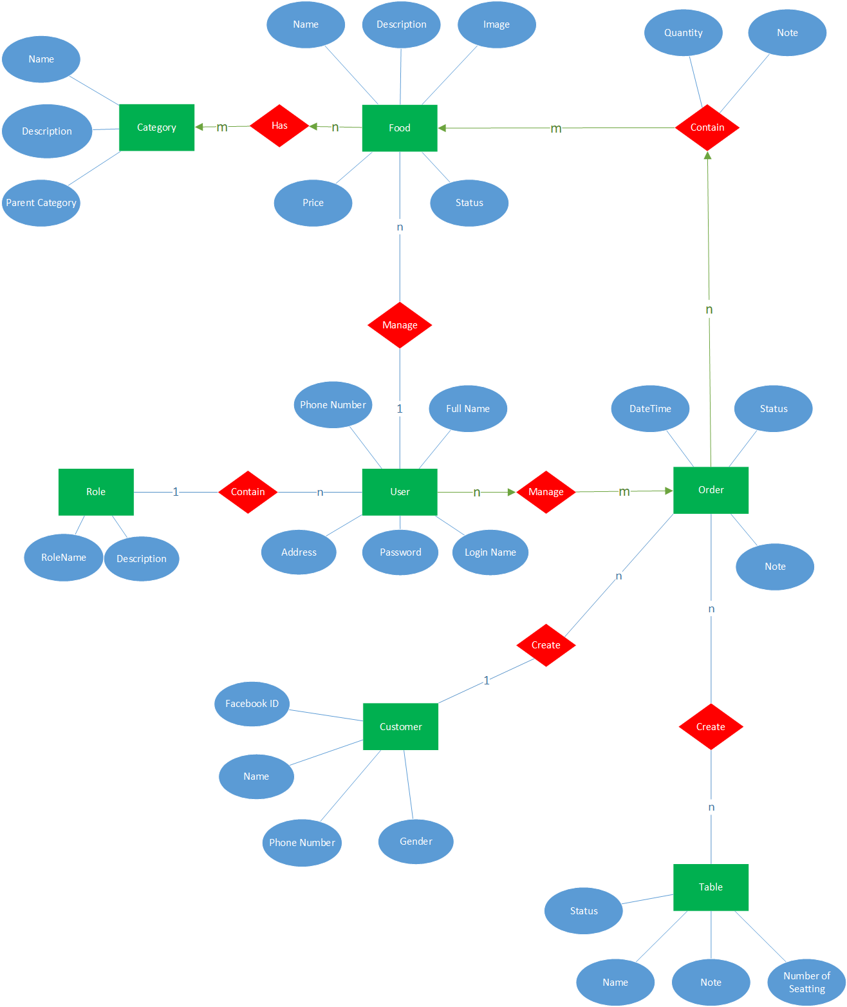*

# SOFTWARE DESIGN DESCRIPTION

## Purpose

The purpose of this chapter is to give the developer team a guide of the system’s architecture and how they should be implemented. This chapter includes:

* Component Diagram
* Architecture Overview
* Sequence Diagram
* Class Diagram
* User Interface Design
* Database Design

## Architecture Overview

### Choice of System Architecture

#### MVVM model

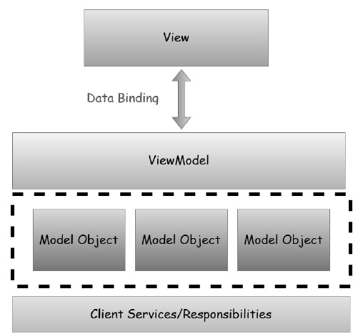The Model-View-ViewModel (MVVM) pattern is an application pattern that isolates the user interface from the underlying business logic. MVVM belongs to a class of patterns called Separated Presentation. These patterns provide a clean separation between the UI and the rest of the application.

Figure : MVVM Model

**The Model,** which provides a view-independent representation of your business entities. The design of the model is optimized for the logical relationships and operations between your business entities, regardless of how the data is presented in the user interface.

**The View** class which is the user interface. It displays information to the user and fires events in response to user interactions.

**The ViewModel** class, which is the bridge between the view and the model. Each View class has a corresponding ViewModel class. The ViewModel retrieves data from the Model and manipulates it into the format required by the View. It notifies the View if the underlying data in the model is changed, and it updates the data in the Model in response to UI events from the View.

#### Advantages and Disadvantages of MVP model

* **Advantage:**
  + ***Maintainability:*** A clean separation of different kinds of code should make it easier to go into one or several of those more granular and focused parts and make changes without worrying.
  + ***Testability:*** With MVVM each piece of code is more granular and if it is implemented right your external and internal dependences are in separate pieces of code from the parts with the core logic that you would like to test
  + ***Extensibility:*** You have a better chance of making any of those parts more reusable, because ofthe clean separation boundaries and more granular pieces of code.
* **Disadvantages:**
  + Some people think that for simple UIs, MVVM can be overkill.
  + Similarly in bigger cases, it can be hard to design the ViewModel.

Debugging would be bit difficult when we have complex data bindings.

### System Architecture

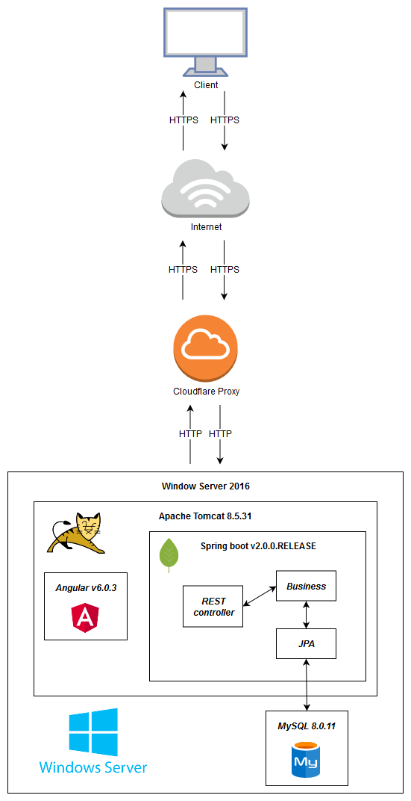

Figure System Architecture Overview

### System Architecture Explanation

#### Cloudflare Proxy

Cloudflare Proxy to help the system faster and safer.

We use it to enable ssl, mitigate DDoS attacks, optimize html,css,js file

#### Window Server 2016

Window Server 2016 is a server operating systems released by Microsoft.

We use it to provide environment to run Apache Tomcat, MySQL Server

#### Apache Tomcat

The Apache Tomcat® software is an open source implementation of the Java Servlet, JavaServer Pages, Java Expression Language and Java WebSocket technologies.

We use it to run ER application

#### MySQL

MySQL is a freely available open source Relational Database Management System (RDBMS) that uses Structured Query Language (SQL).

We use it to store data of ER application

#### Spring boot

Spring Boot makes it easy to create stand-alone, production-grade Spring based Applications that you can "just run".

We use it to build ER application

#### Angular

Angular is a platform that makes it easy to build applications with the web.

We use it to build ER application

## Component Diagram G:\My Drive\CTW\1. Documents\DungNA\Component Diagram_final.png

## Sequence Diagram

### Login by Facebook

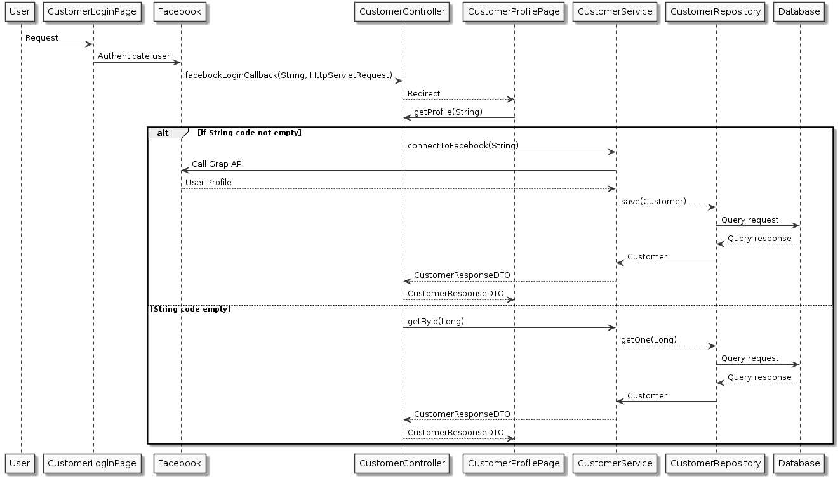

Figure 7: Sequence Diagram- Login by facebook

### Login

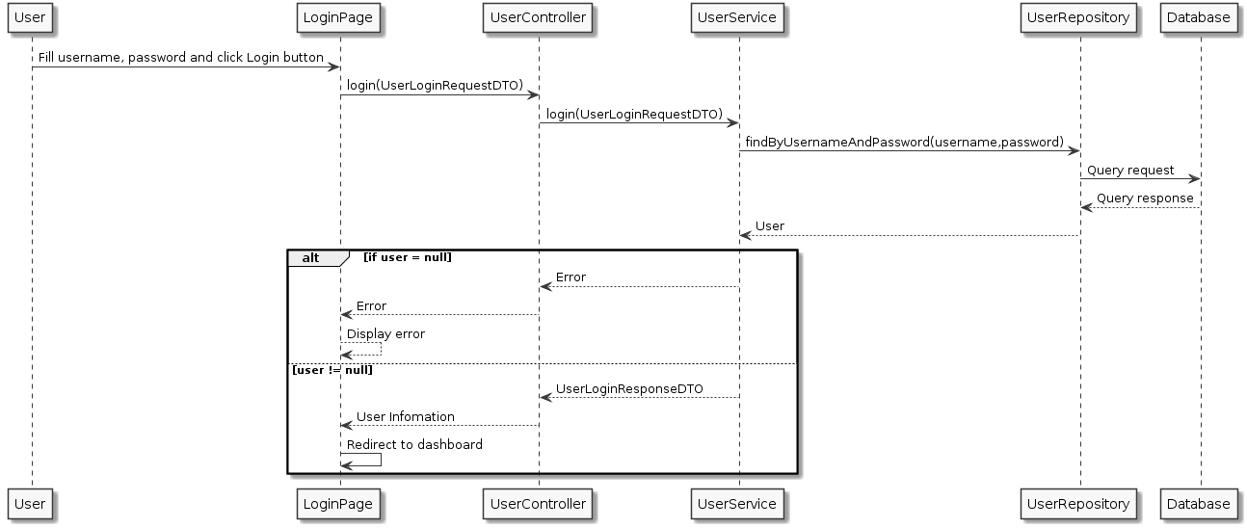

Figure Sequence Diagram- Login (for user)

### Logout

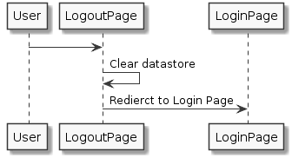

Figure 9 Sequence Diagram- Logout

### Show menu

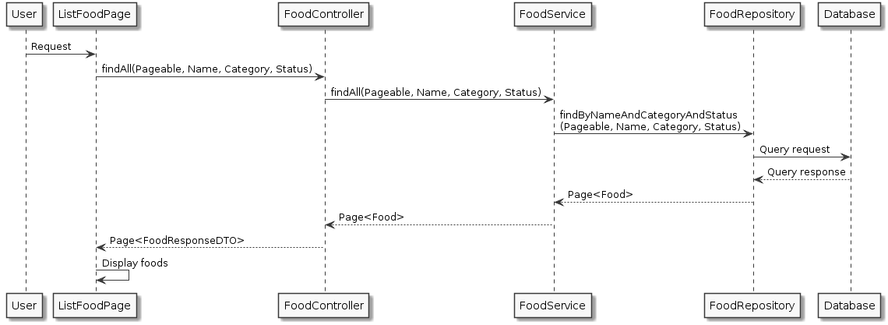

Figure 10 Sequence Diagram- Show menu

### Add foodG:\My Drive\CTW\1. Documents\DungNA\Sequence Diagram\FoodCreate.png

Figure 11 Sequence Diagram- Add food

### Delete food

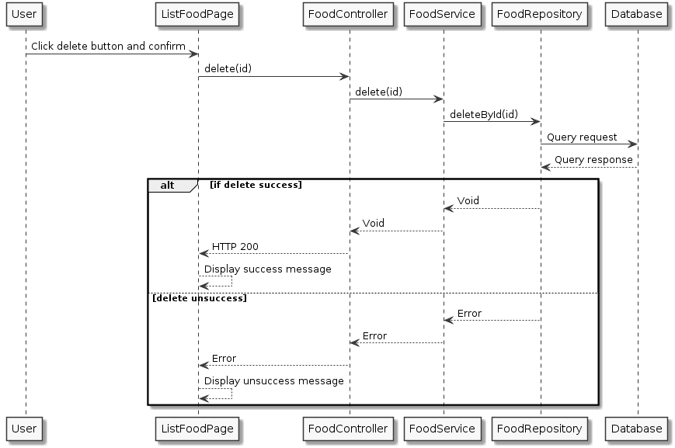

Figure 12 - Sequence Diagram- Delete food

### Add account

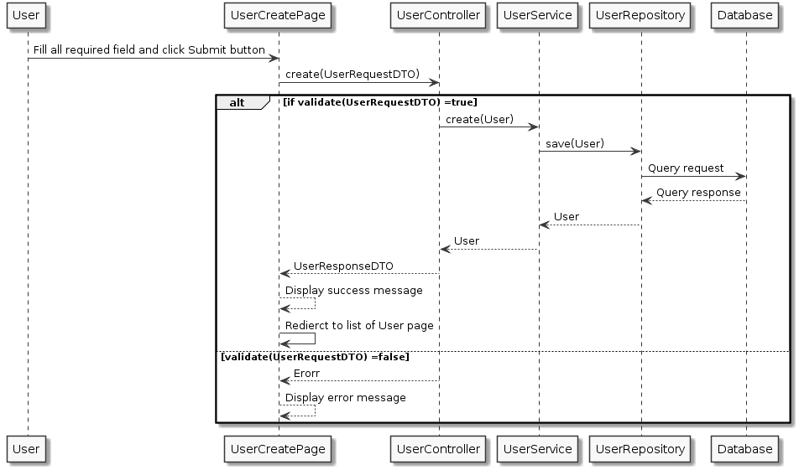

Figure Sequence Diagram- add account

### Edit account

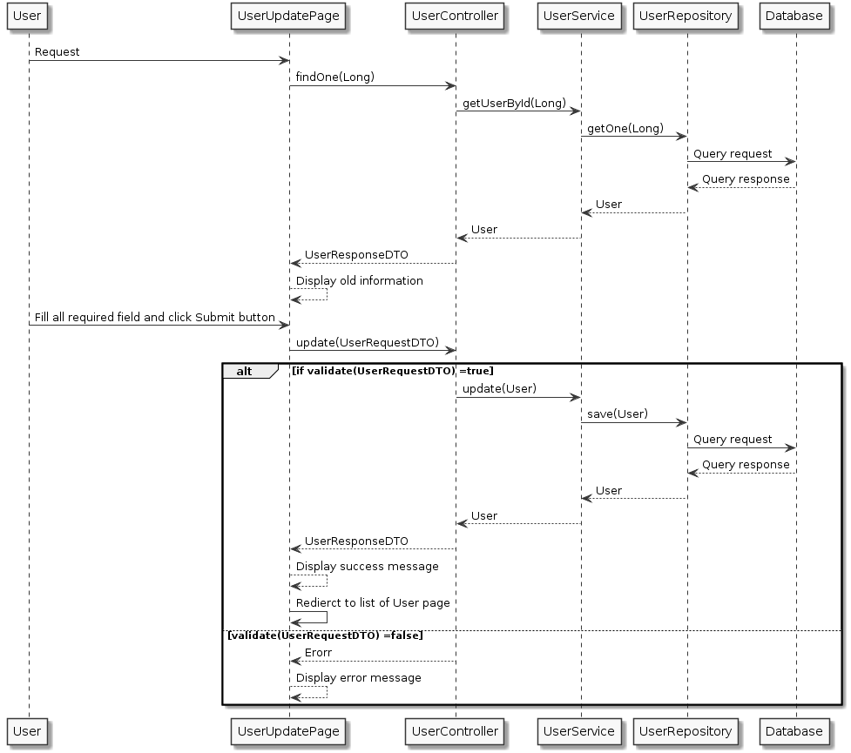

Figure Sequence Diagram- edit account

### Delete account

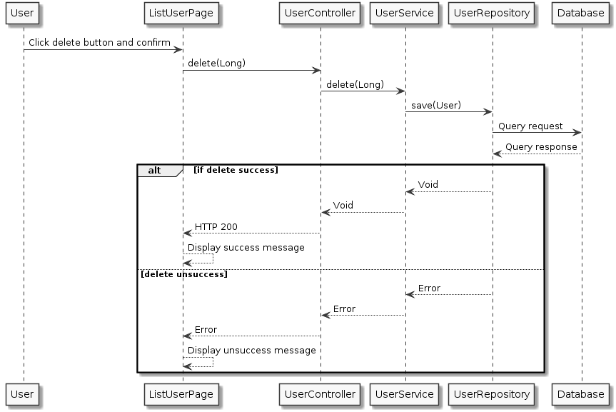

Figure Sequence Diagram- delete account

### View account

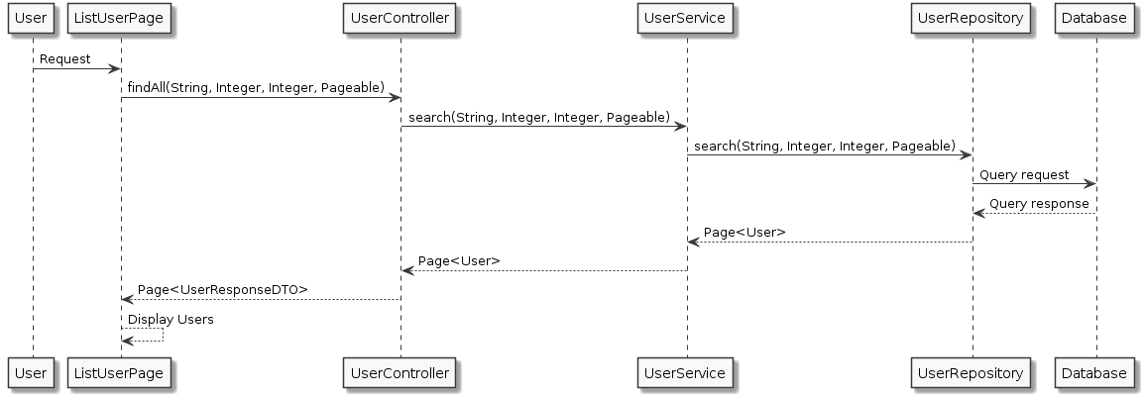

Figure Sequence Diagram- View account

### Add table

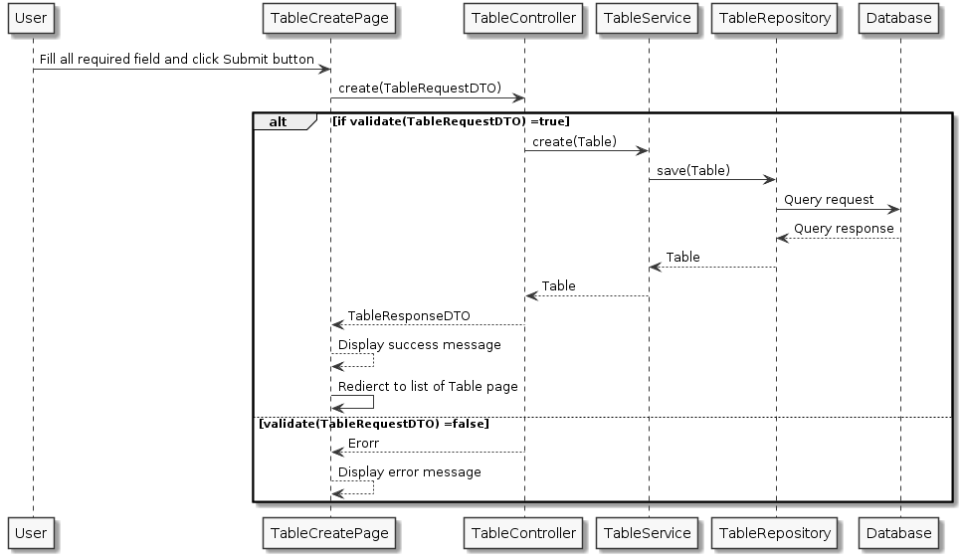

Figure Sequence Diagram- Add table

### Edit table

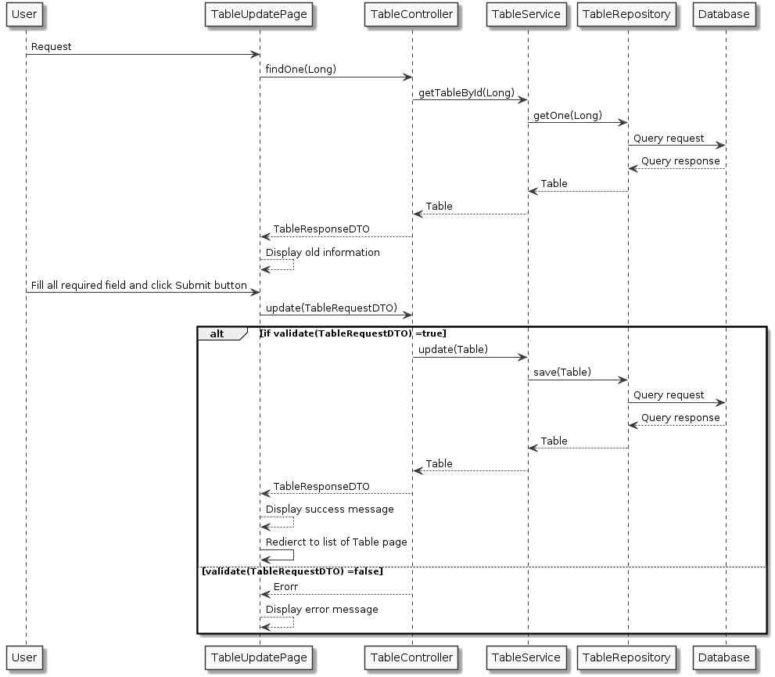

Figure Sequence Diagram- Edit table

### View table

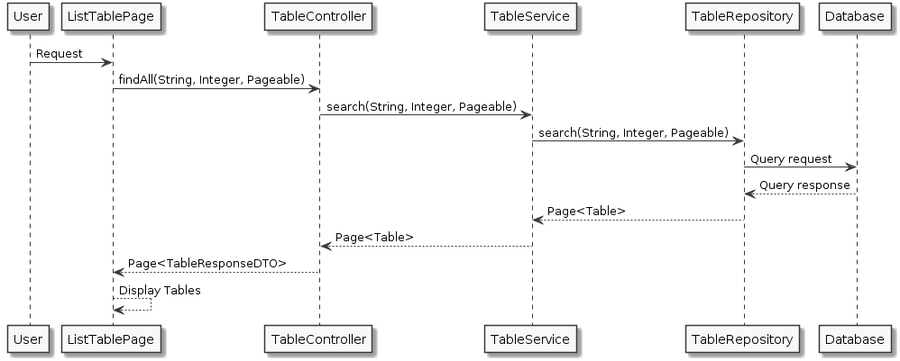

Figure Sequence Diagram- View table

### View statistics

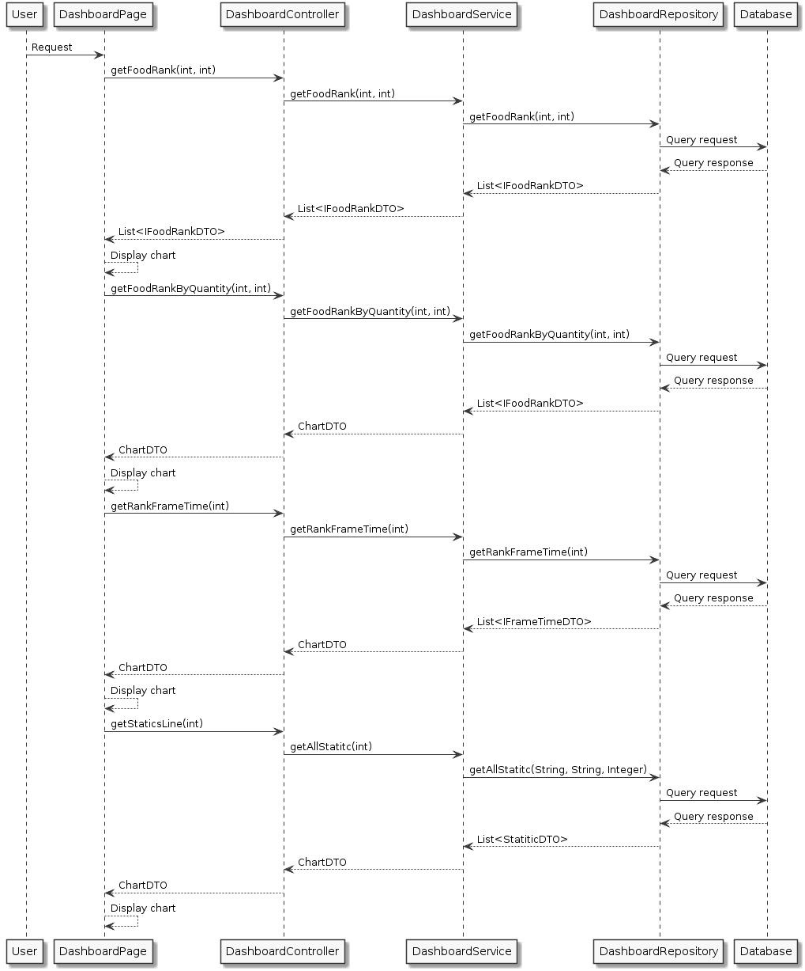

Figure Sequence Diagram- View statistics

### Book table

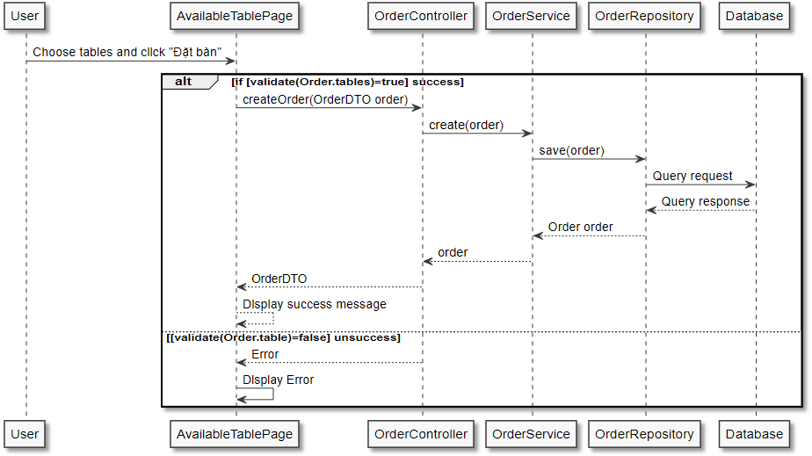

Figure Sequence Diagram- book table

### Cancel table book

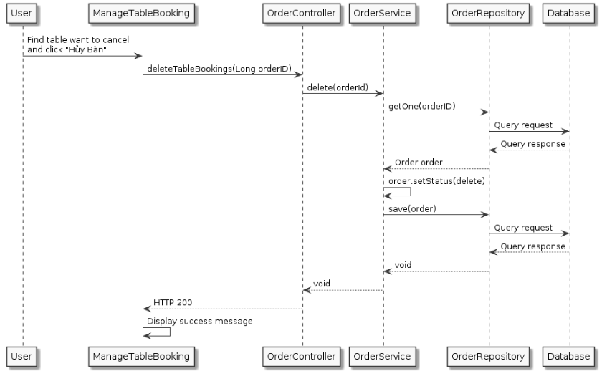

Figure Sequence Diagram- cancel table book

### Add order

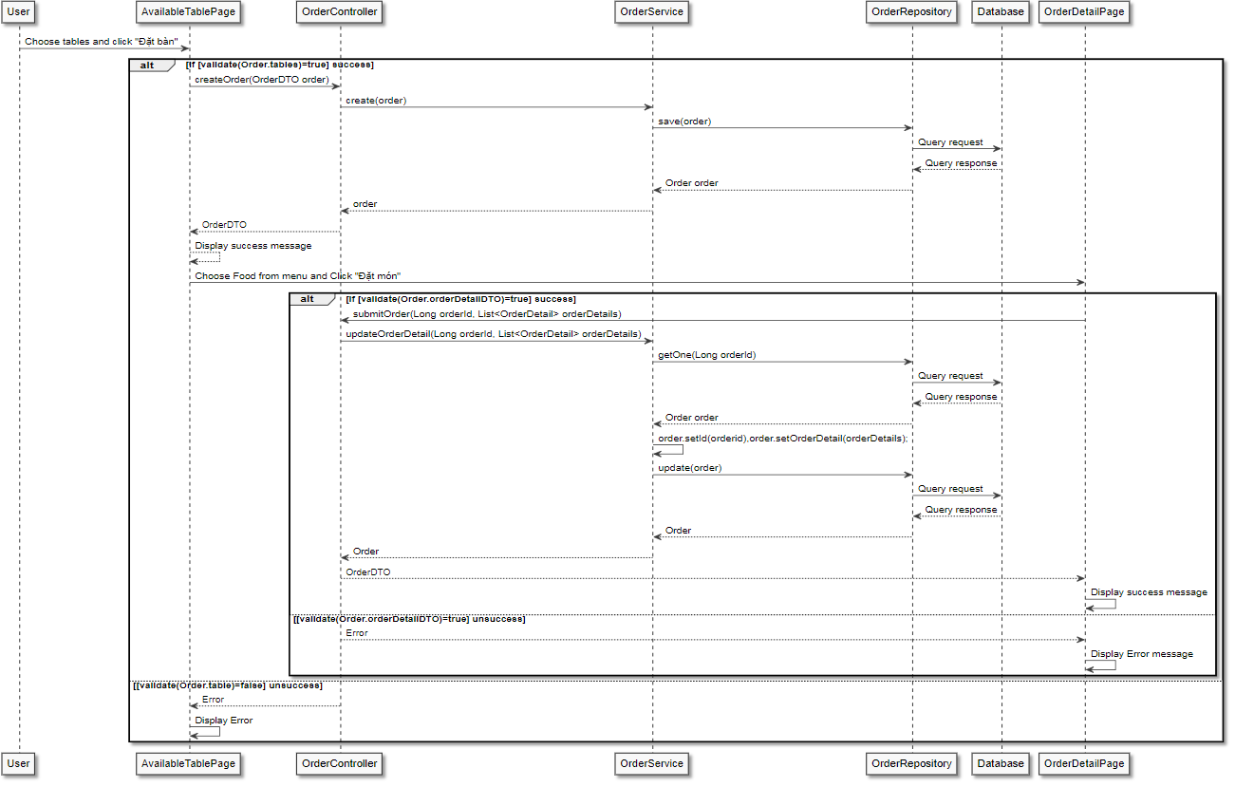

Figure Sequence Diagram- Add order

### View order

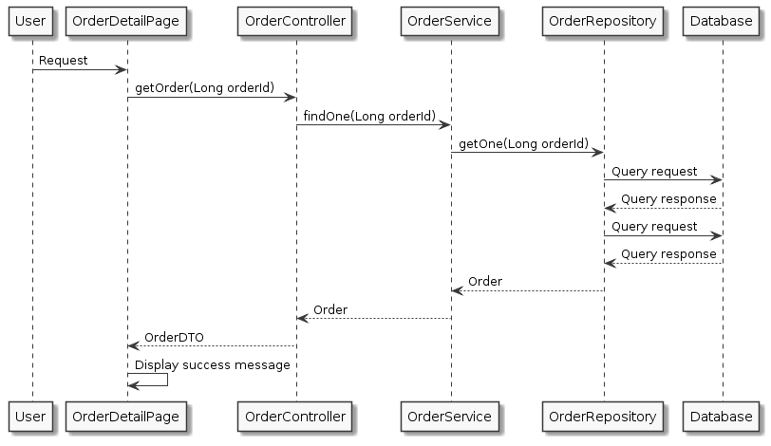

Figure Sequence Diagram- View order

### Delete order

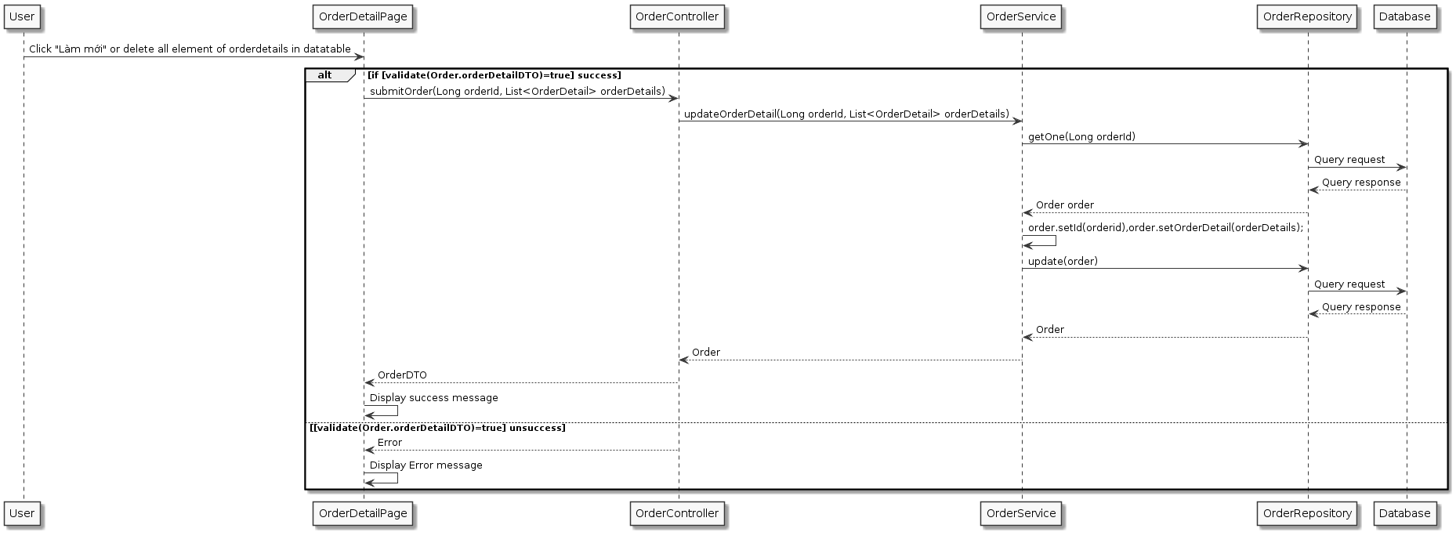

Figure Sequence Diagram- Delete order

### Change order status

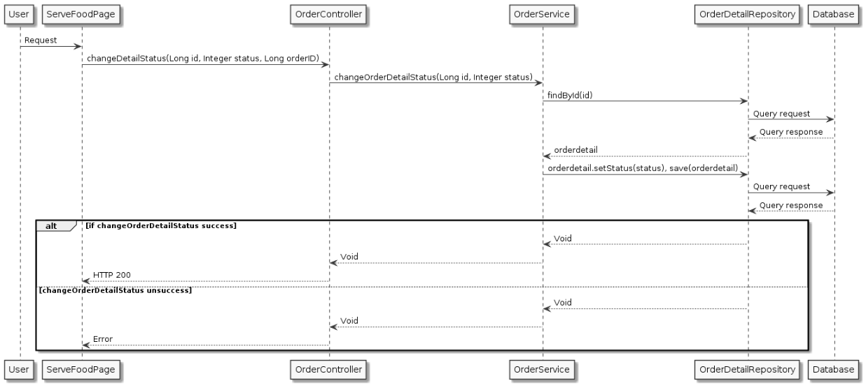

Figure Sequence Diagram- Change order status

### View customer booking status

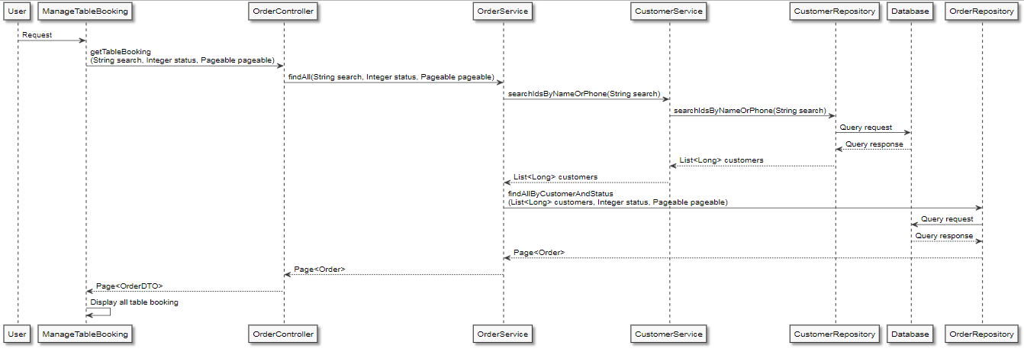

Figure Sequence Diagram- View customer booking status

### Checkout

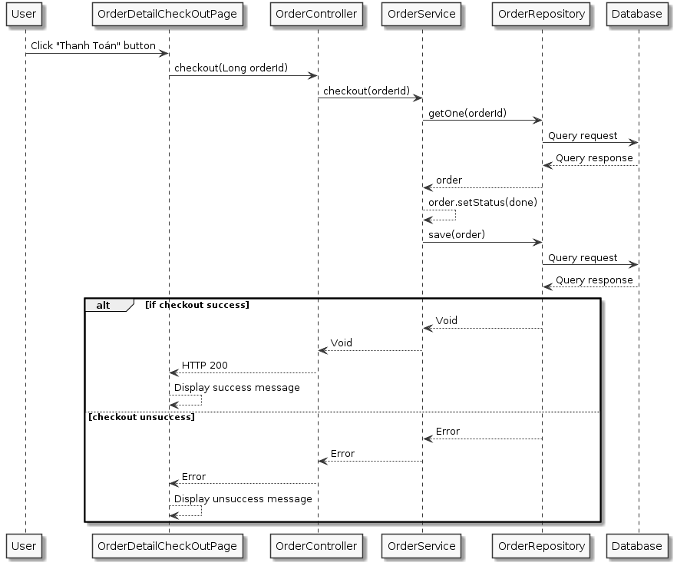

Figure Sequence Diagram- Checkout

## Algorithm

Applied recommendation in food recommend service using Knn.

**Background**

Food recommendation service is a service in project eRestaurant, focus on management restaurant booking and order. So, recommendation service must be small, easy to use and change model data. Because order is small and changing by time, so I choose Knn for this system.

**k-Nearest Neighbors**

**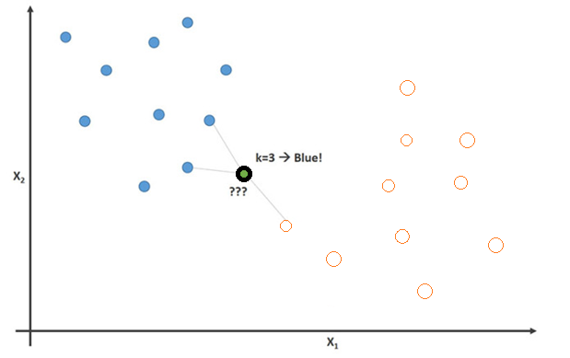**

kNN is a machine learning algorithm to find clusters of similar item based on order, and make predictions using the similar of nearest neighbors. For example, we first present order in a matrix, with the matrix having one row for each order and column food for food in order, like so:



We calculate a function c(x, y) mean distance between item x and y by counting order has both x and y.



This table can update by time if new order come.

Nextly, if new order need to recommend other item, easy to calculate similar of each food with new order.

Example new order is:



So we estimate similar for f2, f4, f5 in table bellow by using some of near function between each food in new order with other food in menu:

|  |  |
| --- | --- |
| **x** | **S(x)** |
| **F2** | 4 |
| **F4** | 3 |
| **F5** | 3 |

Simply, we choose F2 to recommend for new order because it is nearst to new order.

## CRC Cards and Class Diagram

### CRC Cards

|  |  |  |  |  |  |  |  |  |  |  |  |  |  |  |  |  |  |  |  |  |  |  |  |  |  |  |  |  |  |  |  |  |  |  |  |  |
| --- | --- | --- | --- | --- | --- | --- | --- | --- | --- | --- | --- | --- | --- | --- | --- | --- | --- | --- | --- | --- | --- | --- | --- | --- | --- | --- | --- | --- | --- | --- | --- | --- | --- | --- | --- | --- |
| |  |  | | --- | --- | | UserController |  | | Responsibilities | **Collaborators** | | List all user info  Get user info by user id  Create user  Update user info  Delete user info  login for user | UserService  UserMapper |  |  |  | | --- | --- | | UserMapper |  | | Responsibilities | **Collaborators** | | Parser from user Entity to user DTO  Parser from user DTO to user entity  Parser user entity to authentication DTO |  |  |  |  | | --- | --- | | UserService |  | | Responsibilities | **Collaborators** | | List all user info  Get user info by user id  Find user by username password  Get user info by role  Create user  Update user info  Delete user info  Login into system | RoleService  TokenProvider  UserRepository |  |  |  | | --- | --- | | TokenProvider |  | | Responsibilities | **Collaborators** | | Generate token  Get info from JWT  Validate token |  |  |  |  | | --- | --- | | RoleService |  | | Responsibilities | **Collaborators** | | Check “Role” Exist  Fill all role info  Get Role info by id | RoleRepository |      |  |  | | --- | --- | | UserRepository |  | | Responsibilities | **Collaborators** | | List all user info  Get user info by user id  find user by name  Create user  Update user info  Delete user info  check username and password of user account |  | |

|  |  |  |  |  |  |  |  |  |  |  |  |  |  |  |  |  |  |  |  |  |  |  |  |  |
| --- | --- | --- | --- | --- | --- | --- | --- | --- | --- | --- | --- | --- | --- | --- | --- | --- | --- | --- | --- | --- | --- | --- | --- | --- |
| |  |  | | --- | --- | | RoleController |  | | Responsibilities | **Collaborators** | | Check “Role” Exist  Find all of Role info  Get Role info by id | RoleService |  |  |  | | --- | --- | | RoleService |  | | Responsibilities | **Collaborators** | | Check “Role” Exist  Find all of Role info  Get Role info by id | RoleService  UserService |  |  |  | | --- | --- | | RoleService |  | | Responsibilities | **Collaborators** | | Check “Role” Exist  Find all of Role info  Get Role info by id | RoleRepository |  |  |  | | --- | --- | | RoleRepository |  | | Responsibilities | **Collaborators** | | Get role info by id |  | |
| |  |  | | --- | --- | | FoodController |  | | Responsibilities | **Collaborators** | | Find all of food  Get food info by id  Get food list info by category  Get food list info by food status and name  Create food  Update food info  Delete food | FoodService  FoodMapper |  |  |  | | --- | --- | | FoodMapper |  | | Responsibilities | **Collaborators** | | Parser from food entity to food DTO  Parser from food DTO to food entity |  |  |  |  | | --- | --- | | FoodService |  | | Responsibilities | **Collaborators** | | Find all of food by name, status  Get food info by id  Get food list info by category  Create food  Update food info  Delete food  Update food list | FoodRepository  CategoryService |  |  |  | | --- | --- | | FoodRepository |  | | Responsibilities | **Collaborators** | | Find all of food  Get food info by id  Create food  Update food info  Delete food  Find food list by name, status  Find food list which in category list |  |  |  |  | | --- | --- | | CategoryService |  | | Responsibilities | **Collaborators** | | Get category  Get sub category by parent category  Find category by name  Check category exist | CategoryRepository | |
| |  |  | | --- | --- | | CategoryController |  | | Responsibilities | **Collaborators** | | Find all of category  Get category info by category id  Create category  Update category info  Delete category  Get parent category list by sub category id | CategoryService  CategoryMapper |  |  |  | | --- | --- | | CategoryMapper |  | | Responsibilities | **Collaborators** | | Parse to category entity from category request dto  Parse to category dto from category entity |  |  |  |  | | --- | --- | | CategoryService |  | | Responsibilities | **Collaborators** | | Find all of category  Get category info by category id  Create category  Update category info  Delete category  Get parent category list by sub category id  Find category by name  Get sub category list by parent category id | CategoryRepository |  |  |  | | --- | --- | | CategoryRepository |  | | Responsibilities | **Collaborators** | | Find all of category  Get category info by id  Create category  Update category info  Delete category  Get parent category list by sub category id  Find category by name  Get sub category list by parent category id |  | |
| |  |  | | --- | --- | | TableController |  | | Responsibilities | **Collaborators** | | List all table  Find table  Create table  Update table  Delete table  Find table by name and number of seating  Find available table by date | TableService  TableMapper |  |  |  | | --- | --- | | TableMapper |  | | Responsibilities | **Collaborators** | | parse to table entity from table request dto  parse to table dtp from table entity  parse to available table entity from table entity |  |  |  |  | | --- | --- | | TableService |  | | Responsibilities | **Collaborators** | | List all table  Find table  Create table  Update table  Delete table  Find table by name, number of seating  Find available table by date | TableRepository |      |  |  | | --- | --- | | TableRepository |  | | Responsibilities | **Collaborators** | | List all table  Find table  Create table  Update table  Delete table  Find table by name, number of seating  Find available table by date |  | |
| |  |  | | --- | --- | | CustomerController |  | | Responsibilities | **Collaborators** | | Connect to facebook  Facebook connect callback  Update profile customer  Find Customer by phone or name  Check customer is exist or not | CustomerService  CustomerMapper |  |  |  | | --- | --- | | CustomerMapper |  | | Responsibilities | **Collaborators** | | Parse to customer entity from customer dto  Parse to customer dtp from customer entity |  |  |  |  | | --- | --- | | CustomerService |  | | Responsibilities | **Collaborators** | | Connect to facebook  Facebook connect callback  Update profile customer  Find Customer by phone or name  Check customer is exist or not | CustomerRepository  TokenProvider |      |  |  | | --- | --- | | TokenProvider |  | | Responsibilities | **Collaborators** | | Generate token  Get info from JWT  Validate token |  |      |  |  | | --- | --- | | CustomerRepository |  | | Responsibilities | **Collaborators** | | Connect to facebook  Facebook connect callback  Update profile customer  Find Customer by phone or name  Check customer is exist or not | CustomerRepository | |
|  |
| |  |  | | --- | --- | | OrderController |  | | Responsibilities | **Collaborators** | | Find order by status, name  Check order is open or not  Change order status  Create order  Update order  Delete order  Find order by order id  Check out order by id  Change order detail status by order id | OrderService  OrderMapper  PusherConfig |  |  |  | | --- | --- | | OrderMapper |  | | Responsibilities | **Collaborators** | | Parse to order entity from order request dto  Parse to order dto from order entity  Parse to notification dto from order entity |  |  |  |  | | --- | --- | | PusherConfig |  | | Responsibilities | **Collaborators** | | Set sluster  Set pusher key  Set app id |  |  |  |  | | --- | --- | | OrderService |  | | Responsibilities | **Collaborators** | | Find order by status  Check order is open or not  Change order status  Create order  Update order  Delete order  Get order by order id  Check out order by id  Change order detail status by order id | OrderRepository  OrderDetailRepository  CustomerService |  |  |  | | --- | --- | | OrderRepository |  | | Responsibilities | **Collaborators** | | Find order by status , customers id  Create order  Update order  Delete order  Find order by order id  Find Order Over Time |  |  |  |  | | --- | --- | | OrderDetailRepository |  | | Responsibilities | **Collaborators** | | Find order detail by order id  Stream all order detail |  | |

|  |  |
| --- | --- |
| OrderDetailController |  |
| Responsibilities | **Collaborators** |
| Get list order detail by order id | OrderDetailService |

|  |  |
| --- | --- |
| OrderDetailService |  |
| Responsibilities | **Collaborators** |
| Get list order detail by order id | OrderDetailRepository |

|  |  |
| --- | --- |
| OrderDetailRepository |  |
| Responsibilities | **Collaborators** |
| Get list order detail by order id |  |

|  |  |
| --- | --- |
| DashboardController |  |
| Responsibilities | **Collaborators** |
| Get food rank in former month  Get food rank by quantity in former month  Get peak time in frame time of day  Get static line in former days, month, years | DashboardService |

|  |  |
| --- | --- |
| DashboardService |  |
| Responsibilities | **Collaborators** |
| Get food rank in former month  Get food rank by quantity in former month  Get peak time in frame time of day  Get static line in former days, month, years | DashboardRepository |

|  |  |
| --- | --- |
| DashboardRepository |  |
| Responsibilities | **Collaborators** |
| Get food rank in former month  Get food rank by quantity in former month  Get peak time in frame time of day  Get static line in former days, month, years |  |

|  |  |
| --- | --- |
| AuthenticationFilter |  |
| Responsibilities | **Collaborators** |
| Do filter by servlet request, servlet response, filter chain  Get jwt from request by servlet request | TokenProvider  UserService  CustomerService |

|  |  |
| --- | --- |
| TokenProvider |  |
| Responsibilities | **Collaborators** |
| Generate token  Get Info from JWT  Validate token |  |

|  |  |
| --- | --- |
| RecommendController |  |
| Responsibilities | **Collaborators** |
| Train data  Get recommended food list by order detail list | RecommendService |

|  |  |
| --- | --- |
| RecommendService |  |
| Responsibilities | **Collaborators** |
| Train data  Get recommended food list by order detail list | OrderDetailRepository  FoodRepository |

|  |  |
| --- | --- |
| OrderDetailRepository |  |
| Responsibilities | **Collaborators** |
| Find all orderdetail |  |

|  |  |
| --- | --- |
| FoodRepositoryRepository |  |
| Responsibilities | **Collaborators** |
| Find food list by foos id |  |

### G:\My Drive\CTW\1. Documents\Thinh\class diagram\total.PNGClass Diagram

Figure Total class diagram

|  |  |
| --- | --- |
| Use Case | Classes |
| 1. View menu | <interface> RoleService |
| <interface> FoodService |
| <interface> FoodRepository |
| <interface> CategoryRepository |
| <interface> CategoryService |
| FoodServiceImpl |
| CategoryServiceImpl |
| FoodMapper |
| FoodController |
| 1. View table | TableMapper |
| <interface> TableService |
| <interface> TableRepository |
| TableServiceImpl |
| OrderServiceImpl |
| 1. Register | <interface> CustomerService |
| <interface> CustomerRepository |
| TokenProvider |
| CustomerServiceImpl |
| CustomerController |
| 1. Login by Customer | <interface> CustomerService |
| <interface> CustomerRepository |
| TokenProvider |
| CustomerServiceImpl |
| CustomerController |
| 1. Login | <interface> UserService |
| <interface> UserRepository |
| TokenProvider |
| UserServiceImpl |
| UserController |
| TokenProvider |
| 1. View available table | TableMapper |
| <interface> TableRepository |
| TableServiceImpl |
| TableController |
| 1. Manage table booking | PusherConfig |
| <interface> OrderService |
| <interface> OrderRepository |
| OrderServiceImpl |
| CustomerController |
| OrderController |
| 1. Manage order | PusherConfig |
| <interface> OrderService |
| <interface> OrderRepository |
| OrderServiceImpl |
| CustomerController |
| OrderController |
| 1. Notified order | <interface> OrderService |
| <interface> OrderDetailRepository |
| PusherConfig |
| OrderServiceImpl |
| OrderController |
| 1. Serve order | <interface> OrderService |
| <interface> OrderDetailRepository |
| PusherConfig |
| OrderServiceImpl |
| OrderController |
| 1. List waiting order | <interface> OrderService |
| <interface> OrderDetailRepository |
| PusherConfig |
| OrderServiceImpl |
| OrderController |
| 1. Change order status | <interface> OrderService |
| <interface> OrderDetailRepository |
| PusherConfig |
| OrderServiceImpl |
| OrderController |
| 1. List served order | <interface> OrderService |
| <interface> OrderDetailRepository |
| PusherConfig |
| OrderServiceImpl |
| OrderController |
| 1. Find served order | <interface> CustomerService |
| <interface> OrderService |
| <interface> CustomerRepository |
| <interface> OrderRepository |
| CustomerServiceImpl |
| OrderServiceImpl |
| 1. Check out | <interface> OrderService |
| <interface> OrderDetailRepository |
| <interface> OrderRepository |
| OrderServiceImpl |
| OrderController |
| 1. Manage category | <interface> CategoryService |
| <interface> CategoryRepository |
| CategoryServiceImpl |
| CategoryController |
| 1. Manage food | <interface> FoodService |
| <interface> RoleService |
| <interface> FoodRepository |
| <interface> CategoryRepository |
| FoodServiceImpl |
| CategoryServiceImpl |
| FoodController |
| 1. Manage table | <interface> TableService |
| <interface> TableRepository |
| TableServiceImpl |
| TableController |
| 1. Manage agent account | <interface> UserService |
| <interface> RoleService |
| <interface> UserRepository |
| <interface> RoleRepository |
| UserServiceImpl |
| RoleServiceImpl |
| UserController |
| RoleController |

***View menu***

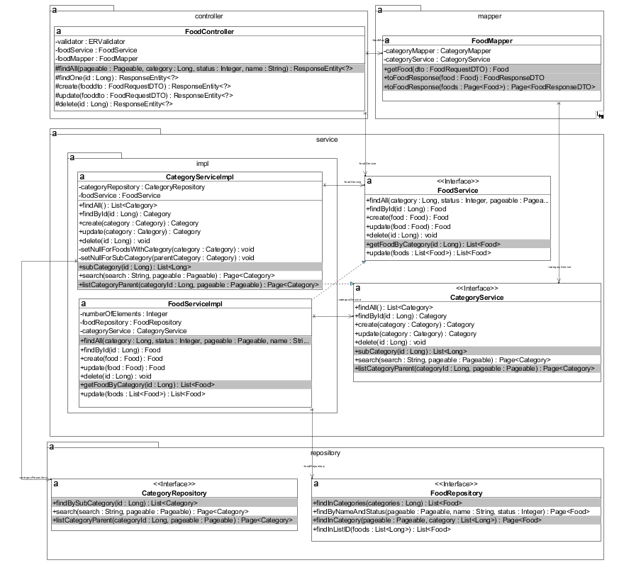

***View table***

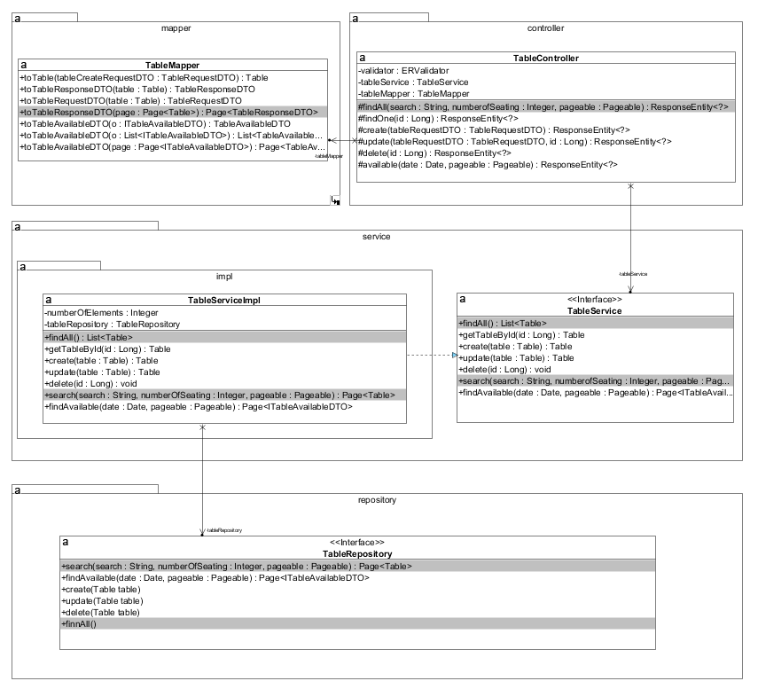

***Register***

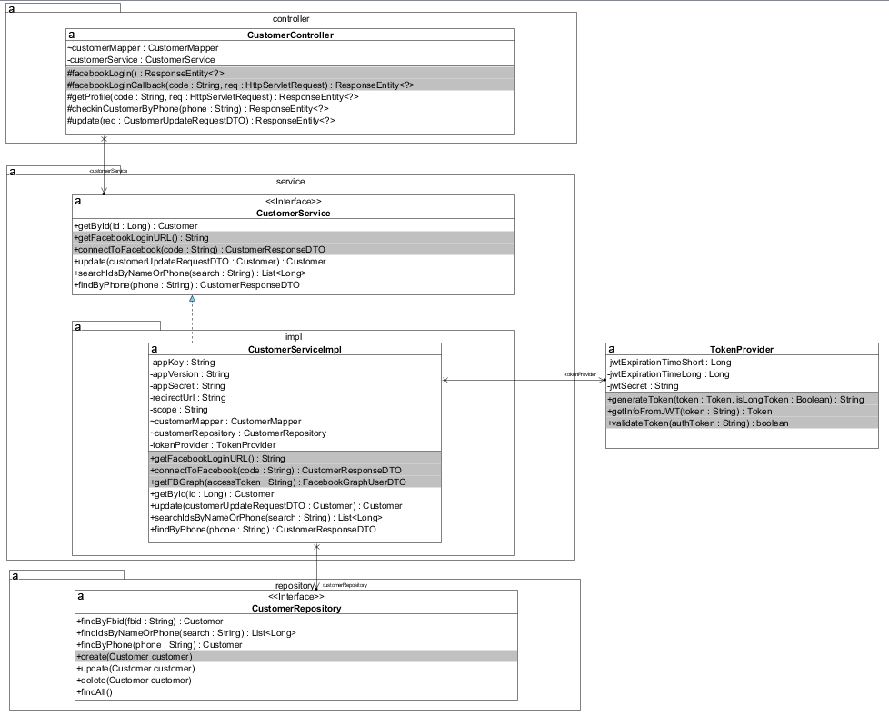

***Login by Customer***



***Login***

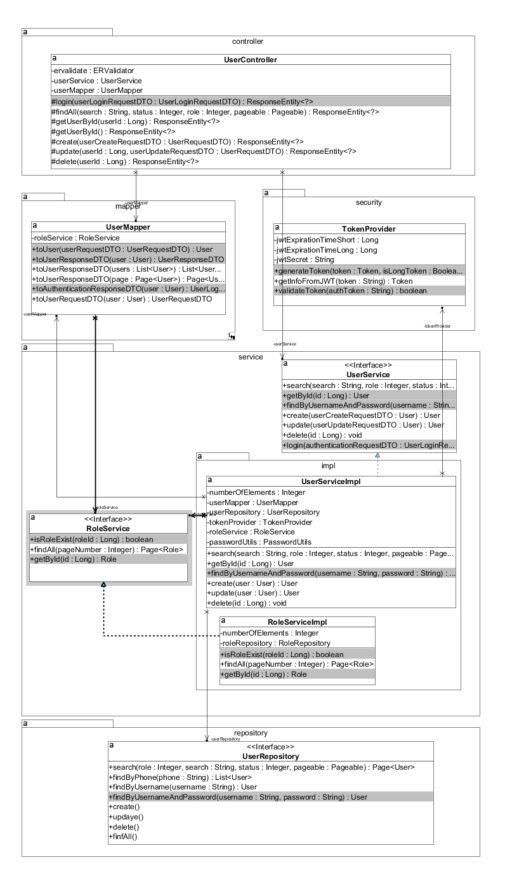

***View available table***

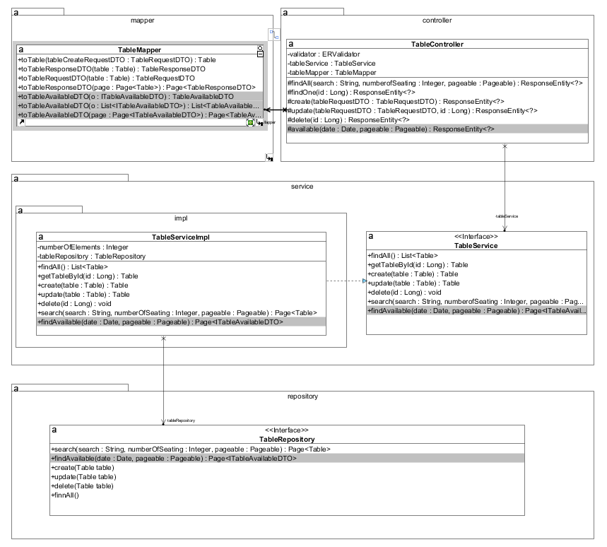

***Book table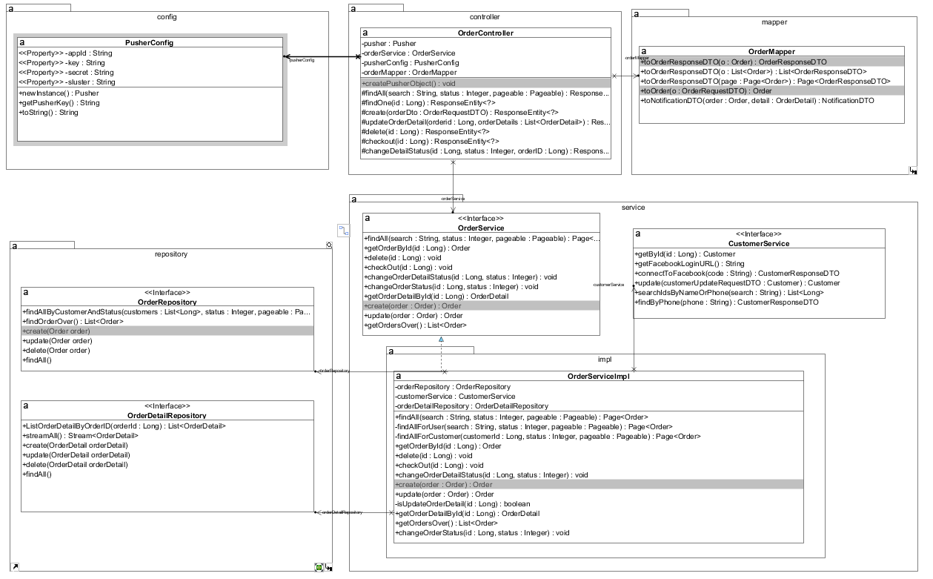***

Edit table book

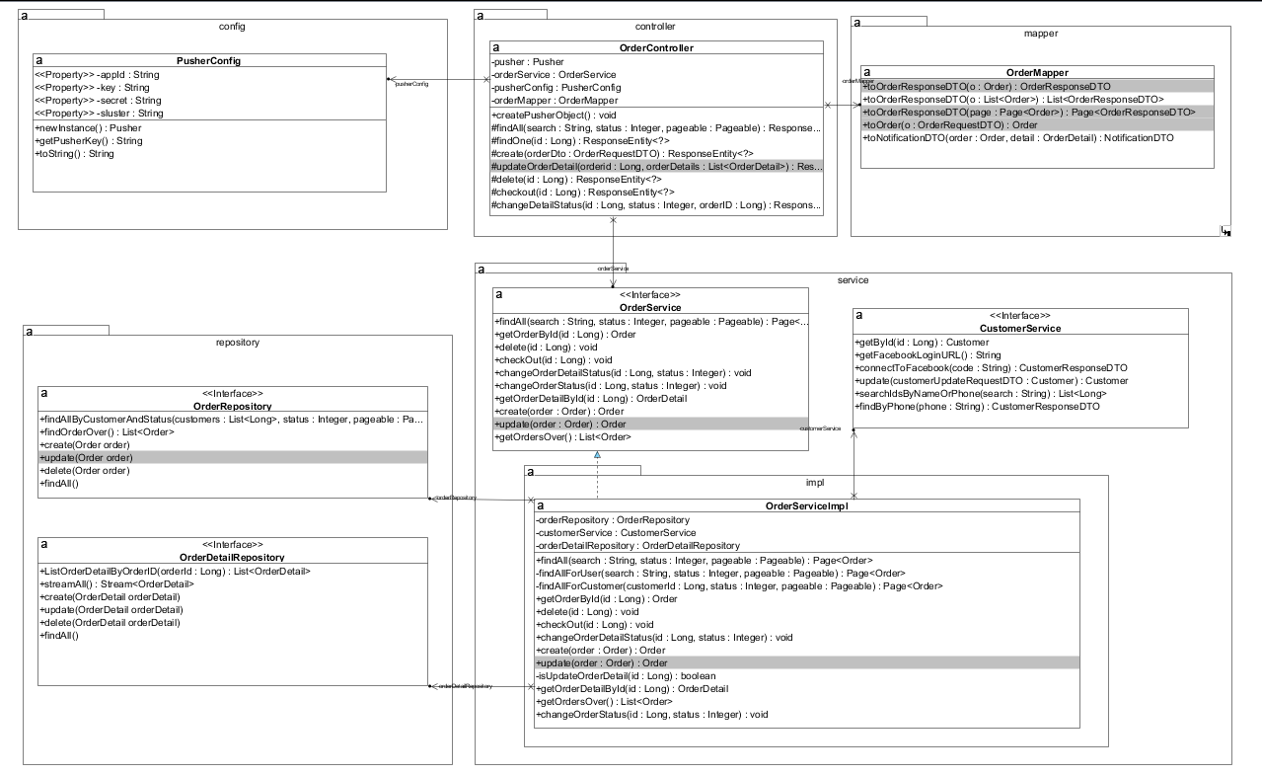

***Cancel table book***



***View table book***

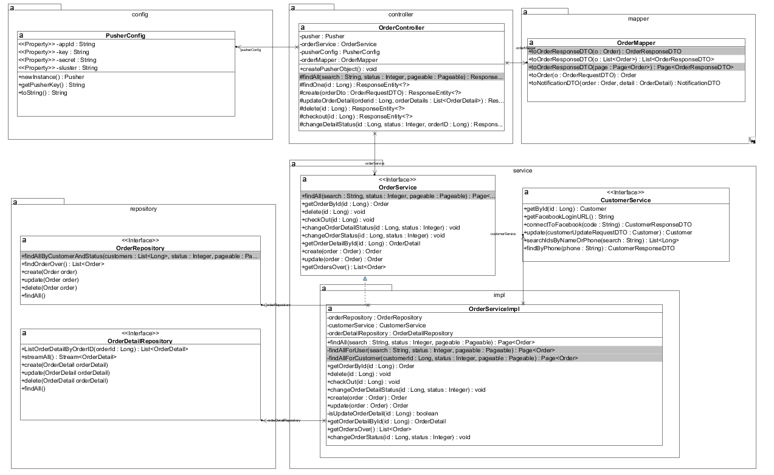

***Add order***



***Edit order***



***Delete order***



***View order***

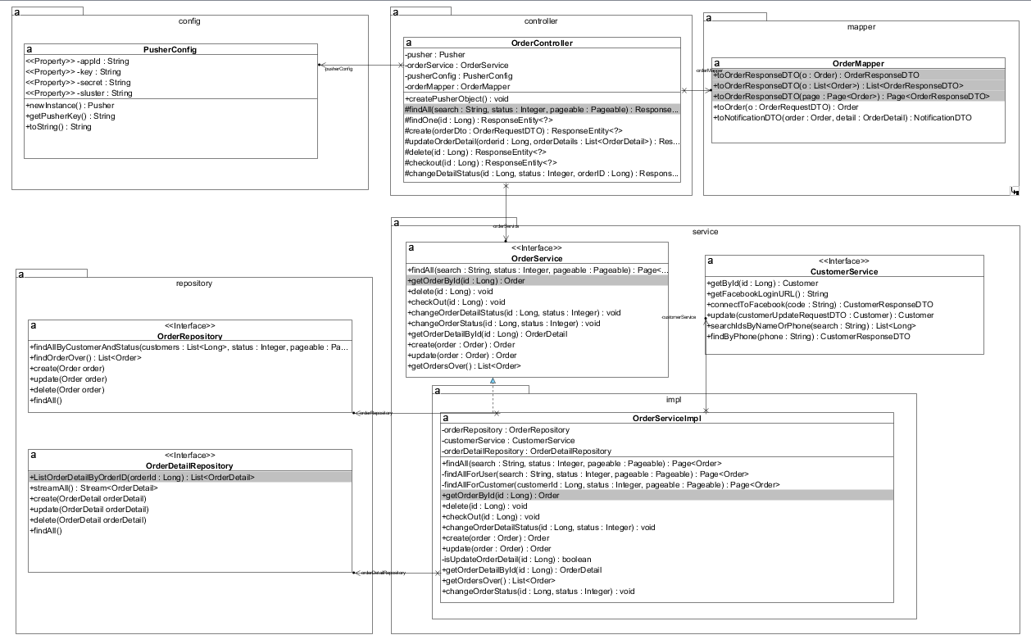

Recommend food

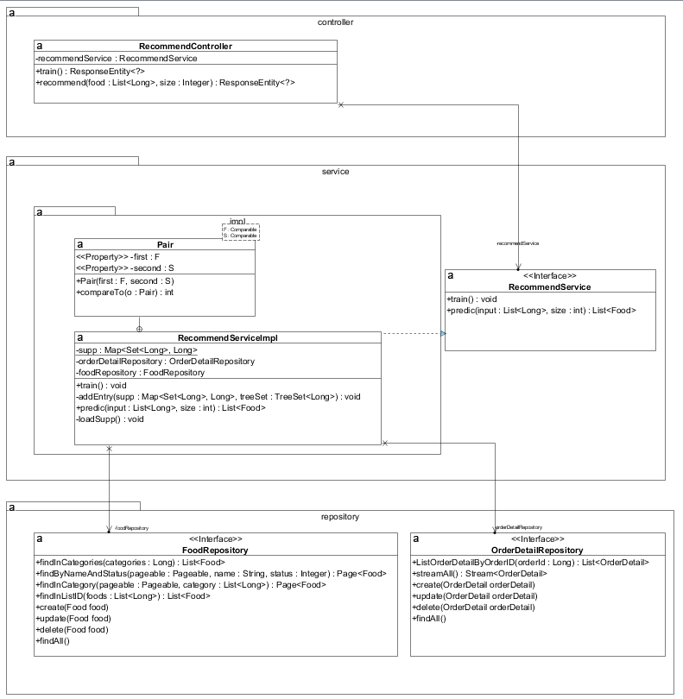

***Notified order***

***Serve order***

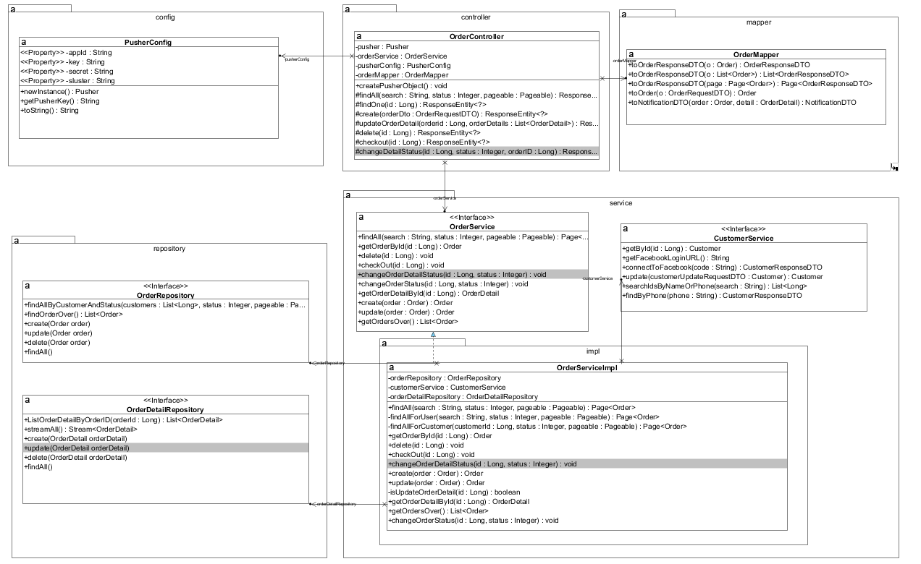

***List waiting order***



***Change order status***



***List served order***



***Check out***

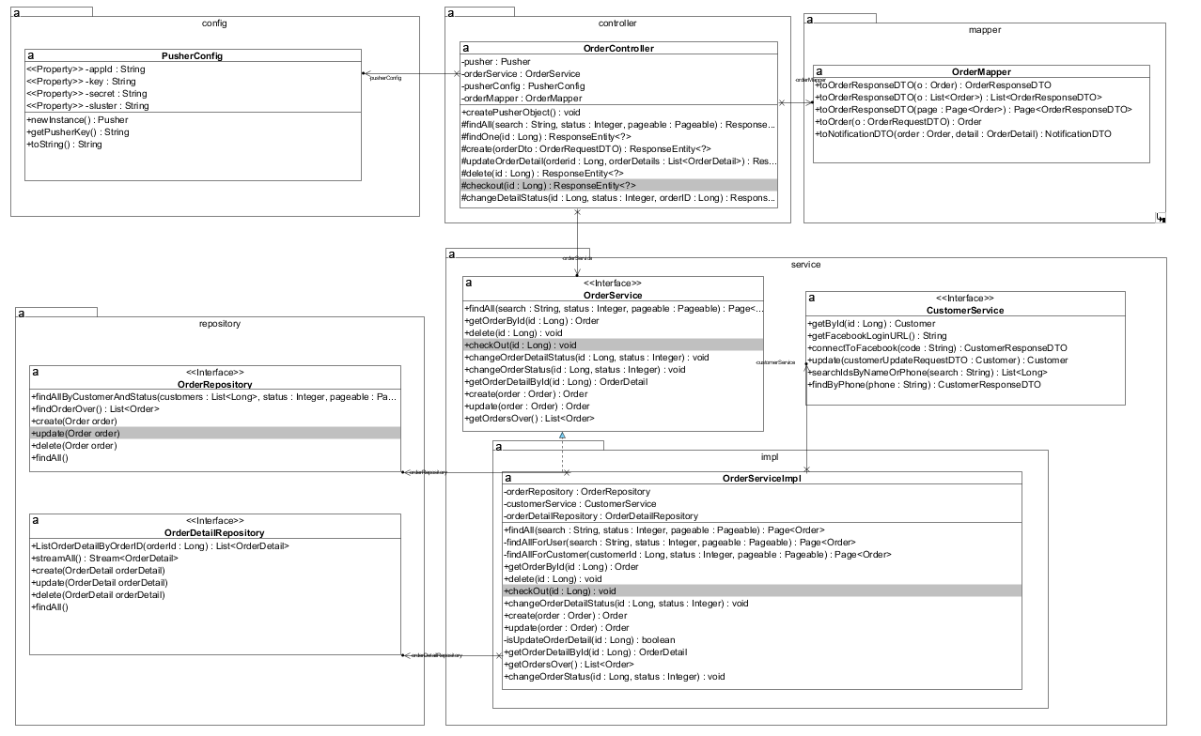

***Manage food***

* + - * 1. *Add food*

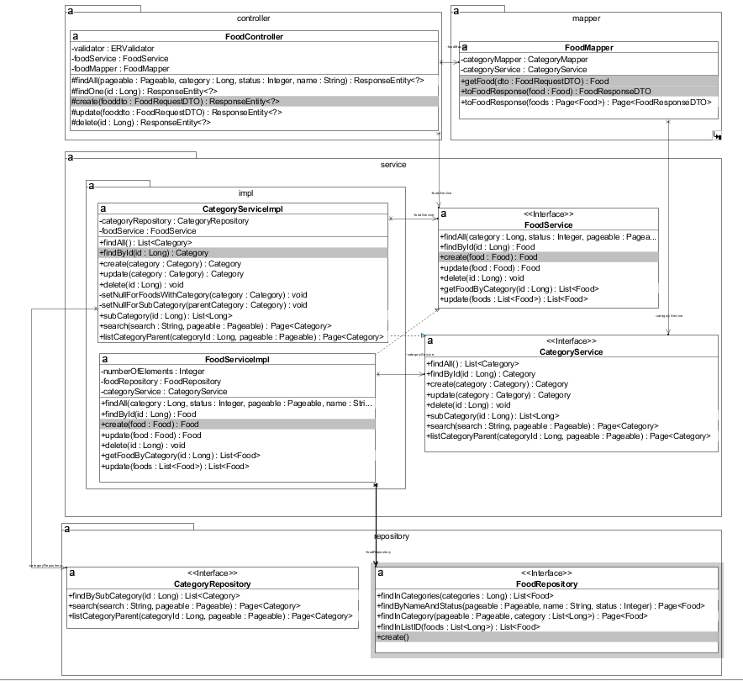

* + - * 1. *Edit food*

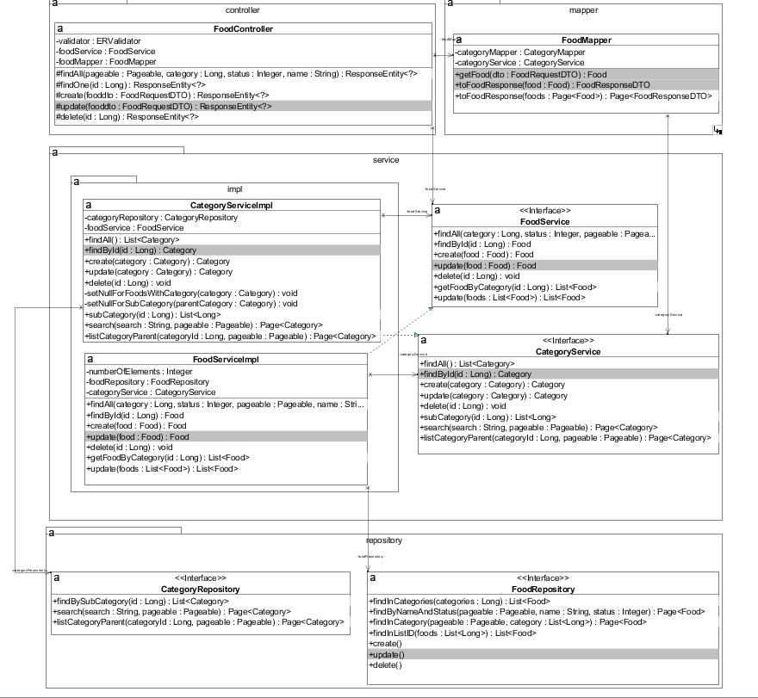

* + - * 1. *Delete food*

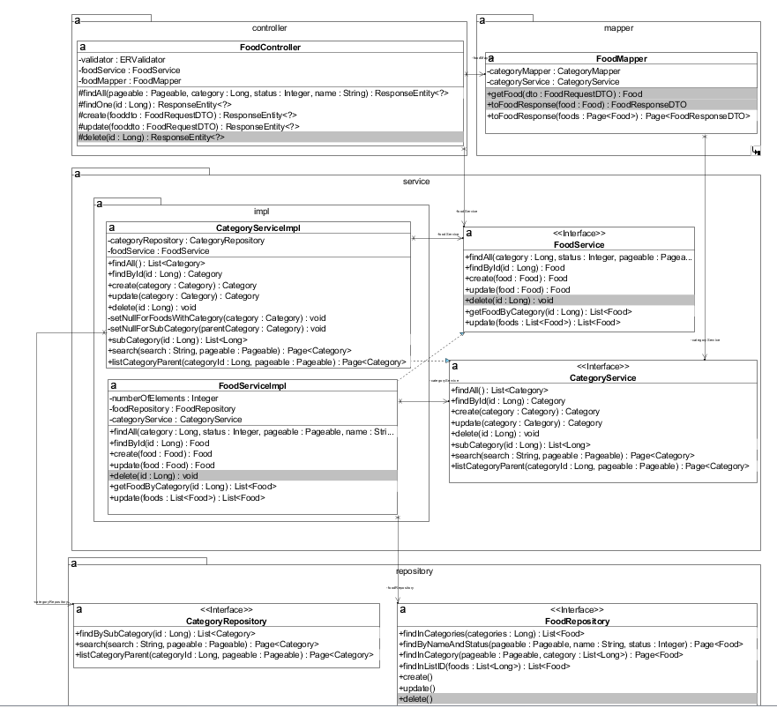

* + - * 1. *View food*

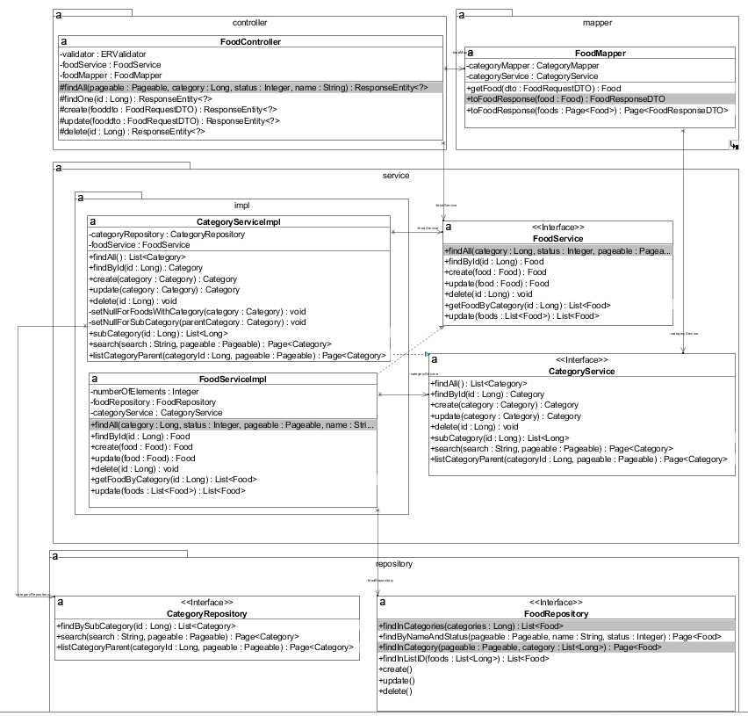

***Manage category***

* + - * 1. *Add category*

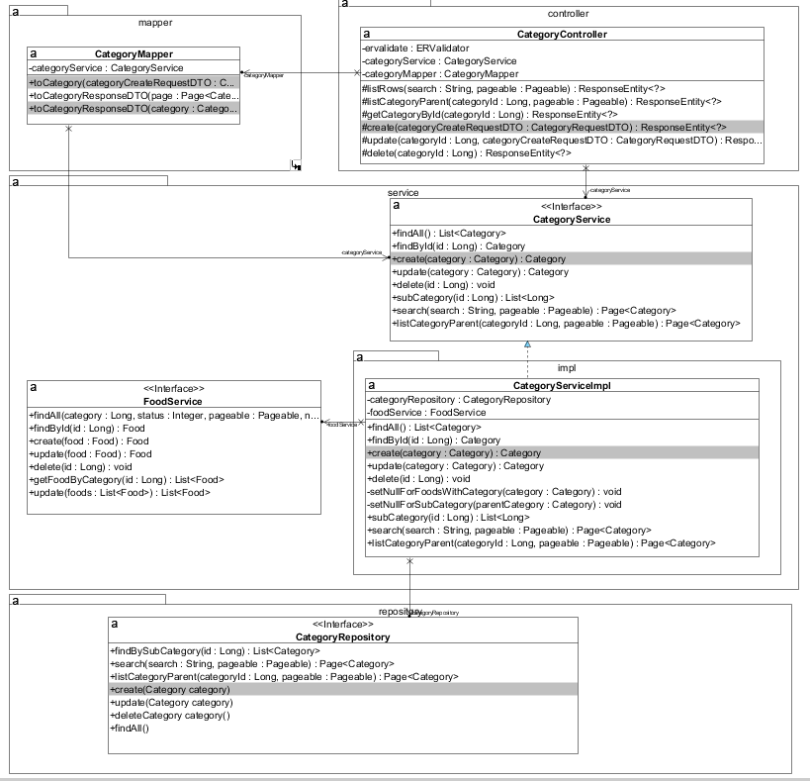

* + - * 1. *Edit category*

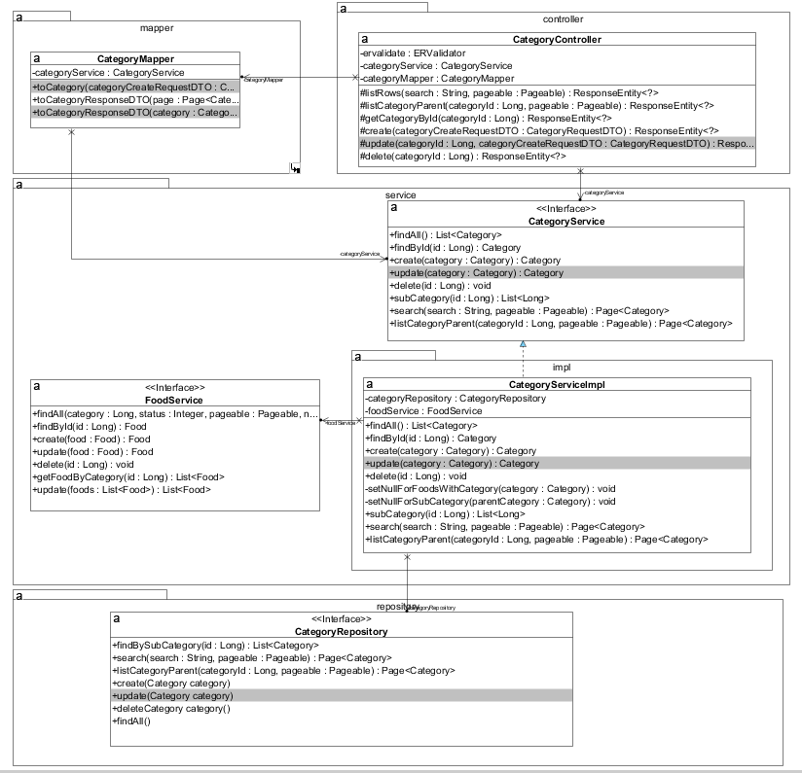

* + - * 1. *Delete category*

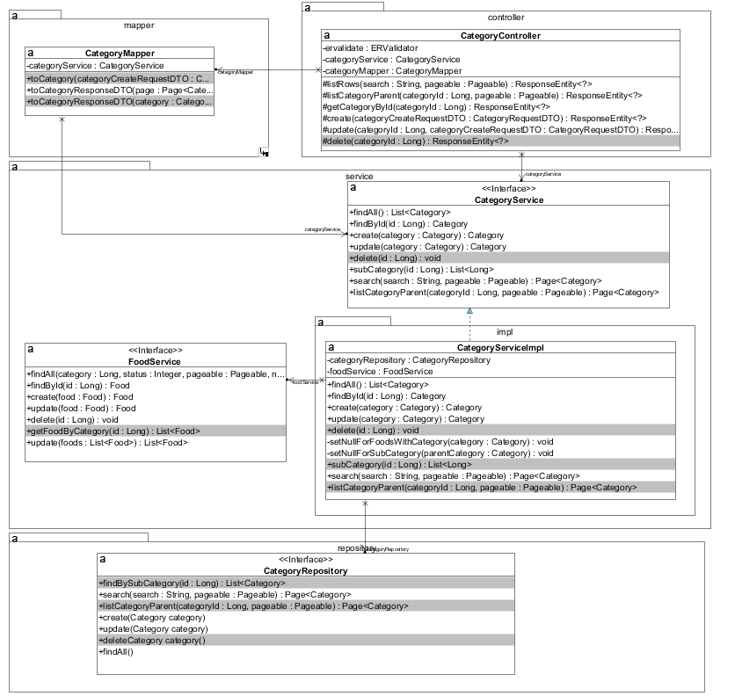

* + - * 1. *View category*

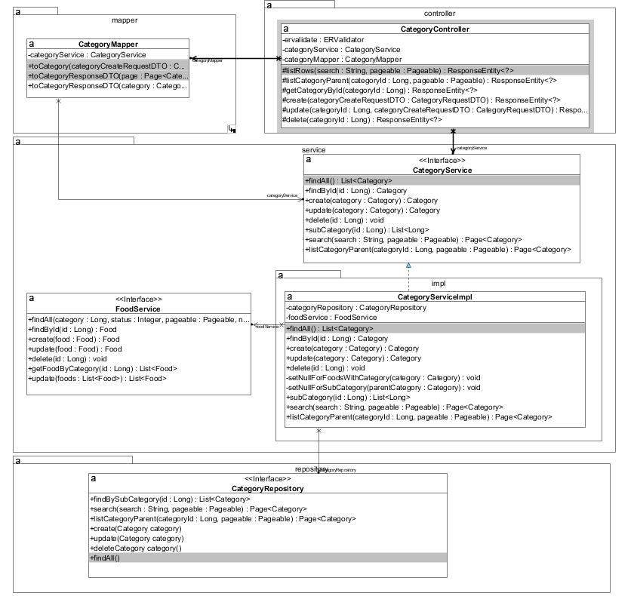

***Manage table***

* + - * 1. *Add table*

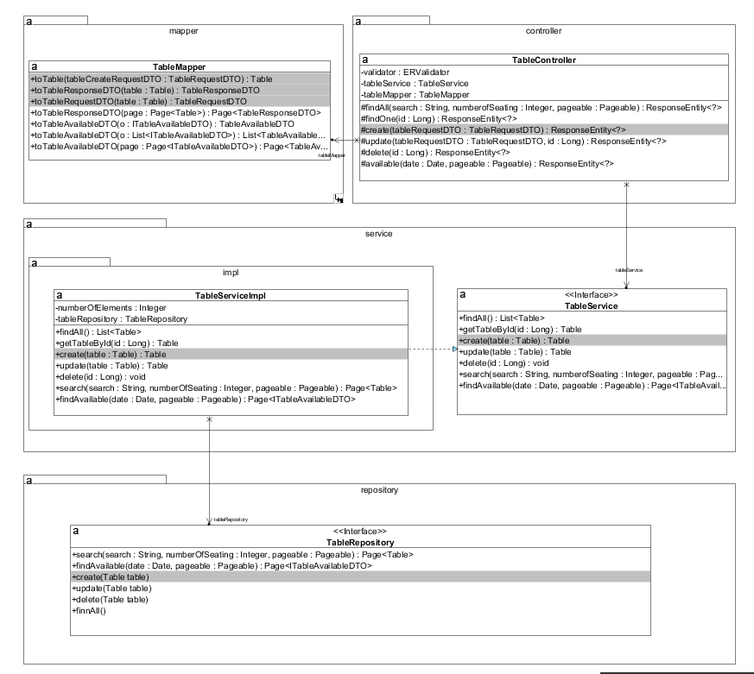

* + - * 1. *Edit table*

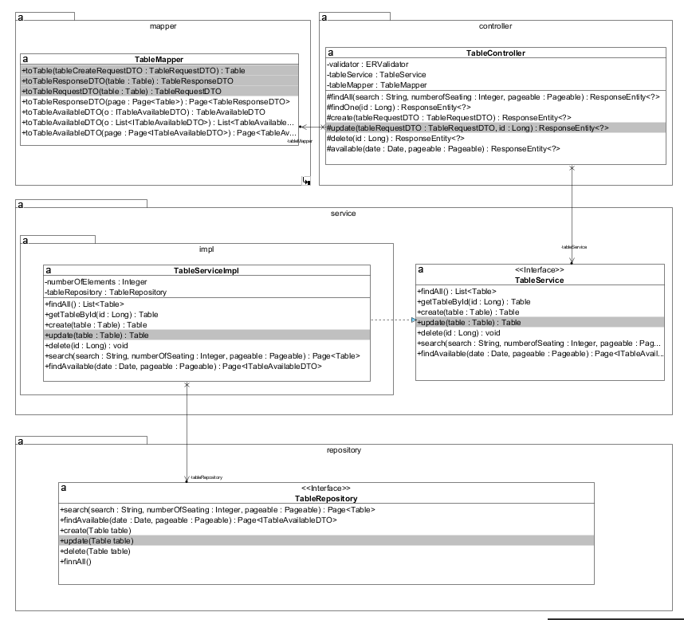

* + - * 1. *Delete table*

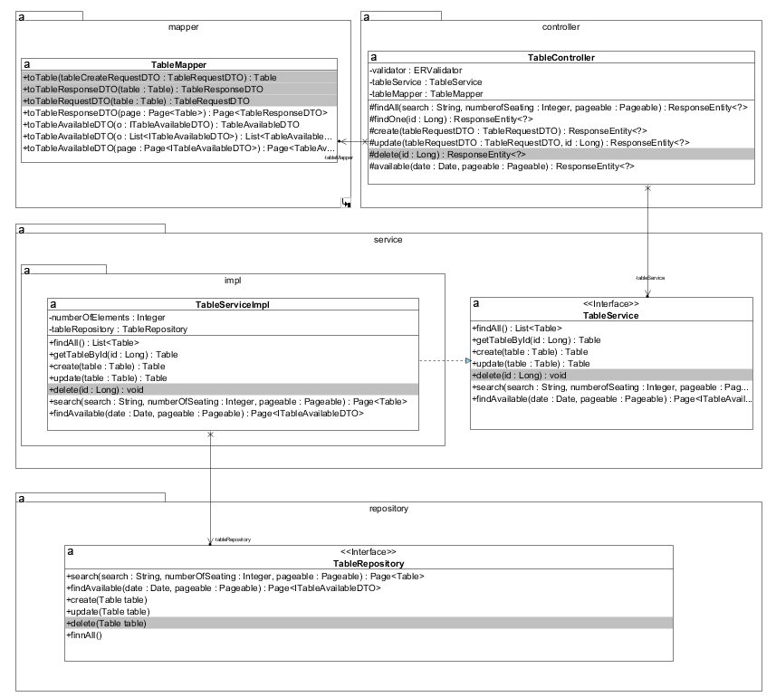

* + - * 1. *View table*



***Manage agent account***

*Add account*

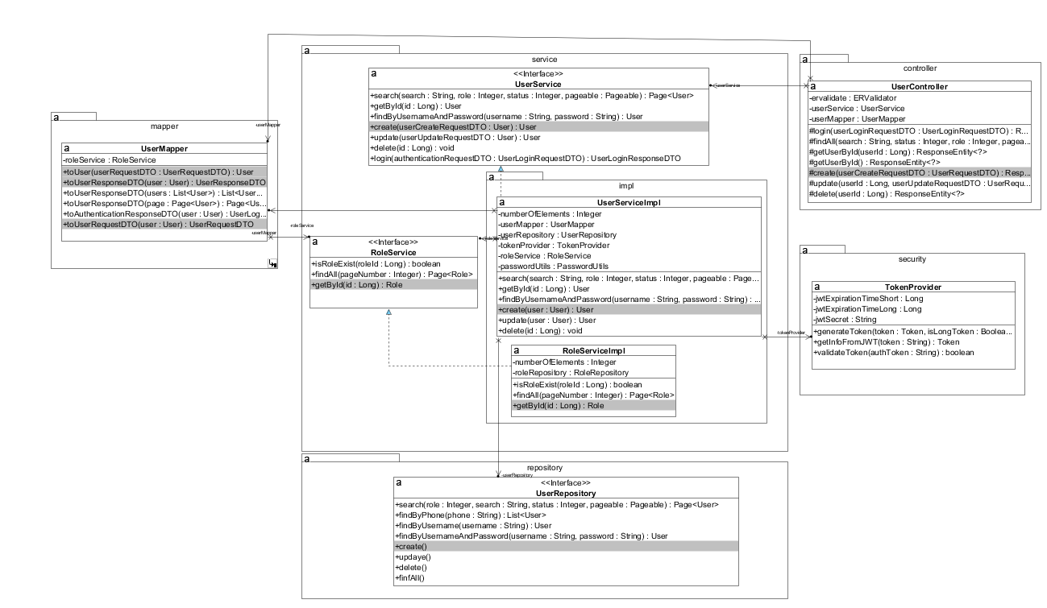

* + - * 1. *Edit account*

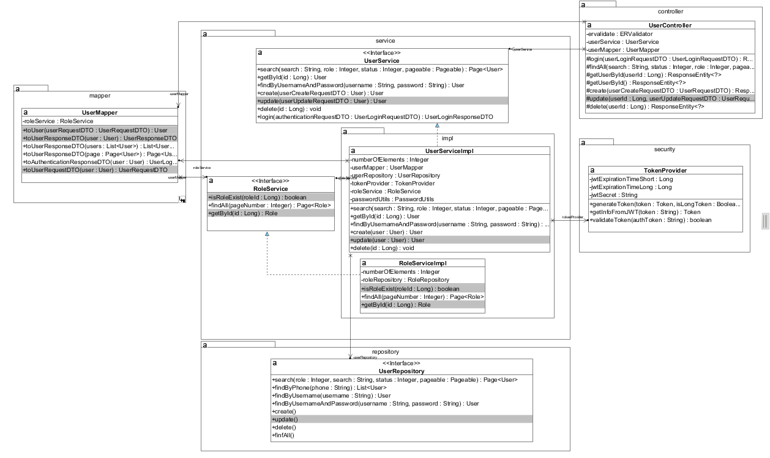

* + - * 1. *Delete account*

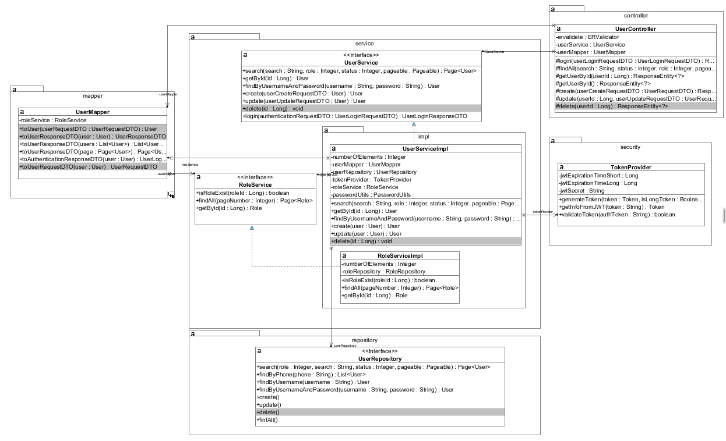

* + - * 1. *View account*

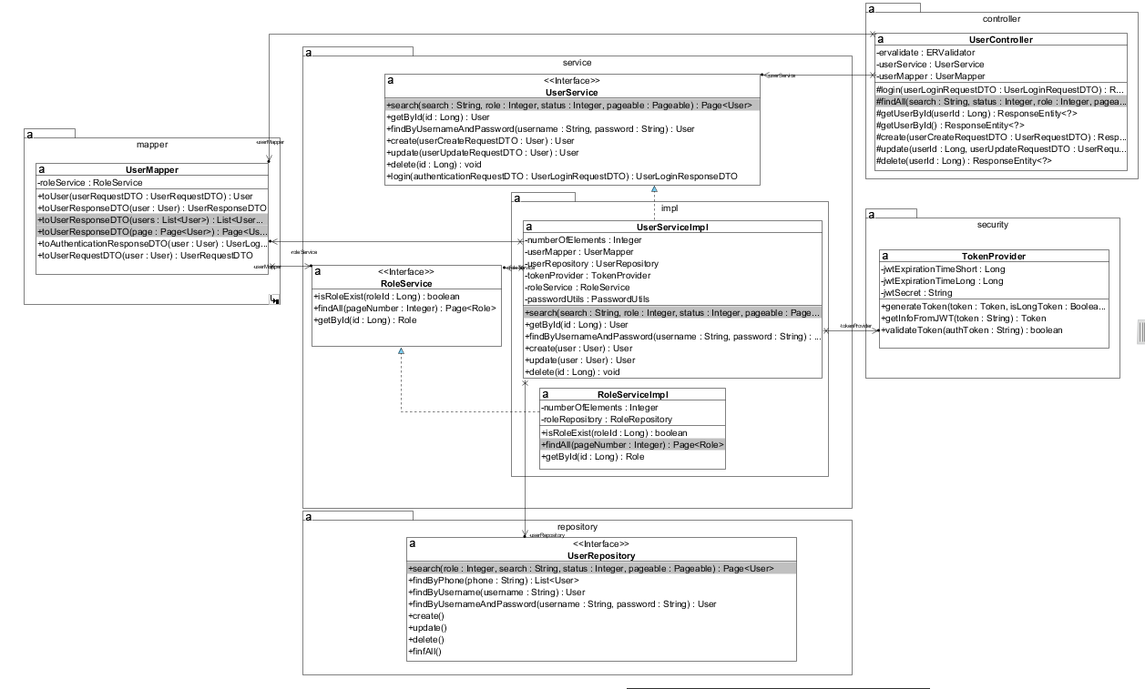

***View statistics***

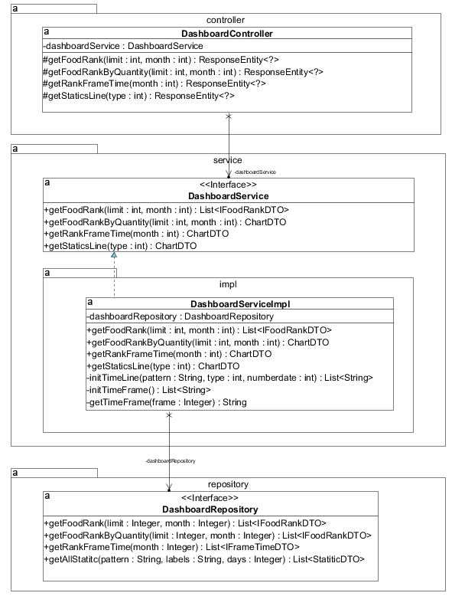

* 1. **Use Interface Design**

### Home page

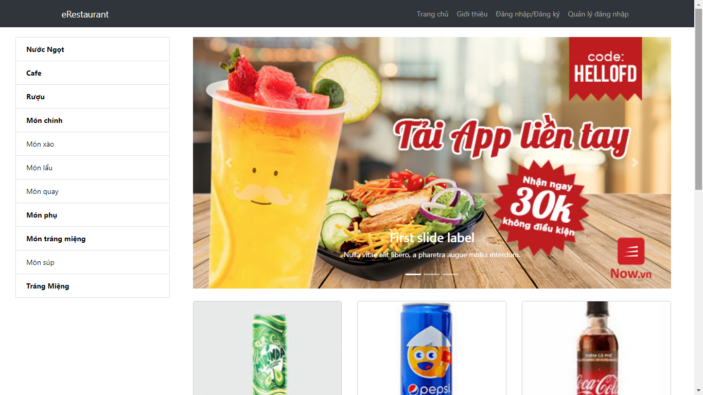

### Restaurant’s Info

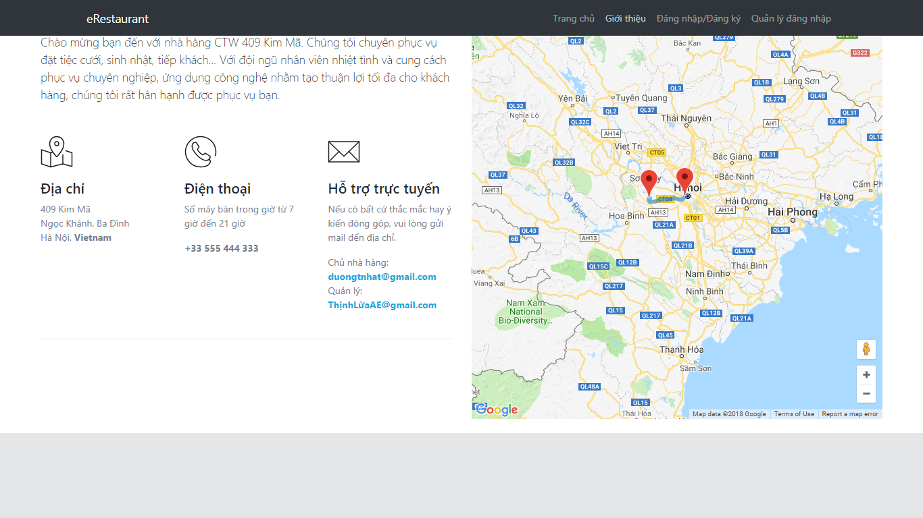

### Login(by staff)

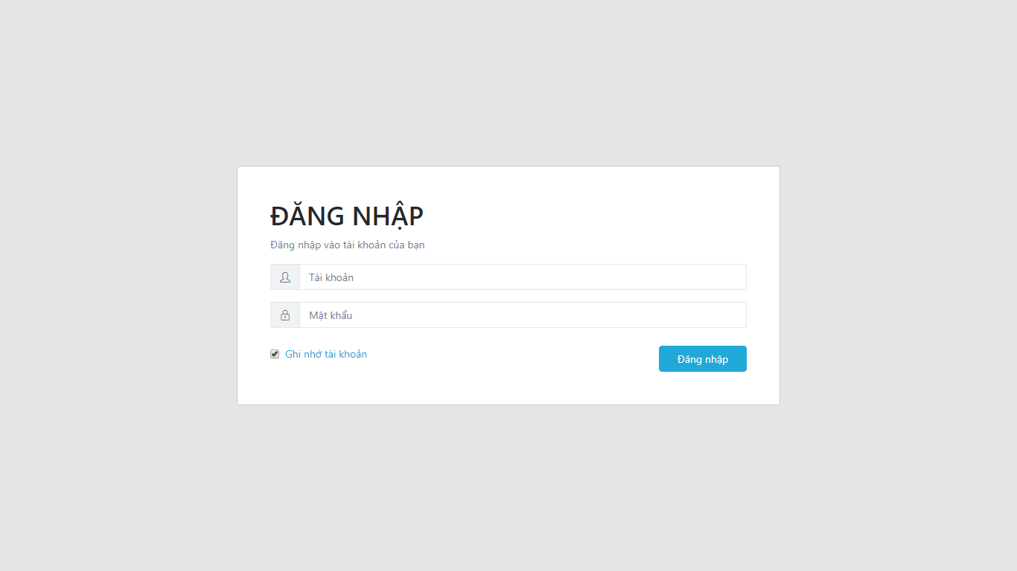

### Agent account management

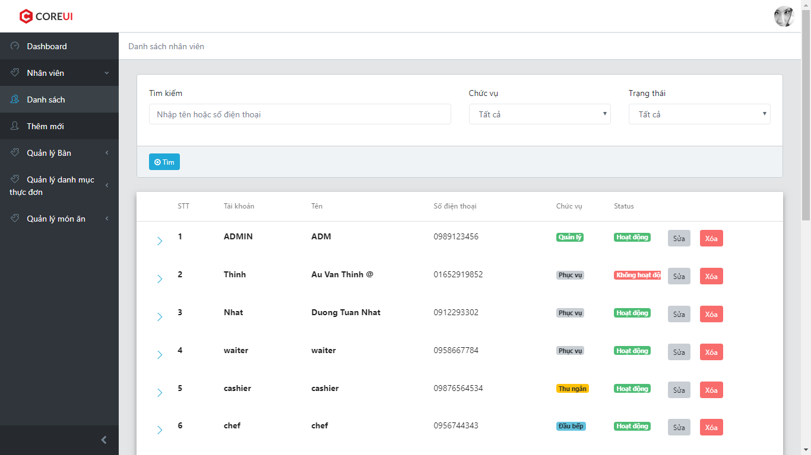

### Create/update agent account

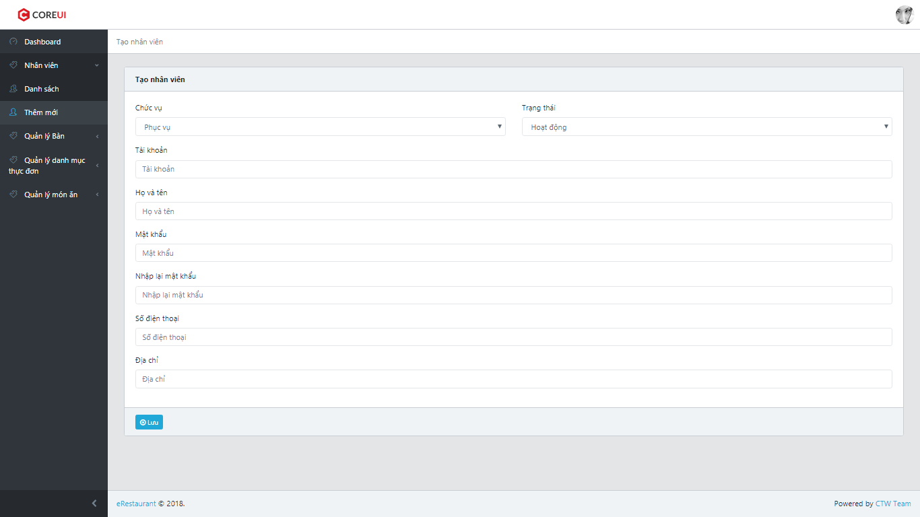

### Table management

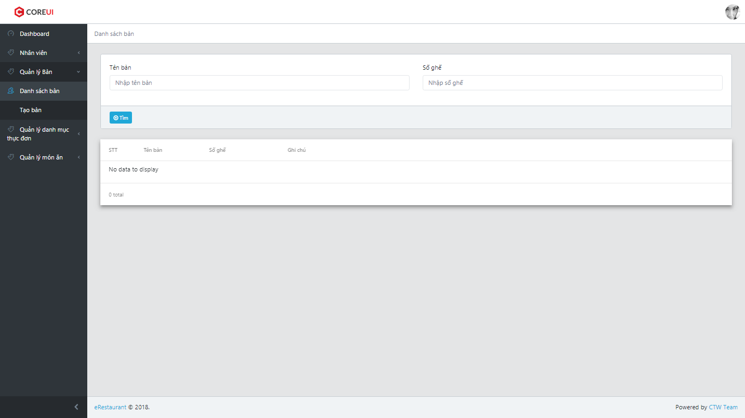

### Create/update table

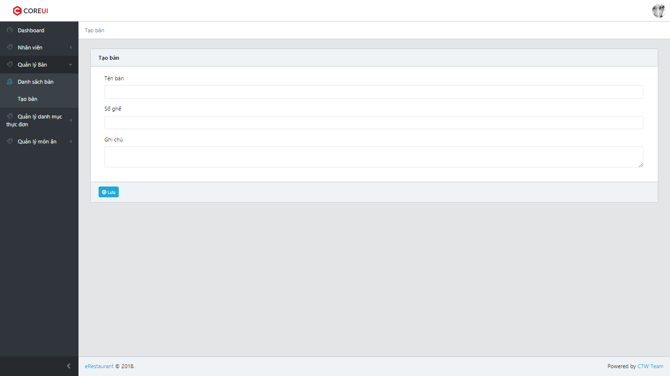

### Category management

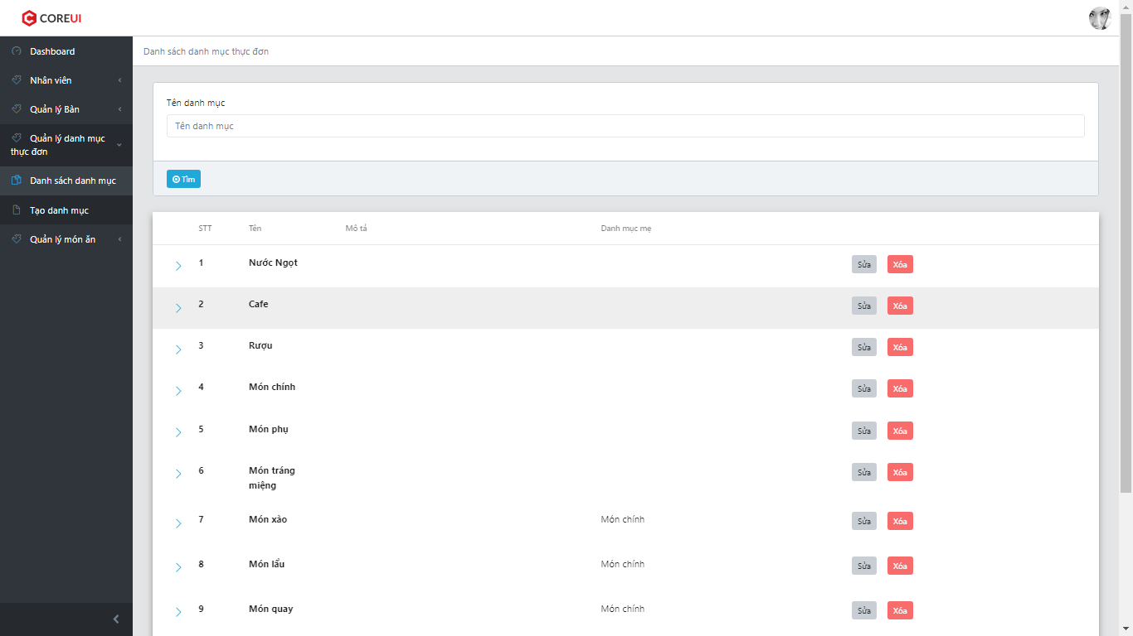

### Create/update category

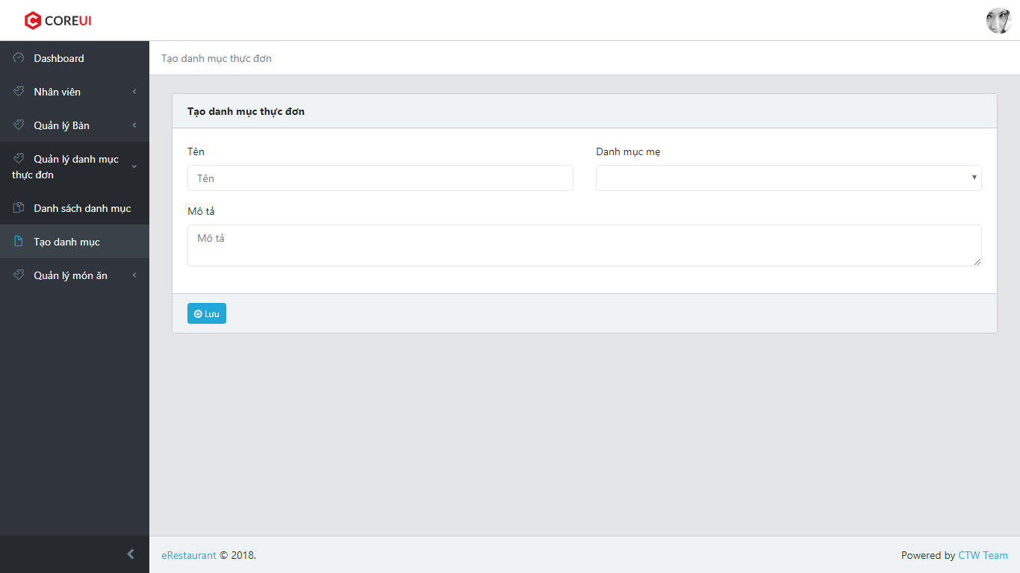

### Food management

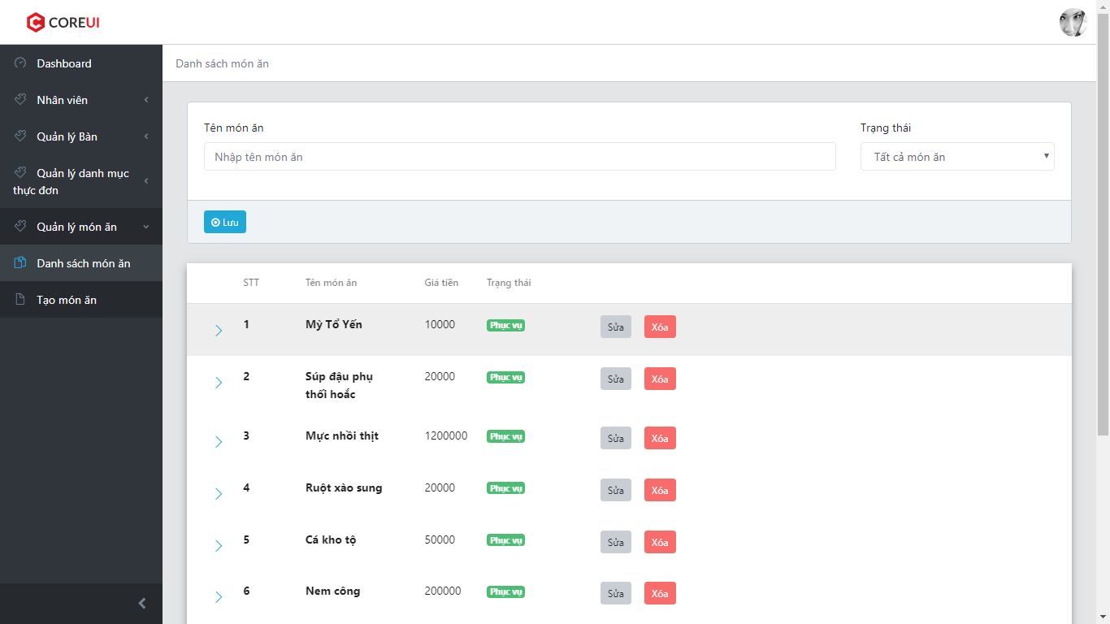

### Create/update food

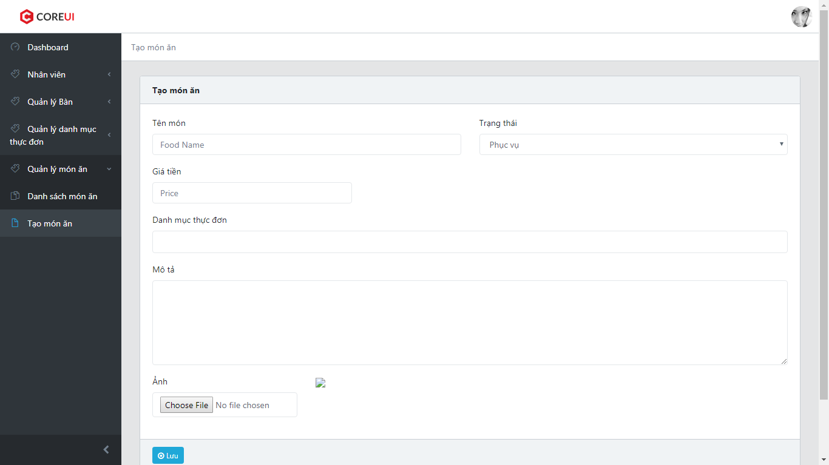

### Available table

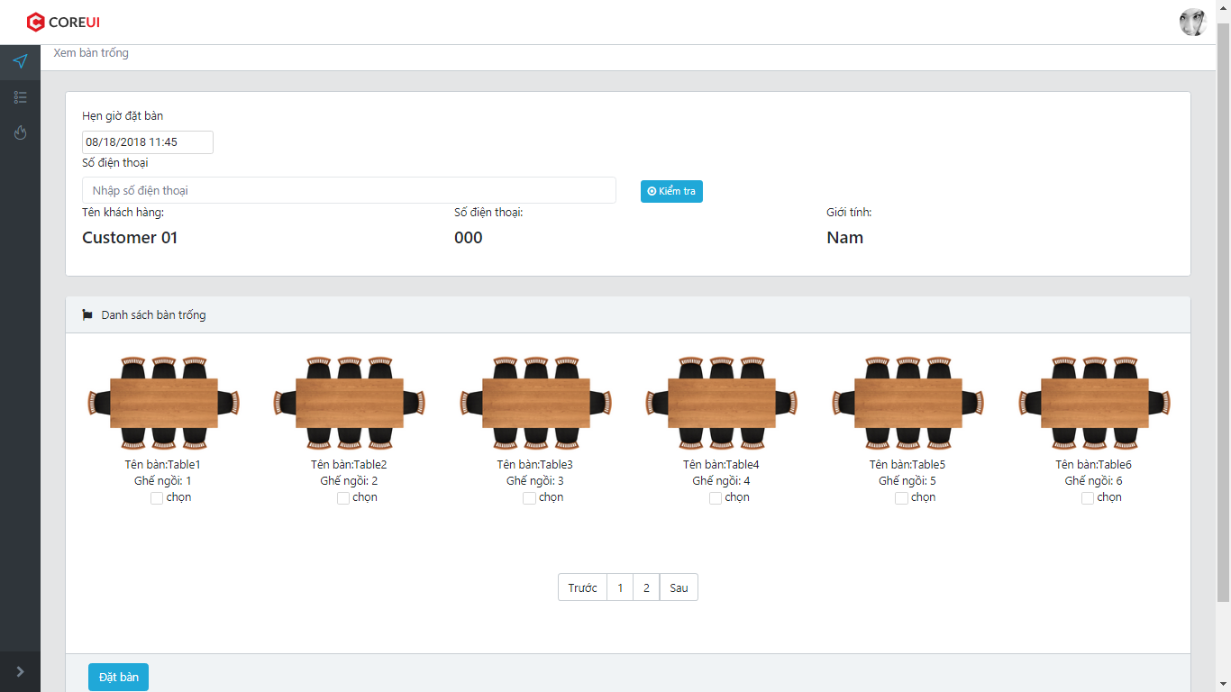

### Manage table booking

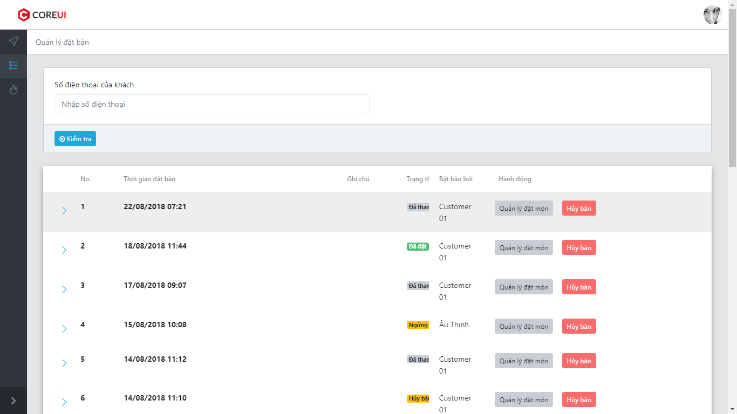

### Manage order

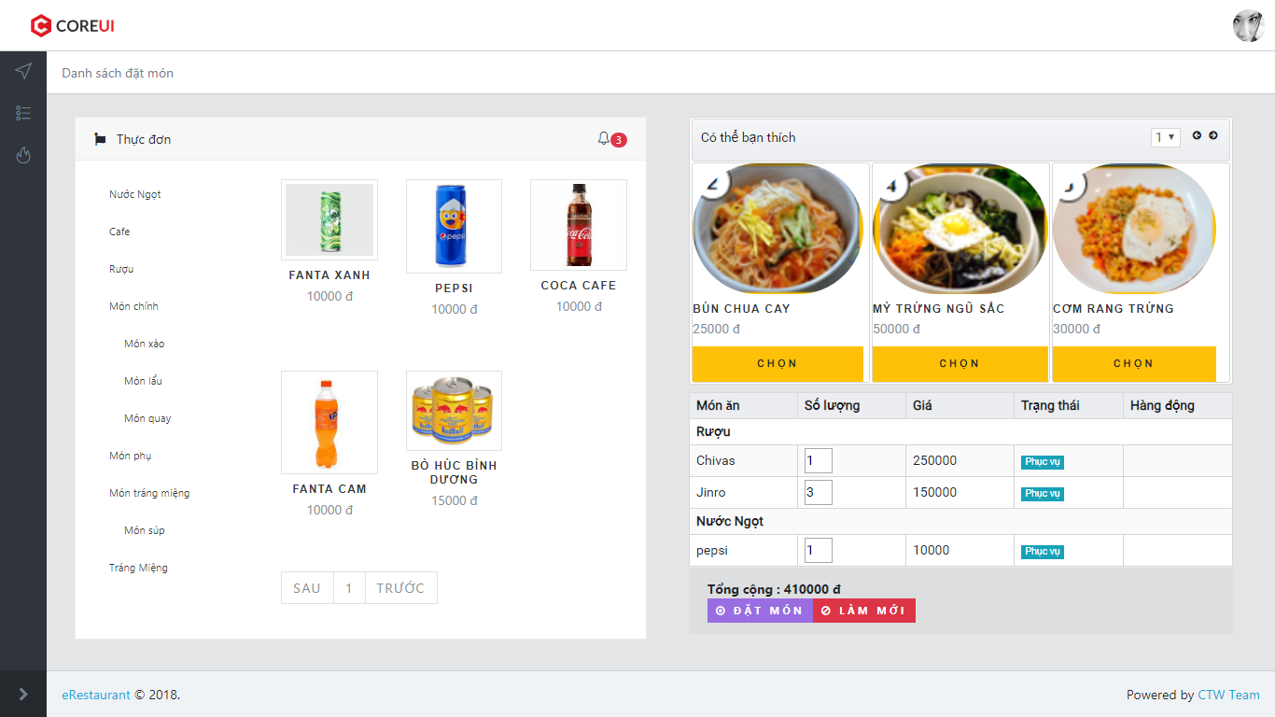

### Waiting foods to serve

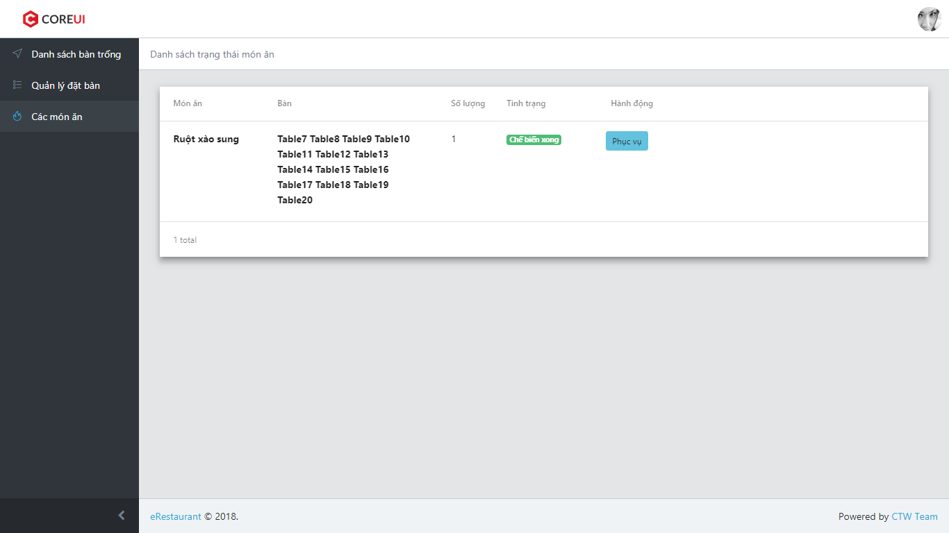

### Waiting foods to cook

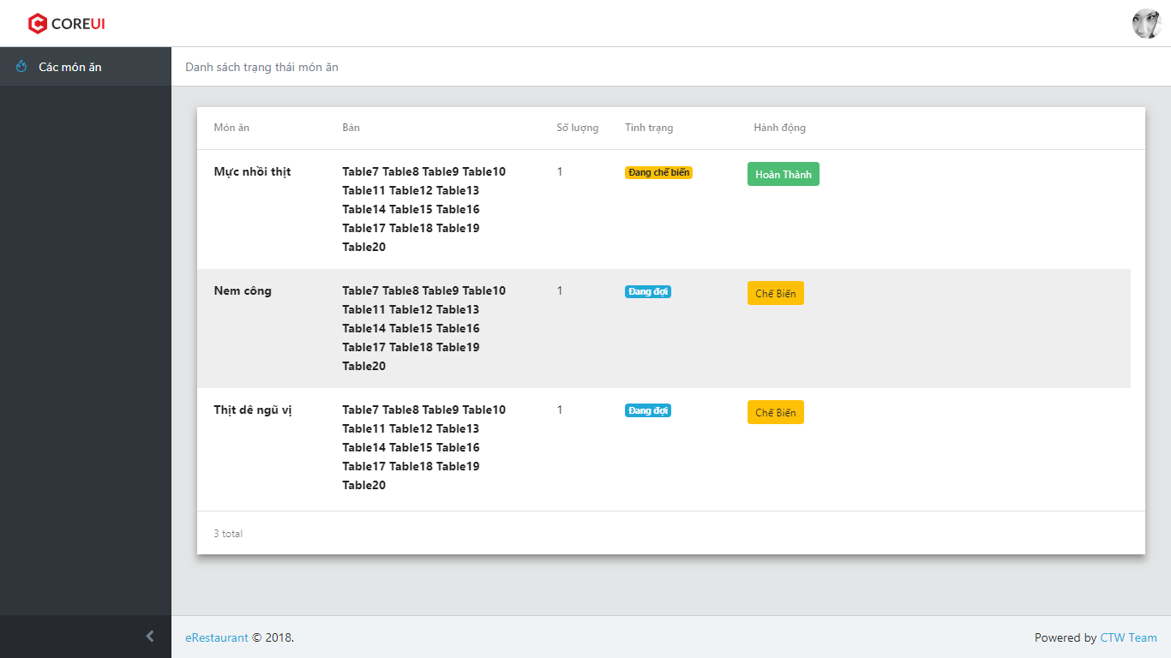

### List order

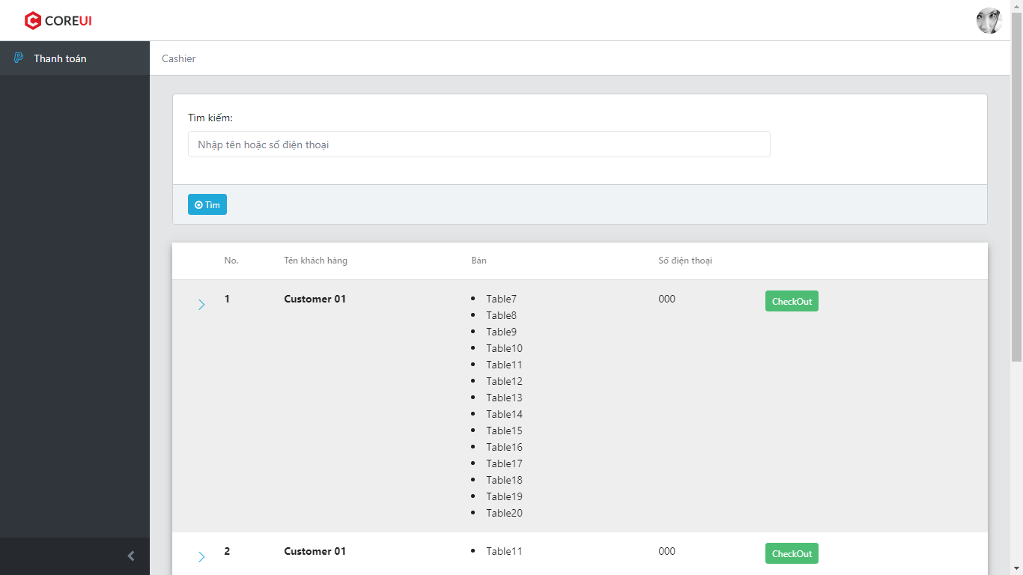

### Check out

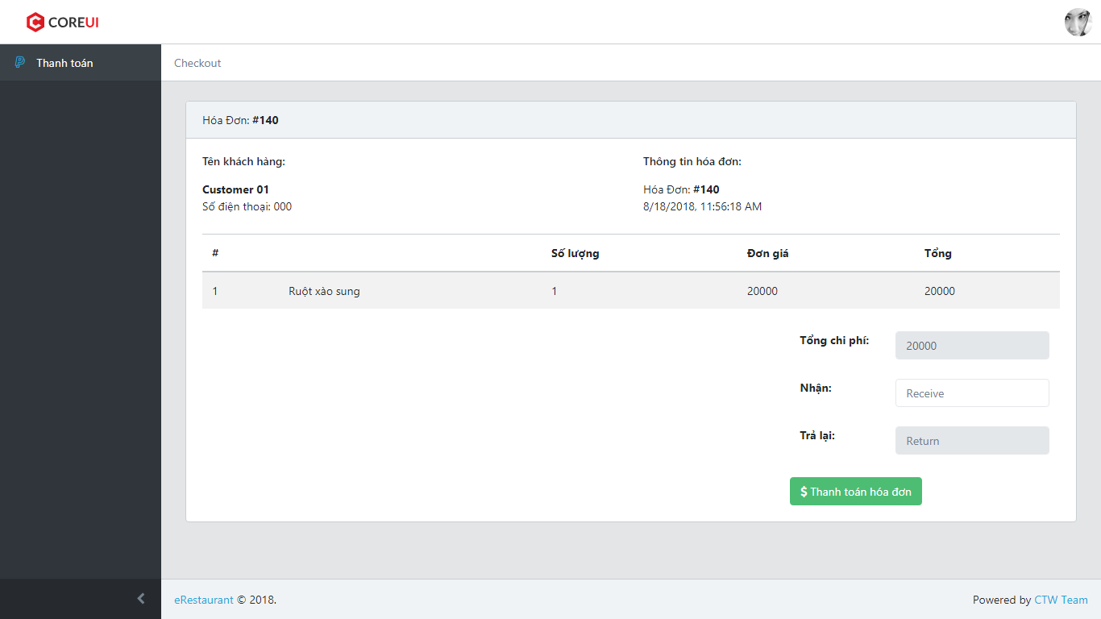

### View statistic

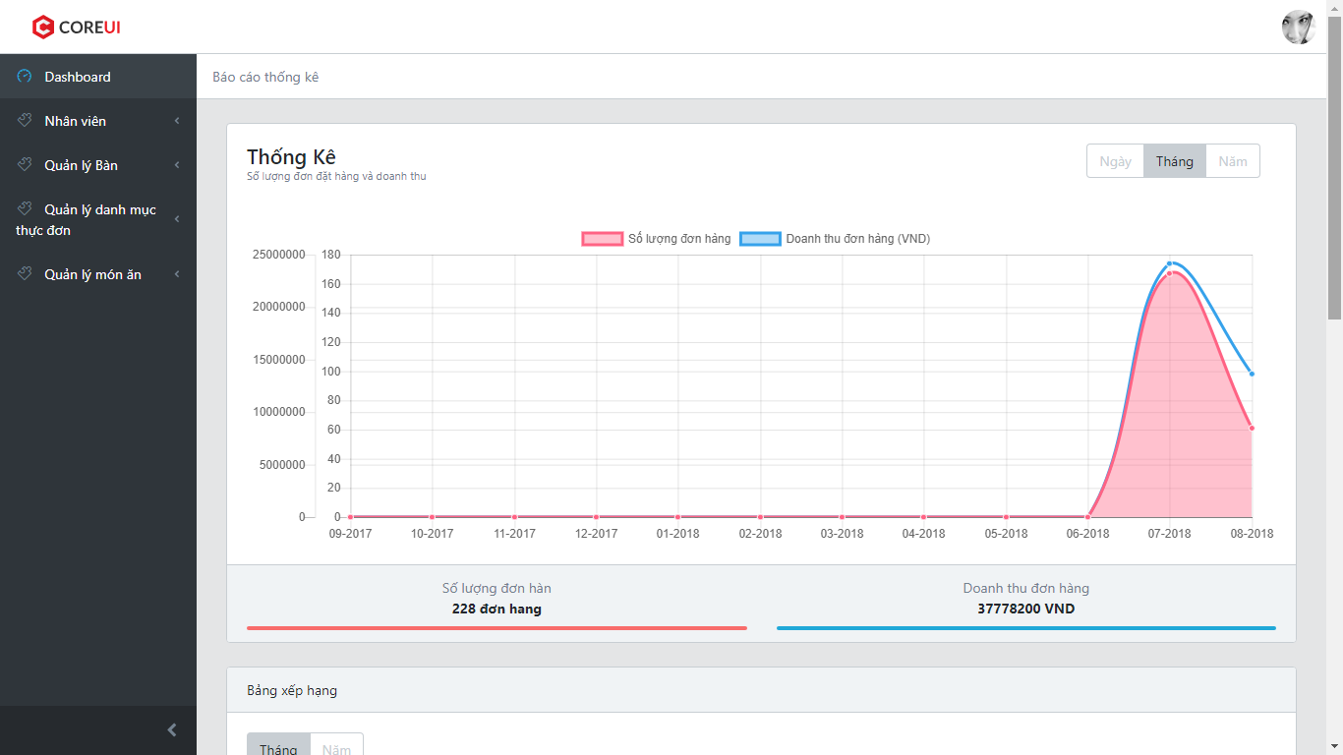

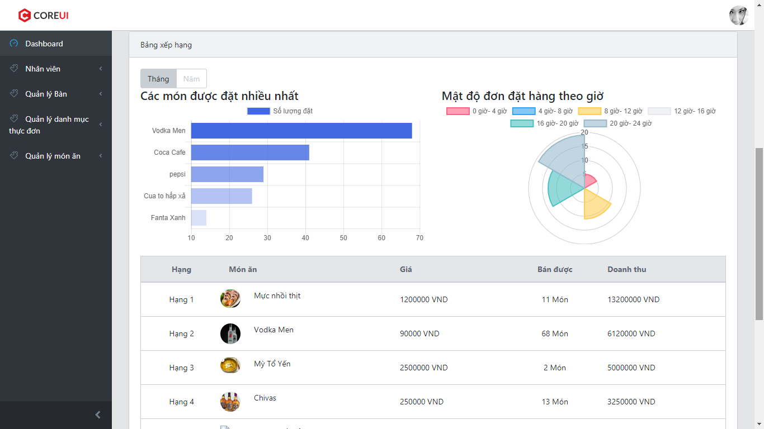

* 1. **Database Design**

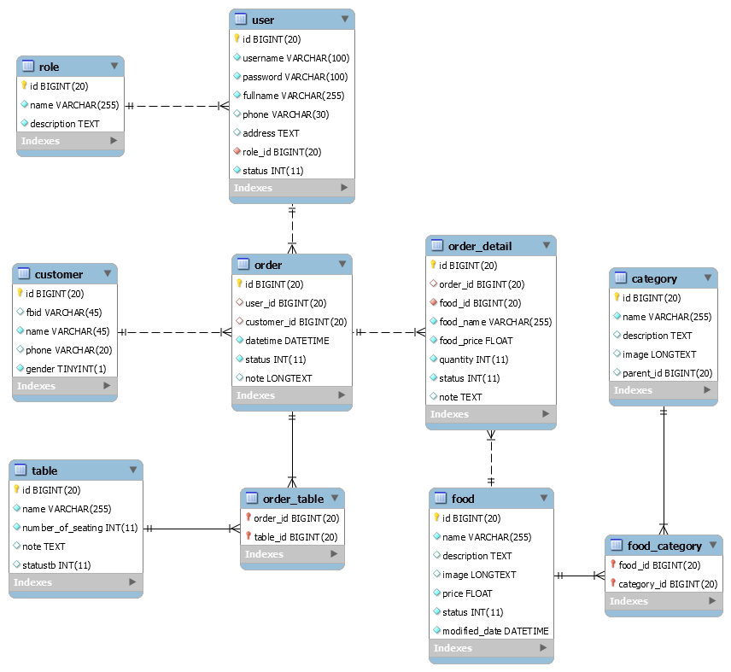

**Figure 30: Database Design**

### Role Table

|  |  |  |  |  |  |  |  |
| --- | --- | --- | --- | --- | --- | --- | --- |
| No. | Field Name | Type | Description | Not Null | Default | Primary Key | Foreign Key |
| 1 | id | BIGINT(20) |  | x |  | x |  |

### User table

|  |  |  |  |  |  |  |  |
| --- | --- | --- | --- | --- | --- | --- | --- |
| No. | Field Name | Type | Description | Not Null | Default | Primary Key | Foreign Key |
| 1 | id | BIGINT(20) |  | x |  | x |  |
| 2 | role\_id | BIGINT(20) |  | x |  |  | x |
| 3 | status | INT(11) |  | x | '1' |  |  |

### Food table

|  |  |  |  |  |  |  |  |
| --- | --- | --- | --- | --- | --- | --- | --- |
| No. | Field Name | Type | Description | Not Null | Default | Primary Key | Foreign Key |
| 1 | id | BIGINT(20) |  | x |  | x |  |
| 2 | price | FLOAT |  | x |  |  |  |
| 3 | status | INT(11) |  | x | '1' |  |  |
| 4 | modified\_date | DATETIME |  | x | CURRENT\_TIMESTAMP |  |  |

### Category table

|  |  |  |  |  |  |  |  |
| --- | --- | --- | --- | --- | --- | --- | --- |
| No. | Field Name | Type | Description | Not Null | Default | Primary Key | Foreign Key |
| 1 | id | BIGINT(20) |  | x |  | x |  |
| 2 | parent\_id | BIGINT(20) |  |  | NULL |  |  |

### Food Category table

|  |  |  |  |  |  |  |  |
| --- | --- | --- | --- | --- | --- | --- | --- |
| No. | Field Name | Type | Description | Not Null | Default | Primary Key | Foreign Key |
| 1 | food\_id | BIGINT(20) |  | x |  | x | x |
| 2 | category\_id | BIGINT(20) |  | x |  | x | x |

### Customer table

|  |  |  |  |  |  |  |  |
| --- | --- | --- | --- | --- | --- | --- | --- |
| No. | Field Name | Type | Description | Not Null | Default | Primary Key | Foreign Key |
| 1 | id | BIGINT(20) |  | x |  | x |  |
| 2 | gender | TINYINT(1) |  | x | '0' |  |  |

### “Table” table

|  |  |  |  |  |  |  |  |
| --- | --- | --- | --- | --- | --- | --- | --- |
| No. | Field Name | Type | Description | Not Null | Default | Primary Key | Foreign Key |
| 1 | id | BIGINT(20) |  | x |  | x |  |
| 2 | number\_of\_seating | INT(11) |  | x |  |  |  |
| 3 | statustb | INT(11) |  |  | '0' |  |  |

### Order\_table table

|  |  |  |  |  |  |  |  |
| --- | --- | --- | --- | --- | --- | --- | --- |
| No. | Field Name | Type | Description | Not Null | Default | Primary Key | Foreign Key |
| 1 | order\_id | BIGINT(20) |  | x |  | x | x |
| 2 | table\_id | BIGINT(20) |  | x |  | x | x |

### Order table

|  |  |  |  |  |  |  |  |
| --- | --- | --- | --- | --- | --- | --- | --- |
| No. | Field Name | Type | Description | Not Null | Default | Primary Key | Foreign Key |
| 1 | id | BIGINT(20) |  | x |  | x |  |
| 2 | user\_id | BIGINT(20) |  |  | NULL |  | x |
| 3 | customer\_id | BIGINT(20) |  |  | NULL |  | x |
| 4 | datetime | DATETIME |  | x | CURRENT\_TIMESTAMP |  |  |
| 5 | status | INT(11) |  | x | '0' |  |  |

### Order Detail table

|  |  |  |  |  |  |  |  |
| --- | --- | --- | --- | --- | --- | --- | --- |
| No. | Field Name | Type | Description | Not Null | Default | Primary Key | Foreign Key |
| 1 | id | BIGINT(20) |  | x |  | x |  |
| 2 | order\_id | BIGINT(20) |  |  | NULL |  | x |
| 3 | food\_id | BIGINT(20) |  | x |  |  | x |
| 4 | food\_price | FLOAT |  | x |  |  |  |
| 5 | quantity | INT(11) |  | x | '1' |  |  |
| 6 | status | INT(11) |  | x | '0' |  |  |

# SOFTWARE TESTING DOCUMENT

## Introduction

### Scope of testing

The primary purpose of this report is to detect software failures so that defects may be **discovered** and correct to ensure that our project is thoroughly tested and resulting in a successful **implementation of** a new social application we are developing. It contains the following sections:

* Scope of Testing.
* Testing Tool and Environment.
* Resources and responsibilities.
* strategy: Test approach, test stages.
* Test schedule.
* Feature to be tested.
* Feature not to be tested.
* Defect Log.
* Test report.

### Stages of testing

#### Stages of testing

There are 4 phases in Testing Process: Unit testing, Integration testing, System testing and Acceptance testing.

|  |  |  |  |
| --- | --- | --- | --- |
| ID | Test Stages | Description | Implementation |
| 1 | Unit testing | Unit testing will be done by the developer and approved by the development team leader. | Development team:  - Nguyen Anh Dung  - Duong Tuan Nhat  - Au Van Thinh  - Nguyen Minh Hieu |
| 2 | Integration testing | Integration testing will be performed by testers. Requirements of the system will be tested in functional flow. Starting after unit testing complete for each flow. Focuses on specific areas of uses case when all requirements are completed, integration test should be performed to ensure all components incorporate well. | All member |
| 3 | System testing | System Testing will be performed by the tester and development team leader with assistance from the individual developers as required. No specific test tools are available for this project. Programs will enter into System/Integration test after all critical defects have been corrected | All member |
| 4 | Acceptance testing | Acceptance testing consist of Alpha Test and Beta Test will be executed by all team members, stand at end user point of view. Determine whether a system satisfies the requirements specified in the requirements analysis phase. Finding defects is not the main focus in this stage. Acceptance testing will assess the system’s readiness for deployment and using. | All member |

#### Types of testing

The test team has to test the following type on Google Chrome.

* GUI test
* Function test
* Performance test
* Acceptance test

#### Range of testing

Team performs all functions defined in the SRS based on the approved version.

## Test Plan

### Testing tools and environment

#### Testing tools



Google Chrome v68.0: Used to test size of web page and size of component on page.

Mozilla Firefox v52.0: Used to test size of web page and size of component on page.

 Trello: Log bug (www.trello.com)

#### Testing environment

The contents of the Testing Environment are shown in the table below:

|  |  |
| --- | --- |
| Software | Hardware |
| Testing environment consists of:  Google Chrome v68.0.  Mozilla Firefox v52.0  Microsoft Office Excel  Microsoft Office Word | Personal computer for developing with the minimum  configuration:  Windows 10 Pro 64bit  Intel® CoreTM i5  Install memory (RAM): 4.00GB  View Sonic VX2263 Screen with resolution 1600x900 &  1366x768 |

### Resources and responsibilities

The contents of the Testing Environment are shown in the table below:

|  |  |  |
| --- | --- | --- |
| ID | Resources | Responsibilities |
| 1 | Project Manager | Responsible for Project Schedules and overall success of the project.  Review Test-case and report. |
| 2 | Tester | Preforming the actual system testing.  Manage test resource and assign test tasks.  Create Test Plan.  Create Test Cases.  Create Test Report.  Execute Test.  Test Log report. |
| 3 | Developer | Create Unit Test.  Fix bugs. |

### Test strategy

#### Test Model

This project follows V-Model process to implement testing. The V model takes the bottom half of the waterfall model and bends it upward into the form of a V, so that the activities on the right verify or validate the work products of the activity on the left. Below figure demonstrates the relationships between each phase of the development life cycle and its associated phase of testing.

More specifically, the left side of the V represents the analysis activities that decompose the users’ needs into small, manageable pieces, while the right side of the V shows the corresponding synthesis activities that aggregate (and test) these pieces into a system that need system that meets the users’ needs.

The V-Model demonstrates the relationships between each phase of the development life cycle and its associated phase of testing. The horizontal and vertical axes represent time or project completeness (left-to-right) and level of abstraction. Advances in the production of executable requirements, architectures, and designs enable testing to begin much earlier on the left side of the V so that requirements, architecture, and design defects can be found and fixed early before they can spread into downstream work products.

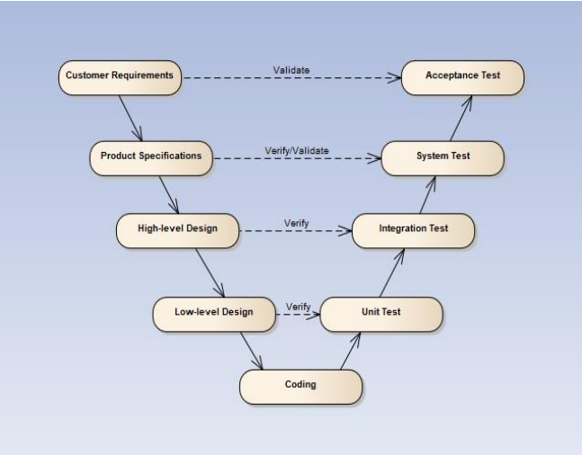

#### Test Type

Testing eRestaurant Project will be carry out in each release package as defined in project plan and depends on internal delivery by development side. Critical test will be defined as any new or modified test for the eRestaurant system. Project Manager will decide which closed defects which the test team cannot determine.

The different types of testing that will be carry out this project are.

* **Function Test:**

- Testing of all implemented functions on the eRestaurant system.

- The testing that will be covered for those functions in function test is verification the validation of the behavior according to requirements.

- Test cases will have to be designed to cover all the above and executed.

- Implemented function’s error message will be included under this test.

* **Gui Test:**

Graphical User Interface (GUI) Testing verifies a user’s interaction with the software. The goal of GUI testing is to ensure that the GUI provides the user with the appropriate access and navigation through the functions of the target-of-test.

In addition, GUI testing ensures that the objects within the GUI function as expected and conform to requirement.

- GUI test will be performed fully on 1600x900 & 1366x768 screen resolution.

- This test is targeted to cover the verification of the overall look and feel of the eRestaurant system including initial position, font, text size, color, focus, initial button, tab order, label, screen sizes and sentences width.

- Check all the GUI elements for size, position, width, length and acceptance of characters or numbers. For instance, it must be able to provide inputs to the input fields.

* + Check if Error Messages are displayed correctly.
  + Check if font used in application is readable.
  + Check if the alignment of the text is proper.
  + Check if the color of the font and warning messages is clear and not confusing.
  + Check if the images have good clarity.
  + Check if the images are properly aligned.
  + Check the positioning of GUI elements for HD screen resolution.
* **Acceptance test:**

The testing is a test conducted to determine if the requirements of a specification are met.

- It involves alpha testing and beta testing. Alpha testing takes place at developers' environments, and involves testing of the operational system by internal member, before it is released to external users. Beta testing takes place at user’s environments, and involves testing by a group of users who use the system at their locations and provide feedback, before the system is released to all users.

#### Test Stage

Table below are the stages in which common test are executed:

|  |  |  |  |
| --- | --- | --- | --- |
| Type of Tests | Stage of Test | | |
| Unit | Integration | System |
| Function Tests | √ | √ | √ |
| GUI Tests |  | √ | √ |
| Acceptance Tests |  |  | √ |

#### Test Schedule

|  |  |  |
| --- | --- | --- |
| Test Schedule | Start Date | End Date |
| Iteration 1: Main features | 18/06/2018 | 15/07/2018 |
| Unit Testing | 18/06/2018 | 05/07/2018 |
| Functional Testing | 05/07/2018 | 15/07/2018 |
| Iteration 2: Other features | 31/07/2018 | 18/08/2018 |
| Unit Testing | 31/07/2018 | 10/08/2018 |
| Functional Testing | 10/08/2018 | 15/08/2018 |
| Acceptance testing | 15/08/2018 | 18/08/2018 |

#### Deliverables

|  |  |  |
| --- | --- | --- |
| Deliverables | Responsibilities | Completion date |
| Test Plan | Tester | 15/06/2018 |
| Test Cases | Tester | 15/08/2018 |
| Test case review | Tester + PM | 16/08/2018 |
| Test Data (Data Set) | Tester | 17/08/2018 |
| Defect report | All members | 18/08/2018 |
| Final test Summary report | PM | 18/08/2018 |

### Feature to be tested

All features represented by use cases will be tested.

### Feature not to be tested

Out of scope features will not to be tested.

## Test Approach

### Unit Test

Unit testing will be done by the developer and approved by the development team leader. eRestaurant uses Junit and Springtest to execute unit test.

eRestaurant embrace this feature in order to gain the following advantages:

* High frequency of automation test
* Reduce the level of bugs in production code
* Save development time
* Easier to change and refactor code
* Improve the design of code especially with Test-Driven Development

The greatest thing is every time you change a block of code, you can always re-run all the test functions to make sure everything is still ok. This would take huge effort if you do it manually.

**Run Unit Test**

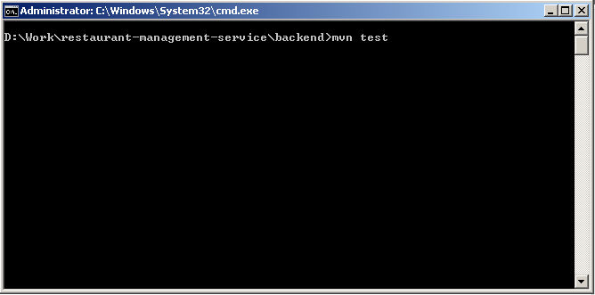

Integration and System Test

****

****

****

****

****

### Acceptance Test

* Acceptance Testing is a level of the software testing process where a system is tested for acceptability. The purpose of this test is to evaluate the system’s compliance with the business requirements and assess whether it is acceptable for delivery.
* Our project will use the Check Lists as a substitute for Acceptance testing.
* The contents of the Checklist be shown in the table below.

|  |  |  |  |
| --- | --- | --- | --- |
| **ID** | **Checklists** | **Yes** | **No** |
| **General** | | | |
| CL-01 | Text on all pages for spelling and grammatical errors. | √ |  |
| CL-02 | Functionality of buttons available on all pages. | √ |  |
| CL-03 | All mandatory fields are validated and indicated by asterisk symbol. | √ |  |
| CL-04 | All error messages are displayed in same CSS style, using red color. | √ |  |
| CL-05 | Delete functionality for any record on page are asked for confirmation. | √ |  |
| CL-06 | All numeric values are formatted properly. | √ |  |
| **GUI and Usability** | | | |
| CL-07 | Screens are designed follow project standards. | √ |  |
| CL-08 | The screen well organized and easy to use. | √ |  |
| CL-09 | All fields on page (e.g. text box, radio options, dropdown lists) should be aligned properly. | √ |  |
| CL-10 | The most important fields are located where they are easy to see. | √ |  |
| CL-11 | Information is presented in the order that the user needs it. | √ |  |
| CL-12 | The static text is clear, concise, and meaningful. | √ |  |
| CL-13 | All static text words are spelled out (correctly!) and abbreviations used only when space is limited. | √ |  |
| CL-14 | All icons and elements are flat | √ |  |
| CL-15 | Pop-up menus are provided for the user to access information about an object's properties or perform specific tasks on the object. | √ |  |
| CL-16 | Command buttons are used to trigger application processes. | √ |  |
| CL-17 | Checkboxes are used to show independent on/off choices. Can tick on more different answer. | √ |  |
| CL-18 | Radio buttons are used to show sets of two or more mutually exclusive choices. Only allow tick on 1 answer. | √ |  |
| CL-19 | System display notification message when meet trouble, error. | √ |  |
| **Window Components** | | | |
| CL-20 | The correct primary window type is used. | √ |  |
| CL-21 | The correct dialog box type is used. | √ |  |
| CL-22 | Available cancel button functionality for dialog box. | √ |  |
| **Database** | | | |
| CL-23 | Correct data is getting saved in database upon successful page submit. | √ |  |
| CL-24 | Values columns are not accepting null values. | √ |  |
| CL-25 | Radio button options are saved correctly in database. | √ |  |
| CL-26 | Database fields are designed with correct data type and data length. | √ |  |
| CL-27 | Null values are not allowed for Primary key column. | √ |  |
| **Security** | | | |
| CL-28 | Password information should be stored in encrypted format only. | √ |  |

### Defect Log

* eRestaurant project uses www.trello.com to manager bug list.
* Every member of eRestaurant project creates an account in www.trello.com to get bug and fix bug.
* Processes:
* Testers log bug to trello.com under Bugs list and assign developer who’s in charge of the functions that have bugs.
* Developers fix bug and move bug to Fixed bug list and assign tester who logs the bug.
* Tester checks the bug again:
  + If bug fixed, Tester checks the test case and change percent of completeness to 100% and close bug.
  + If bugs are not fixed, Tester move bug back to Bugs list and assign developer again

## Test Report

### Bug list report

|  |  |  |  |  |  |  |  |
| --- | --- | --- | --- | --- | --- | --- | --- |
| Bug ID | TestCase | Log Date | Decription | Owner | Assignee | Status | Retest date |
| 1 | TC.03.01 | 7/24/2018 | whenDeleteCategory\_thenReturnSuccess: status expected 200- but was 400 | Duong Nhat | Au Thinh | Done | 8/12/2018 |
| 2 | TC.02.01 | 7/24/2018 | whenUpdateCategoryNotFound\_thenReturnError: status expected 404- but was 200 | Duong Nhat | Au Thinh | Done | 7/24/2018 |
| 3 | TC.01.03 | 7/24/2018 | whenAddCategoryWithParentIsChild\_thenReturnError: status expected 404- but was 200 | Duong Nhat | Au Thinh | Done | 8/12/2018 |
| 4 | TC.08.02 | 7/24/2018 | whenGetFoodByName\_thenReturnArray status expected Array has content "test" but was has not | Duong Nhat | Duong Nhat | Done | 7/24/2018 |
| 5 | TC.07.01 | 7/24/2018 | henDelete\_thenReturnSuccess: status expected 200 but was 400 | Duong Nhat | Duong Nhat | Done | 7/24/2018 |
| 6 | TC.09.01 | 7/24/2018 | whenCreateWithoutName\_thenReturn404 status expected 404 but was 200 | Duong Nhat | Minh Hieu | Done | 7/24/2018 |
| 7 | TC.09.03 | 7/24/2018 | whenCreateWithNumberOfSeatIsNegative\_thenReturn404 status expected 404 but was 200 | Duong Nhat | Duong Nhat | Done | 7/24/2018 |
| 8 | TC.13.01 | 7/24/2018 | whenUpdateWithIDNotExist\_thenReturnNotFoundId status expected 404 but was 200 | Au Thinh | Minh Hieu | Done | 7/24/2018 |
| 9 | TC.19.01 | 7/24/2018 | whenAvailabeBookOneTable\_thenReturnArrayJson status expected 400 but was 200 | Au Thinh | Minh Hieu Anh Dung | Done | 7/24/2018 |
| 10 | TC.15.01 | 7/24/2018 | whenFindAll\_thenReturnArrayJson status expected 200 but was 400 | Au Thinh | Anh Dung | Done | 7/24/2018 |
| 11 | TC.02.01 | 7/24/2018 | whenUpdateWithIDNotExist\_thenReturnNotFoundId status expected 404 but was 405 | Au Thinh | Au Thinh | Done | 7/24/2018 |
| 12 | TC.01.01 | 7/24/2018 | whenCreate\_thenReturnBadRequest status expected status expected 400 but was 404 | Au Thinh | Au Thinh | Done | 7/24/2018 |
| 13 | TC.18.02 | 8/8/2018 | fix bug thiếu bàn khi đặt hàng - màng hình quản lý book | Au Thinh | Minh Hieu | Done | 8/17/2018 |
| 14 | TC.13.02 | 8/8/2018 | fix bug trong user unit test | Au Thinh | Anh Dung | Done | 8/17/2018 |
| 15 | TC.16.01 | 8/8/2018 | fix bug hiện 2 sản phẩm giống nhau trong menu | Au Thinh | Duong Nhat | Done | 8/13/2018 |
| 16 | TC.25.02 | 8/8/2018 | fix bug không chọn đặt bàn vẫn đặt được món | Au Thinh | Minh Hieu | Done | 8/17/2018 |
| 17 | TC.26.06 | 8/12/2018 | lỗi phân trang màn hình manager order | Au Thinh | Minh Hieu | Done | 8/17/2018 |
| 18 | TC.20.12 | 8/12/2018 | lỗi manager order. khi order 3 sản phẩm báo thành công nhưng reload thì chỉ còn 1 sản phẩm | Au Thinh | Minh Hieu Anh Dung | Done | 8/17/2018 |
| 19 | TC.16.02 | 8/12/2018 | homepage bị mất thanh topbar khi co nhỏ màn hình | Au Thinh | Minh Hieu | Done | 8/15/2018 |
| 20 | TC.26.01 | 8/14/2018 | realtime: khi đặt bột bàn mới từ màn hình khác thì màn hình quản lý đặt bàn chưa reload | Au Thinh | Minh Hieu Anh Dung | Done | 8/14/2018 |
| 21 | TC.01.01 | 8/14/2018 | manage category: không lưu được category khi tạo mới hoặc edit | Au Thinh | Au Thinh | Done | 8/14/2018 |
| 22 | TC.26.01 | 8/14/2018 | Realtime: bật 2 màn hình manager order với order id giống nhau: khi pick món manager order rồi summit. màn hình thứ 2 không reload | Au Thinh | Minh Hieu Anh Dung | Done | 8/14/2018 |
| 23 | TC.21.04 | 8/14/2018 | Realtime: bật màn hình chef, manager order với order id giống nhau: khi đổi trạng thái món ăn in chef, màn hình manager order ko reload | Au Thinh | Minh Hieu Anh Dung Duong Nhat | Done | 8/14/2018 |
| 24 | TC.05.01 | 8/14/2018 | Manage Food: không lưu đc food khi tạo mới hoặc edit | Au Thinh | Duong Nhat | Done | 8/15/2018 |
| 25 | TC.24.01 | 8/14/2018 | Manage Table: danh sách bàn ko hiển thị | Au Thinh | Minh Hieu | Done | 8/15/2018 |
| 26 | TC.21.04 | 8/14/2018 | realtime: ko pick món nào rồi ấn submit (manager order) vẫn hiện thông báo có món cần nấu ở màn hình chef | Au Thinh | Minh Hieu Anh Dung | Done | 8/14/2018 |
| 27 | TC.13.01 | 8/14/2018 | Manage Agent Account: không lưu đc nhân viên khi tạo mới hoặc sửa | Au Thinh | Anh Dung | Done | 8/14/2018 |
| 28 | TC.22.04 | 8/14/2018 | Realtime: màn hình cashier, manager booking: khi checkout 1 order màn hình manager booking không reload status | Au Thinh | Anh Dung | Done | 8/14/2018 |
| 29 | TC.22.04 | 8/14/2018 | Realtime: màn hình cashier, manager booking: khi hủy một order (manager book), màn hình cashier ko reload | Au Thinh | Anh Dung | Done | 8/14/2018 |
| 30 | TC.24.01 | 8/16/2018 | fix available table (khong hien thi table vs status = 2) | Au Thinh | Minh Hieu | Done | 8/17/2018 |
| 31 | TC.20.07 | 8/16/2018 | fix bug không tương thich event ở các browser khác nhau | Au Thinh | Minh Hieu | Done | 8/17/2018 |
| 32 | TC.13.03 | 8/20/2018 | Repassword không giống password vẫn update đc | Duong Nhat | Minh Hieu Anh Dung | Done | 8/22/2018 |
| 33 | TC.13.03 | 8/21/2018 | Màng hình quản lý nhân viên: ko cần pass vẫn tạo được account | Duong Nhat | Minh Hieu | Done | 8/23/2018 |

### Iteration 1

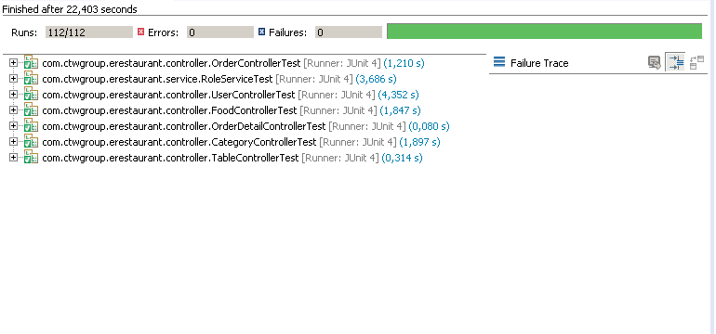

### Iteration 2

|  |  |  |  |  |  |  |
| --- | --- | --- | --- | --- | --- | --- |
| No | Module Code | Pass | Fail | Untested | N/A | Number of testcase |
| 1 | Admin | 40 | 0 | 0 | 0 | 40 |
| 2 | Guest | 4 | 0 | 0 | 0 | 4 |
| 3 | Customer | 24 | 0 | 0 | 0 | 24 |
| 4 | Chef | 4 | 0 | 0 | 0 | 4 |
| 5 | Cashier | 8 | 0 | 0 | 0 | 8 |
| 6 | Waiter | 26 | 0 | 0 | 0 | 26 |
| 7 | Authen | 25 | 0 | 0 | 0 | 25 |
|  | Total | 131 | 0 | 0 | 0 | 131 |
|  |  |  |  |  |  |  |
|  | Test Coverage | 100.00% |  |  |  |  |
|  | Test Success Coverage | 100.00% |  |  |  |  |

# SOFTWARE USER’S MANUAL

## User Guidelines

### HomePage

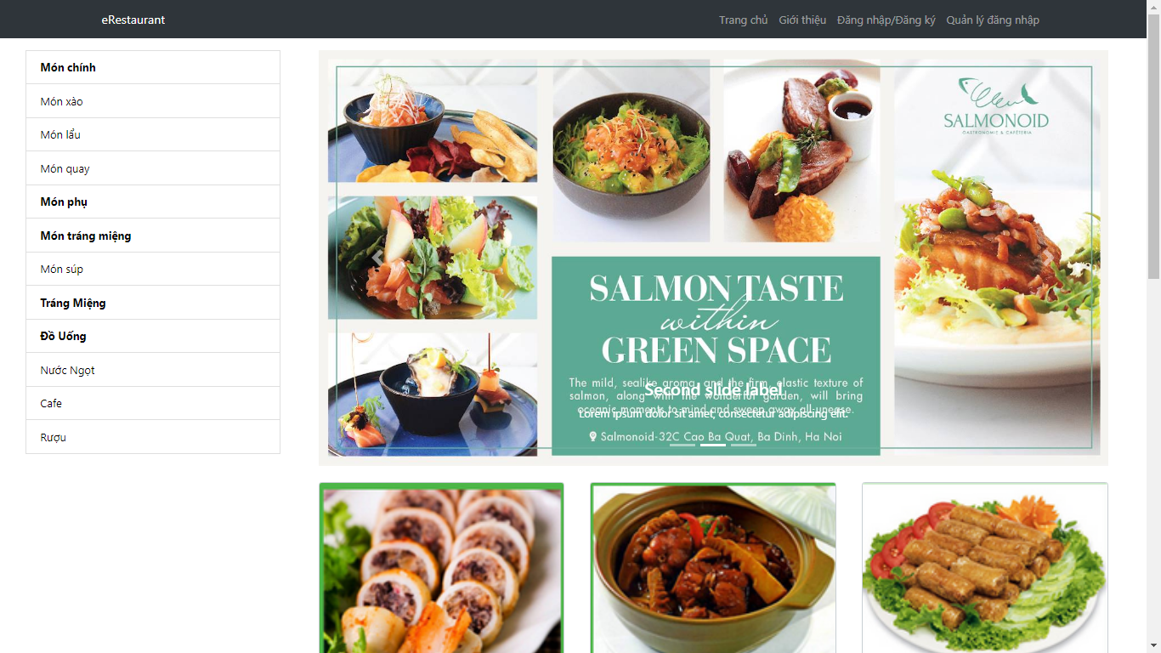

### Information page

1. In HomPage click on “Giới thiệu” button

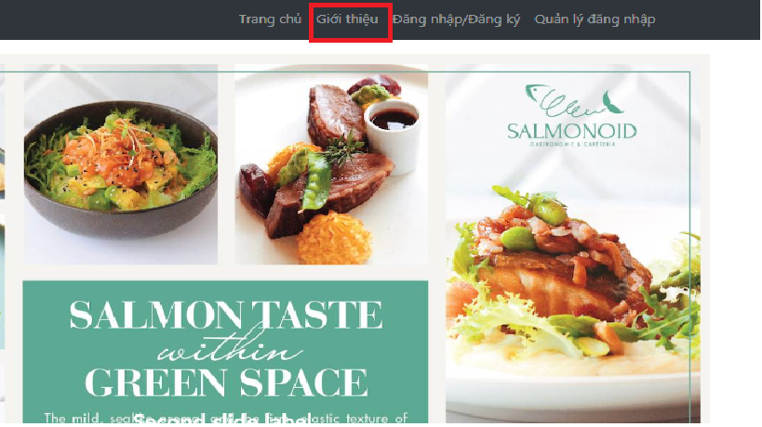

1. ER System displays Infomation page

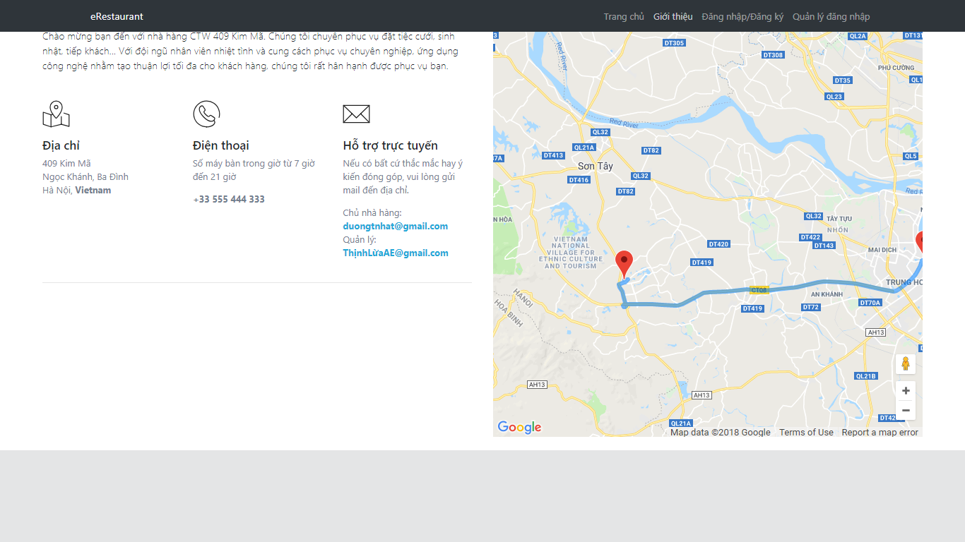

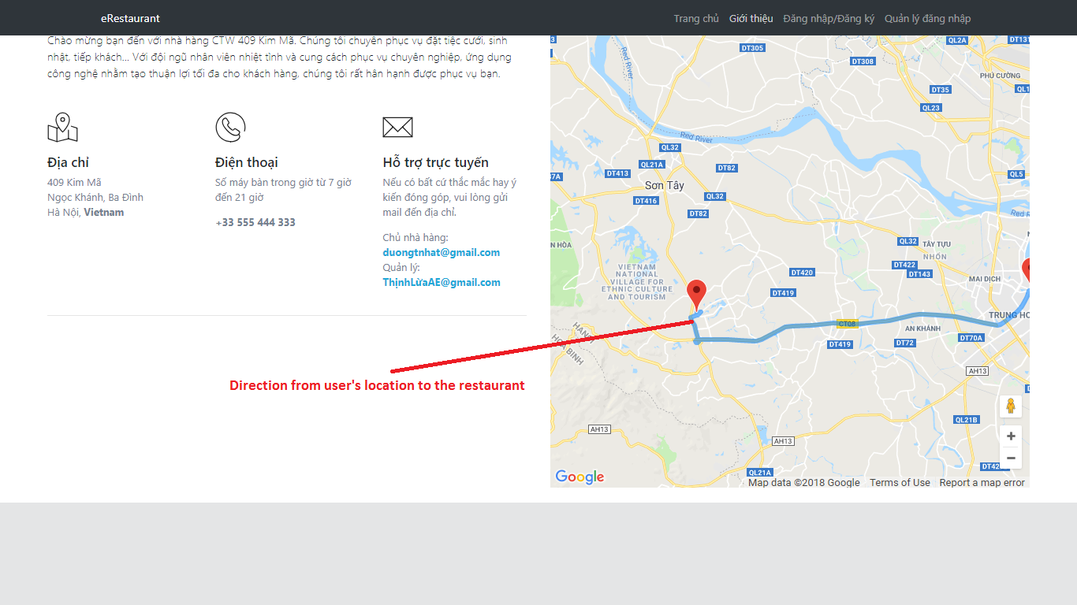

### Login by staff

1. In HomPage click on “Quản lý đăng nhập” button

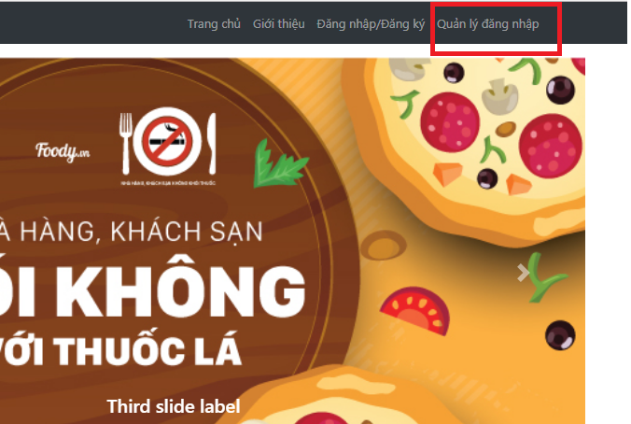

1. ER System display login page

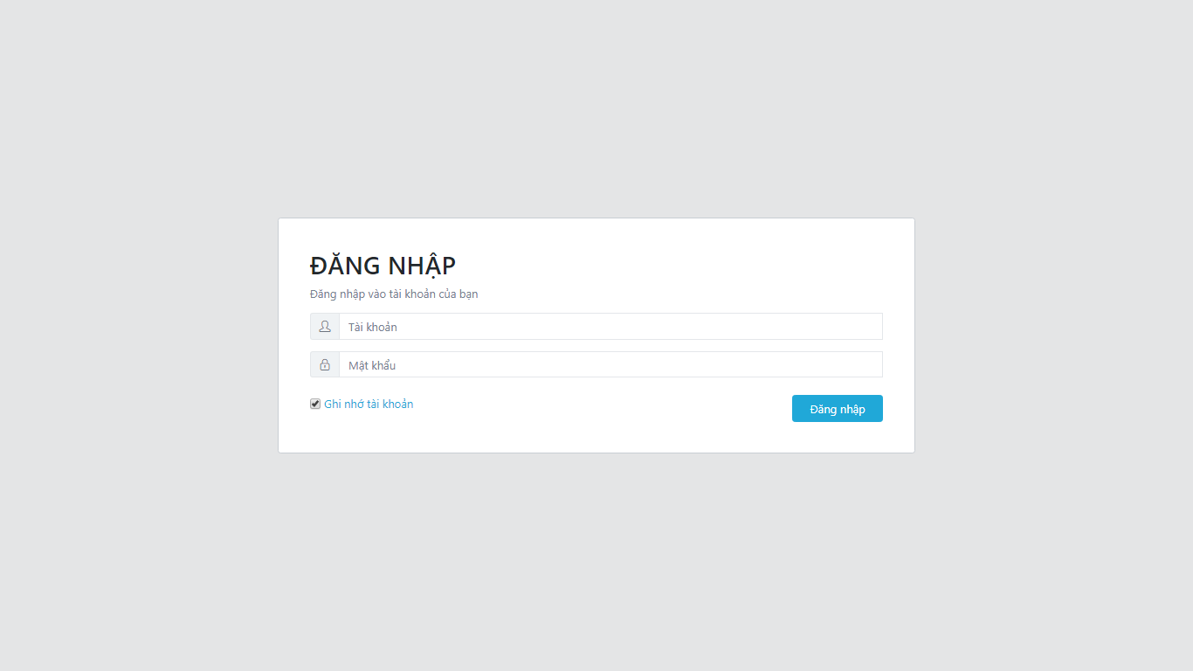

1. Enter Username and Password

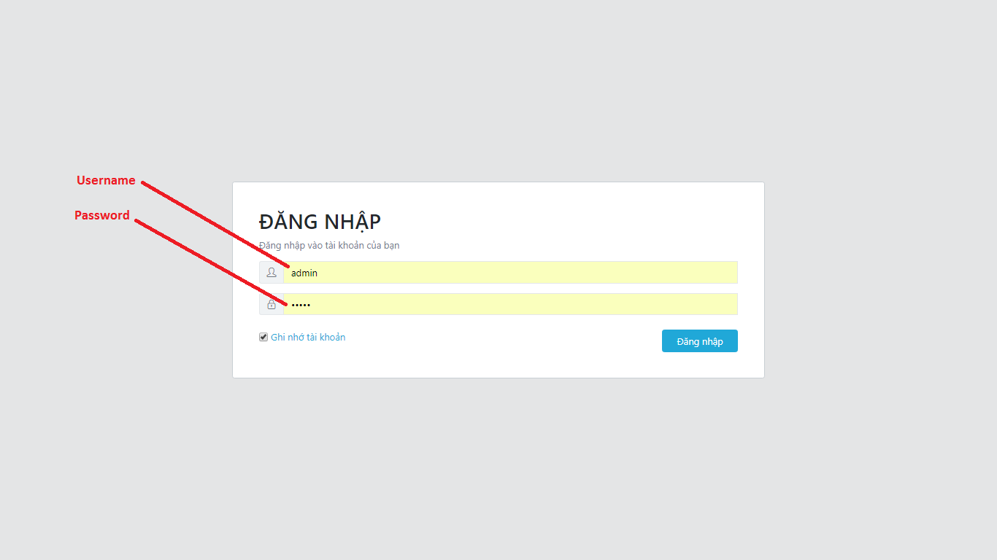

1. Click on “Đăng nhập” button

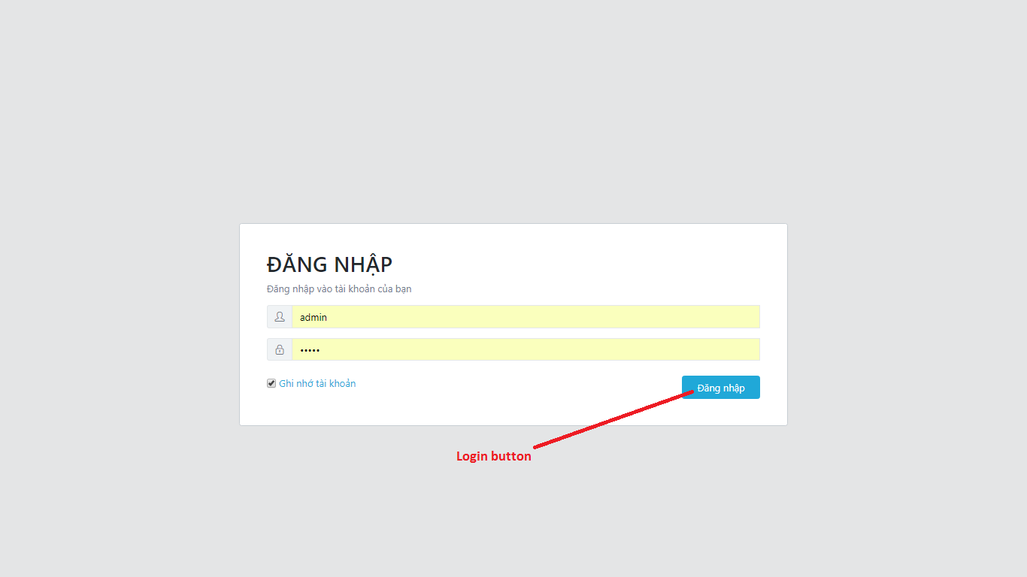

1. ER System redirect user to page which matches user’s role

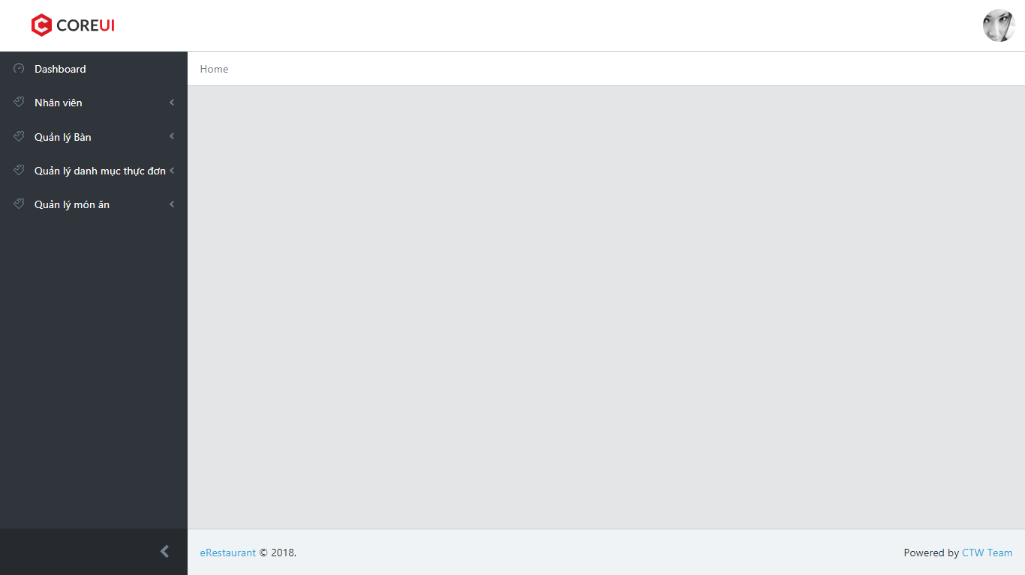

### Logout

1. Click on avatar in top-right

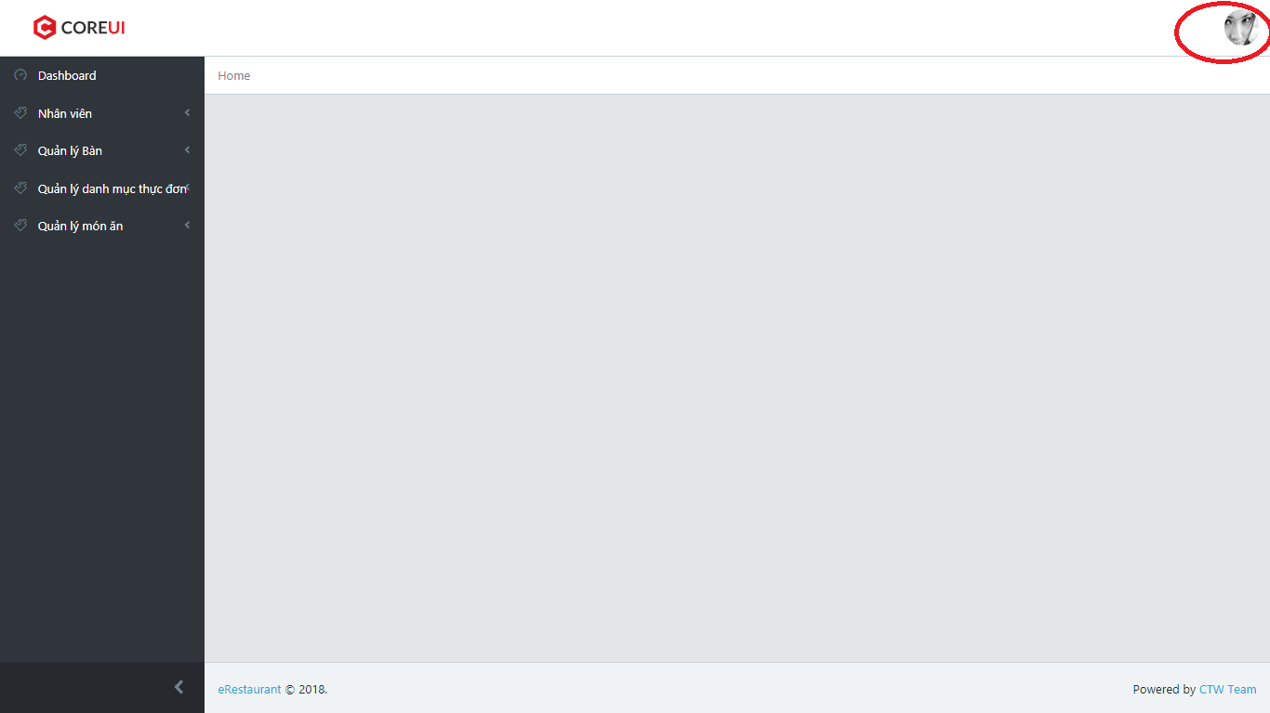

1. Click on “Thoát” button

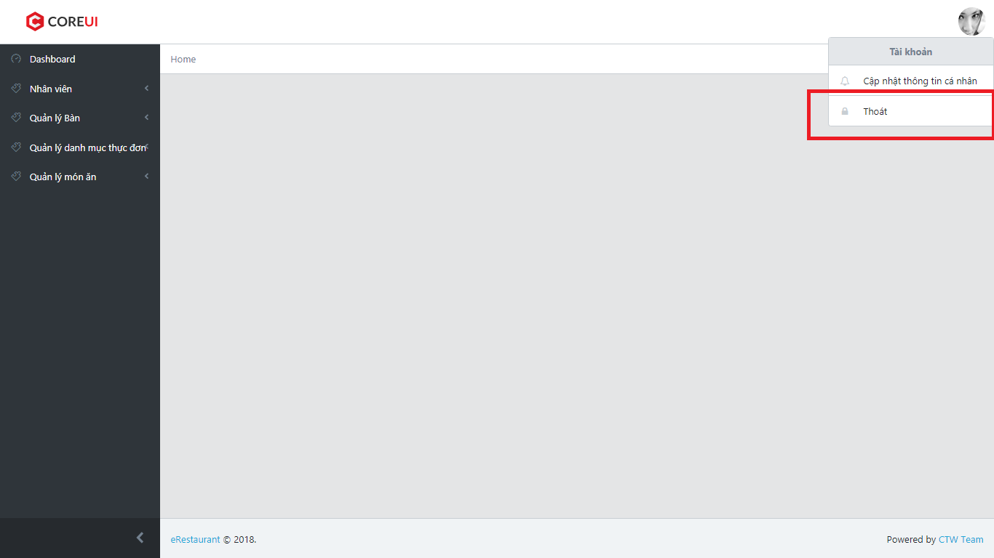

1. ER System log user out and redirect to homepage

### List account

1. Login as Admin
2. Click on “Nhân viên” in sidebar
3. Click on “Danh sách”

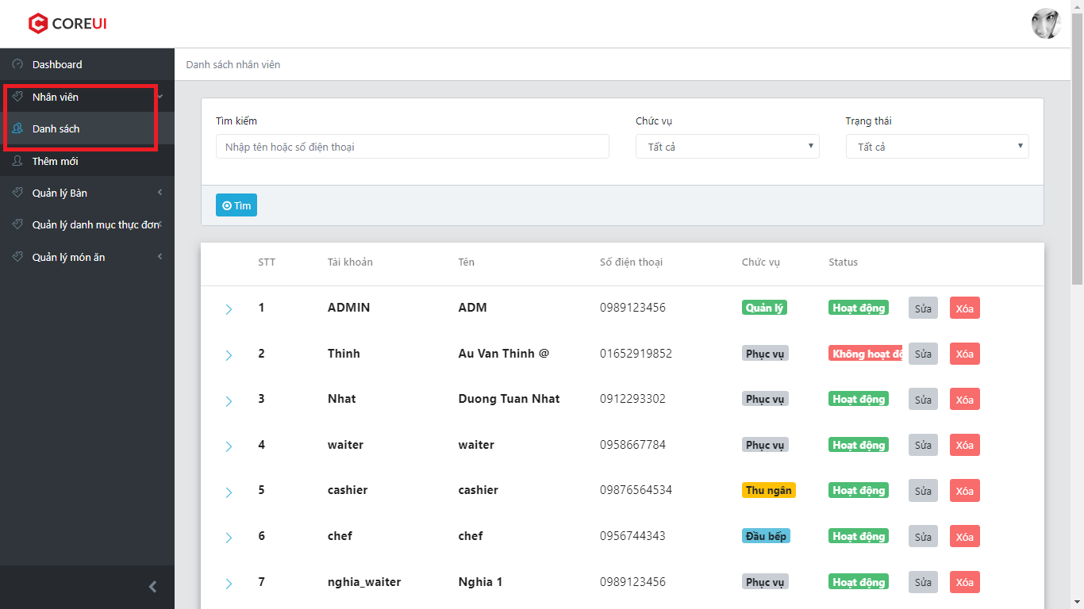

1. ER System display list account

### Search account

1. Enter search condition in “Tìm kiếm”, choose role and status form “Chức vụ” and “Status” combo box
2. Click on “Tìm” button

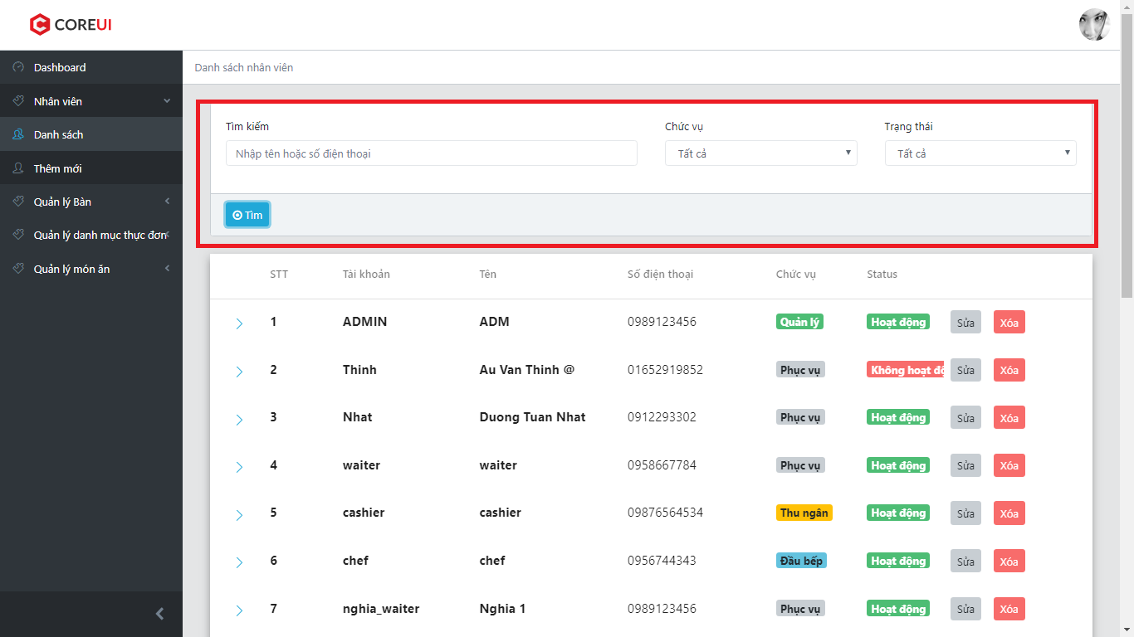

1. ER System display all result matching with search condition

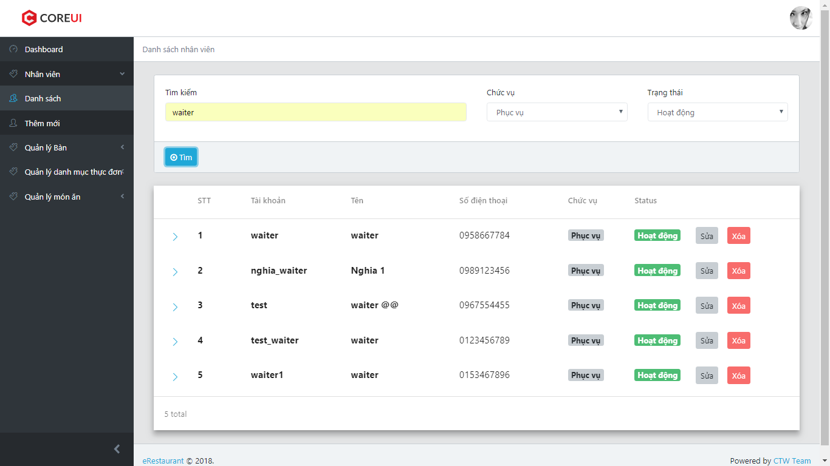

### Delete account

1. Clicks on “Xóa” button

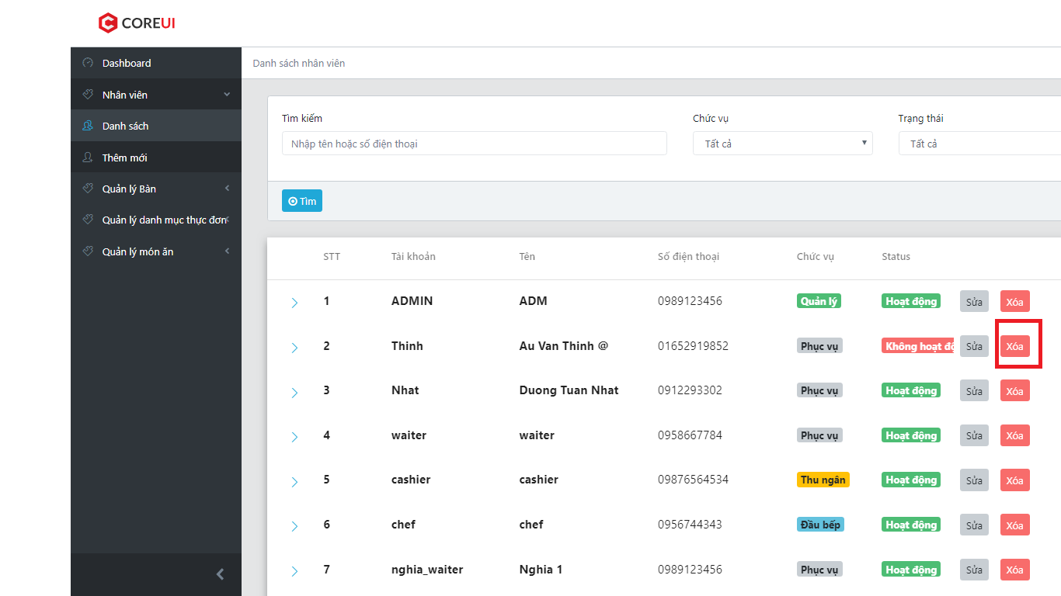

1. ER system display a confirm box

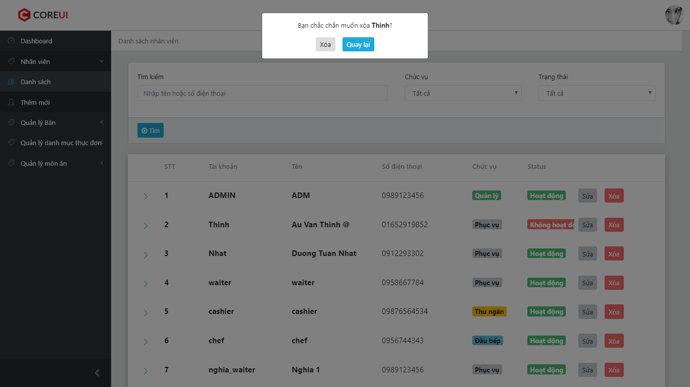

1. User can choose “Xóa” to delete account or ”Quay lại” to back to list account screen
2. If user choose “Xóa” instep 3, ER System delete chosen account then display list account

### Edit account

1. Click on “Sửa” button

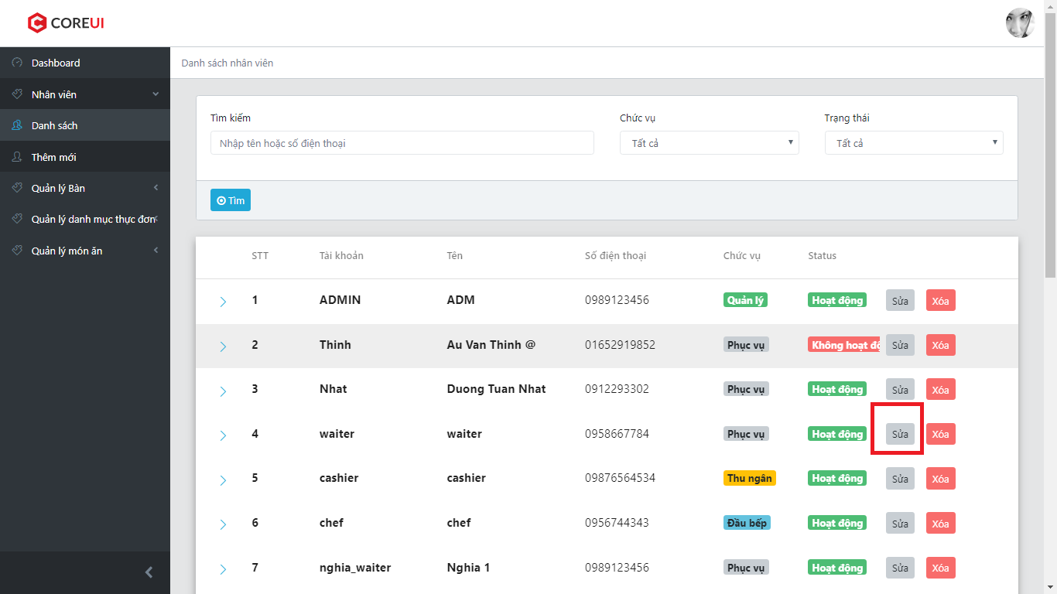

1. ER System redirect user to Edit Account
2. Fill Account’s information to all fields
3. Click on “Lưu” button

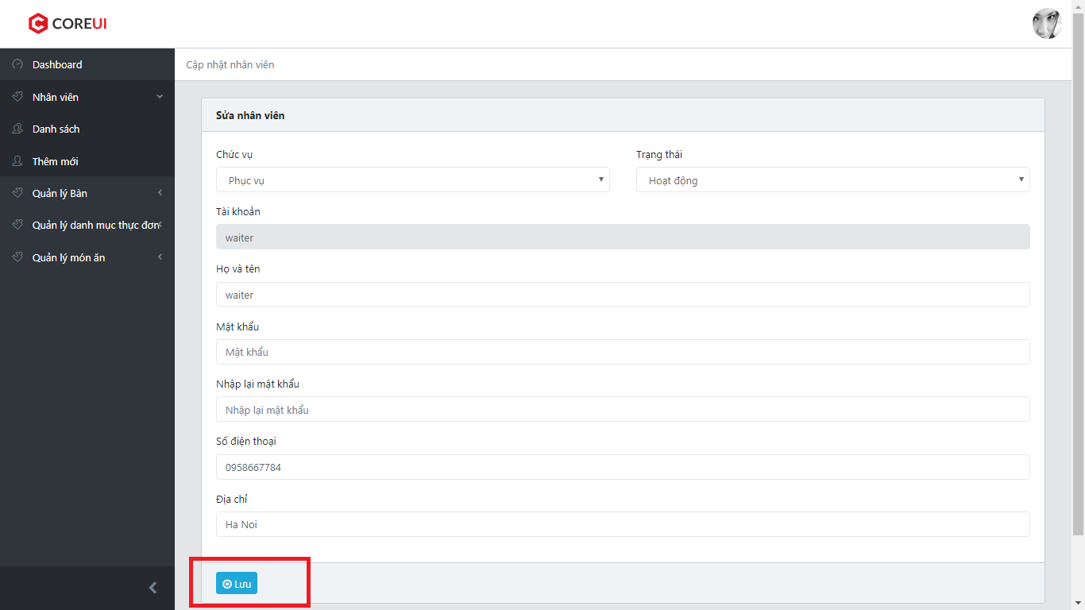

1. ER System redirect user to List Account

### Create account

1. Click on “Thêm mới” in side bar

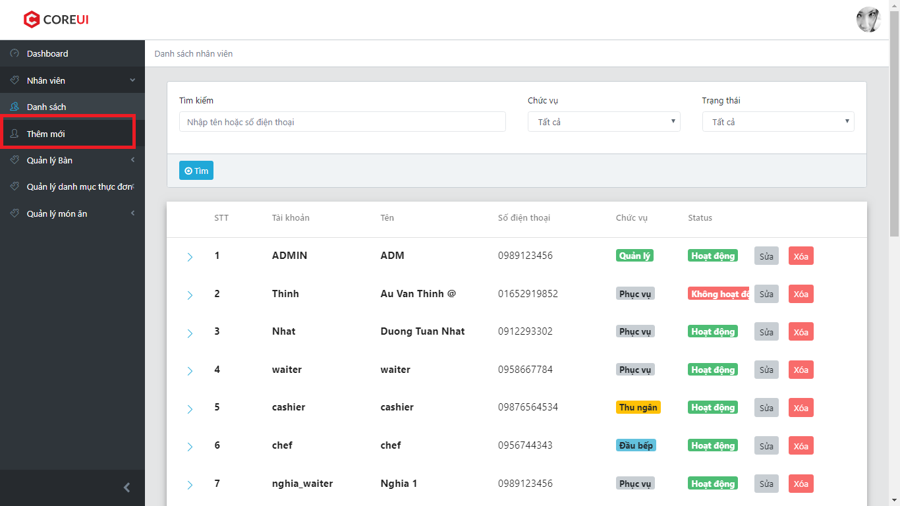

1. ER System redirect user to Create Account
2. Fill Account’s information to all fields
3. Click on “Lưu” button

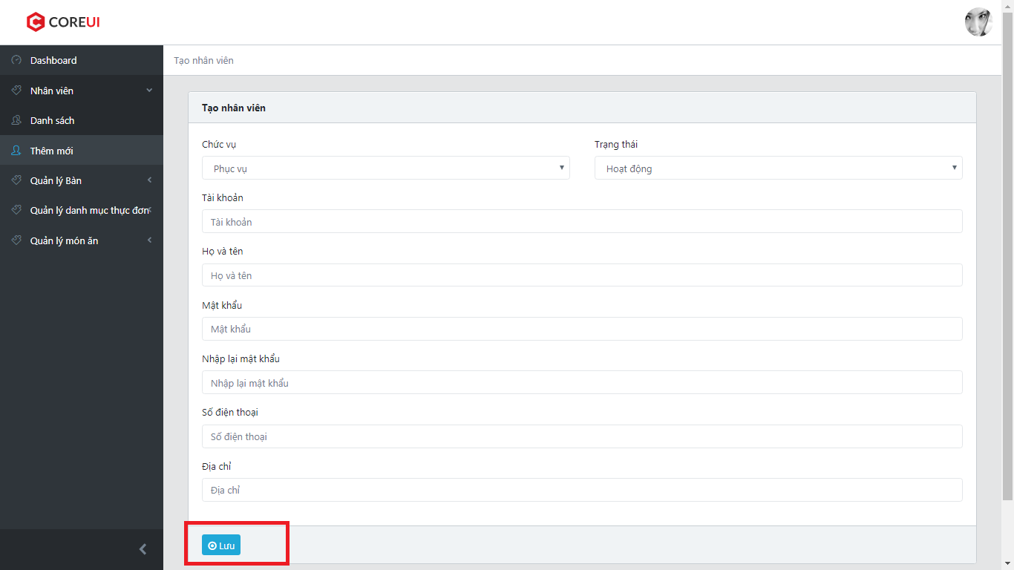

1. ER System redirect user to List Account

### List table

1. Click on “Quản lý bàn” in side bar
2. Click on “Danh sách bàn”
3. ER System display list table

### Delete table

1. Click on “Xóa” button
2. ER System display a confirm box
3. User can choose “Xóa” to delete account or ”Quay lại” to back to list tables screen
4. If user choose “Xóa” instep 3, ER System delete chosen table then display list tables

### Edit table

1. Click on “Sửa” button
2. ER System redirect to Edit Page
3. Fill Account’s information to all fields
4. Click on “Lưu” button
5. ER System redirect user to List Table

### Create table

1. Click on “Tạo bàn” in side bar

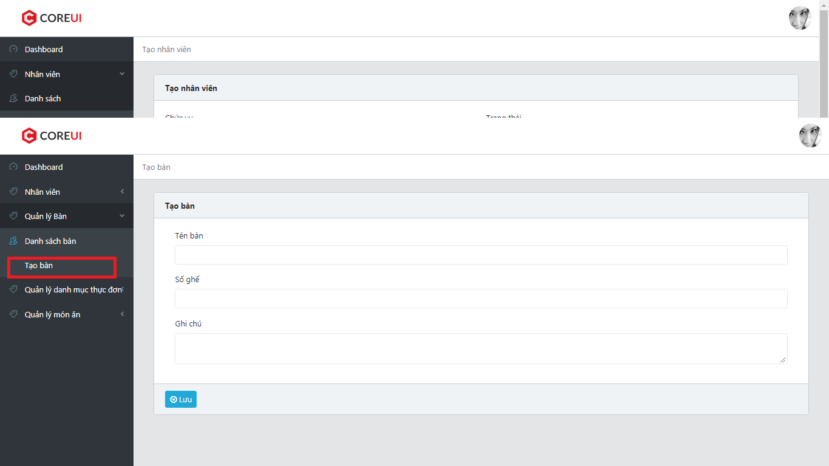

1. ER System redirect user to Create Table
2. Fill Table’s information to all fields
3. Click on “Lưu” button

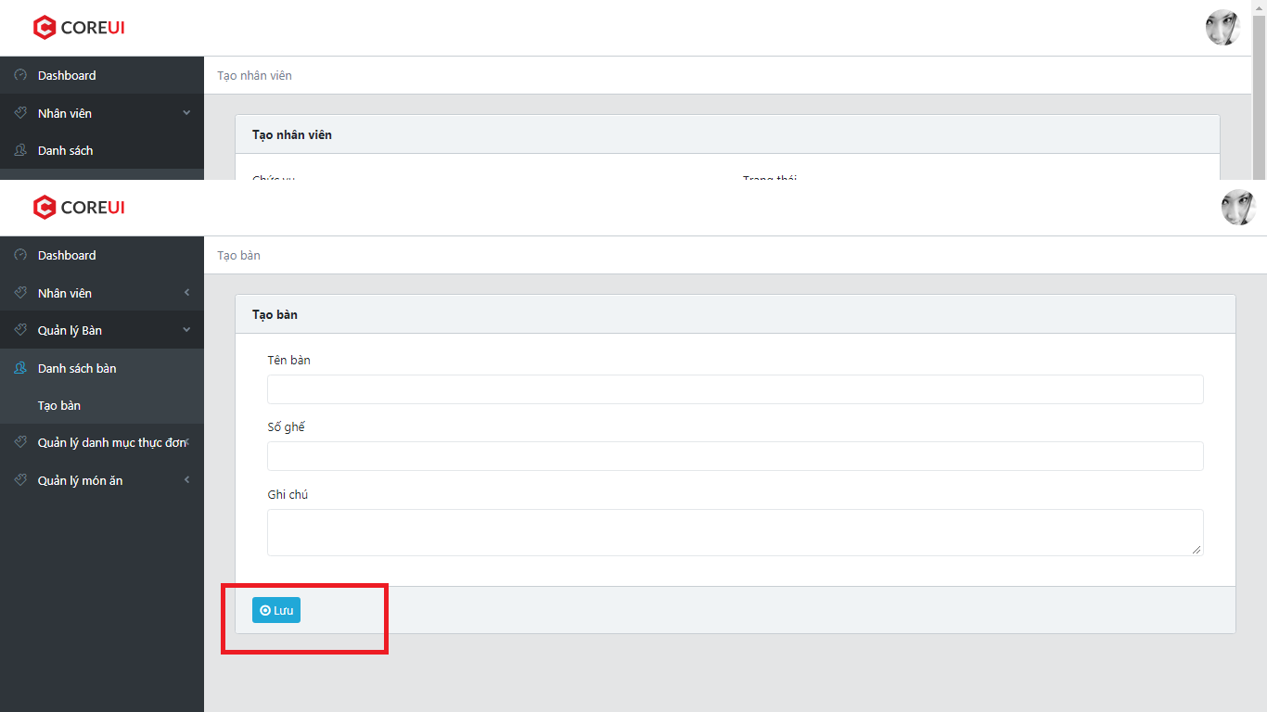

1. ER System redirect user to List Table

### List category

1. Click on “Quản lý danh mục thực đơn” in sidebar
2. Click on “Danh sách danh mục”

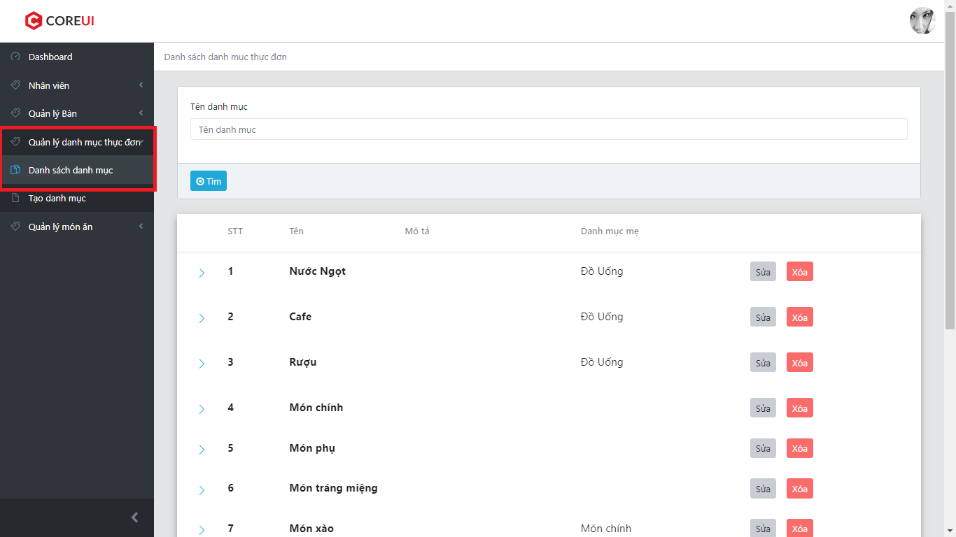

1. ER System display list category

### Search category

1. Enter search condtion in search field
2. Click “Tìm” button
3. ER System display all category matching with search condition

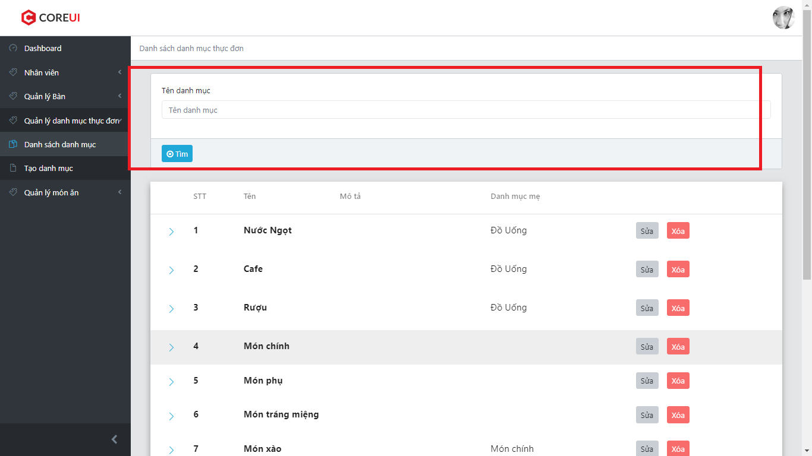

### Delete category

1. Click on “Xóa” button

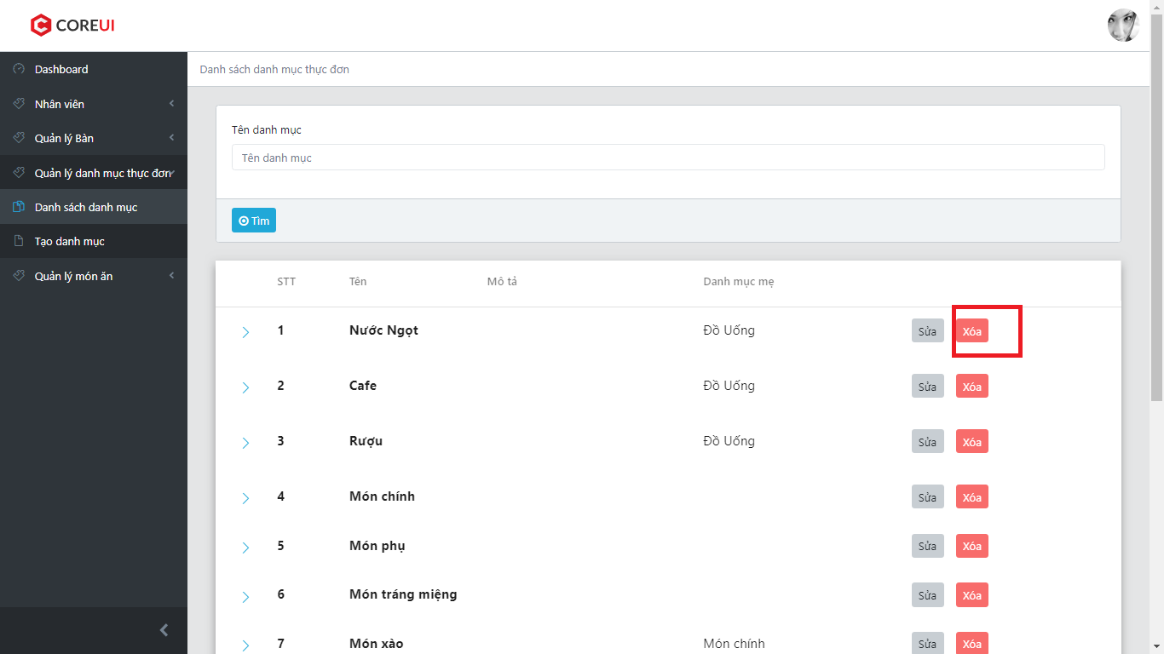

1. ER System display a confirm box

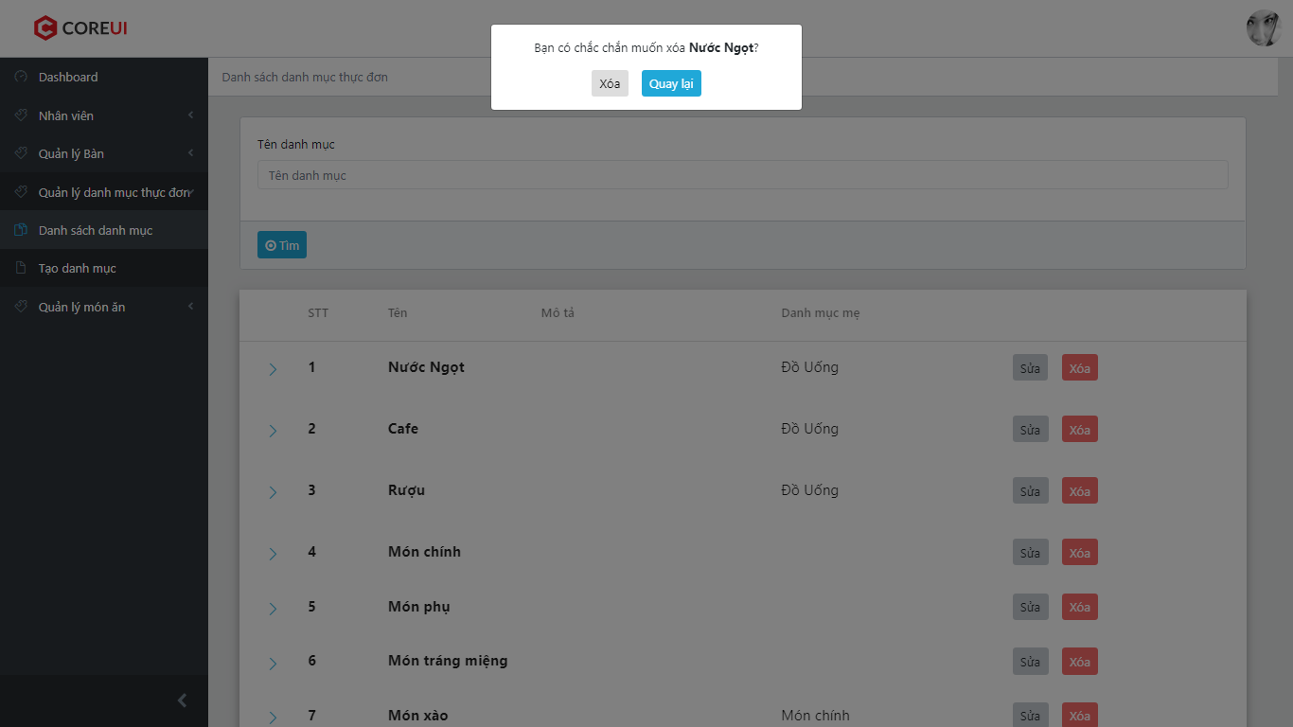

1. User can choose “Xóa” to delete account or ”Quay lại” to back to list categories screen
2. If user choose “Xóa” instep 3, ER System delete chosen category then display list categories

### Edit category

1. Click on “Sửa” button

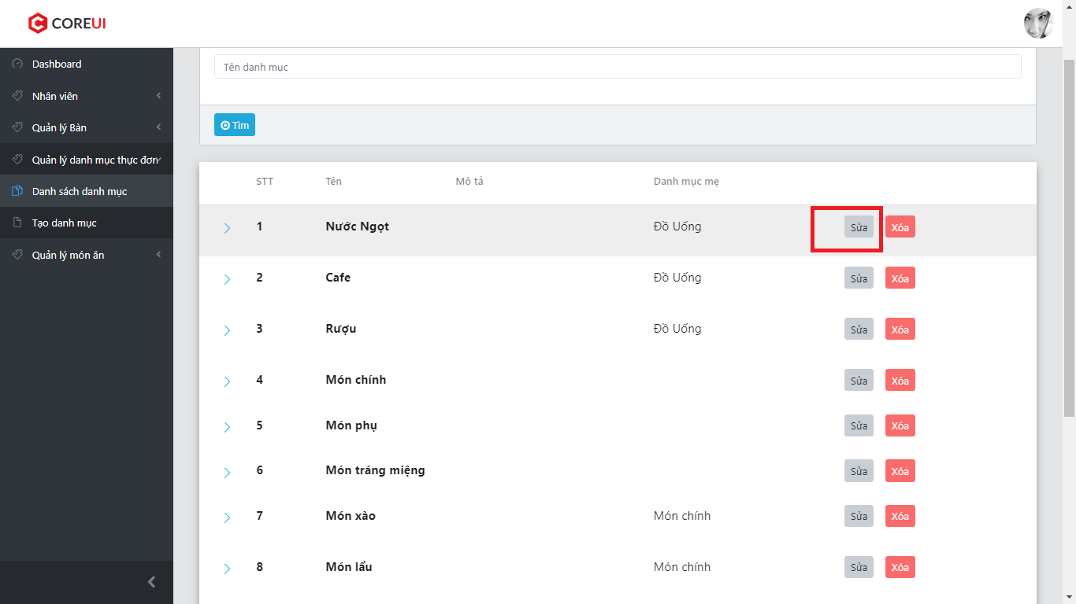

1. ER System redirect to Edit Page

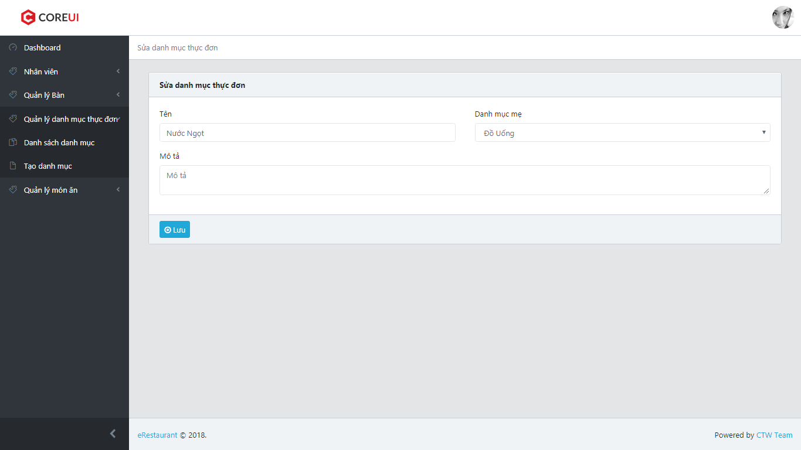

1. Fill Category’s information to all fields
2. Click on “Lưu” button

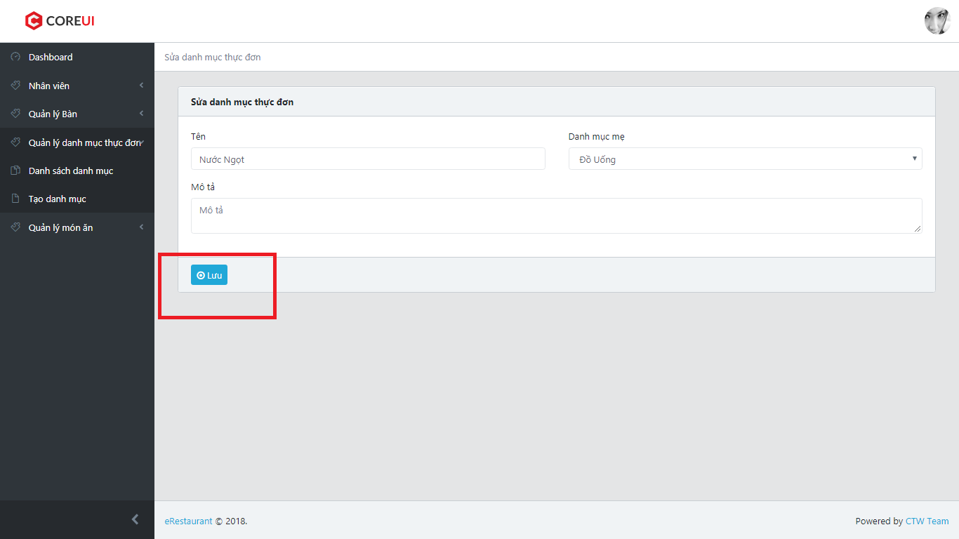

1. ER System redirect user to List Category

### Create category

1. Click on “Tạo danh mục” in side bar

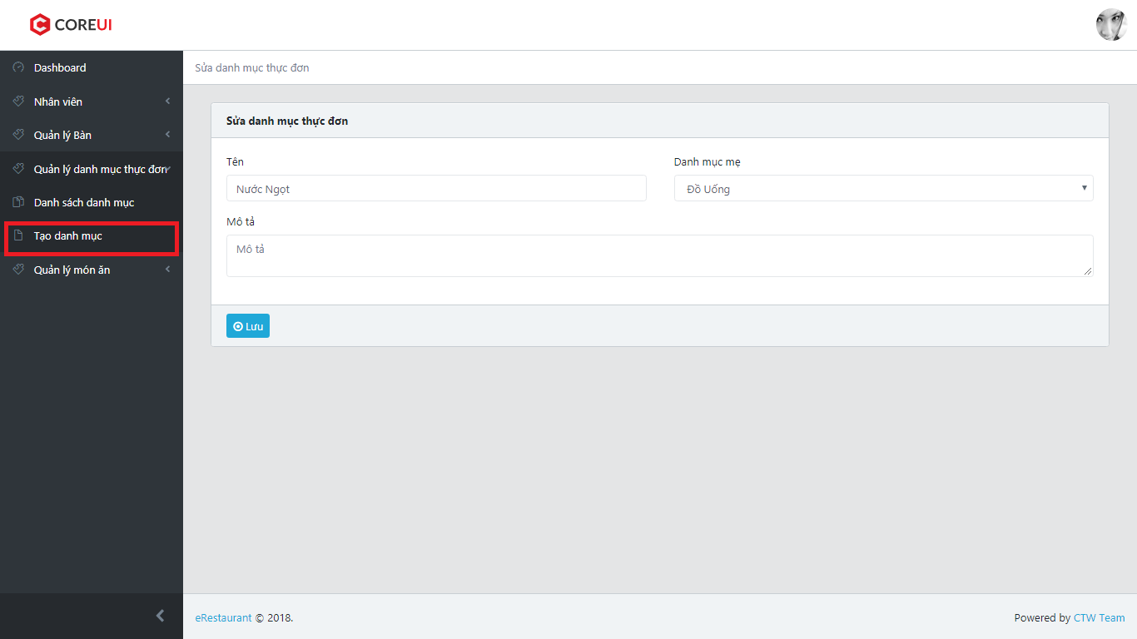

1. ER System redirect user to Create Category

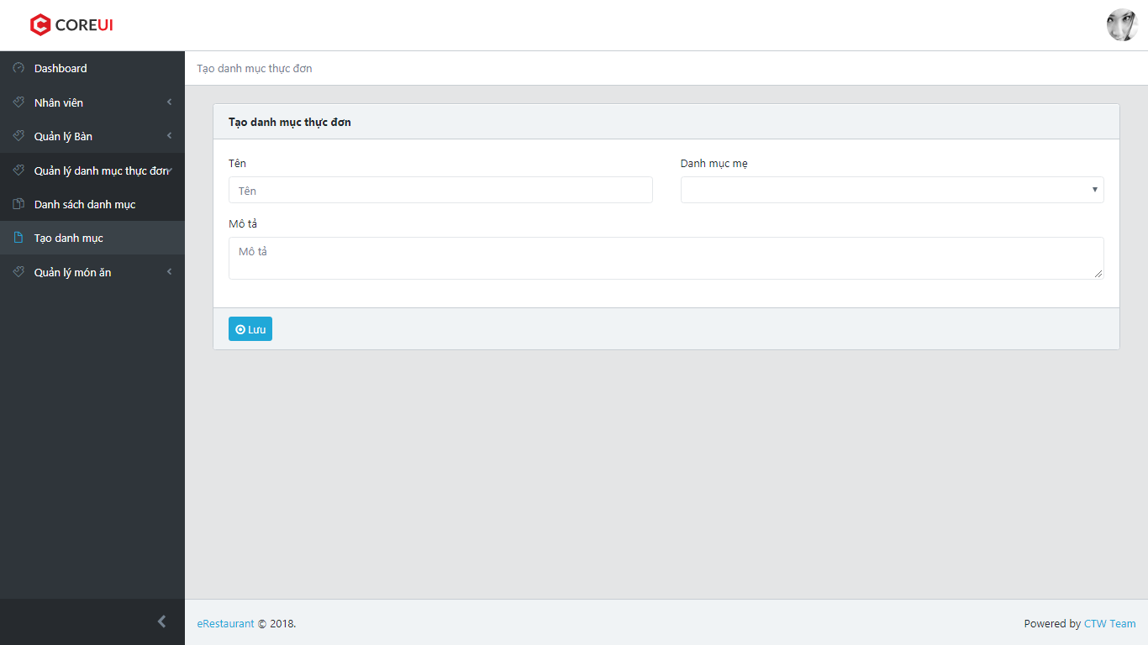

1. Fill Category’s information to all fields
2. Click on “Lưu” button

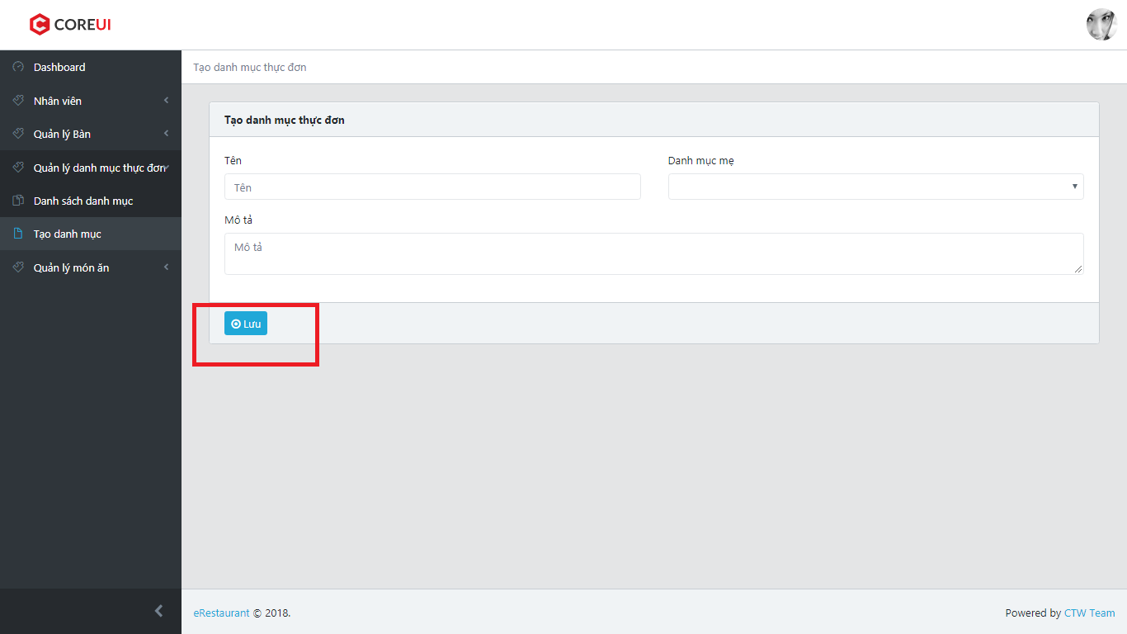

1. ER System redirect user to List Categories

### List food

1. Click on “Quản lý món ăn” in sidebar
2. Click on “Danh sách món ăn”

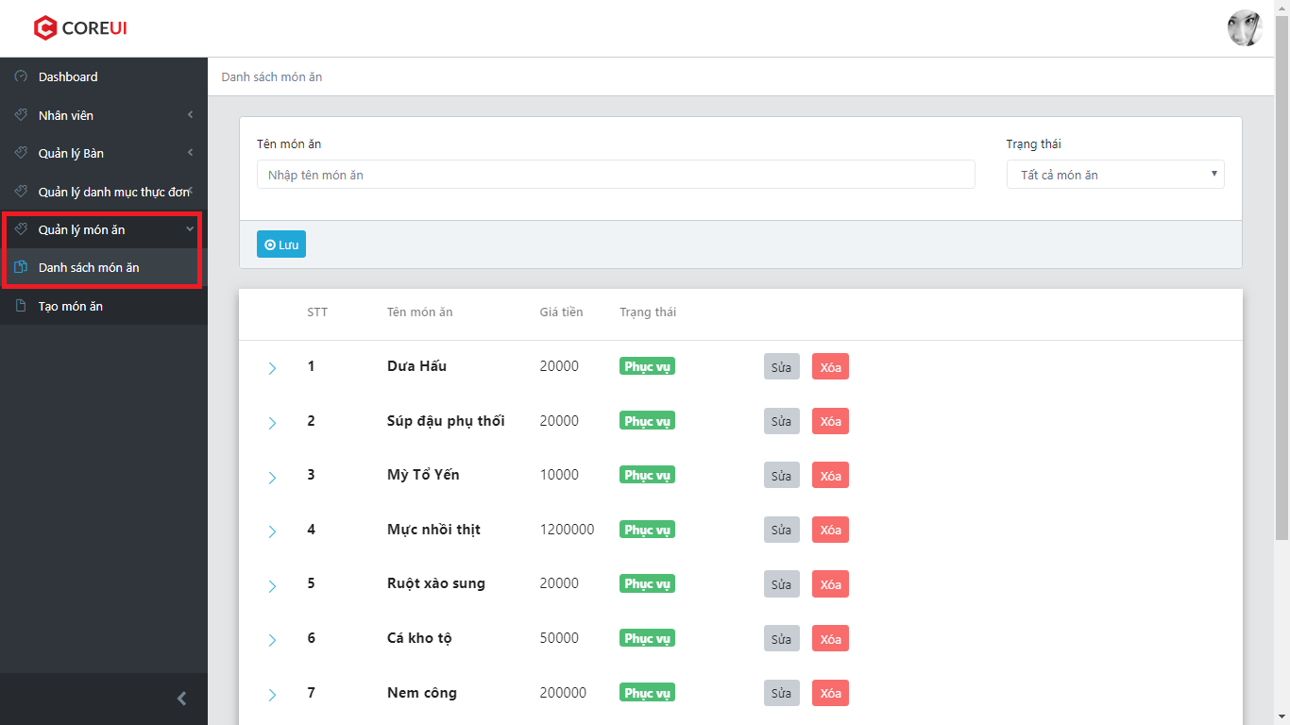

1. ER System display list foods

### Search food

1. Enter search condtion in search field
2. Click “Tìm” button

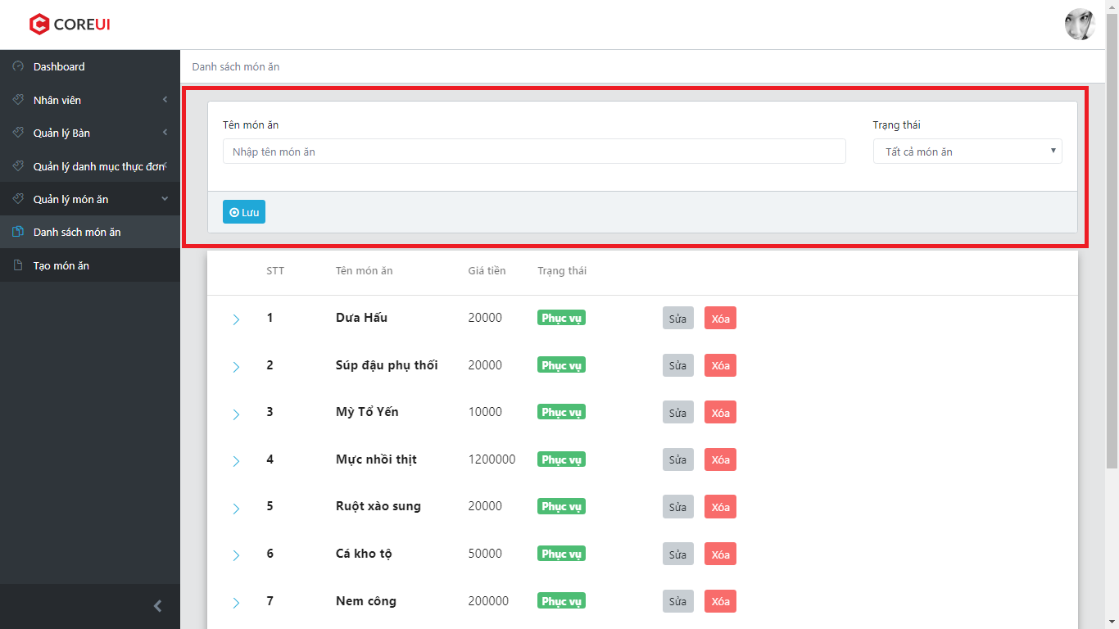

1. ER System display all food matching with search condition

### Delete food

1. Click on “Xóa” button

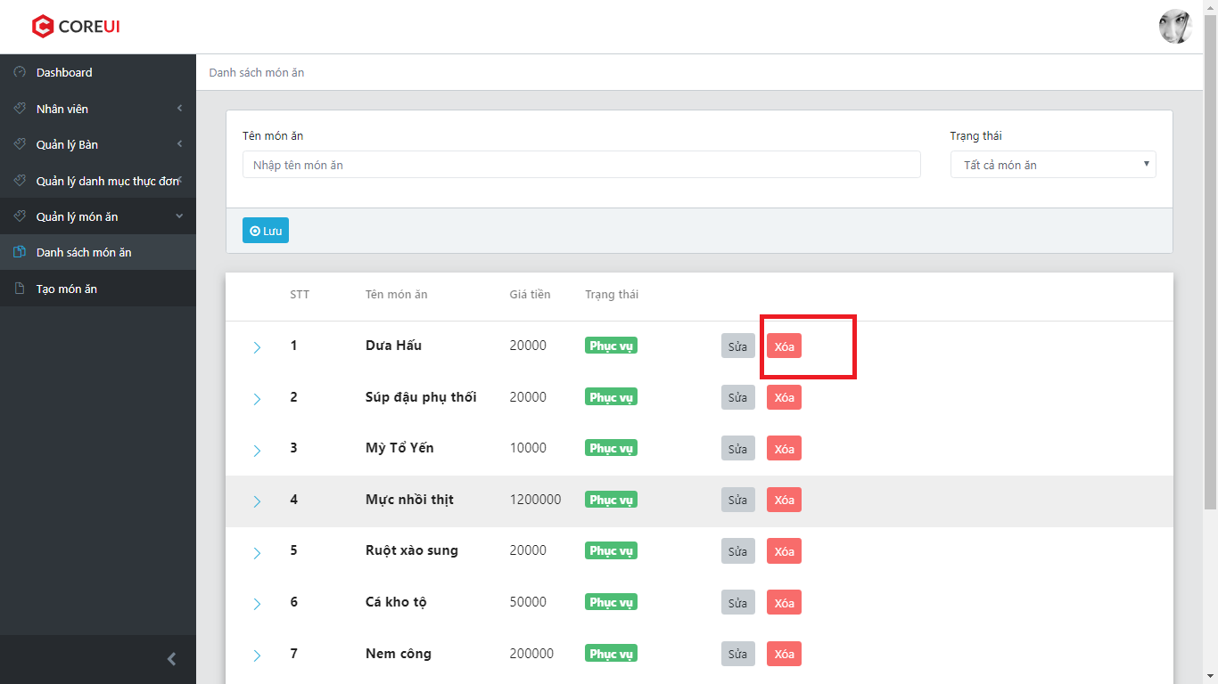

1. ER System display a confirm box

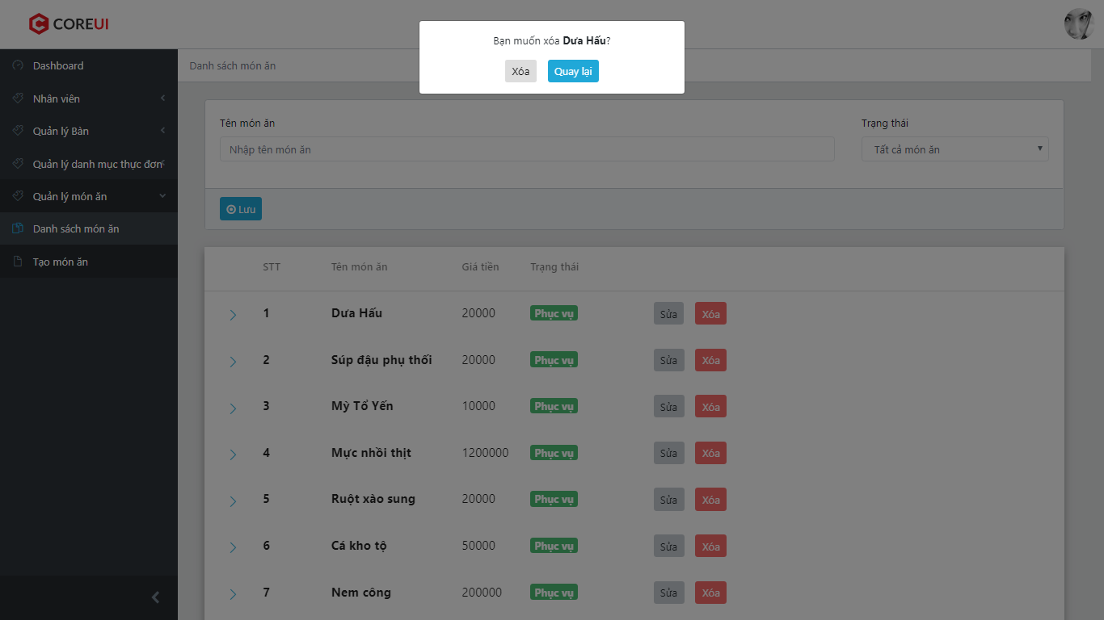

1. User can choose “Xóa” to delete food or ”Quay lại” to back to list food sscreen
2. If user choose “Xóa” instep 3, ER System delete chosen food then display list foods

### Edit food

1. Click on “Sửa” button

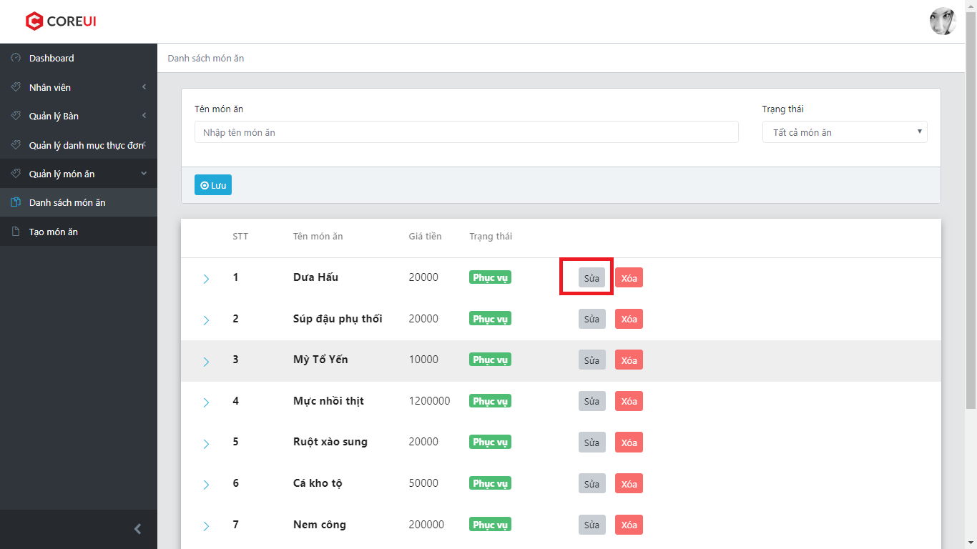

1. ER System redirect to Edit Page

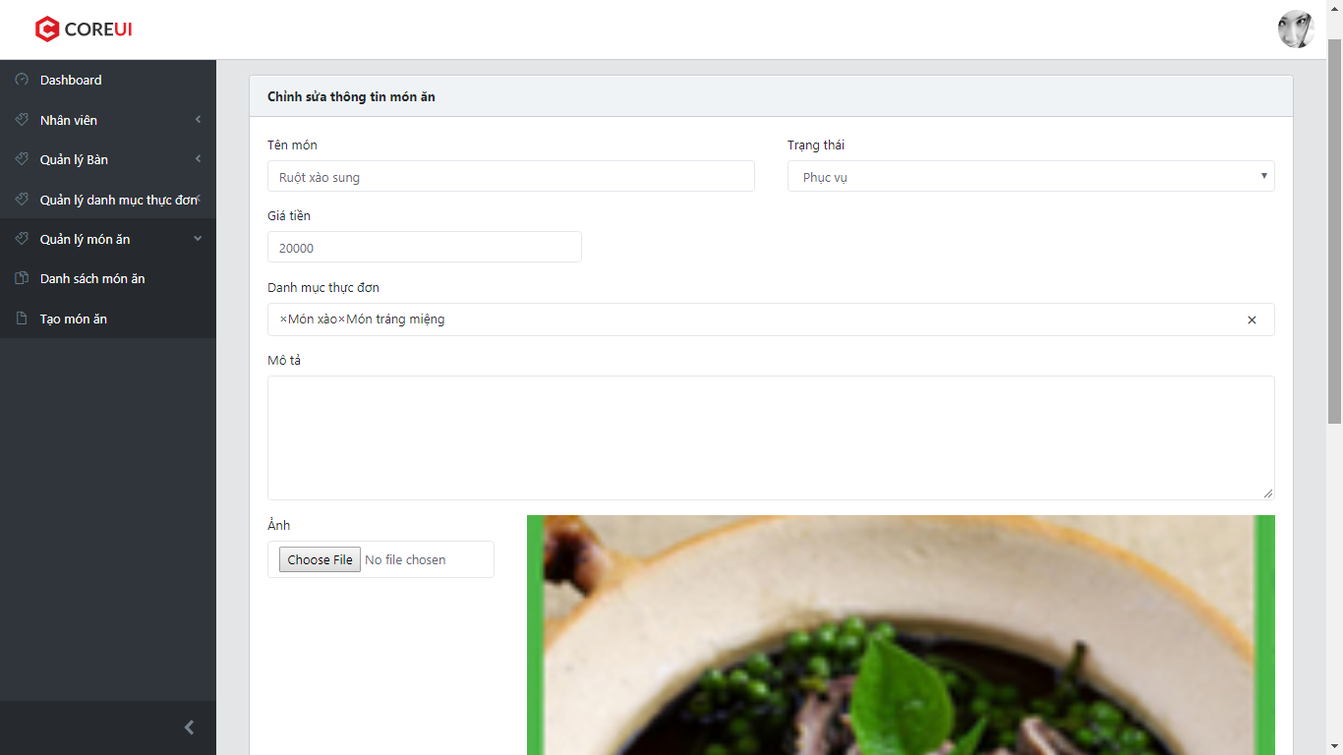

1. Fill Food’s information to all fields
2. Click on “Lưu” button

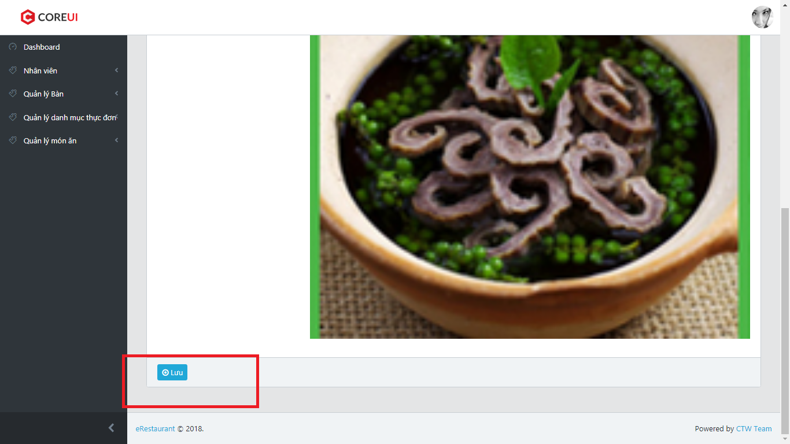

1. ER System redirect user to List Foods

### Create food

1. Click on “Tạo món ăn” in sidebar

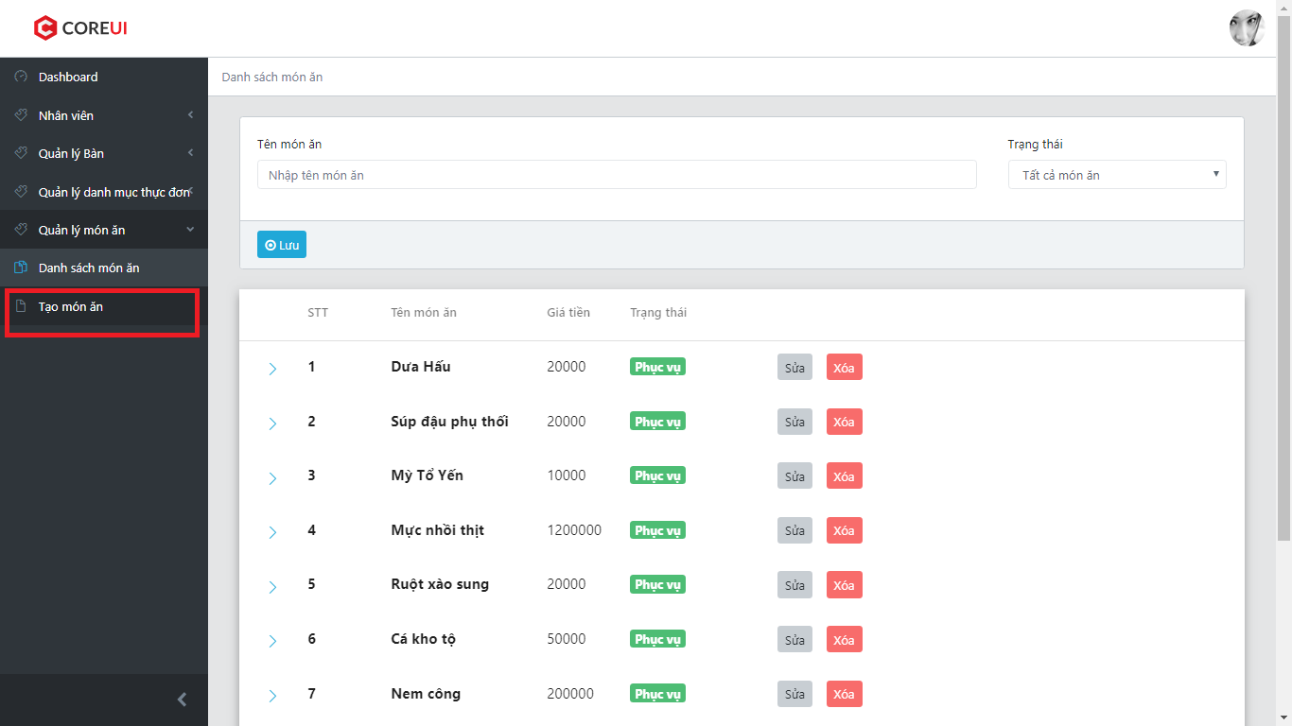

1. ER System redirect user to Create Food

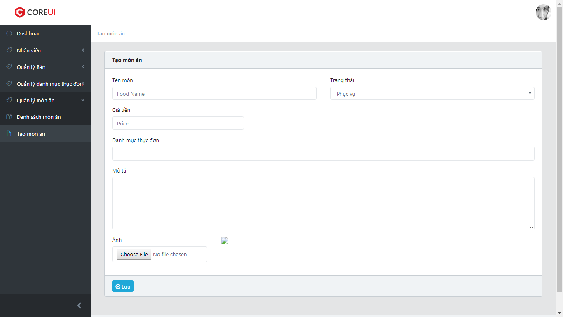

1. Fill Food’s information to all fields
2. Click on “Lưu” button

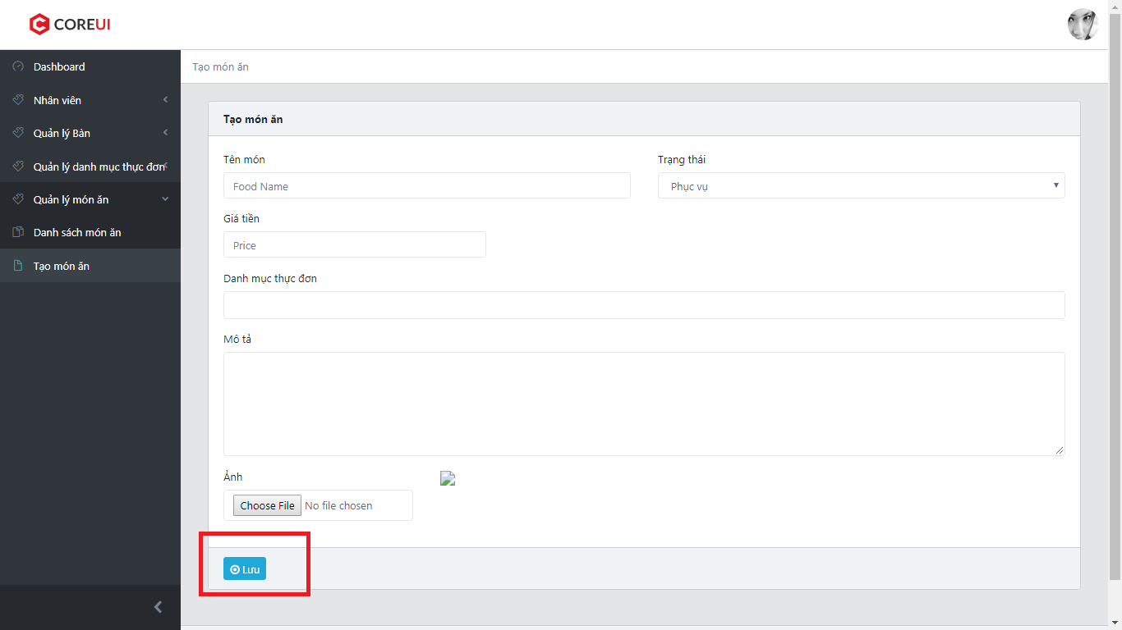

1. ER System redirect user to List Foods

### View statistic

1. Click on “Dashboard” in sidebar

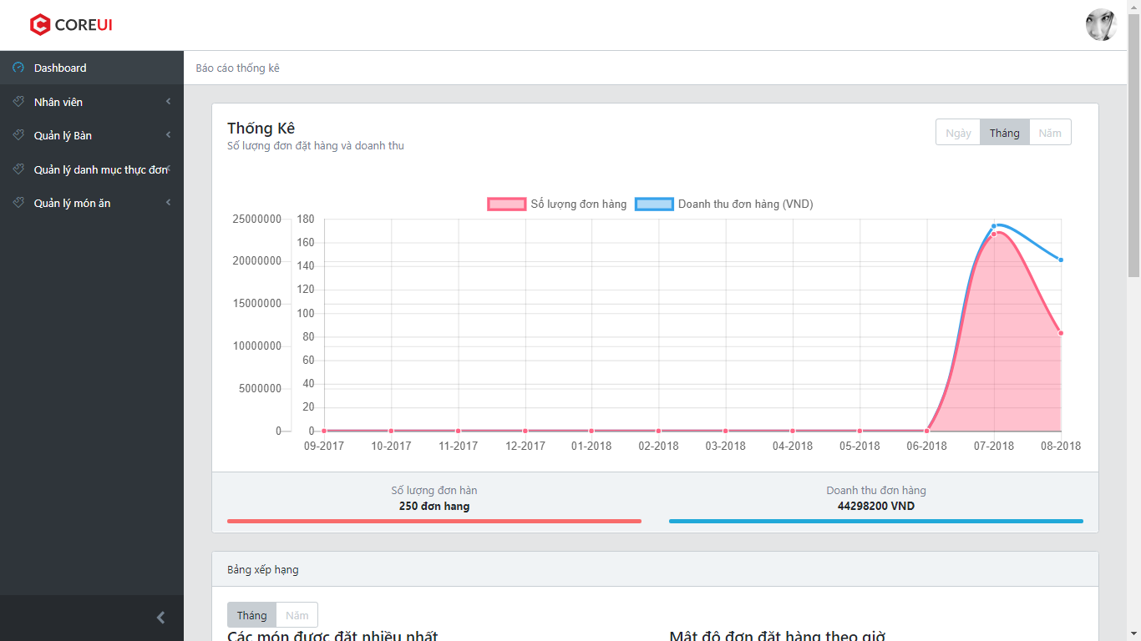

1. ER System display dashboard
2. Click on “Ngày”, “Tháng”, “Năm” to view statistic by Day. Month, Year

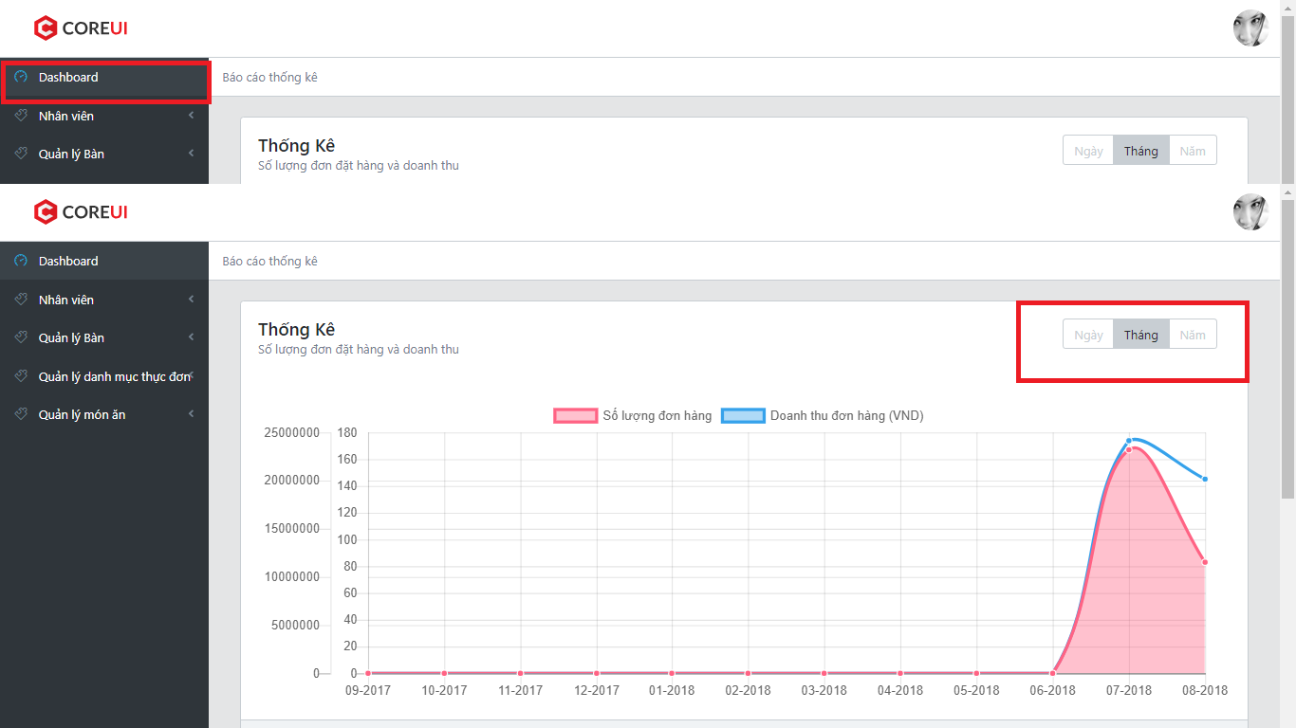

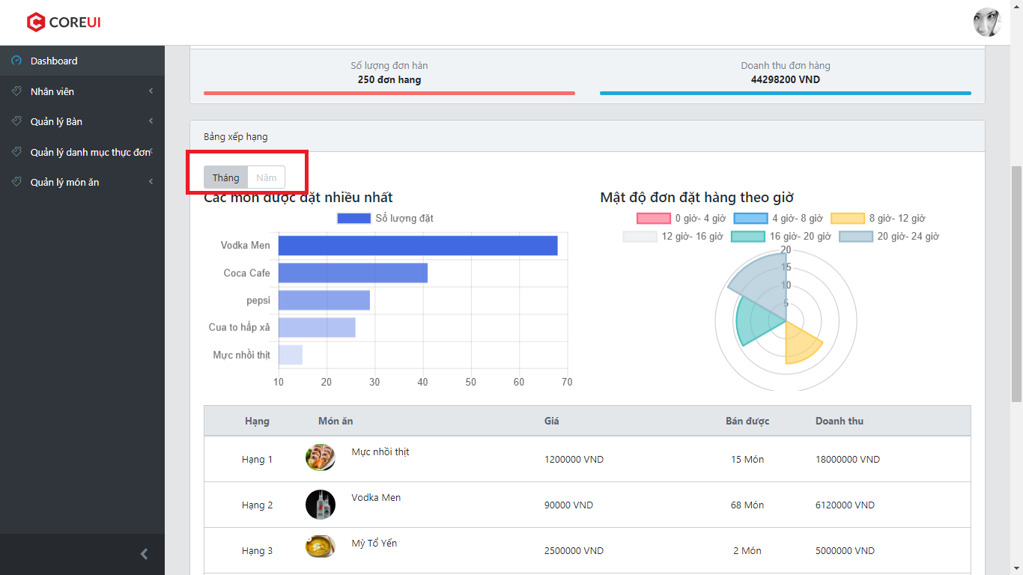

### Login/Register

1. Click on “Đăng nhập/Đăng ký” in homepage

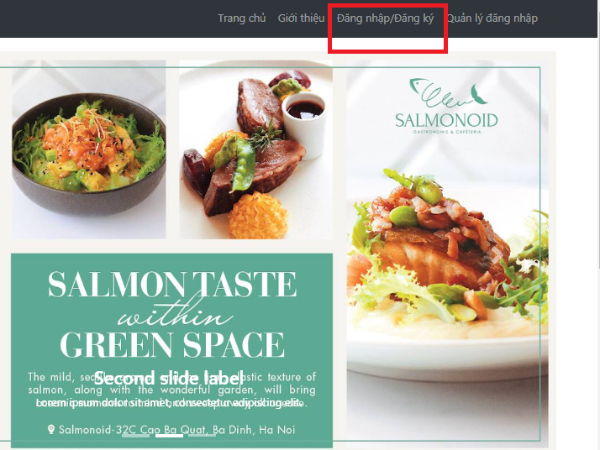

1. ER system log user in system by Facebook Account

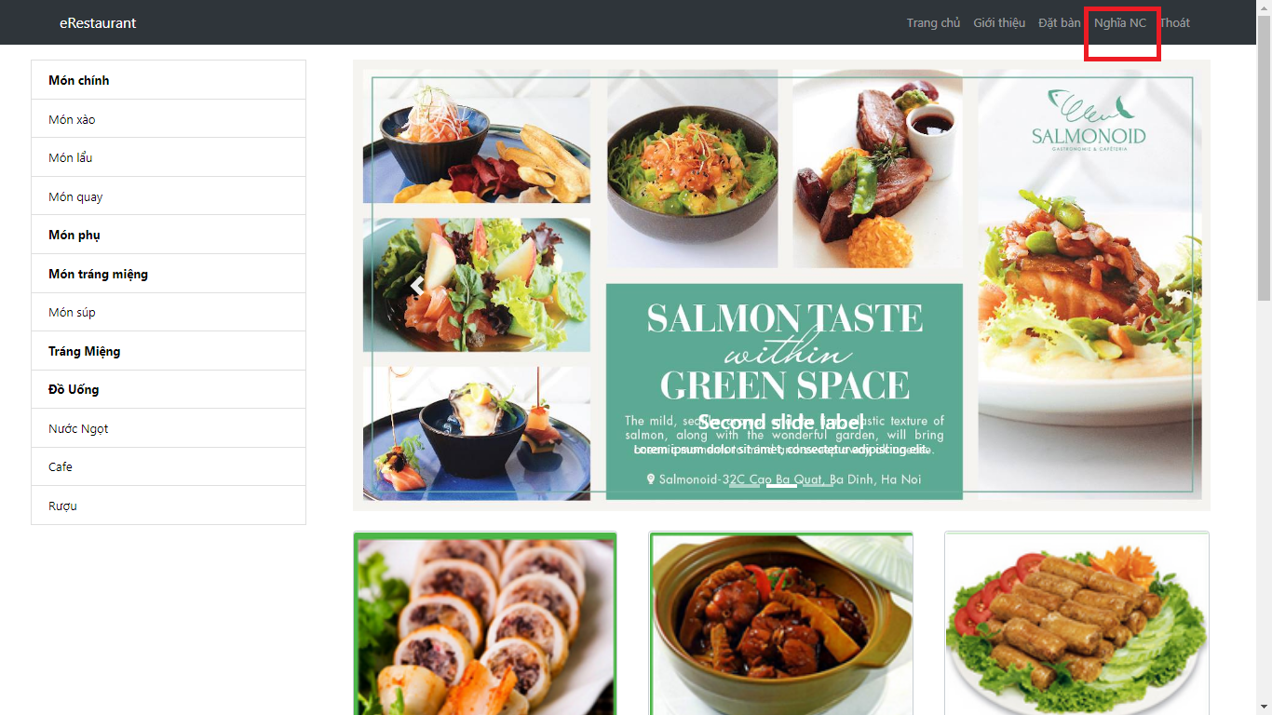

* + 1. List available table

1. Click on “Đặt bàn” in homepage

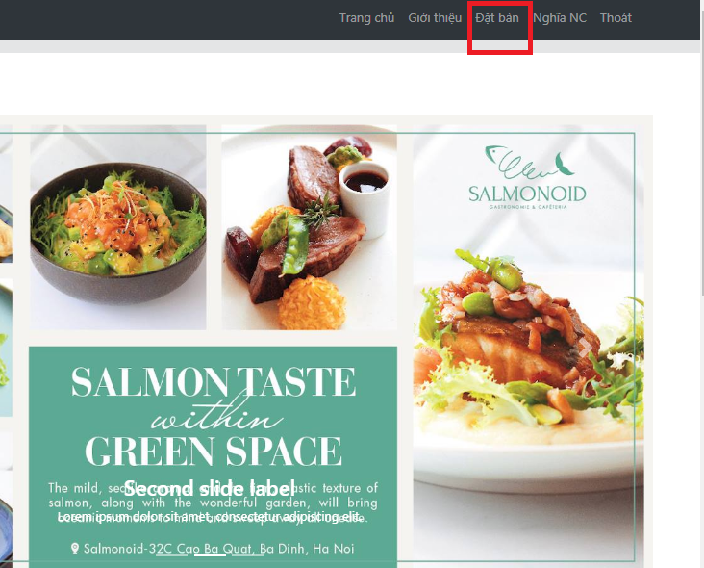

1. ER System display all available table

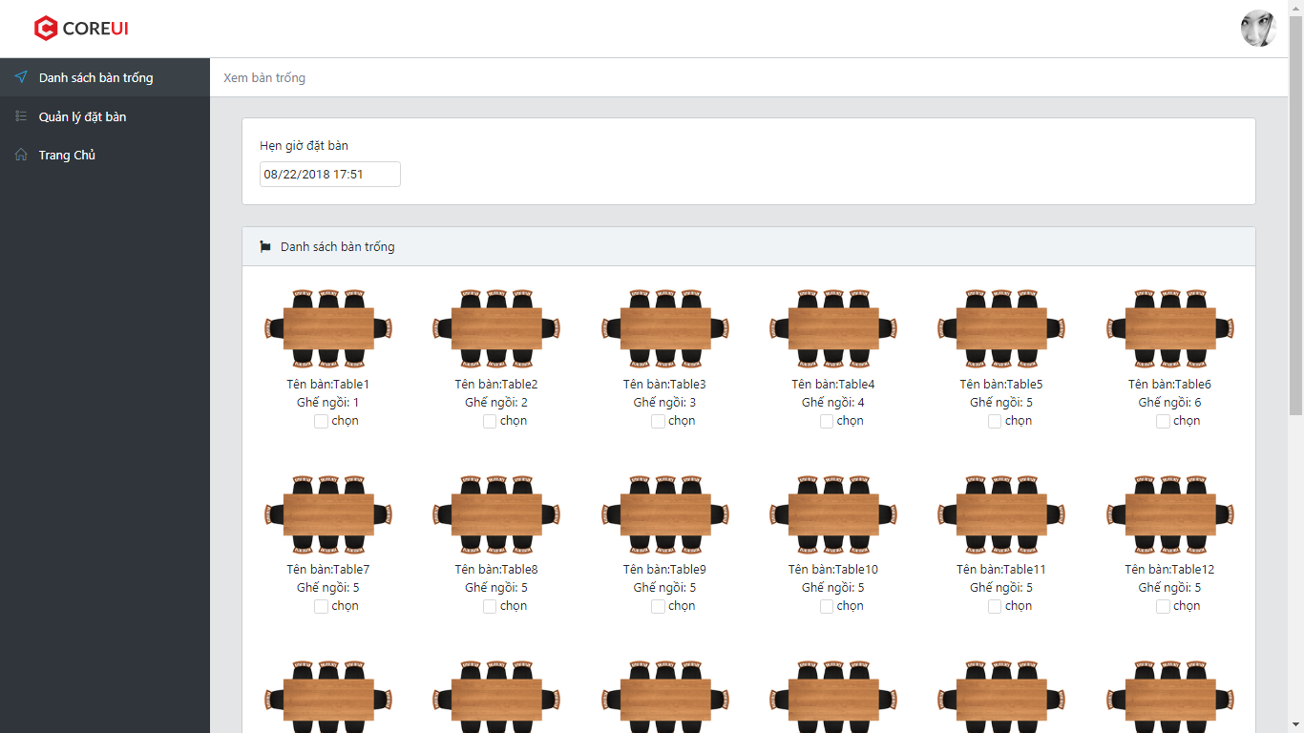

### Book table

1. Choose date and time for table booking

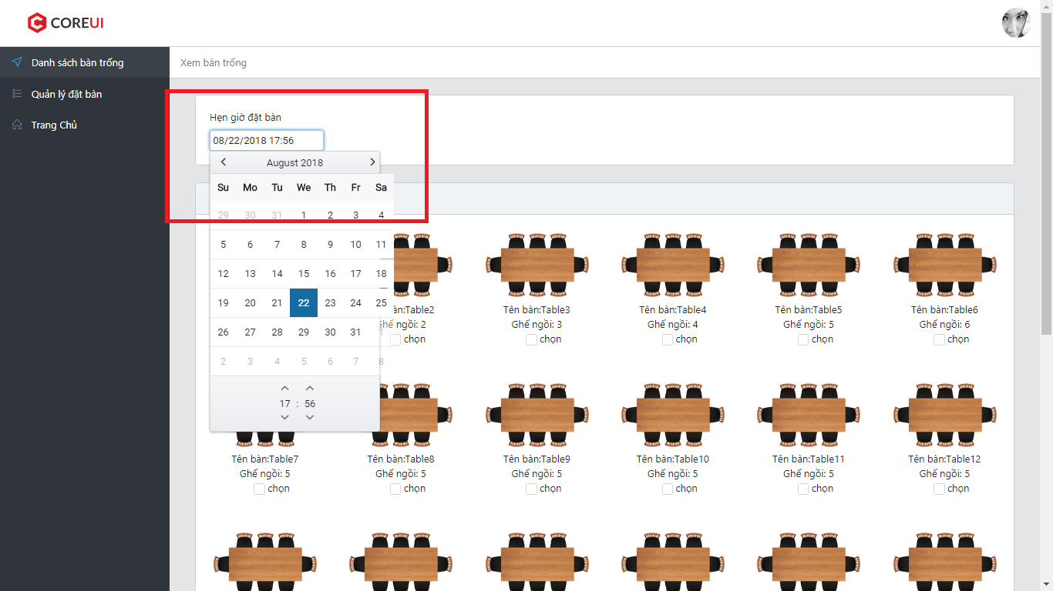

1. Click in checkbox to choose tables

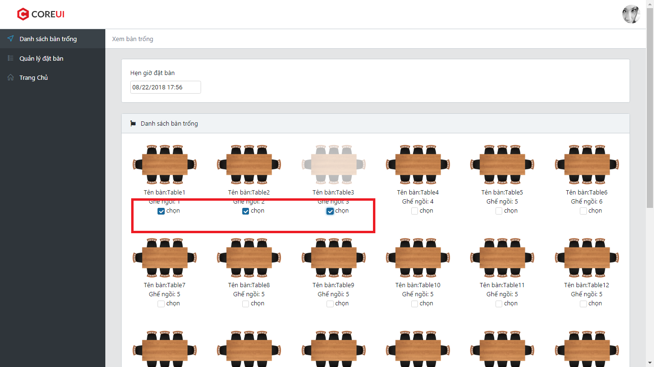

1. Click “Đặt bàn” to book tables

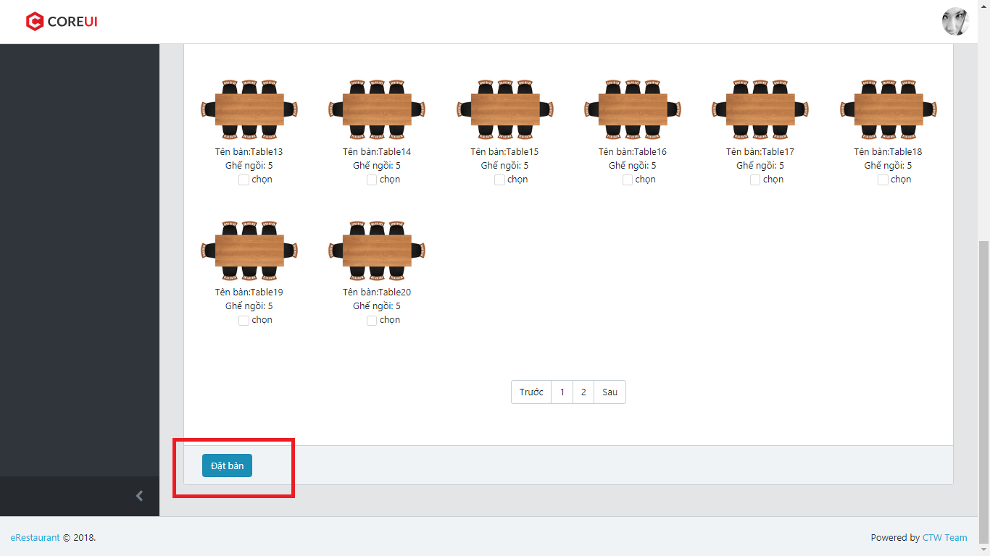

1. ER System redirect user to Manage Order Screen

### Manage booking table (customer)

1. Click on “Quản lý đặt bàn”

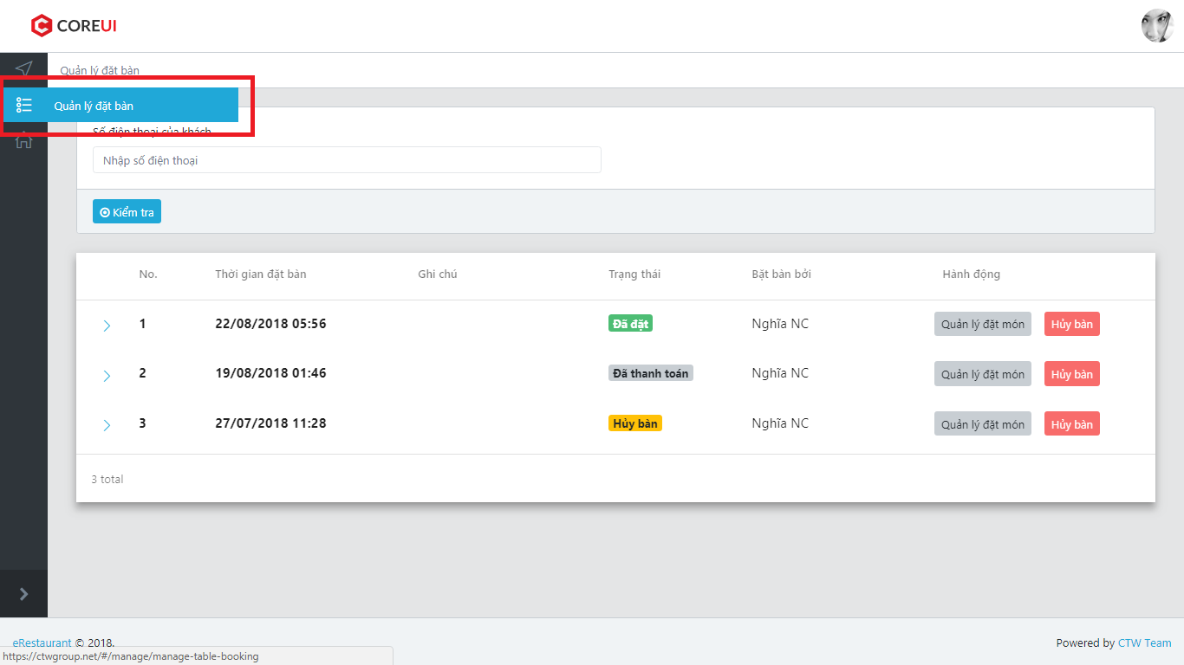

1. ER System display Manage Booking screen

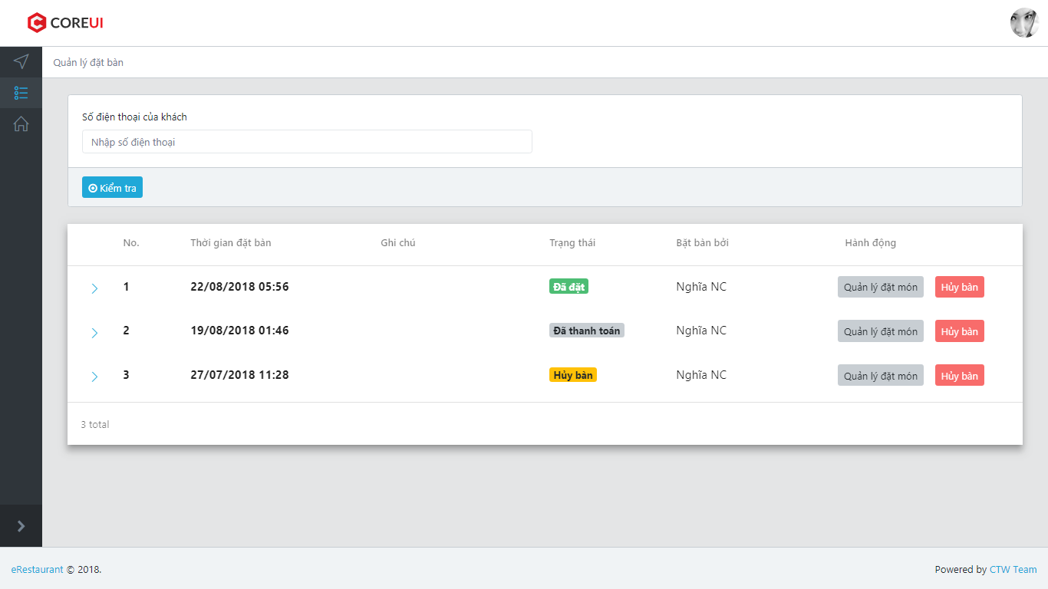

1. Click on “Hủy bàn” to cancel table booking

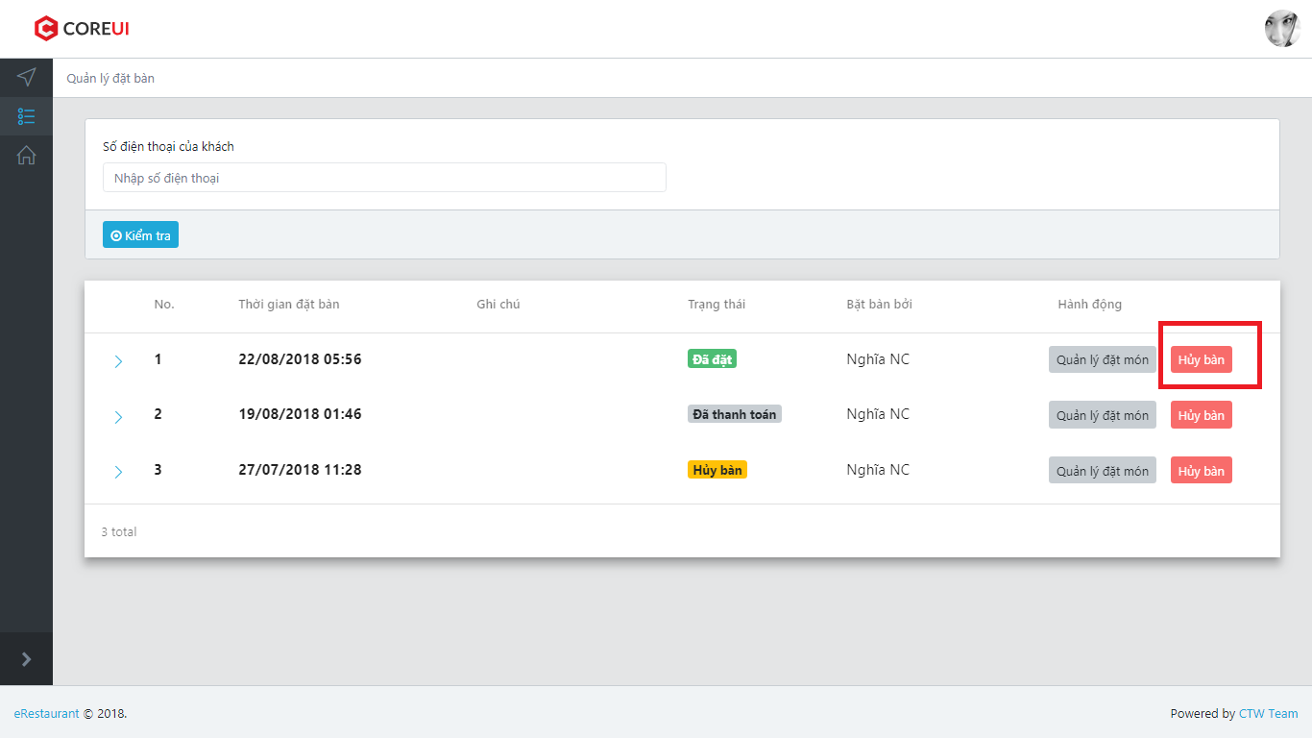

1. ER System display confirm box

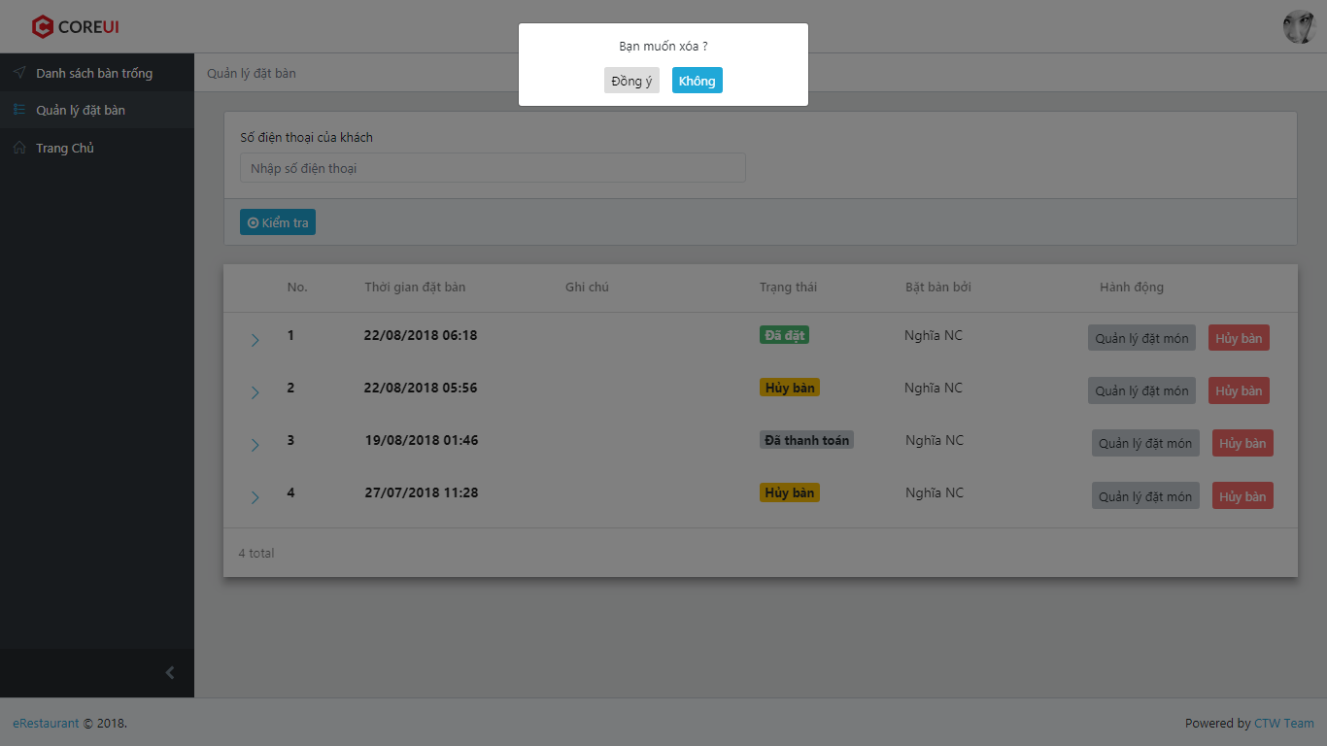

1. User can choose “Đồng ý” to cancel boking or ”Không” to back to list booked tables
2. If user choose “Xóa” instep 3, ER System change status of chosen booked table to “Hủy bàn” then display list booked tables

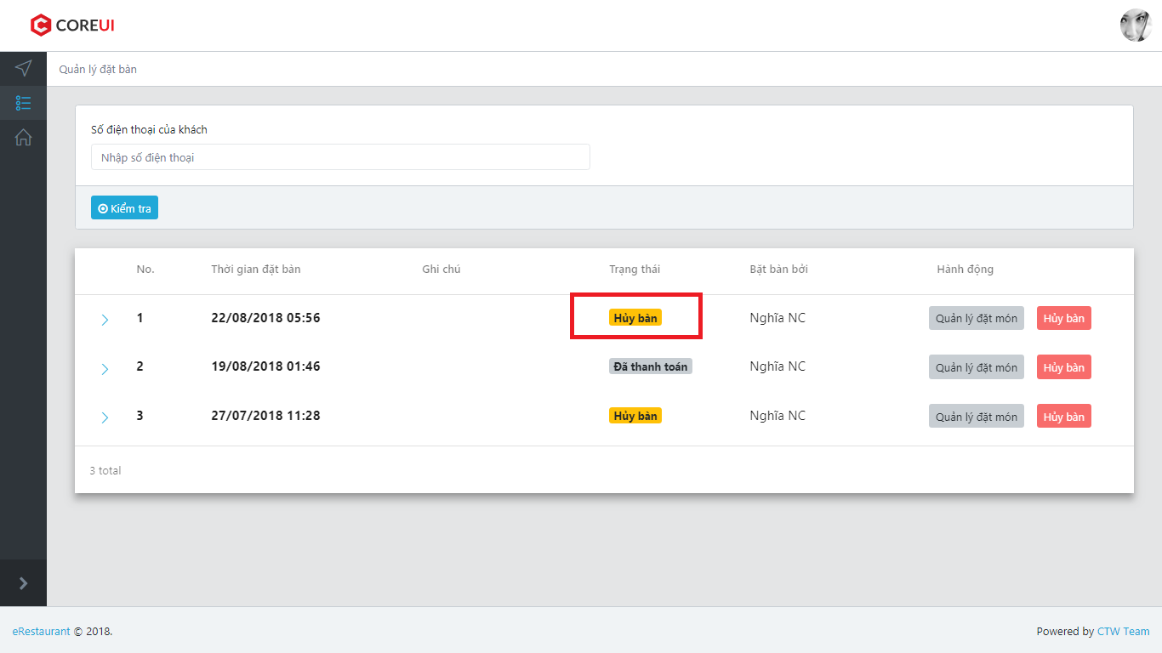

1. Click on “Quản lý đặt món”

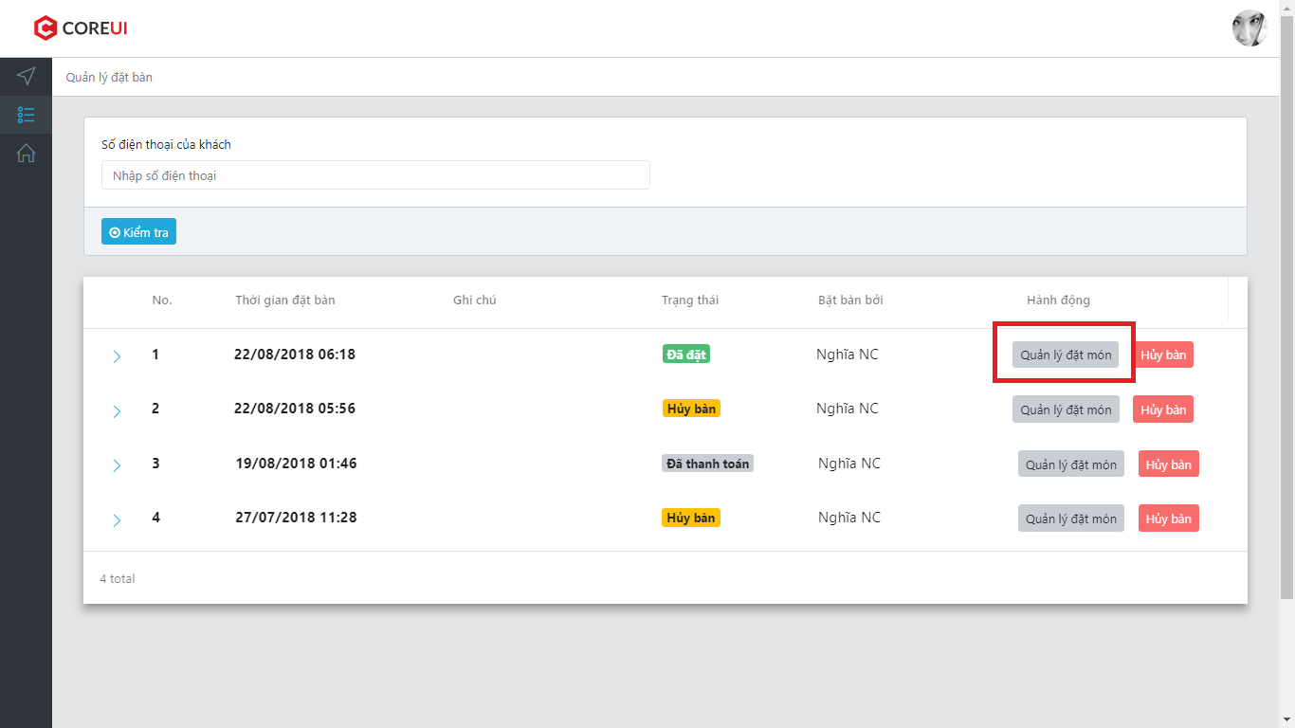

1. ER System redirect user to Manage Order Screen

### Manage booking table (waiter)

1. Click on “Quản lý đặt bàn”

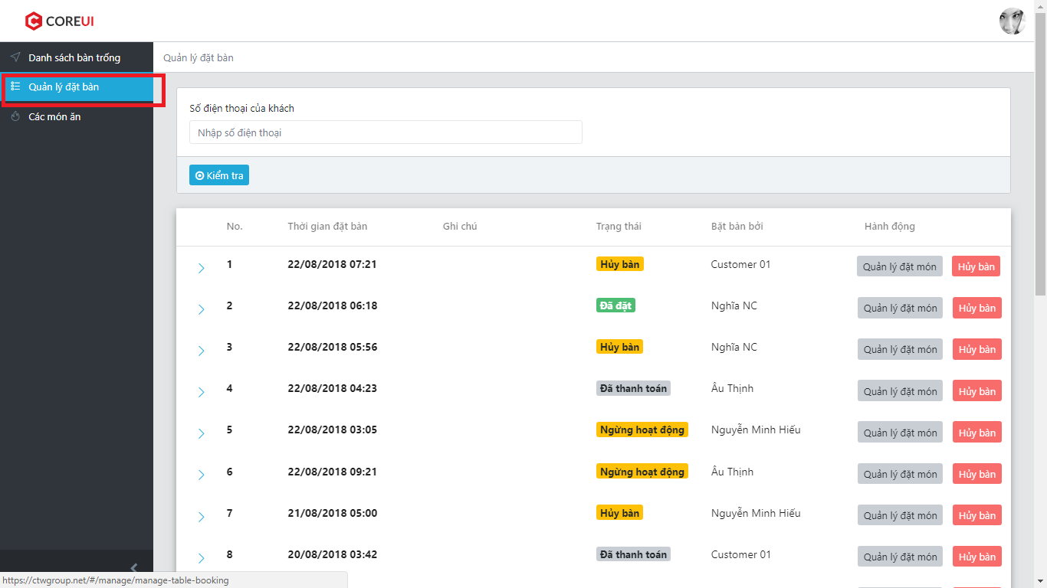

1. ER System display Manage Booking screen

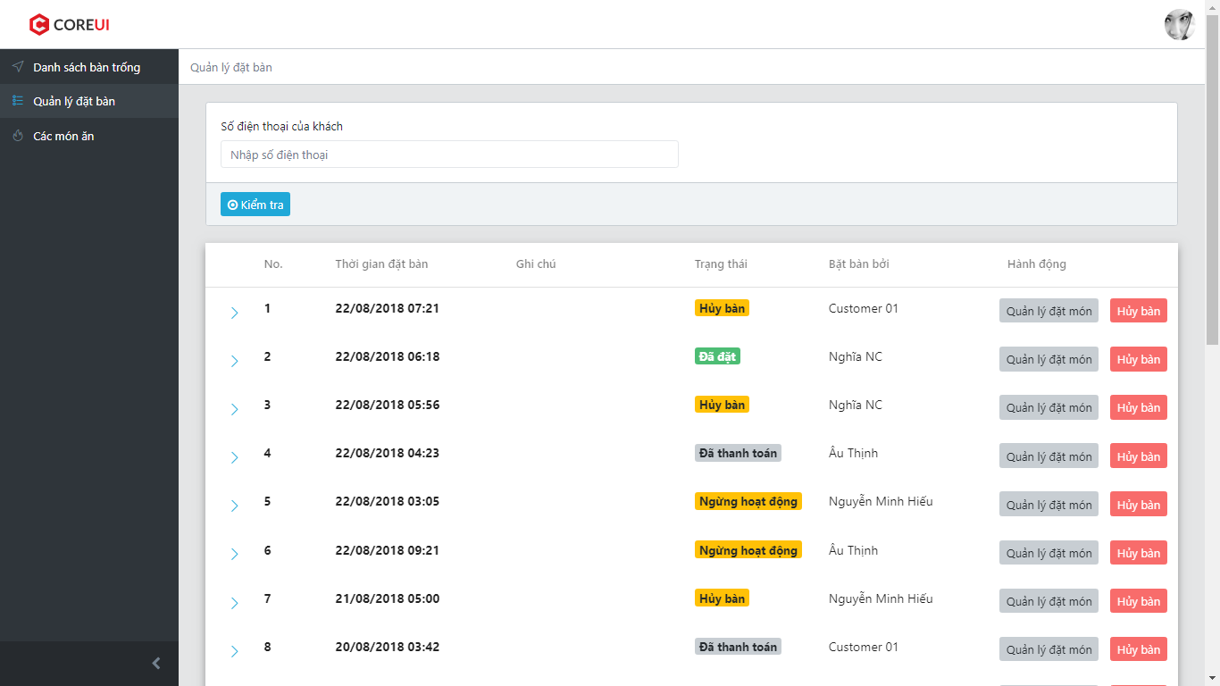

1. Click on “Hủy bàn” to cancel table booking

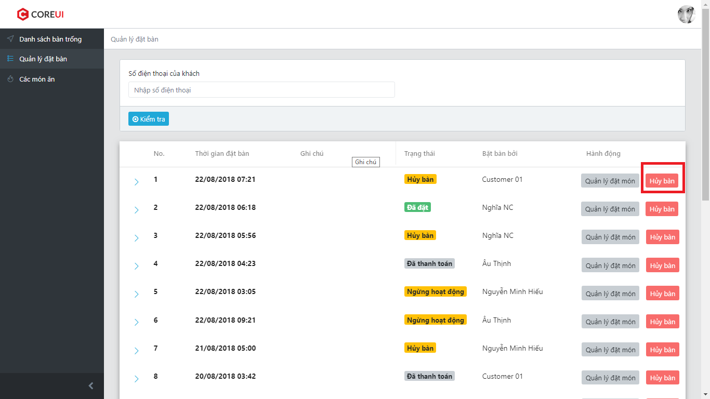

1. ER System display confirm box

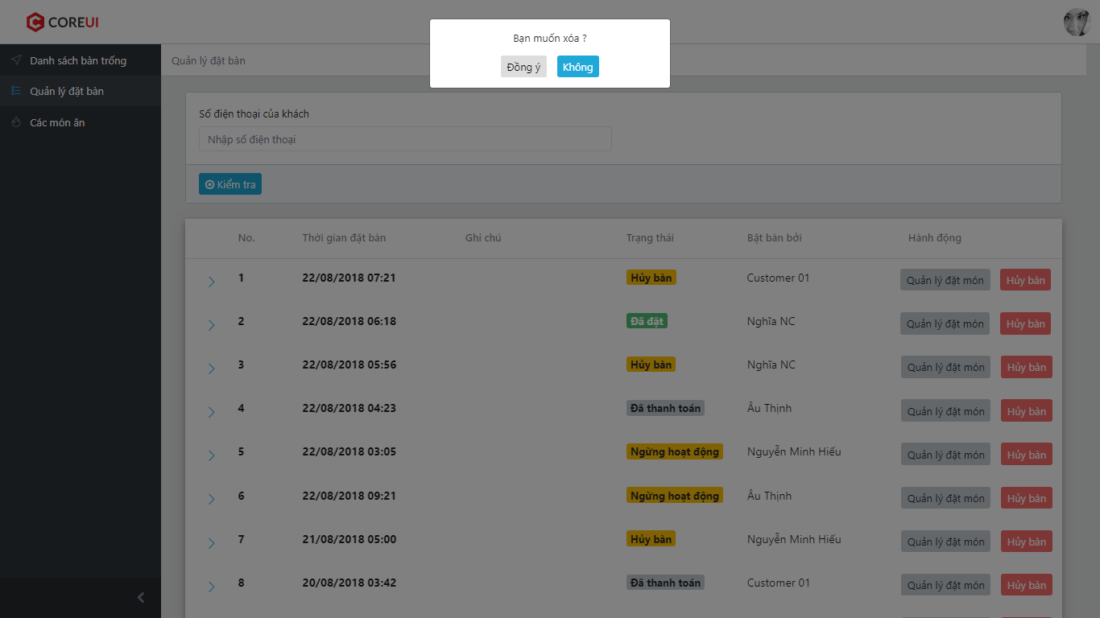

1. User can choose “Đồng ý” to cancel boking or ”Không” to back to list booked tables
2. If user choose “Xóa” instep 3, ER System change status of chosen booked table to “Hủy bàn” then display list booked tables
3. Click on “Quản lý đặt món”

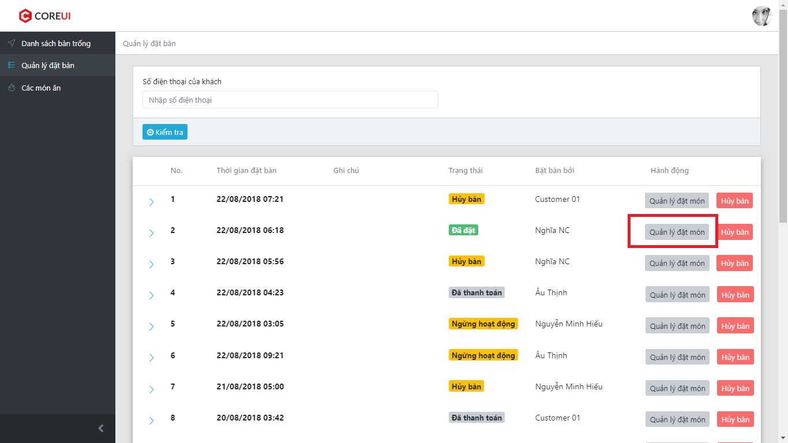

1. ER System redirect user to Manage Order Screen

### Manage order

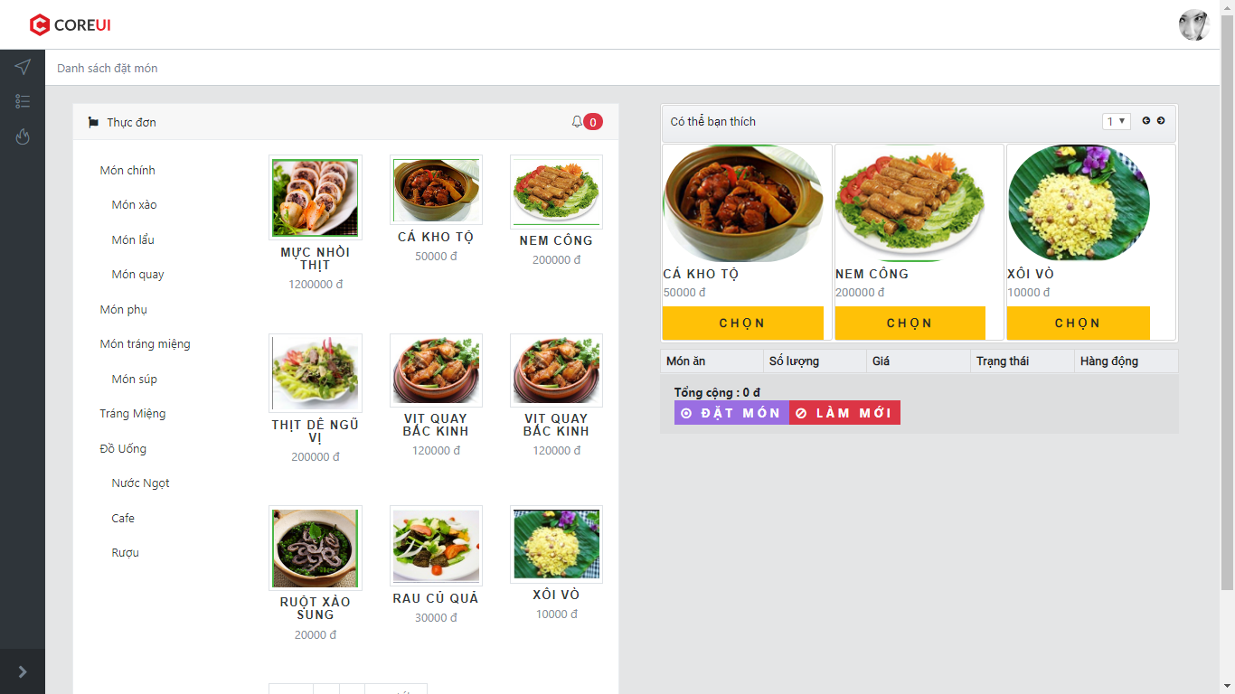

1. Click on menu in left side to view foods

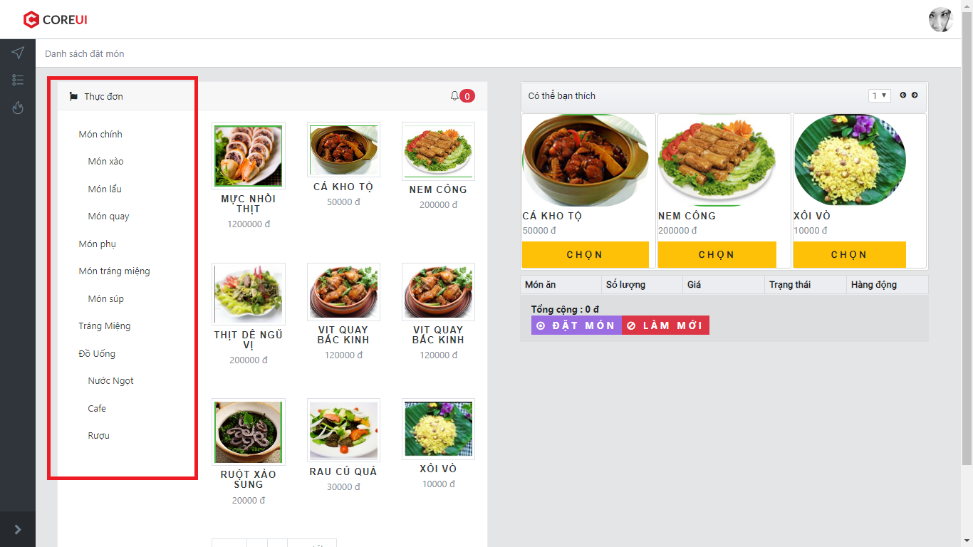

1. Click “Chọn” food

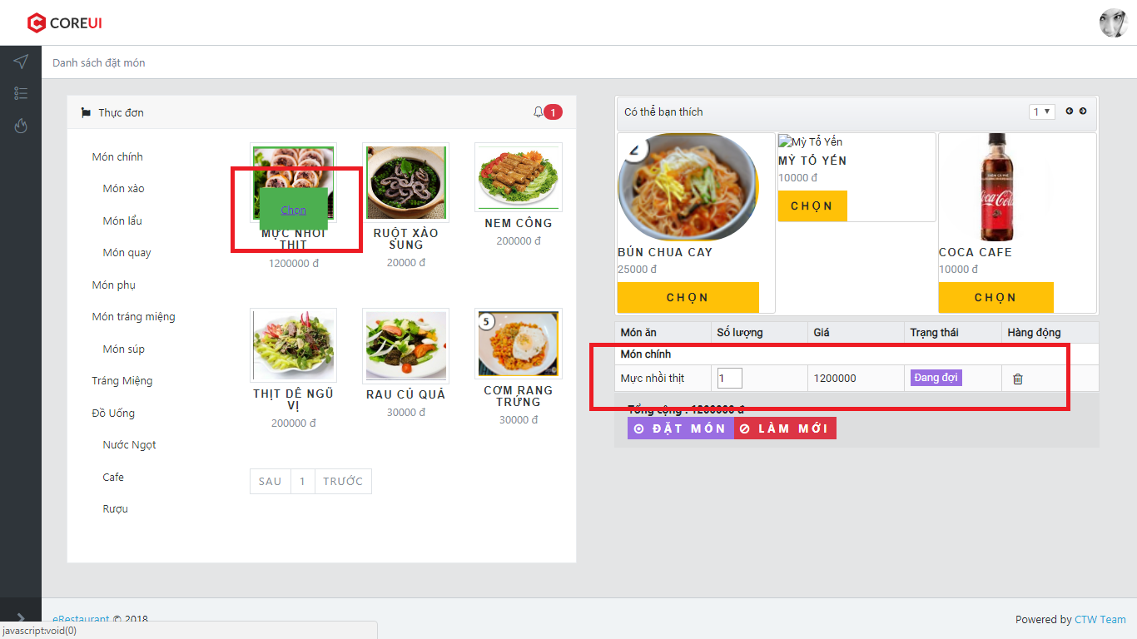

1. Click “Chọn” food from recommend list

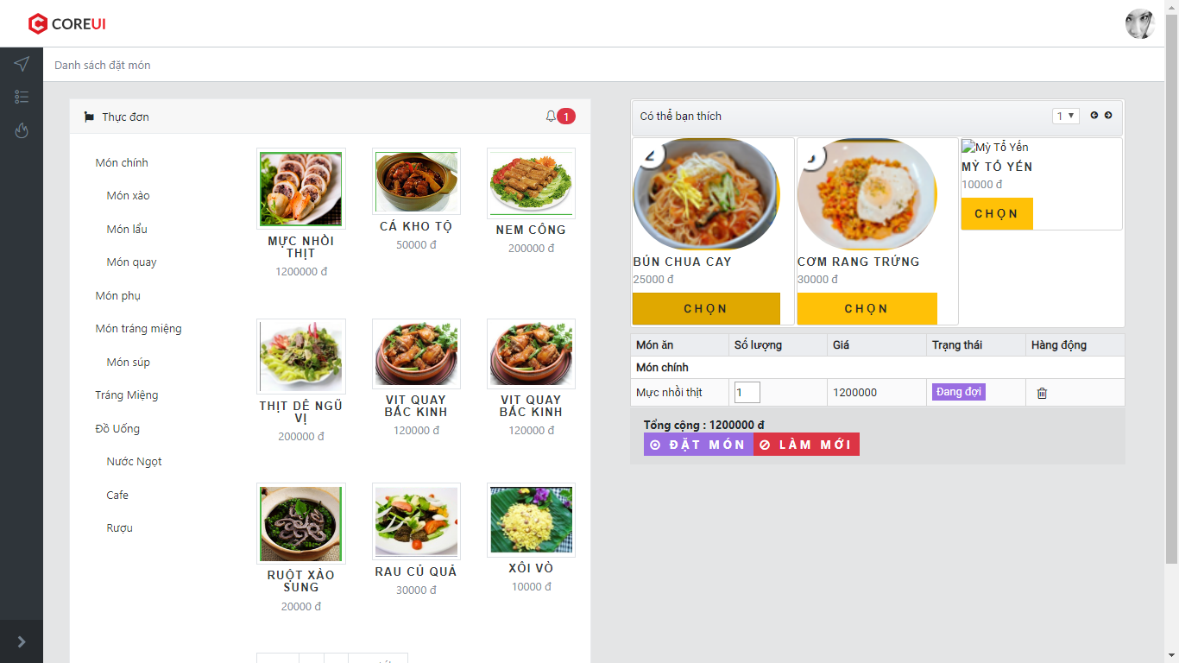

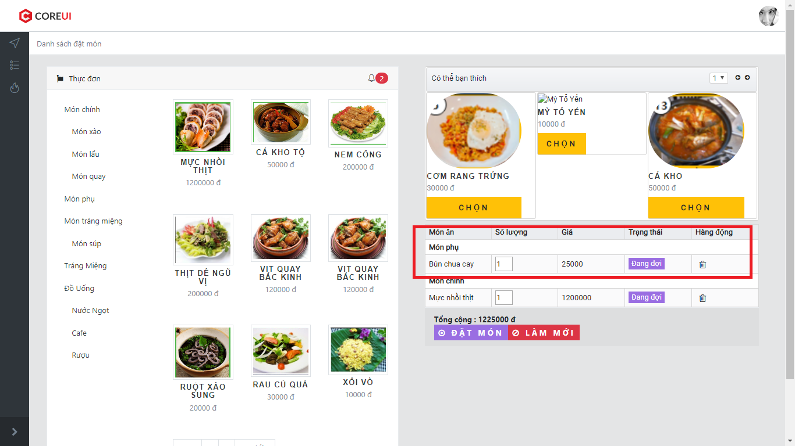

1. Click on ‘garbage can’ icon to remove food from order

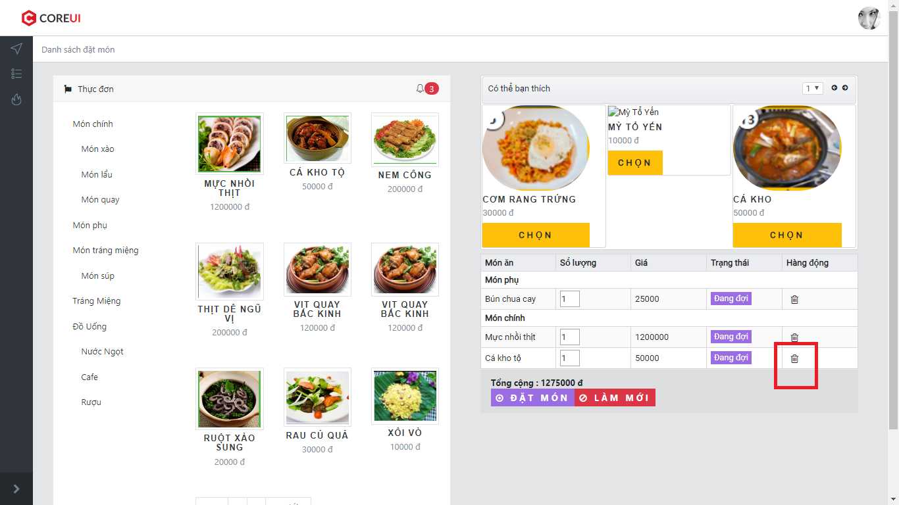

1. ER System display a confirm box

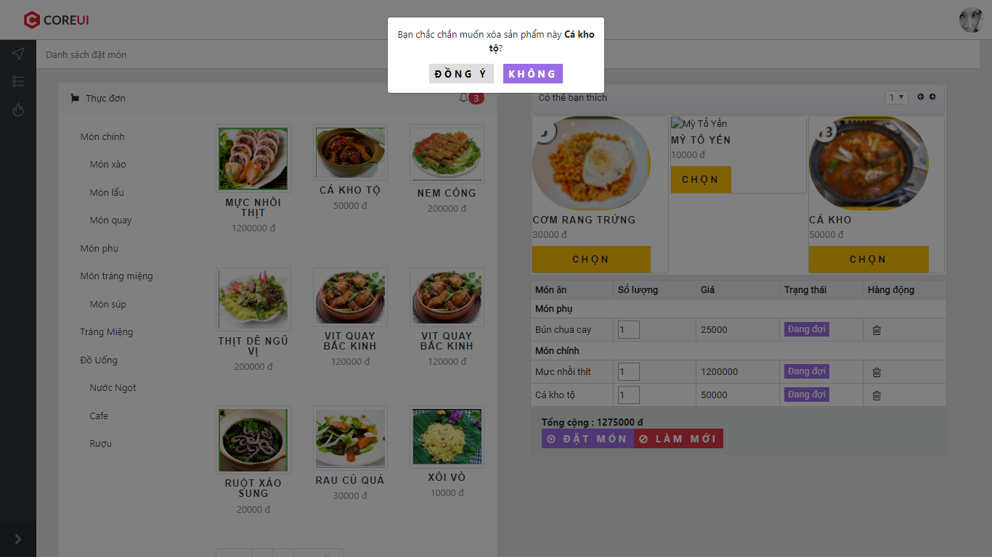

1. User can choose “Đồng ý” to remove food or ”Không” to back
2. If user choose “Xóa” instep 3, ER System remove chosen food from order list
3. Click on “Làm mới” button

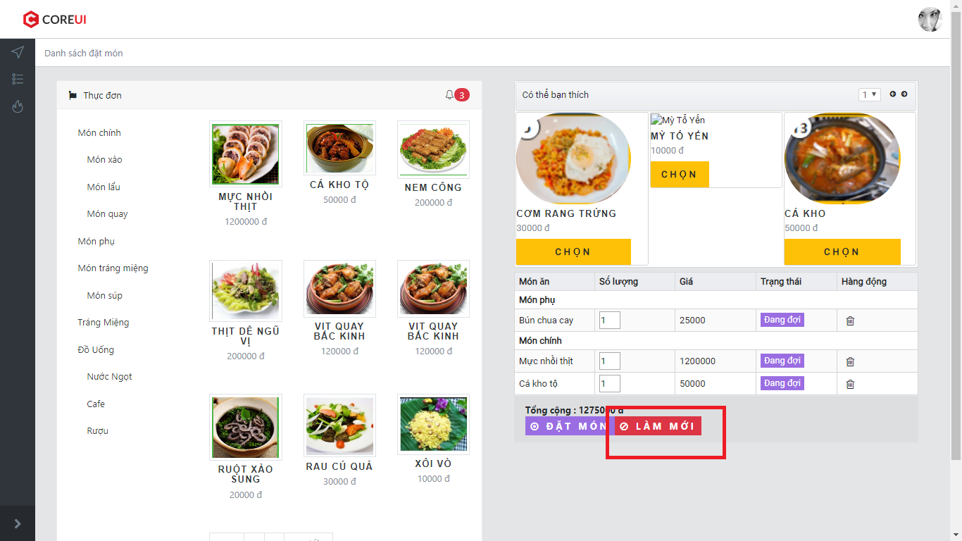

1. ER System display a confirm box

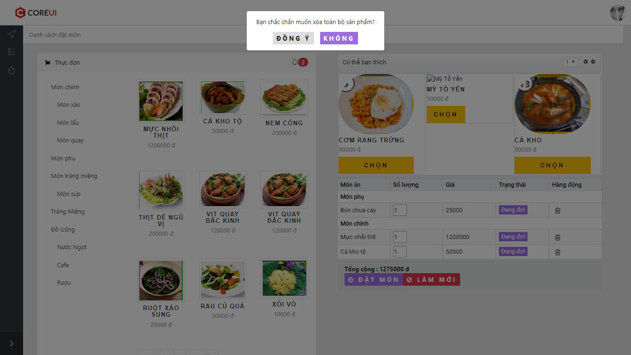

1. User can choose “Đồng ý” to remove all food or ”Không” to back
2. If user choose “Xóa” instep 3, ER System remove all food from order list
3. Click on “Đặt món”

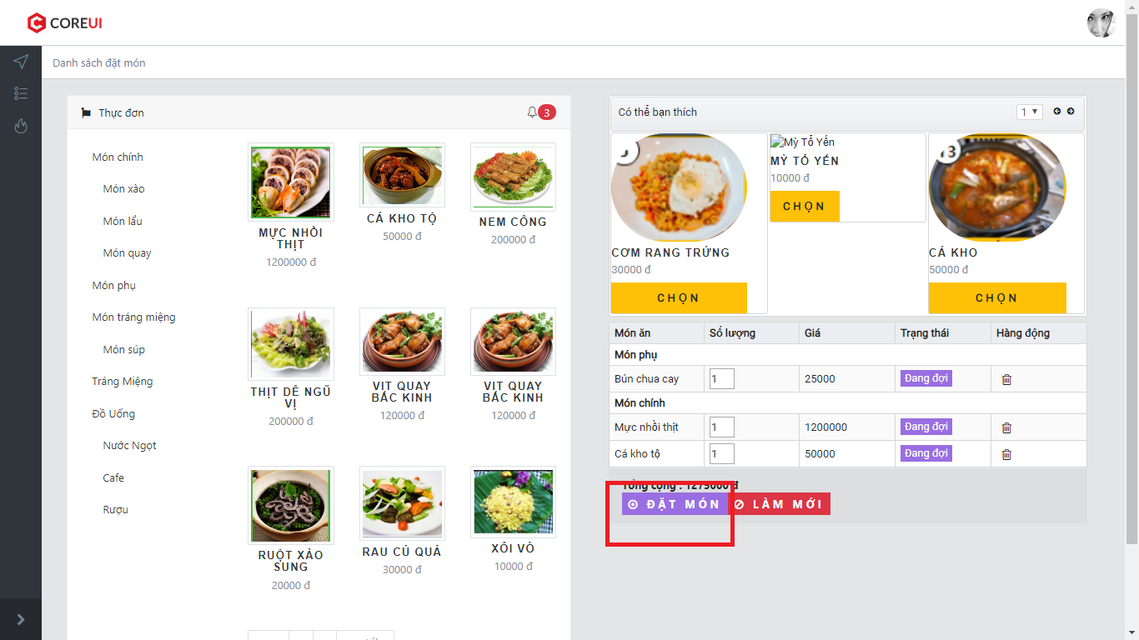

1. Order has been submited

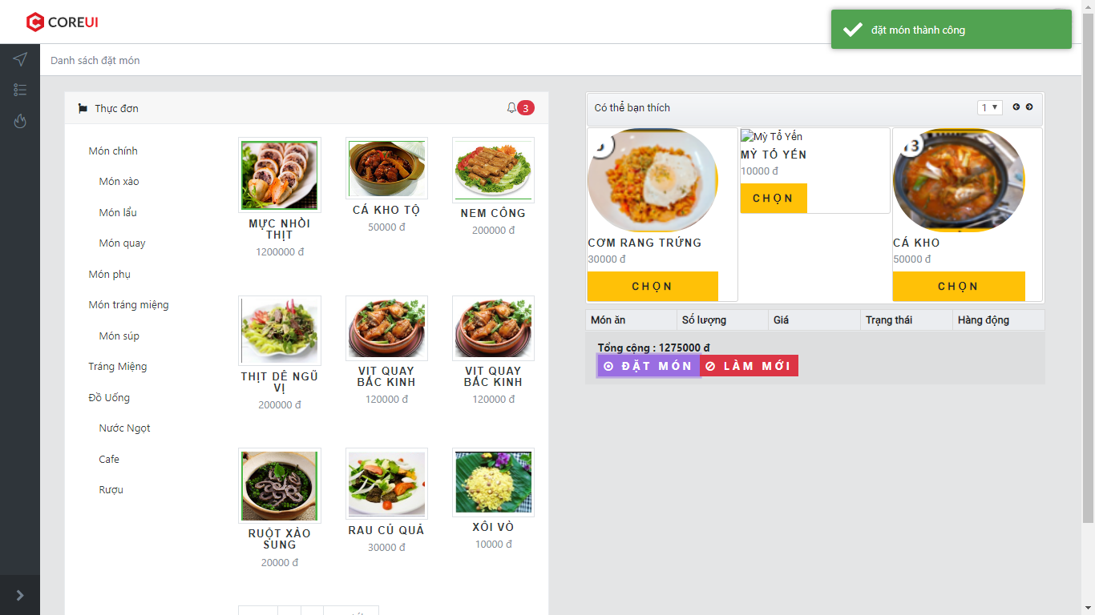

### List food waiting to cook

1. Login as Chef
2. Click on “Các món ăn”
3. ER System displays all food waiting to cook

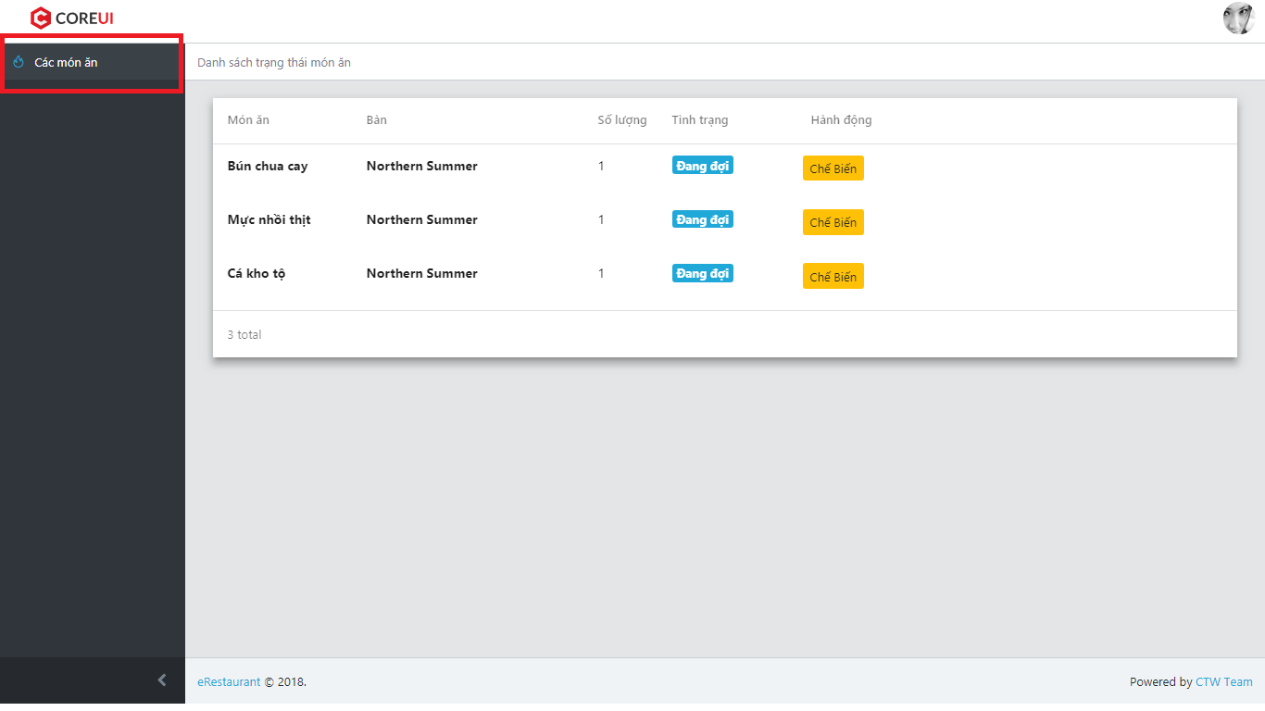

### Change status of food

1. Click on “Chế biến” button

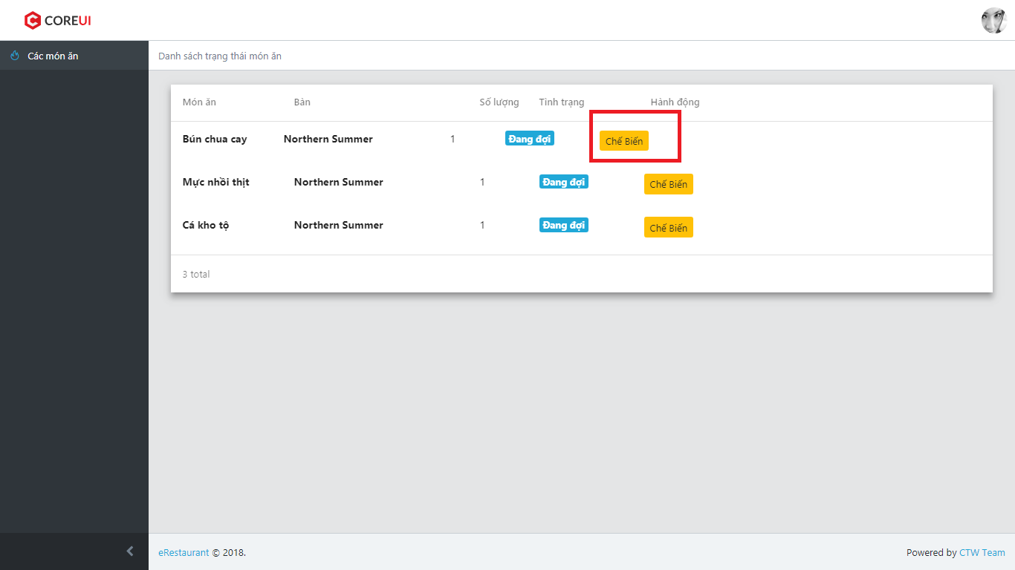

1. ER System display confirm box

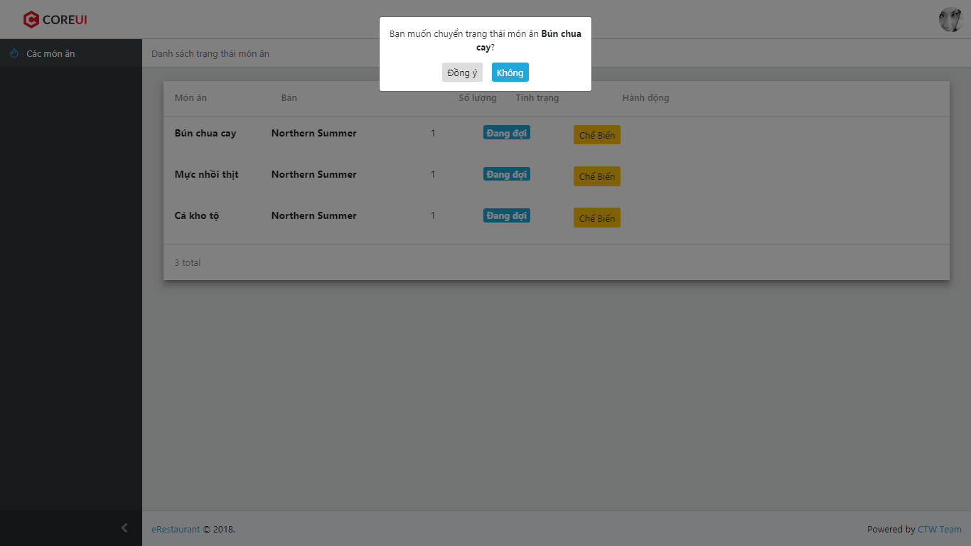

1. User choose “Đồng ý” to change status or “Không” to back
2. Food has 2 status: “Đang đợi”, “Đang chế biến”
3. If click on “Hoàn thành”, food is removed from list

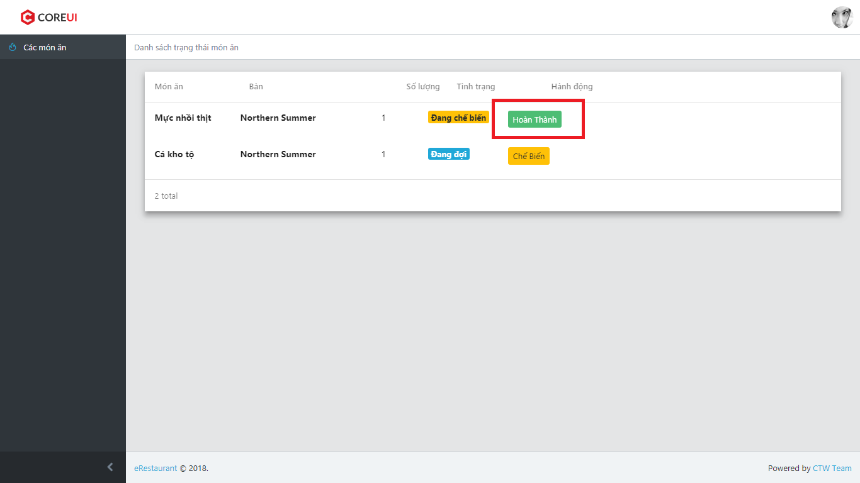

### List food waiting to be served

1. Login system as Waiter
2. Click on “Các món ăn”
3. ER System display all food waiting to be served

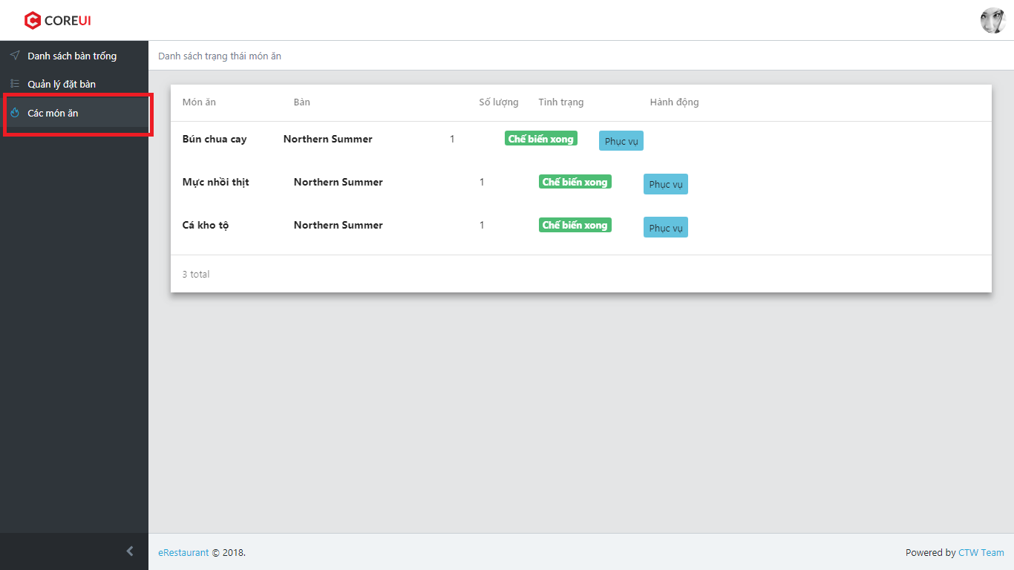

### Serve food

1. Click on “Phục vụ”

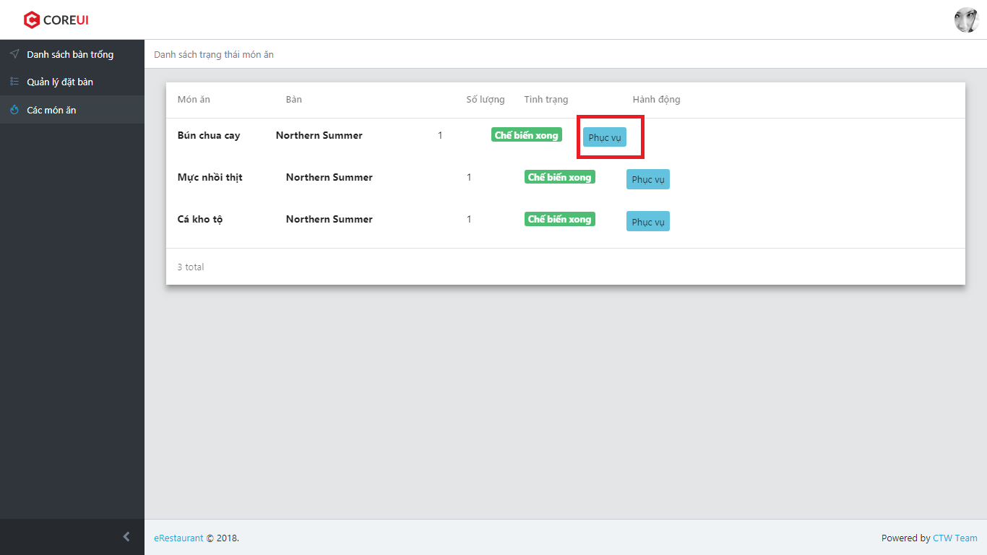

1. ER System display confirm box

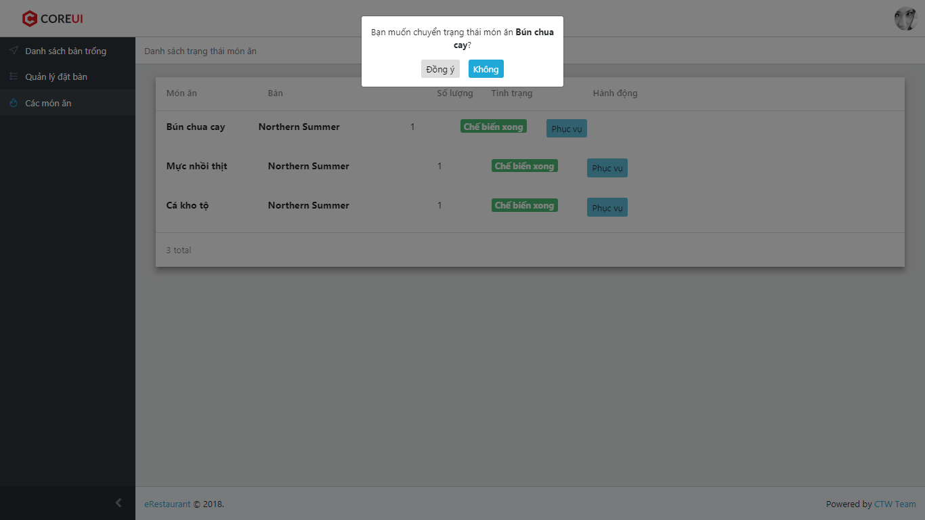

1. User choose “Đồng ý” to serve order or “Không” to back

### List order has been served

1. Login as Cashier
2. Click on “Thanh toán”
3. ER display List order has been served

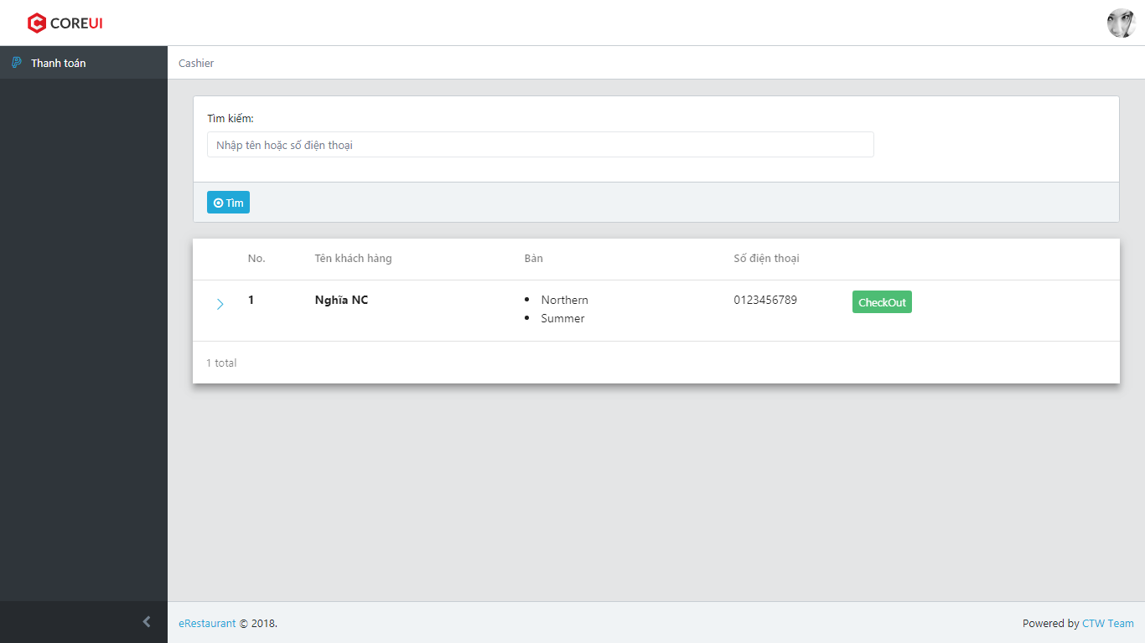

### CheckOut

1. Click on “CheckOut”

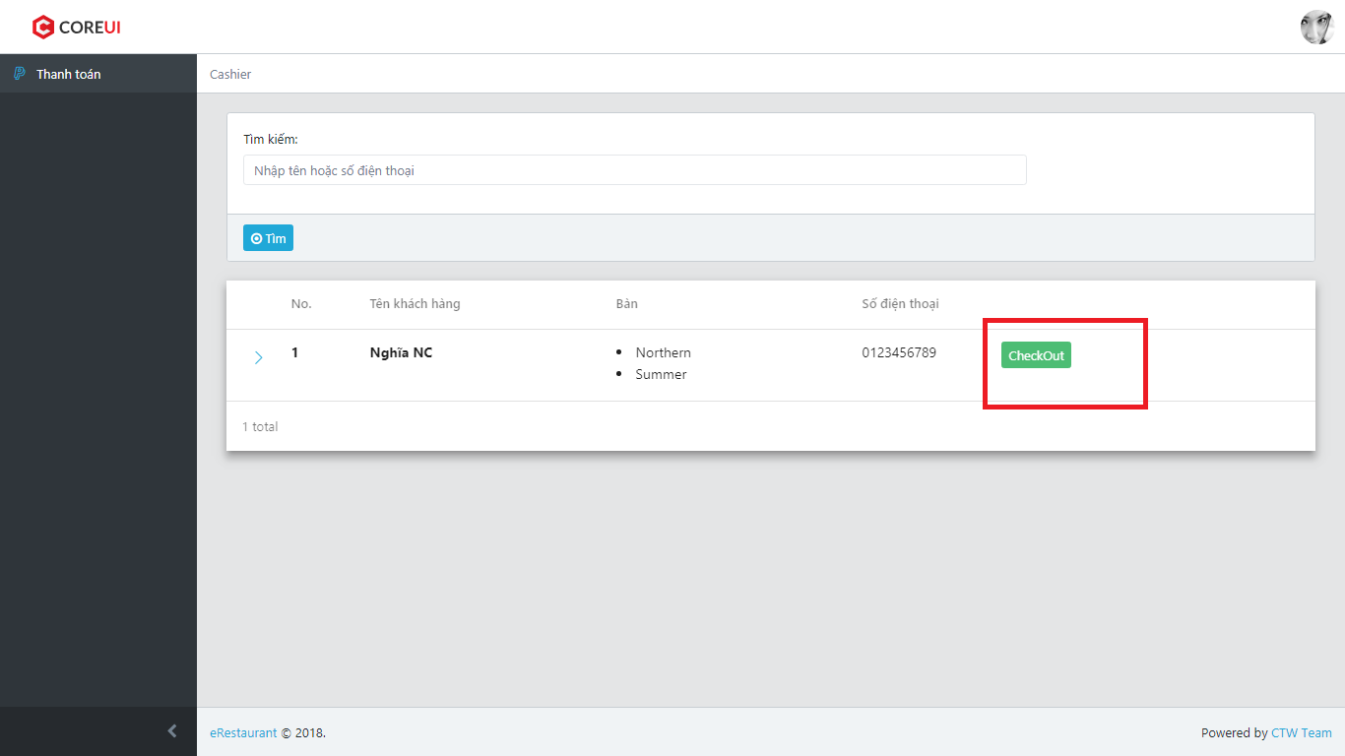

1. Redirect user to CheckOut screen

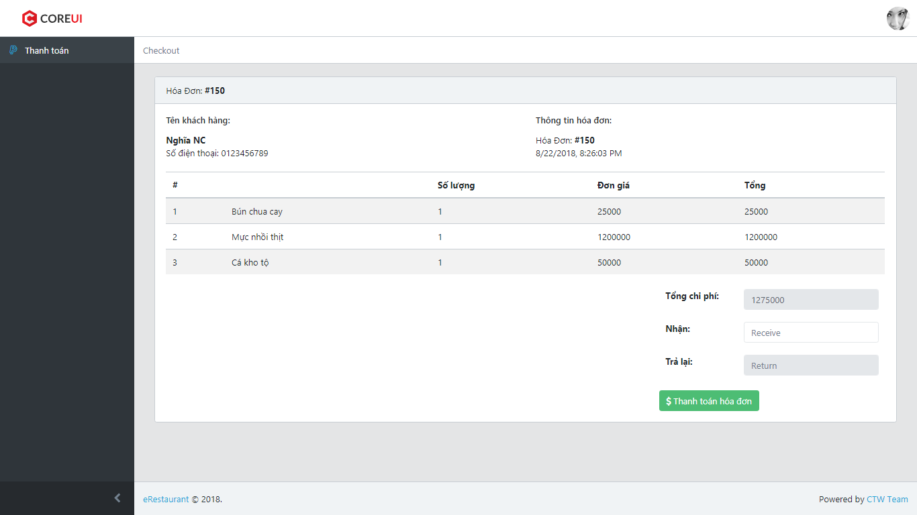

1. Enter receive cash

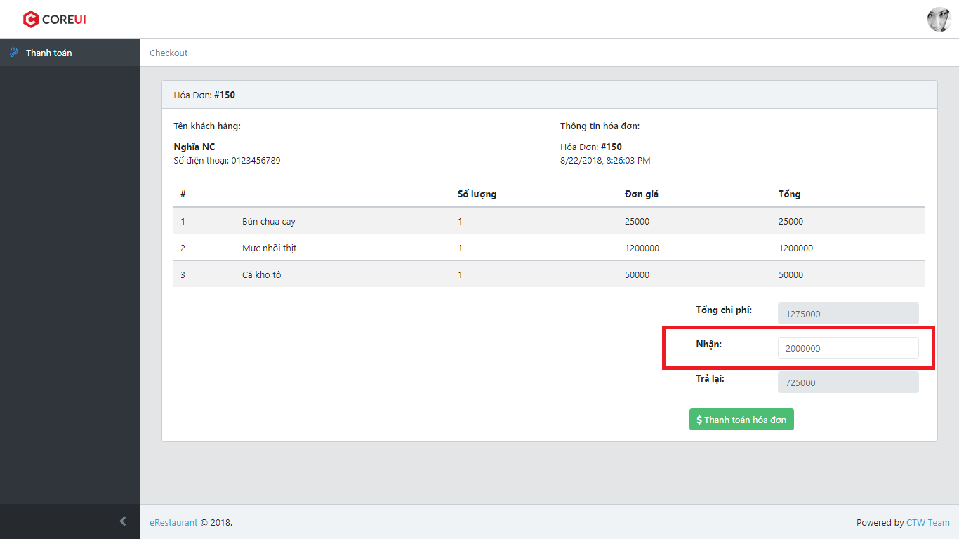

1. Click on “$ Thanh toán hóa đơn”

